CPE301 – SPRING 2019

Design Assignment 2C

Student Name: Serak Gebremedhin

Student #: 2000862766

Student Email: gebremed@unlv.nevada.edu

Primary Github address: https://github.com/Ber-geb/effective-octo-reaction

Directory: effective-octo-reaction/DesignAssignments/DA2C/

Submit the following for all Labs:

1. In the document, for each task submit the modified or included code (only) with highlights and justifications of the modifications. Also, include the comments.
2. Use the previously create a Github repository with a random name (no CPE/301, Lastname, Firstname). Place all labs under the root folder ESD301/DA, sub-folder named LABXX, with one document and one video link file for each lab, place modified asm/c files named as LabXX-TYY.asm/c.
3. If multiple asm/c files or other libraries are used, create a folder LabXX-TYY and place these files inside the folder.
4. The folder should have a) Word document (see template), b) source code file(s) and other include files, c) text file with youtube video links (see template).

1. **COMPONENTS LIST AND CONNECTION BLOCK DIAGRAM w/ PINS**

List of Components used:

Saleae Logic Analyzer

M/F Jumper Wires

Green LED

Two Resistors

One Mini Push Button Switch

Breadboard

Atmega328P Xplained MiniBoard

Block diagram with pins used in the Atmega328P:

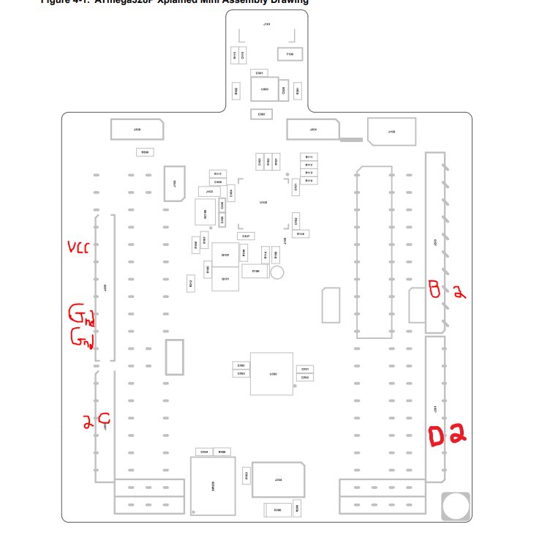

This shows the Xplained Mini Assembly Drawing. The areas of the drawing drawn in red indicate which pins were used.

1. **INITIAL/MODIFIED/DEVELOPED CODE OF TASK 1/A**

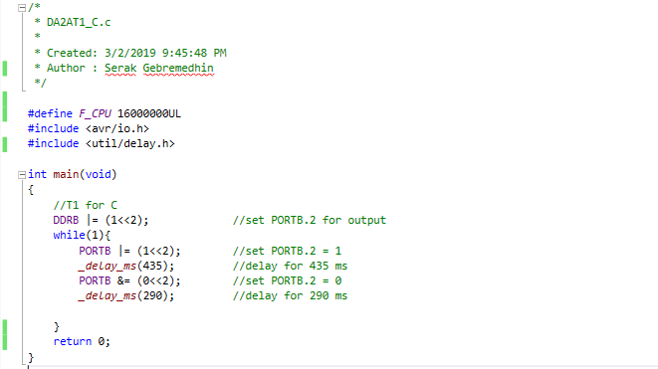

This is C code for Task 1 for **Design Assignment 2A**.

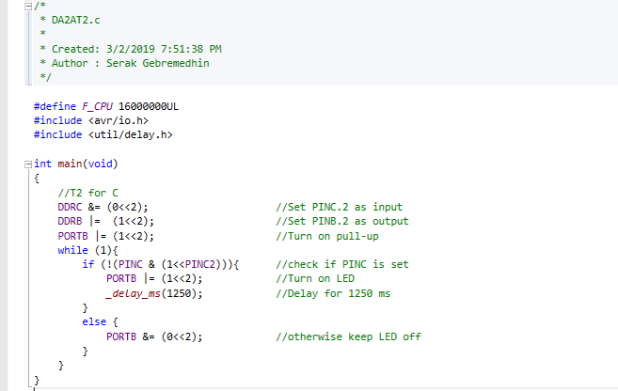

This is C code for Task 2 for **Design Assignment 2A.**

1. **DEVELOPED MODIFIED CODE OF TASK 2/A from TASK 1/A**

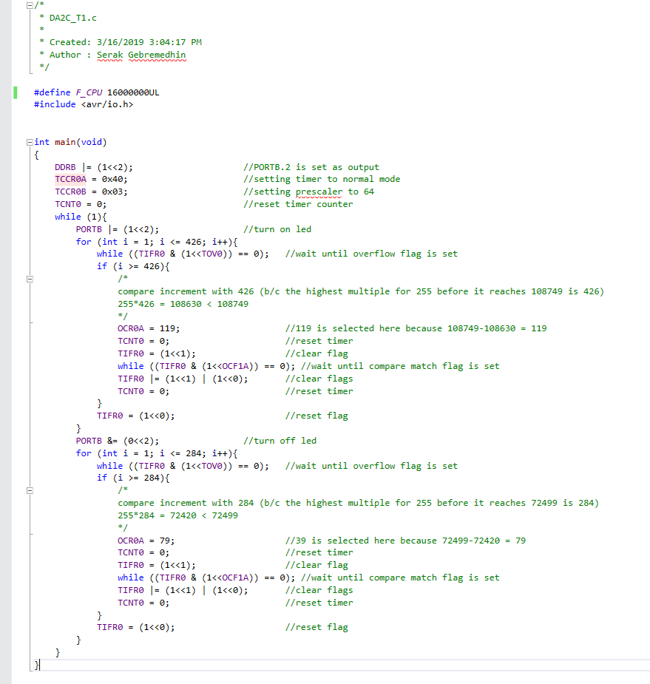

This is the “modified” code in C for Task 1 for **Design Assignment 2C**. This modifies the code from DA2A task 1.

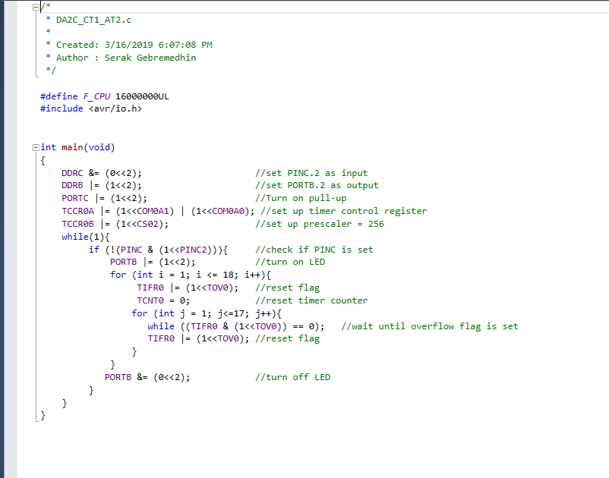

This is the “modified” code in C for Task 1 for **Design Assignment 2C**. This modifies the code from DA2A task 2.

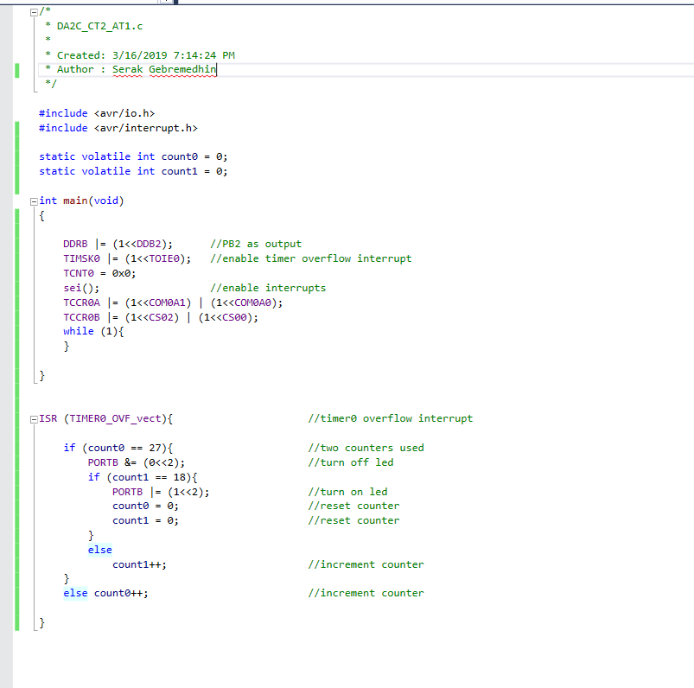

This is the “modified” code in C for Task 2 for **Design Assignment 2C**. This modifies the code from DA2A task 1.

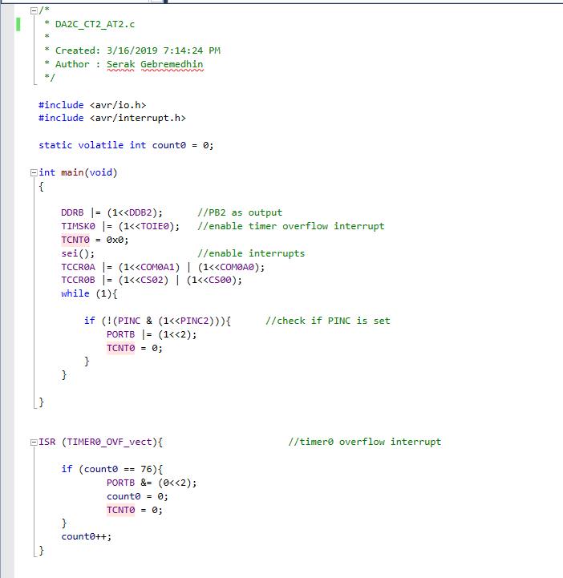

This is the “modified” code in C for Task 2 for **Design Assignment 2C**. This modifies the code from DA2A task 2.

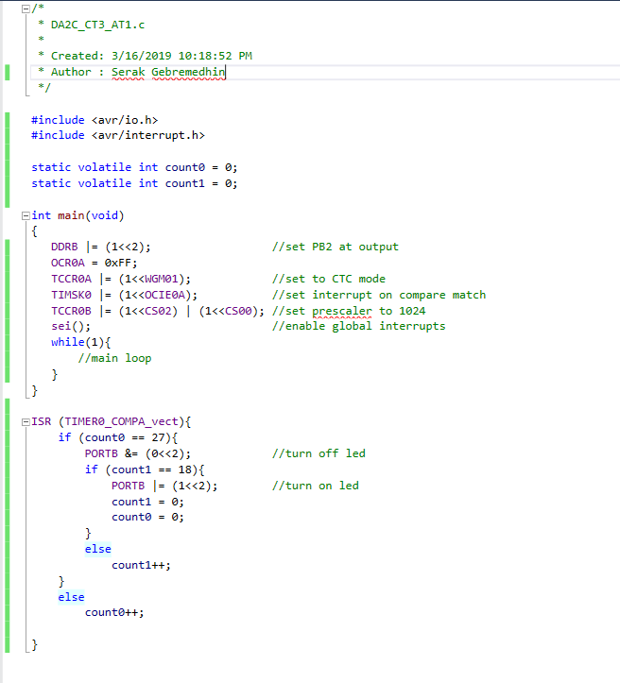

This is the “modified” code in C for Task 3 for **Design Assignment 2C**. This modifies the code from DA2A task 1.

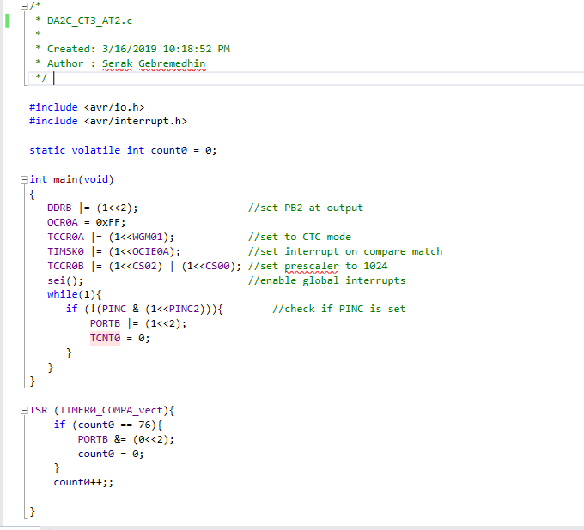

This is the “modified” code in C for Task 3 for **Design Assignment 2C**. This modifies the code from DA2A task 2.

1. **SCHEMATICS**

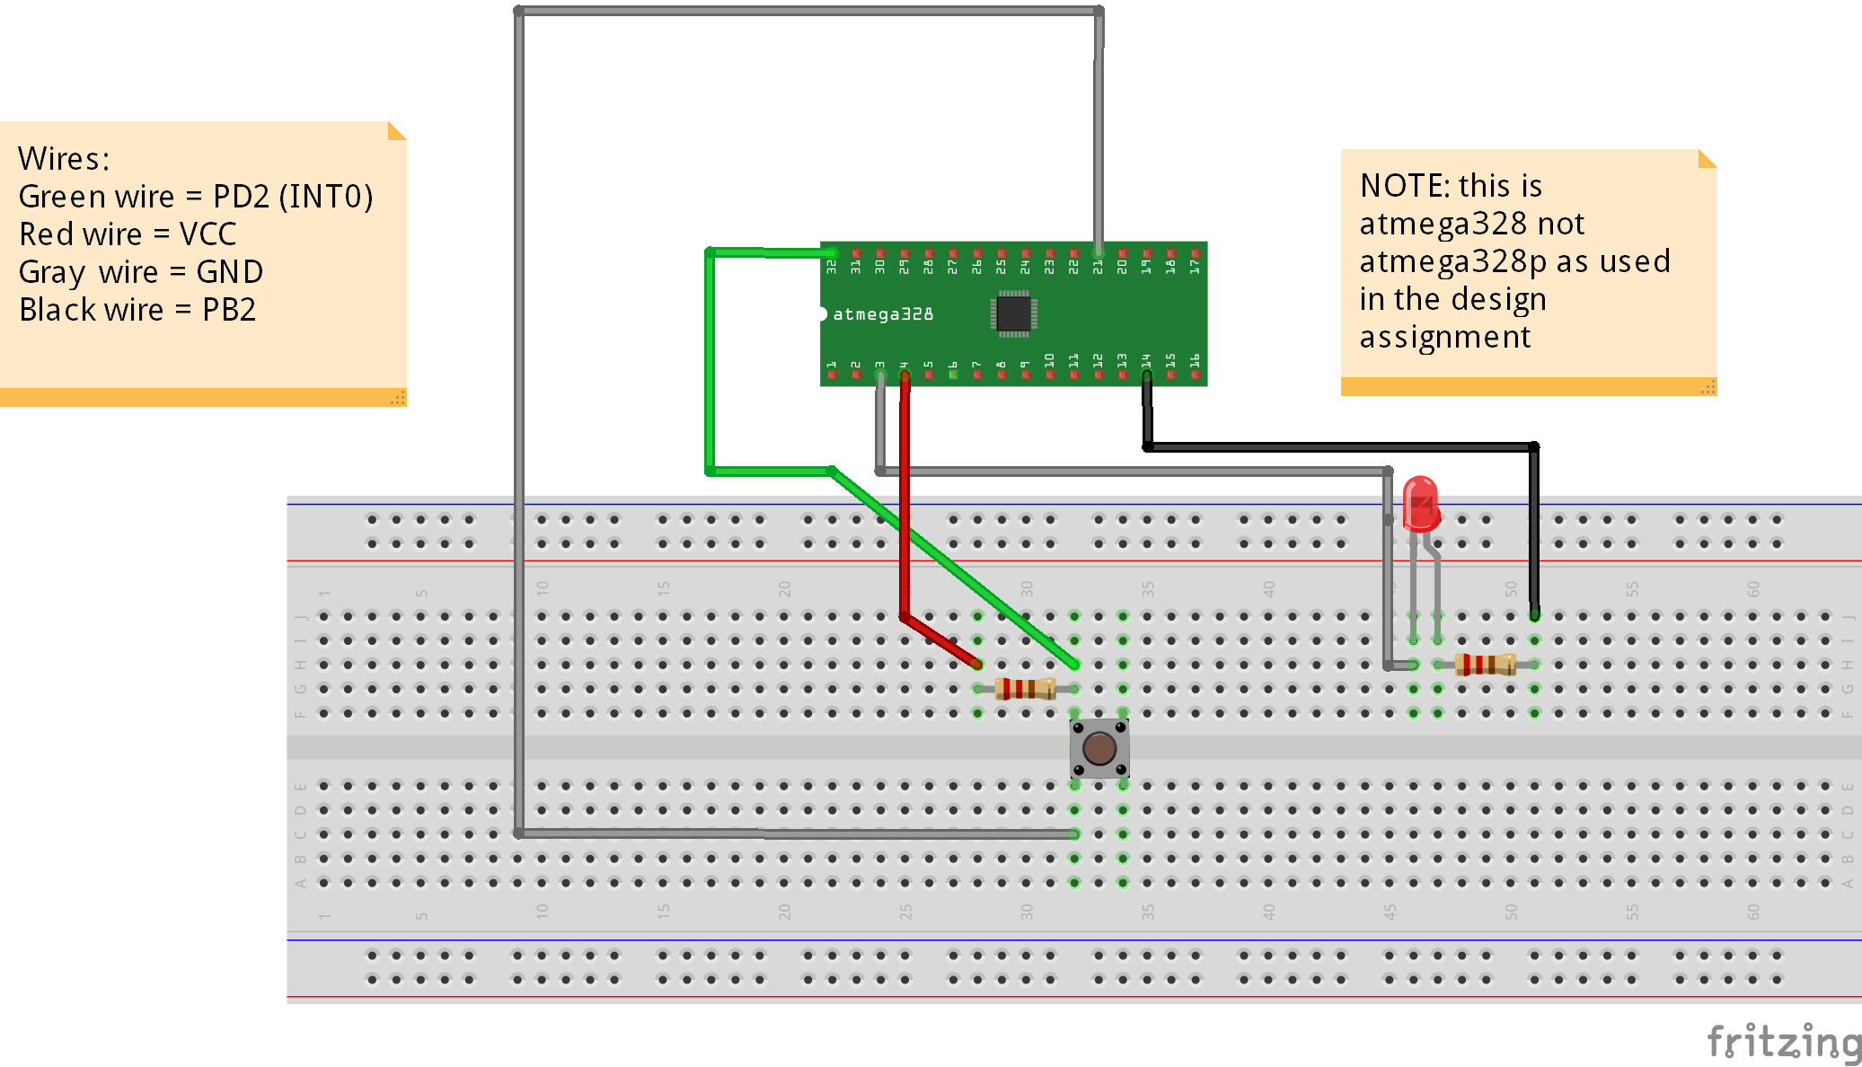

This shows schematic of the circuit implemented for this assignment.

1. **SCREENSHOTS OF EACH TASK OUTPUT (ATMEL STUDIO OUTPUT)**

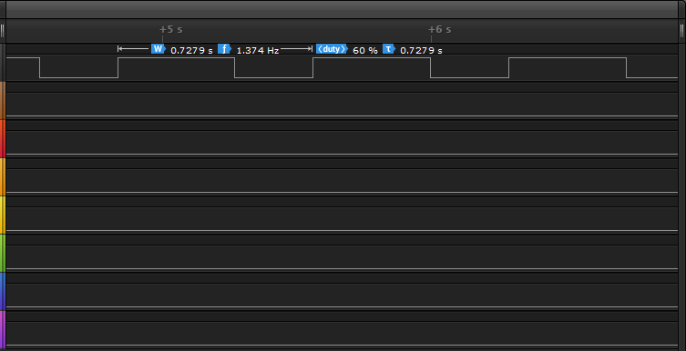

This is the logic analyzer for Task 1 for **Design Assignment 2C**. This is modified version of DA2A task 1.

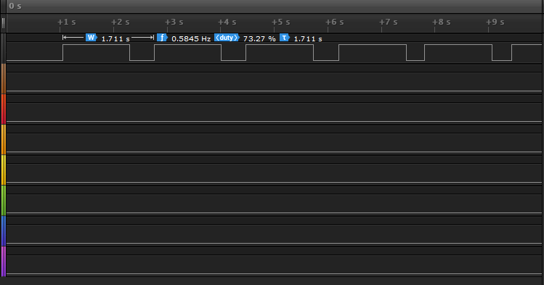

This is the logic analyzer for Task 1 for **Design Assignment 2C**. This is modified version of DA2A task 2.

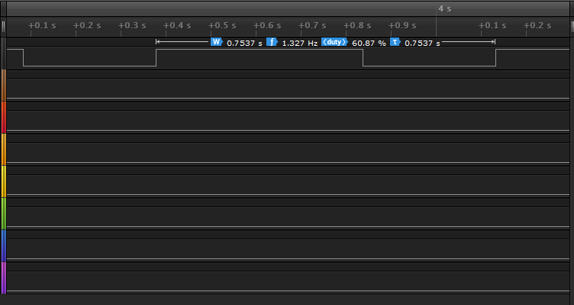

This is the logic analyzer for Task 2 for **Design Assignment 2C**. This is modified version of DA2A task 1.

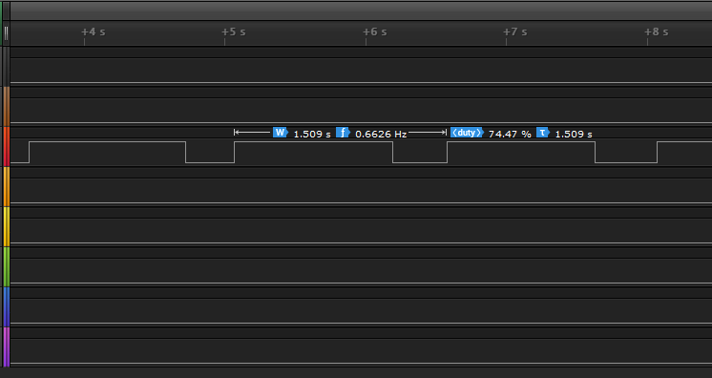

This is the logic analyzer for Task 2 for **Design Assignment 2C**. This is modified version of DA2A task 2.

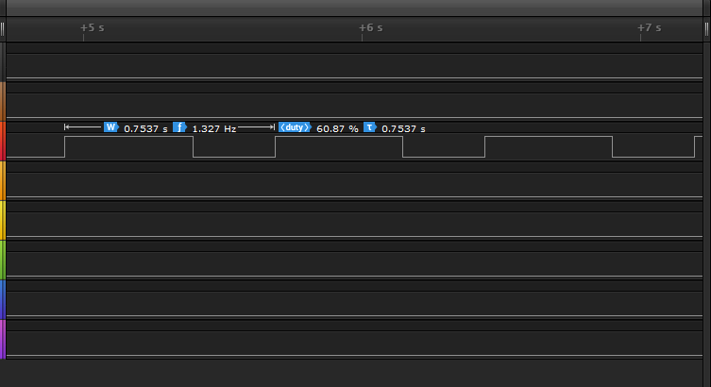

This is the logic analyzer for Task 3 for **Design Assignment 2C**. This is modified version of DA2A task 1.

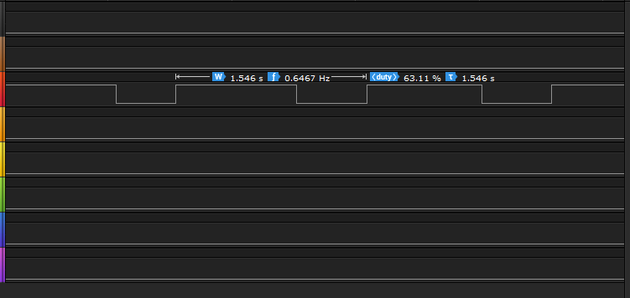

This is the logic analyzer for Task 3 for **Design Assignment 2C**. This is modified version of DA2A task 2.

1. **SCREENSHOT OF EACH DEMO (BOARD SETUP)**

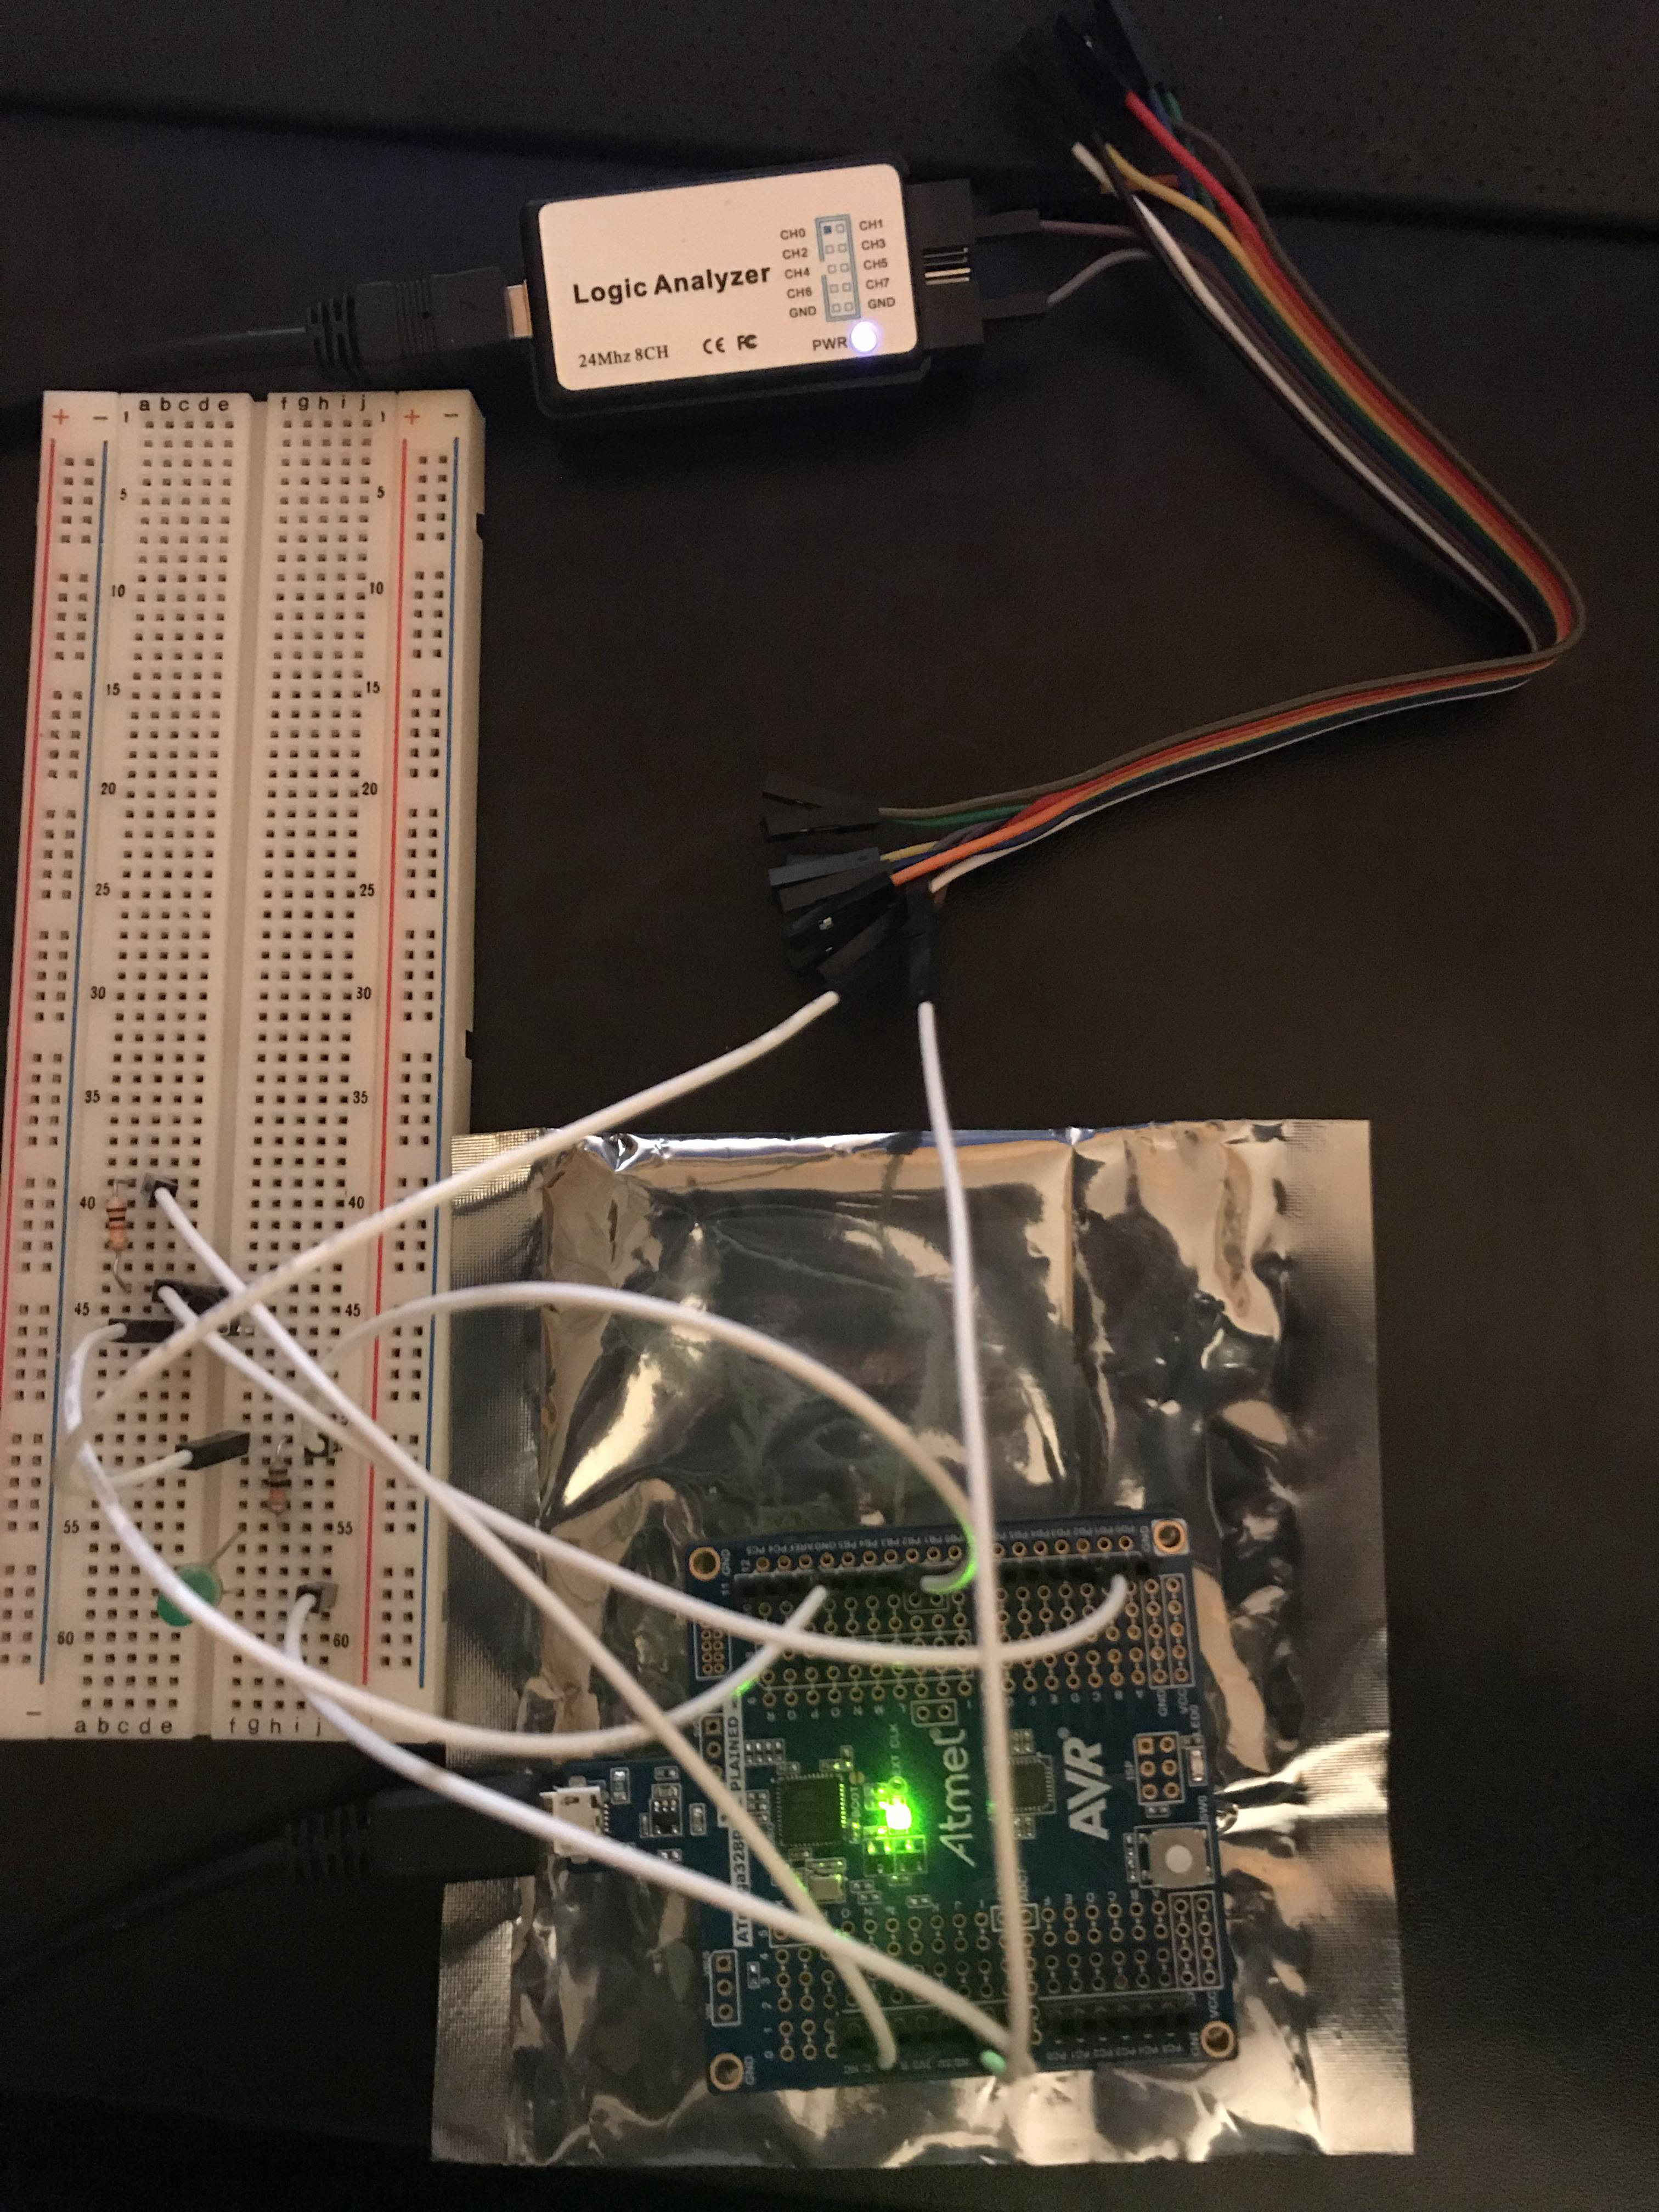

This shows the board setup with the breadboard, jumper wires, AtMega328P, and the Logic Analyzer connected to the PB.2 pin.

1. **VIDEO LINKS OF EACH DEMO**

<https://youtu.be/wYfOhApBYTQ>

This following video link will show only one video; however, each demo in the video will be labeled to make sure the viewer knows which demo is currently being shown.

1. **GITHUB LINK OF THIS DA**

<https://github.com/Ber-geb/effective-octo-reaction>

**Student Academic Misconduct Policy**

<http://studentconduct.unlv.edu/misconduct/policy.html>

“This assignment submission is my own, original work”.

Serak Gebremedhin