CPE301 – SPRING 2019

Design Assignment 4A

Student Name: Serak Gebremedhin

Student #: 2000862766

Student Email: gebremed@unlv.nevada.edu

Primary Github address: https://github.com/Ber-geb/effective-octo-reaction

Directory: effective-octo-reaction/DesignAssignments/DA4A/

Submit the following for all Labs:

1. In the document, for each task submit the modified or included code (only) with highlights and justifications of the modifications. Also, include the comments.
2. Use the previously create a Github repository with a random name (no CPE/301, Lastname, Firstname). Place all labs under the root folder ESD301/DA, sub-folder named LABXX, with one document and one video link file for each lab, place modified asm/c files named as LabXX-TYY.asm/c.
3. If multiple asm/c files or other libraries are used, create a folder LabXX-TYY and place these files inside the folder.
4. The folder should have a) Word document (see template), b) source code file(s) and other include files, c) text file with youtube video links (see template).

1. **COMPONENTS LIST AND CONNECTION BLOCK DIAGRAM w/ PINS**

List of Components used:

Breadboard

Atmega328P Xplained MiniBoard

TB6612FNG

Block diagram with pins used in the Atmega328P:

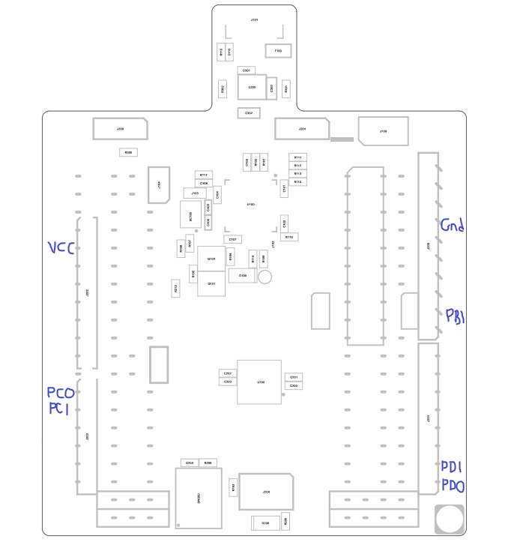

This shows the Xplained Mini Assembly Drawing. The areas of the drawing drawn in blue indicate which pins were used.

1. **INITIAL/MODIFIED/DEVELOPED CODE OF TASK 1/A**

There is “modified” code for this design assignment

1. **DEVELOPED MODIFIED CODE OF TASK 2/A from TASK 1/A**

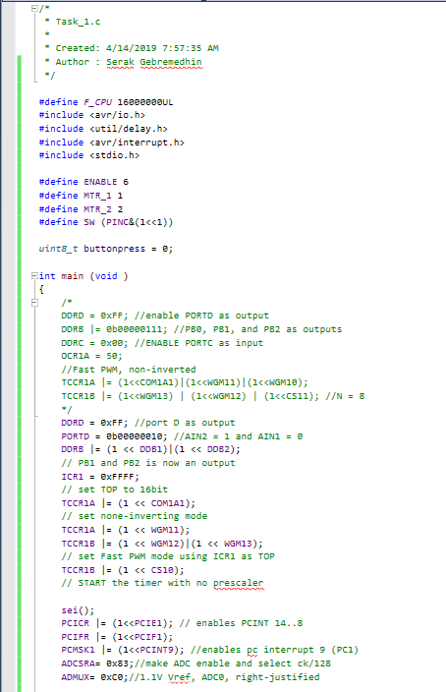

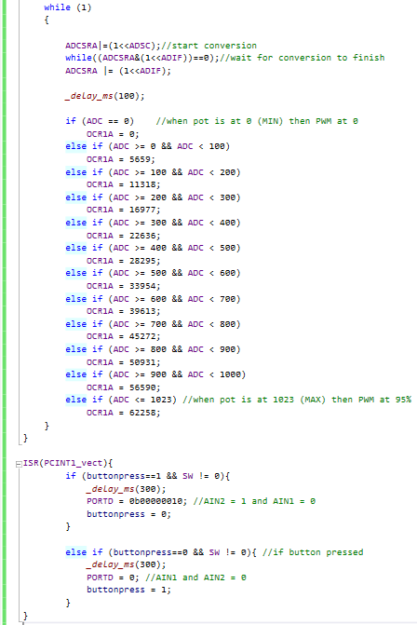

This shows the code in C for **Design Assignment 4A**.

1. **SCHEMATICS**

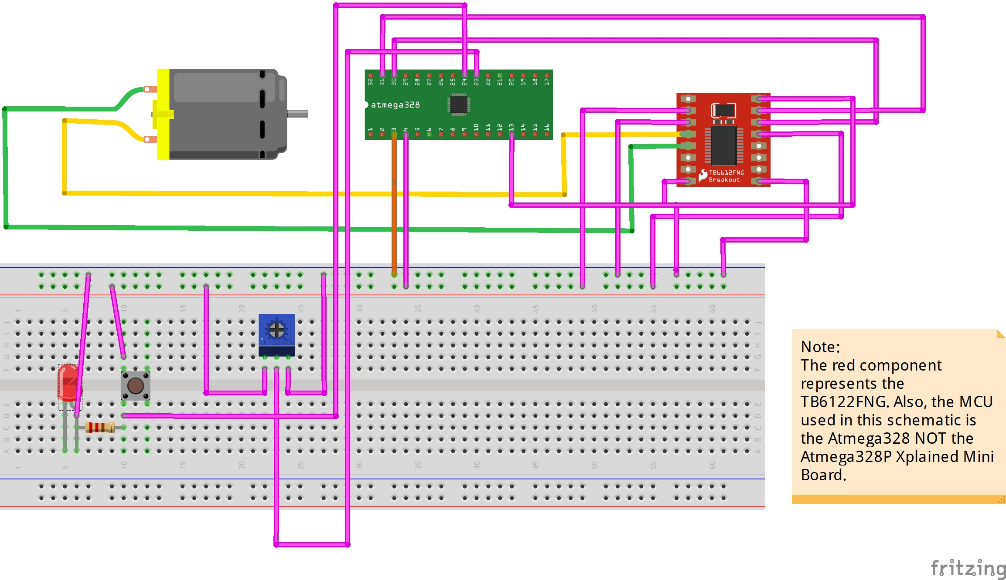

This is the schematic used for **Design Assignment 4A**.

1. **SCREENSHOTS OF EACH TASK OUTPUT (ATMEL STUDIO OUTPUT)**

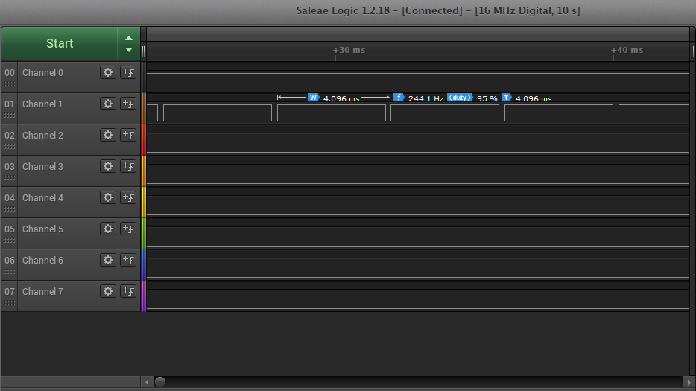

This shows the Salae Logic Analyzer. The potentiometer is at max; thus, a 95% duty cycle is shown.

1. **SCREENSHOT OF EACH DEMO (BOARD SETUP)**

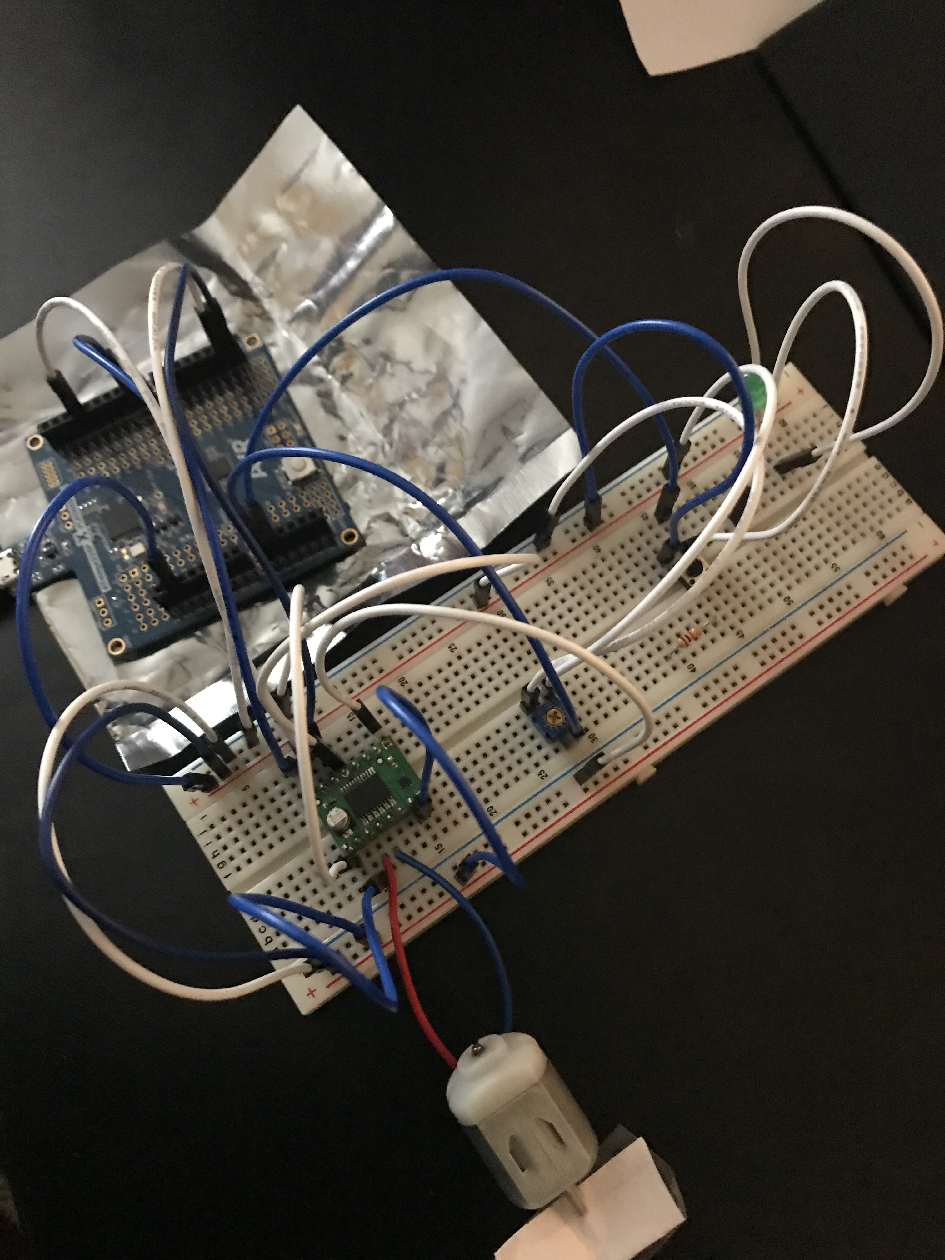

This shows the board setup for this design assignment. These pictures shows the following: a breadboard, the potentiometer, the TB6612FNG, the ATmega328P Xplained Mini, the DC motor, an LED, a pushbutton, jumper wires, and a resister.

1. **VIDEO LINKS OF EACH DEMO**

<https://youtu.be/Yfh-P_GZY8s>

1. **GITHUB LINK OF THIS DA**

<https://github.com/Ber-geb/effective-octo-reaction>

**Student Academic Misconduct Policy**

<http://studentconduct.unlv.edu/misconduct/policy.html>

“This assignment submission is my own, original work”.

Serak Gebremedhin