CPE301 – SPRING 2019

Design Assignment 4B

Student Name: Serak Gebremedhin

Student #: 2000862766

Student Email: gebremed@unlv.nevada.edu

Primary Github address: https://github.com/Ber-geb/effective-octo-reaction

Directory: effective-octo-reaction/DesignAssignments/DA4B/

Submit the following for all Labs:

1. In the document, for each task submit the modified or included code (only) with highlights and justifications of the modifications. Also, include the comments.
2. Use the previously create a Github repository with a random name (no CPE/301, Lastname, Firstname). Place all labs under the root folder ESD301/DA, sub-folder named LABXX, with one document and one video link file for each lab, place modified asm/c files named as LabXX-TYY.asm/c.
3. If multiple asm/c files or other libraries are used, create a folder LabXX-TYY and place these files inside the folder.
4. The folder should have a) Word document (see template), b) source code file(s) and other include files, c) text file with youtube video links (see template).

1. **COMPONENTS LIST AND CONNECTION BLOCK DIAGRAM w/ PINS**

List of Components used:

Breadboard

Atmega328P Xplained MiniBoard

Potentiometer

ULN2003A

Unipolar Stepper Motor

Analog Servo Motor

Block diagram with pins used in the Atmega328P:

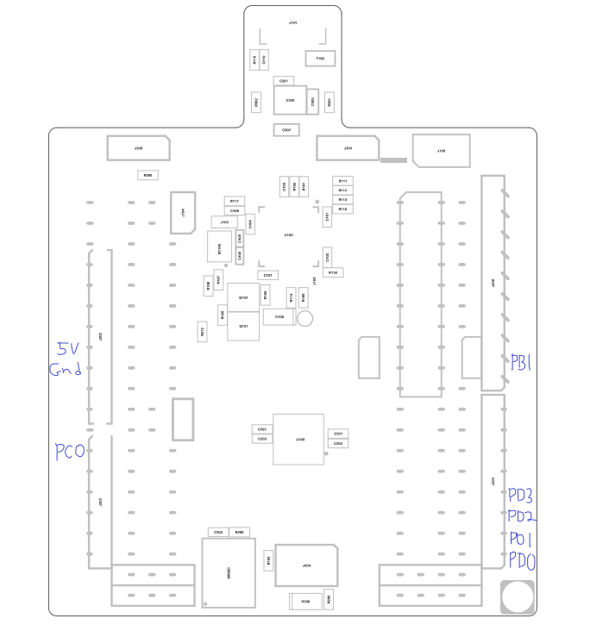

This shows the Xplained Mini Assembly Drawing. The areas of the drawing drawn in blue indicate which pins were used.

1. 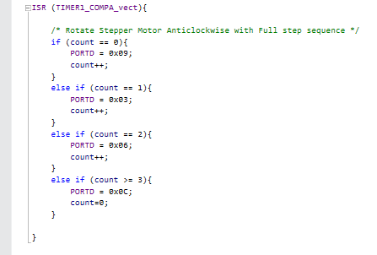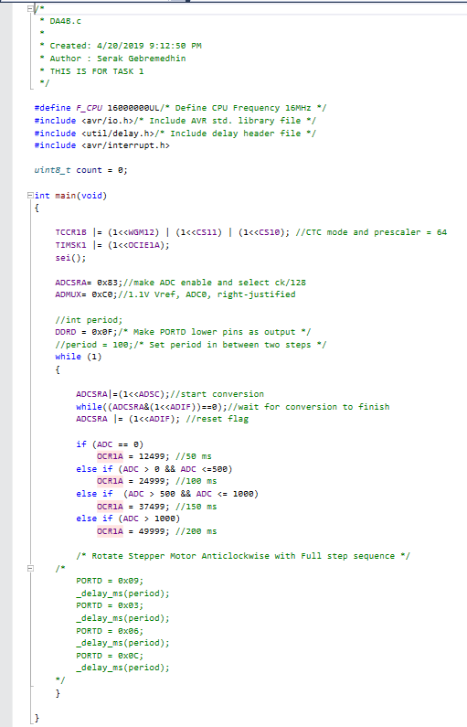**INITIAL/MODIFIED/DEVELOPED CODE OF TASK 1/A**

This shows the C code for task 1 of **Design Assignment 4B**.

1. **DEVELOPED MODIFIED CODE OF TASK 2/A from TASK 1/A**

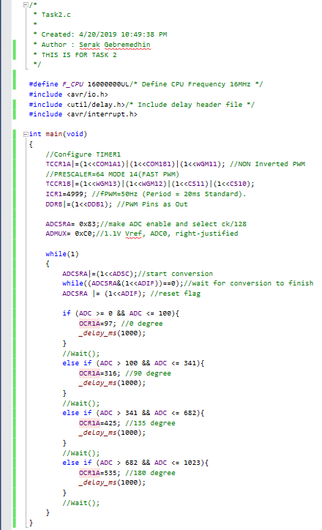

This shows the code in C for task 2 of **Design Assignment 4B**.

1. **SCHEMATICS**

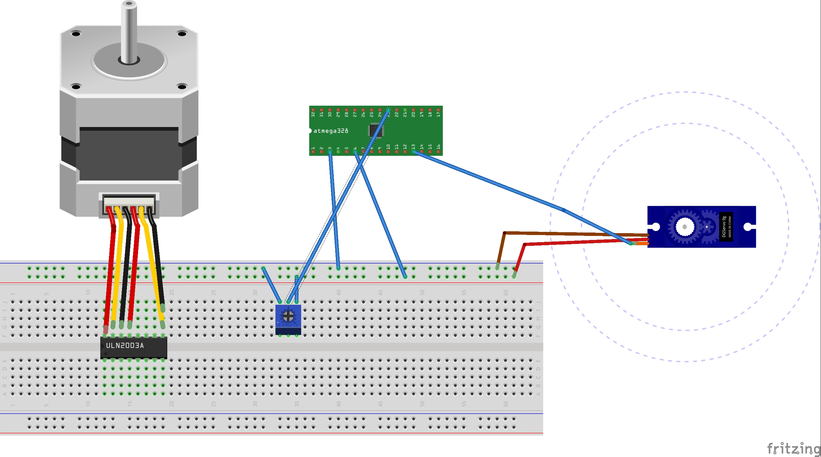

This is the schematic used for **Design Assignment 4B**. One important thing to note is that the Atmega, Stepper Motor, and the Servo motor are not the exact model or version used in the actual demonstration. Some of the wire connections for the stepper motor may be incorrect on the schematic.

1. **SCREENSHOTS OF EACH TASK OUTPUT (ATMEL STUDIO OUTPUT)**

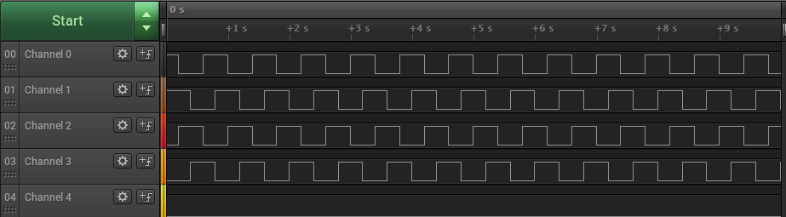

This shows the Salae Logic Analyzer for task 1. The channels 0-3 are connected to PD0-3, respectively. The potentiometer is at max.

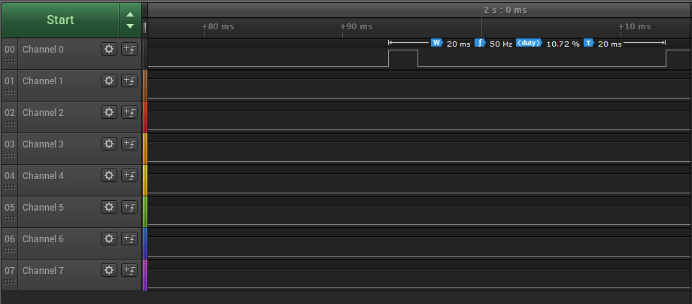

This shows the Salae Logic Analyzer for task 2. Channel 0 is connected to PB1. The potentiometer is at max.

1. **SCREENSHOT OF EACH DEMO (BOARD SETUP)**

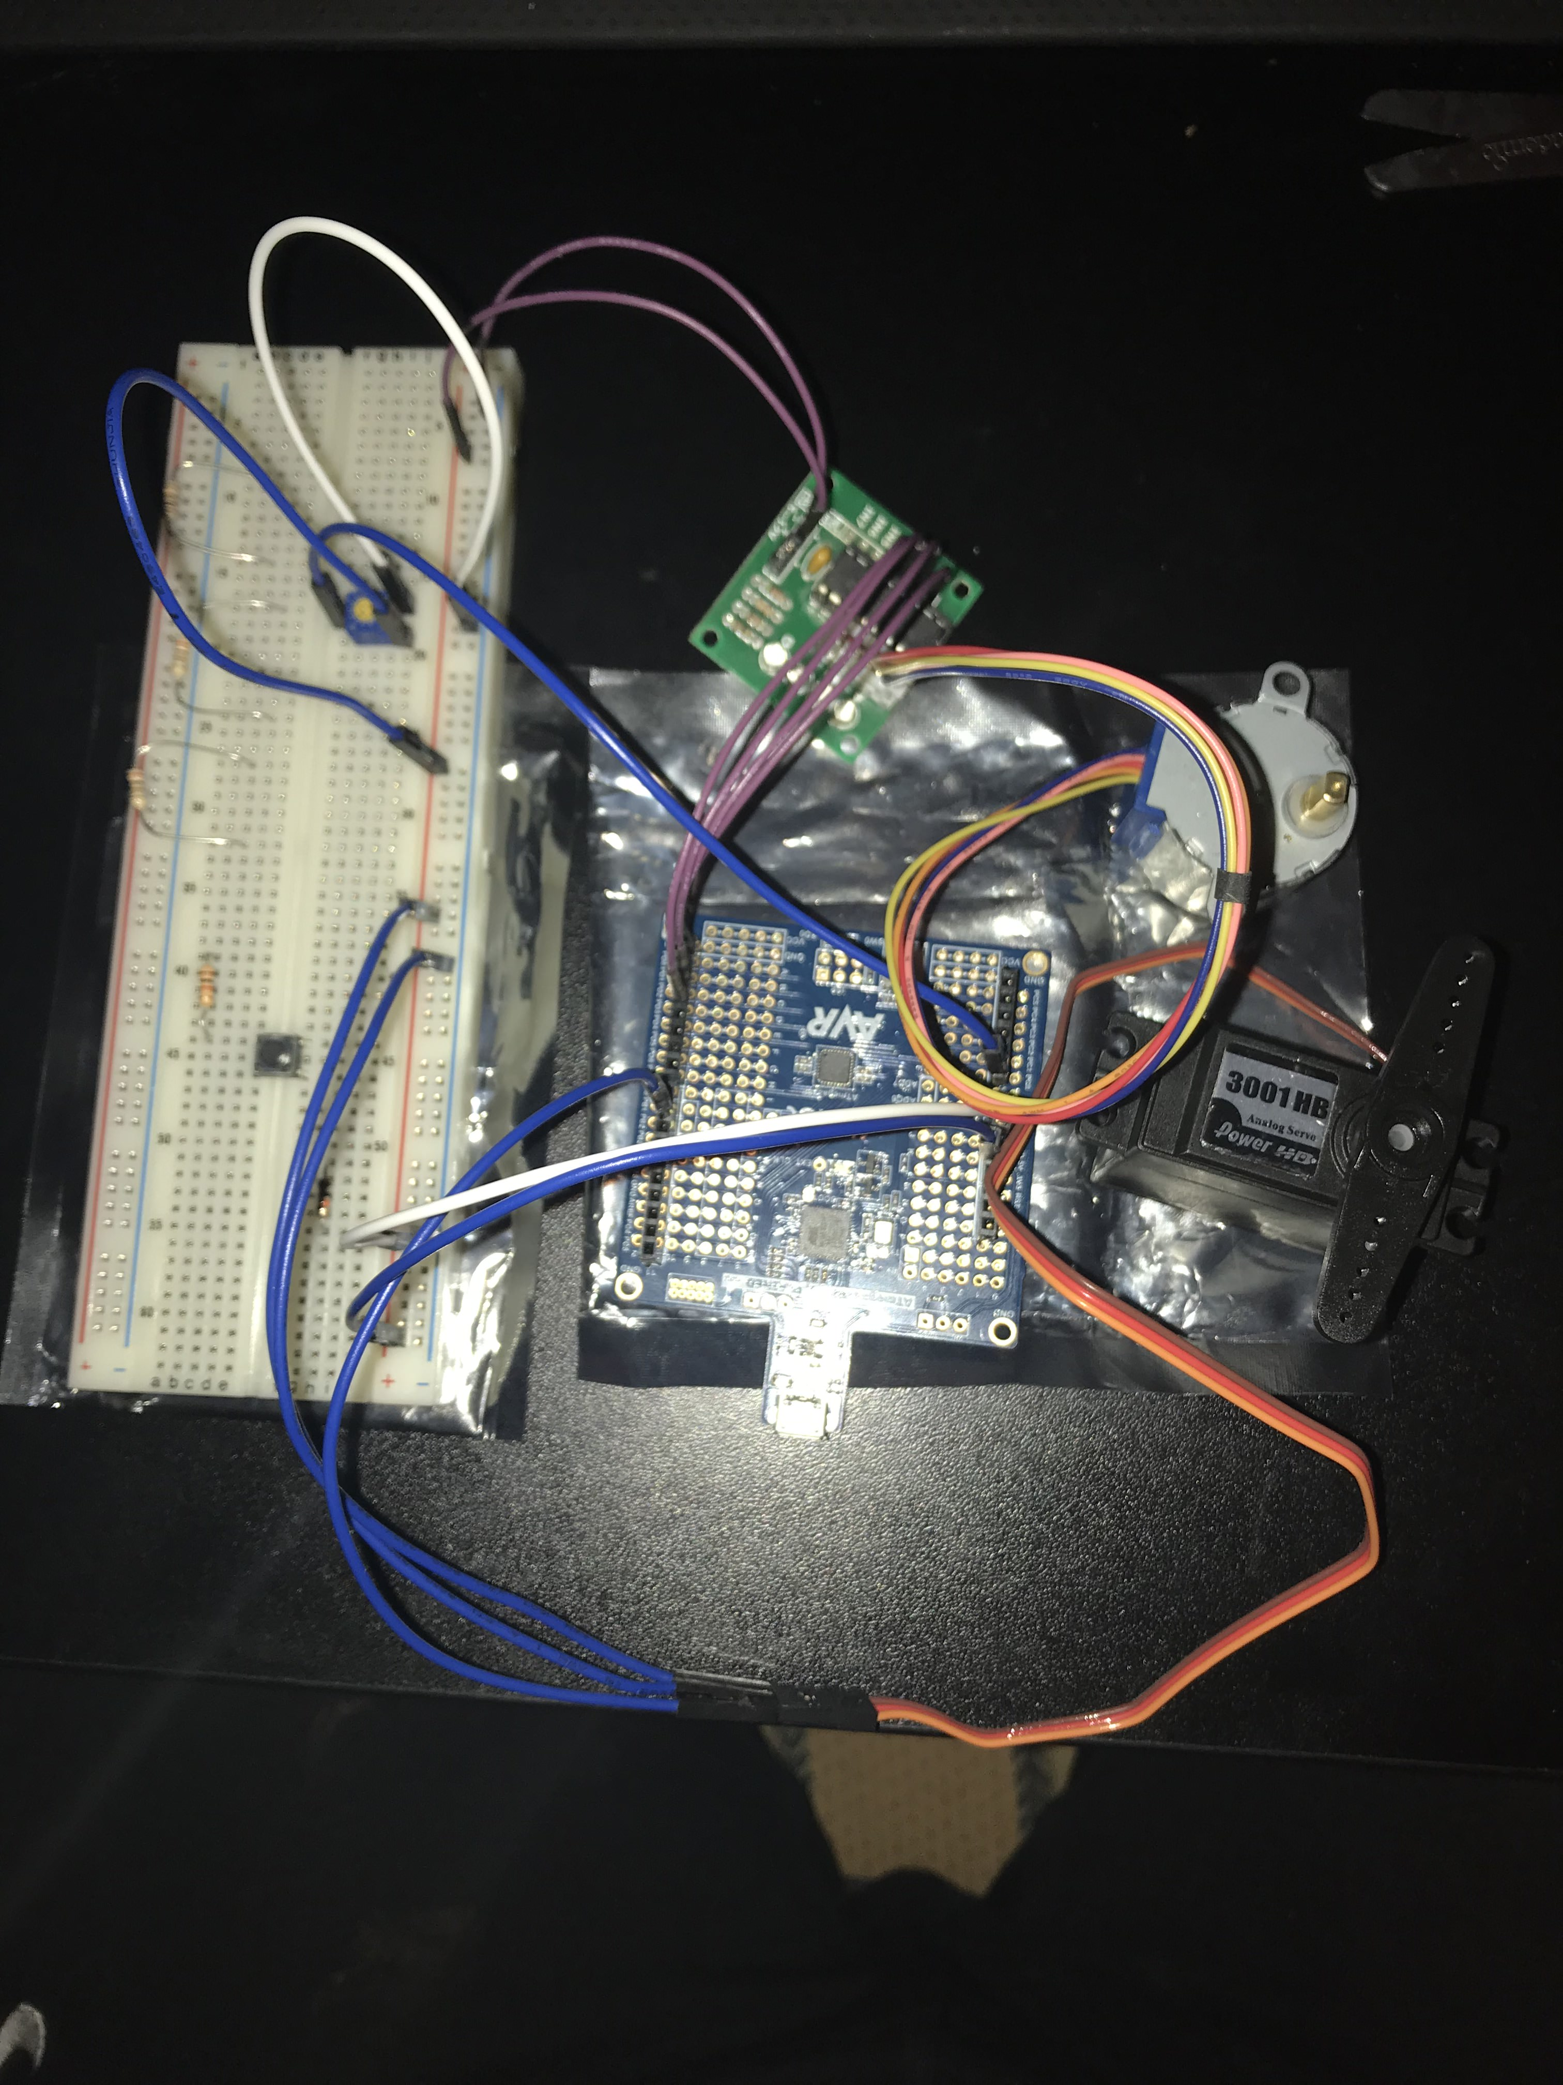

This shows the board setup for this design assignment. The picture shows the following: a breadboard, the potentiometer, ULN2003A, the ATmega328P Xplained Mini, the stepper motor, servo motor, and jumper wires.

1. **VIDEO LINKS OF EACH DEMO**

<https://youtu.be/kDpBq-wPw2U>

1. **GITHUB LINK OF THIS DA**

<https://github.com/Ber-geb/effective-octo-reaction>

**Student Academic Misconduct Policy**

<http://studentconduct.unlv.edu/misconduct/policy.html>

“This assignment submission is my own, original work”.

Serak Gebremedhin