CPE301 – SPRING 2019

Design Assignment 5

Student Name: Serak Gebremedhin

Student #: 2000862766

Student Email: gebremed@unlv.nevada.edu

Primary Github address: https://github.com/Ber-geb/effective-octo-reaction

Directory: effective-octo-reaction/DesignAssignments/DA5/

Submit the following for all Labs:

1. In the document, for each task submit the modified or included code (only) with highlights and justifications of the modifications. Also, include the comments.
2. Use the previously create a Github repository with a random name (no CPE/301, Lastname, Firstname). Place all labs under the root folder ESD301/DA, sub-folder named LABXX, with one document and one video link file for each lab, place modified asm/c files named as LabXX-TYY.asm/c.
3. If multiple asm/c files or other libraries are used, create a folder LabXX-TYY and place these files inside the folder.
4. The folder should have a) Word document (see template), b) source code file(s) and other include files, c) text file with youtube video links (see template).

1. **COMPONENTS LIST AND CONNECTION BLOCK DIAGRAM w/ PINS**

List of Components used:

Breadboard

Atmega328P Xplained MiniBoard

nRF24L01

FTDI Chip

Block diagram with pins used in the Atmega328P:

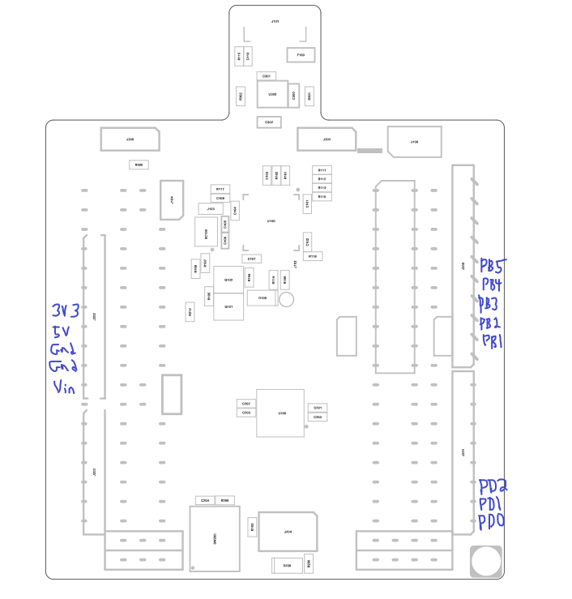

This shows the Xplained Mini Assembly Drawing. The areas of the drawing drawn in blue indicate which pins were used.

1. **INITIAL/MODIFIED/DEVELOPED CODE OF TASK 1/A**

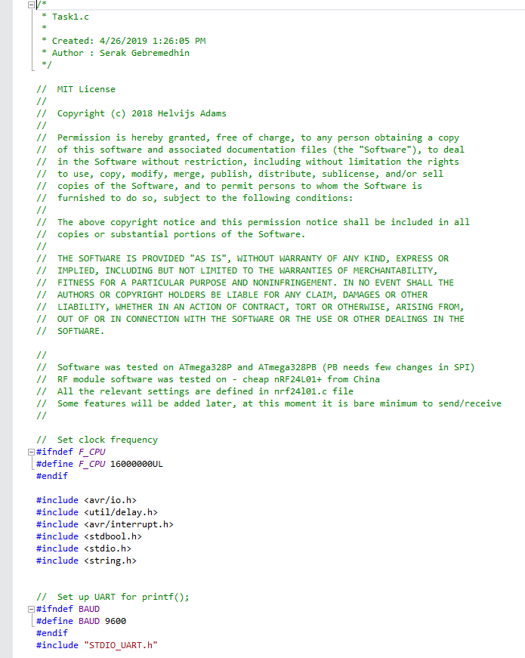

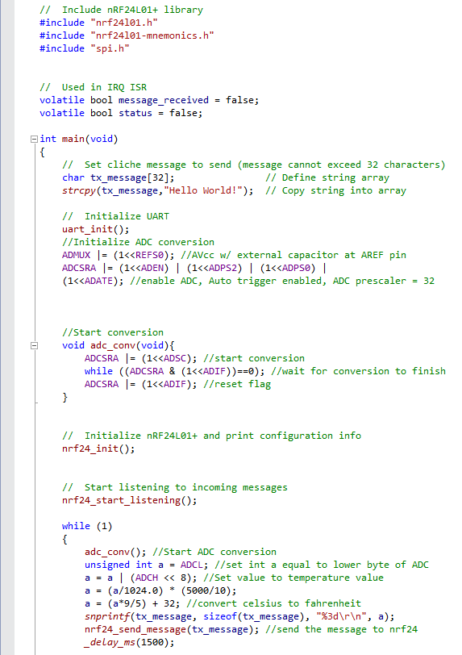

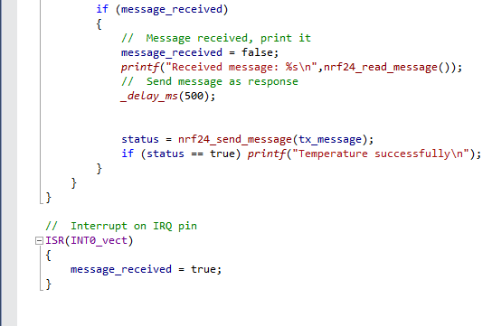

This shows the main C code provided in the github library. The only modified section of code is within the main function as well as a new function called adc_conv().

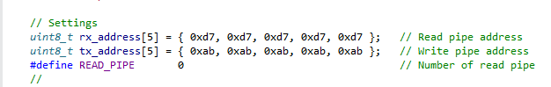

This shows the portion of the nrf24L01 C code that was modified. Everything else in the code remained the same.

1. **DEVELOPED MODIFIED CODE OF TASK 2/A from TASK 1/A**

There is no task 2 for this design assignment.

1. **SCHEMATICS**

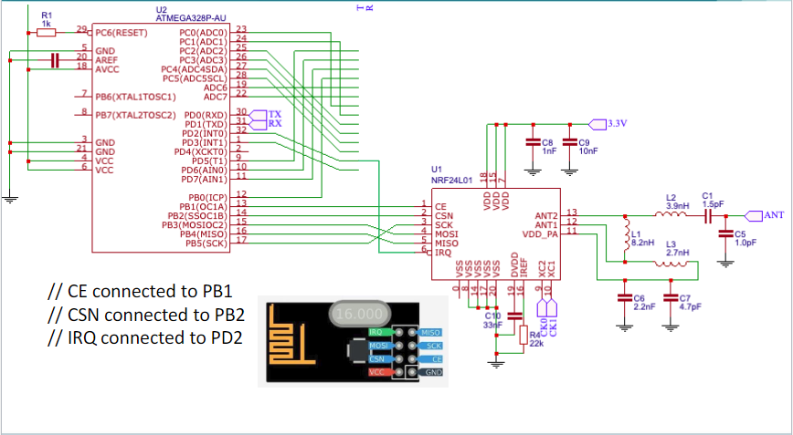

This is the schematic used for **Design Assignment 5**. nRF24L01 is included in the picture above, but the FTDI chip is missing. The FTDI chip is connected to the PD0 and PD1 pins on the atmega328P Xplained Mini.

1. **SCREENSHOTS OF EACH TASK OUTPUT (ATMEL STUDIO OUTPUT)**

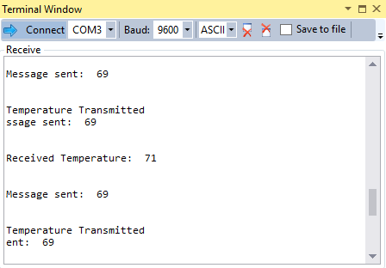

This shows the terminal during the debugging process of the program.

1. **SCREENSHOT OF EACH DEMO (BOARD SETUP)**

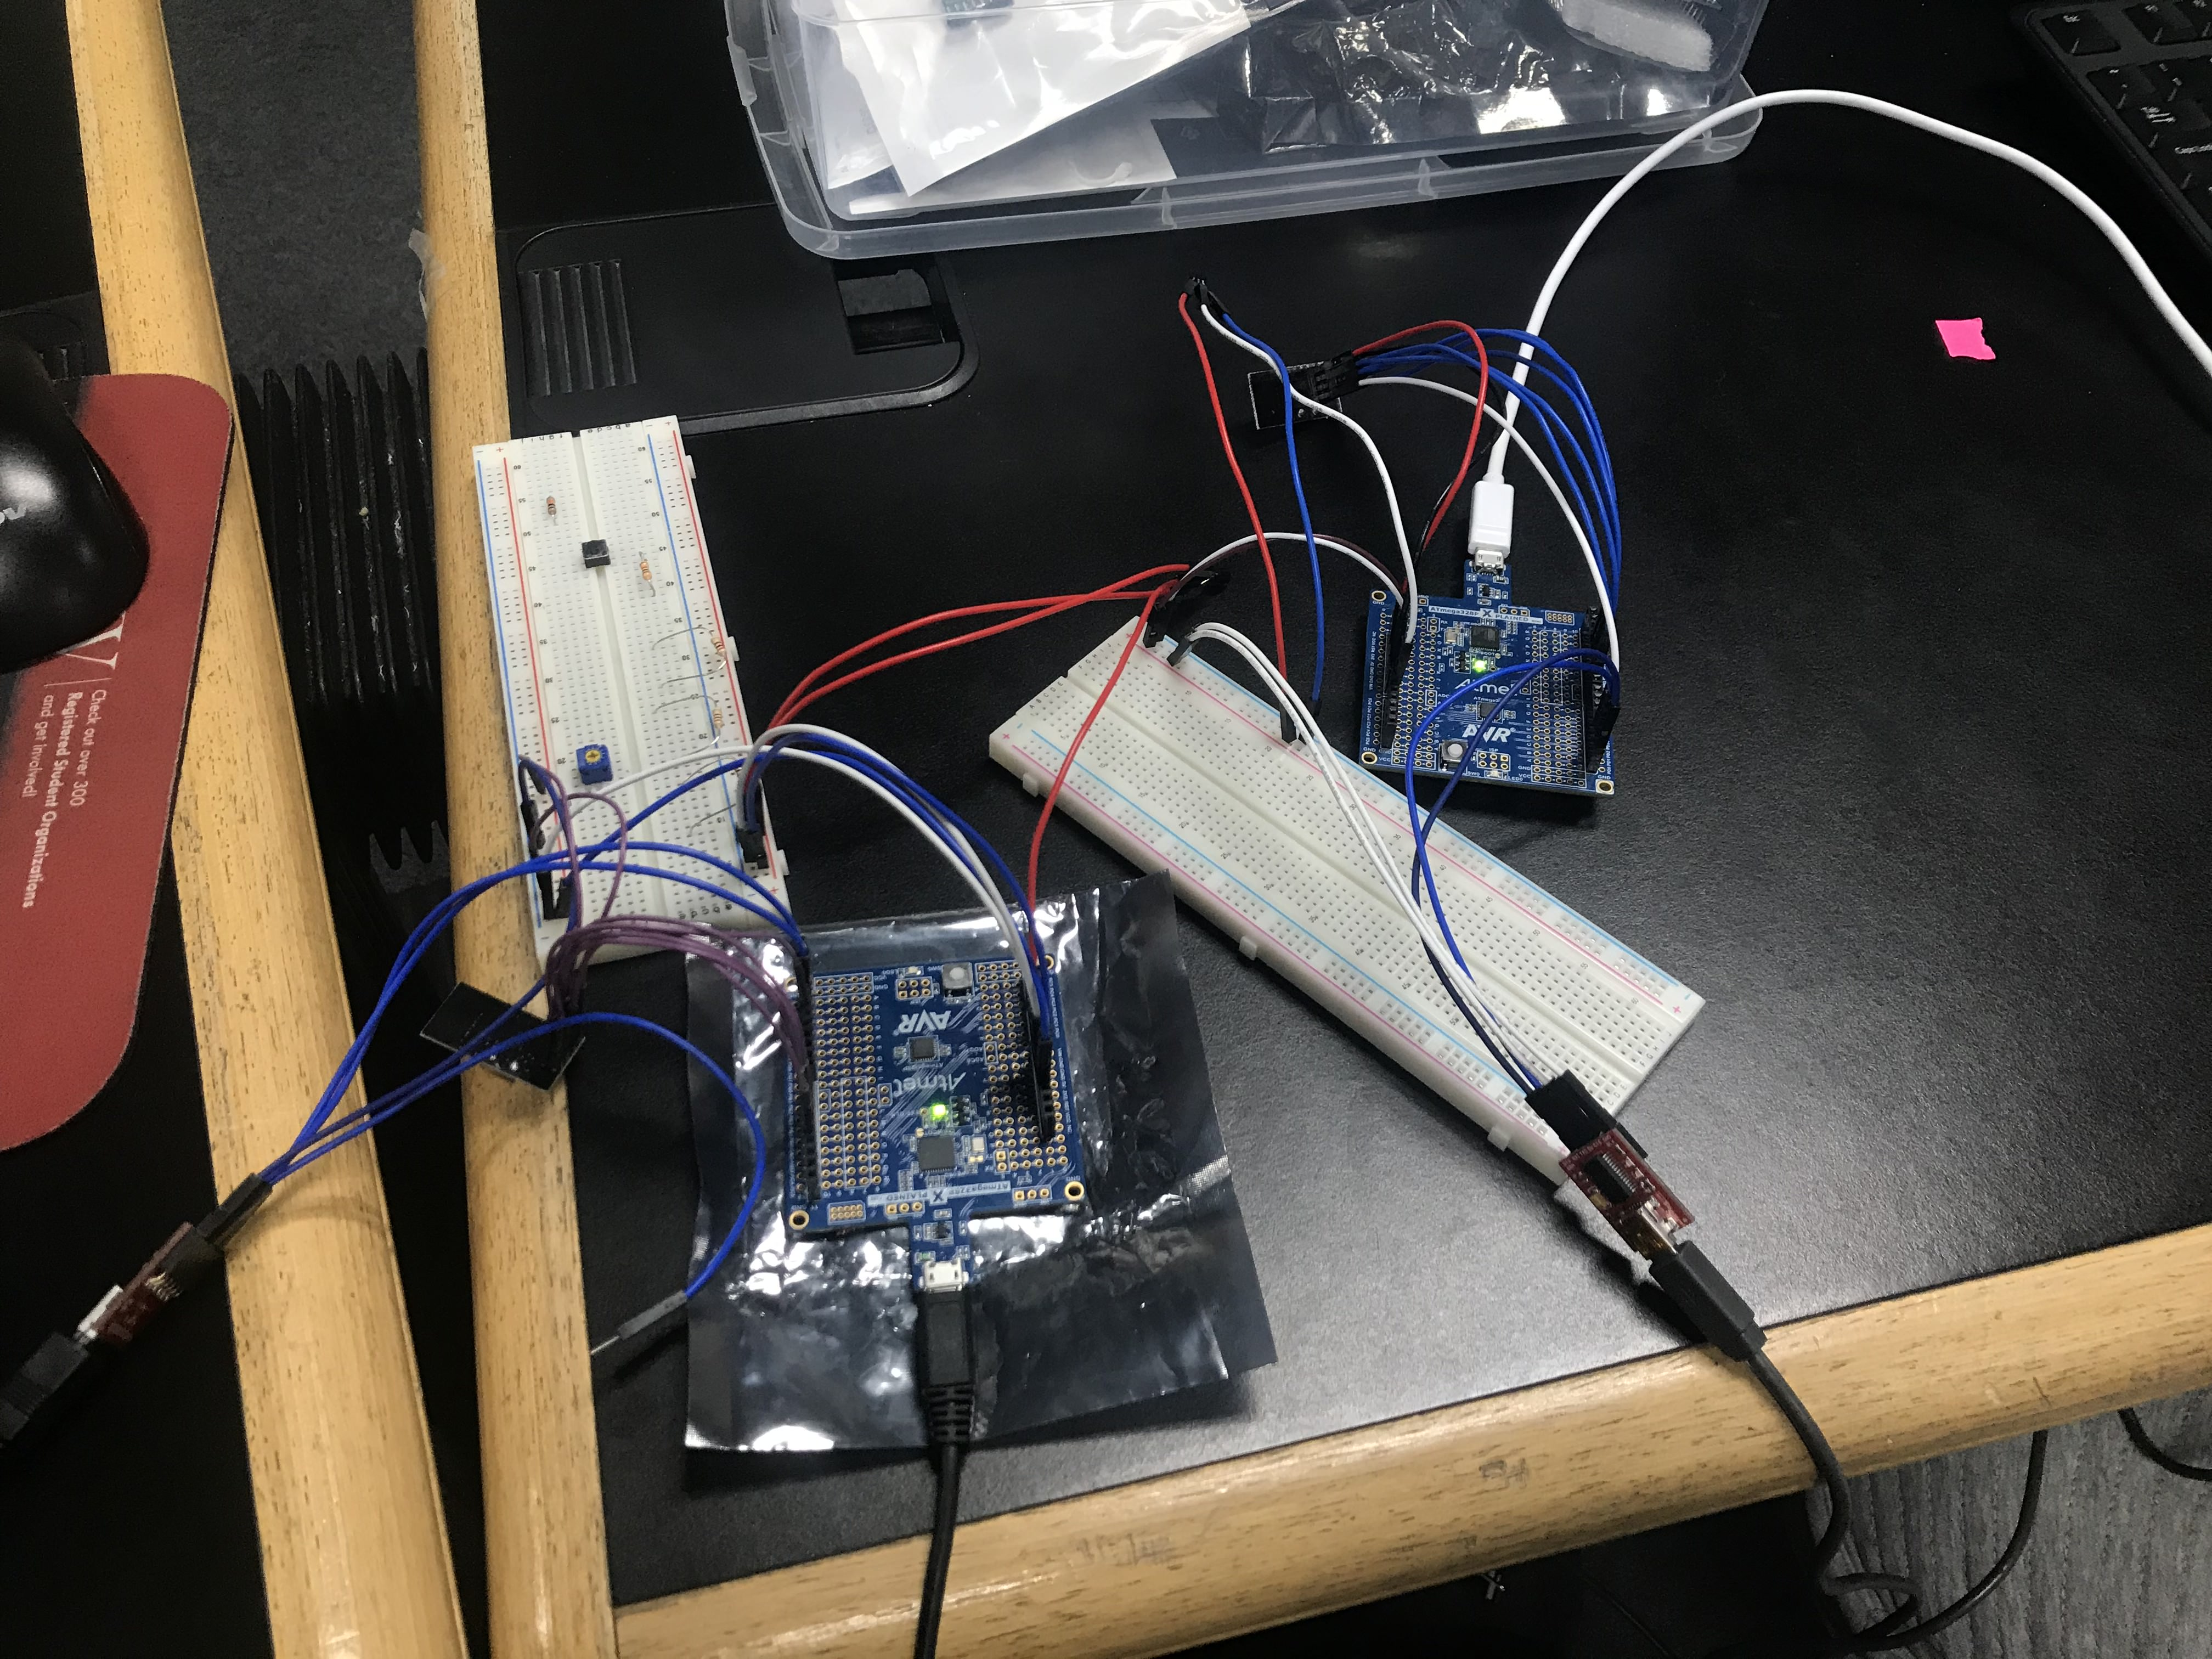

This shows the board setup for this design assignment. There are two atmega boards (one is mine and the other is my partner’s) which are using the nrf24L01 to communicate with each other. There are also two breadboards, two FTDI chips, and two LM35s.

1. **VIDEO LINKS OF EACH DEMO**

<https://youtu.be/CFYcn8p44B4>

1. **GITHUB LINK OF THIS DA**

<https://github.com/Ber-geb/effective-octo-reaction>

**Student Academic Misconduct Policy**

<http://studentconduct.unlv.edu/misconduct/policy.html>

“This assignment submission is my own, original work”.

Serak Gebremedhin