CPE301 – SPRING 2019

MIDTERM 1

Student Name: Serak Gebremedhin

Student #: 2000862766

Student Email: gebremed@unlv.nevada.edu

Primary Github address: <https://github.com/Ber-geb/effective-octo-reaction>

Directory: effective-octo-reaction/Midterms/Midterm_1

Submit the following for all Labs:

1. In the document, for each task submit the modified or included code (only) with highlights and justifications of the modifications. Also, include the comments.
2. Use the previously create a Github repository with a random name (no CPE/301, Lastname, Firstname). Place all labs under the root folder ESD301/Midterm, sub-folder named LABXX, with one document and one video link file for each lab, place modified asm/c files named as LabXX-TYY.asm/c.
3. If multiple asm/c files or other libraries are used, create a folder LabXX-TYY and place these files inside the folder.
4. The folder should have a) Word document (see template), b) source code file(s) and other include files, c) text file with youtube video links (see template).

1. **COMPONENTS LIST AND CONNECTION BLOCK DIAGRAM w/ PINS**

List of Components used:

Breadboard

Atmega328P Xplained MiniBoard

FTDI Basic

LM35

USB to ESP-01 Adapter

ESP-01 Adapter(Blue)

ESP8266-01 (Black)

Block diagram with pins used in the Atmega328P:

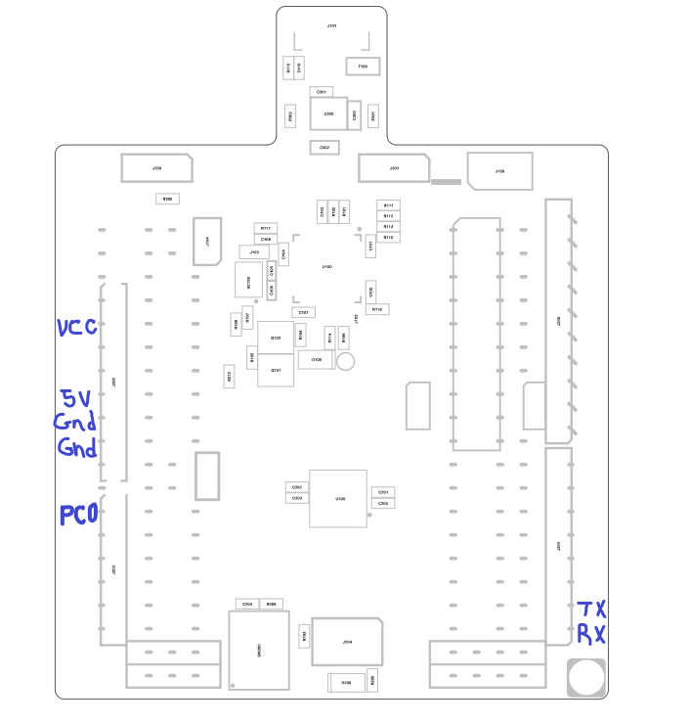

This shows the Xplained Mini Assembly Drawing. The areas of the drawing drawn in blue indicate which pins were used.

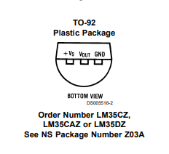

This is the LM35 schematic.

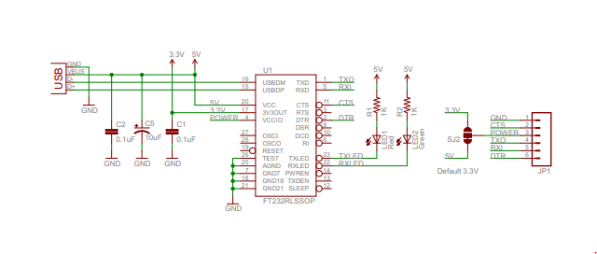

This is the LTDI basic schematic with a default 5V.

1. **INITIAL/MODIFIED/DEVELOPED CODE OF TASK 1/A**

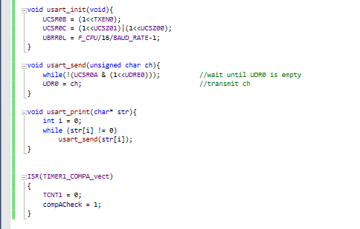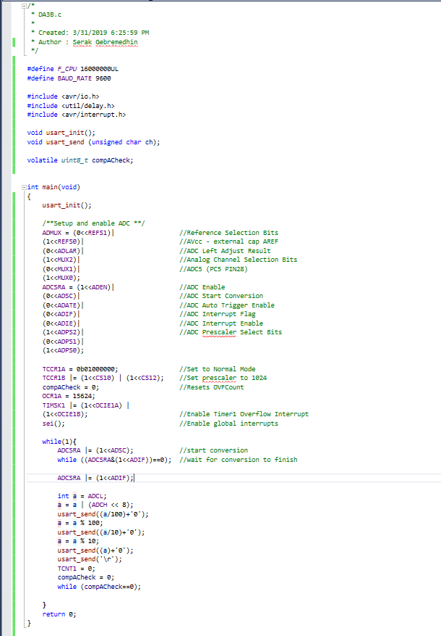This shows the original code for **DA3B**.

1. **DEVELOPED MODIFIED CODE OF TASK 2/A from TASK 1/A**

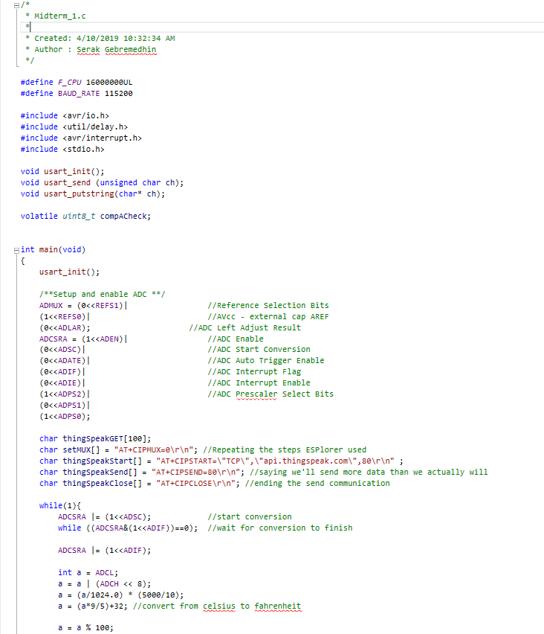

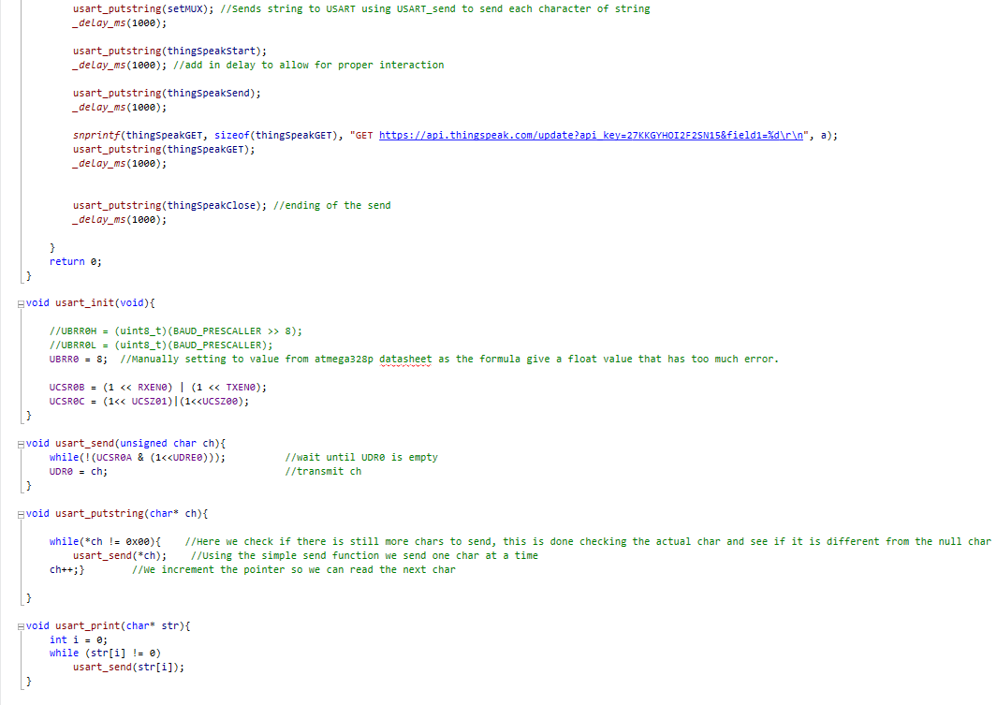

This shows the main code in C for midterm 1 that is modified for **Midterm 1**.

1. **SCHEMATICS**

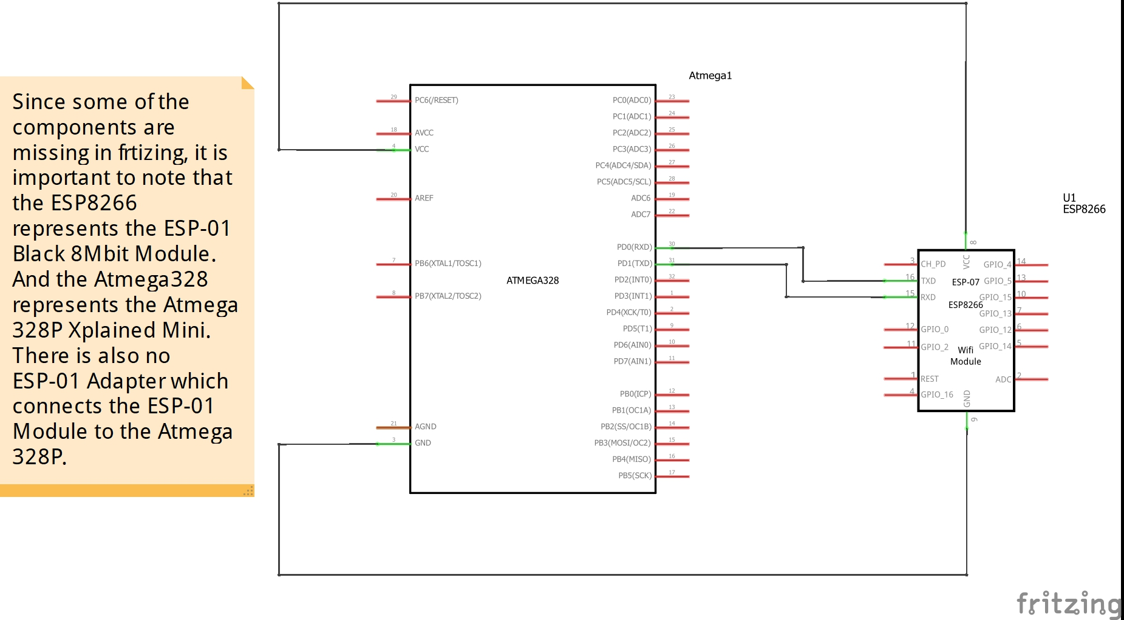

This shows the schematic for the Midterm. An important thing to note is that fritzing did not have a schematic of some of the components that were used for this Midterm, thus there are some assumptions made in this schematic.

1. **SCREENSHOTS OF EACH TASK OUTPUT (ATMEL STUDIO OUTPUT)**

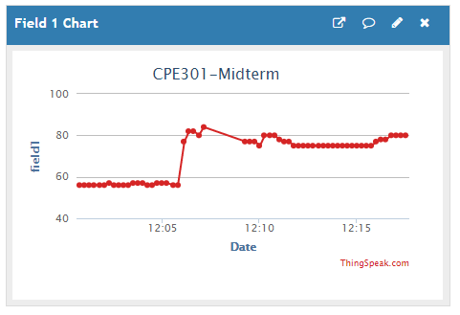

This is the chart shown on ThingSpeak which is the values of the temperature sensor. The author **username is sgeb123** and **Channel ID is 754795**. The **channel name is CPE301-Midterm**.

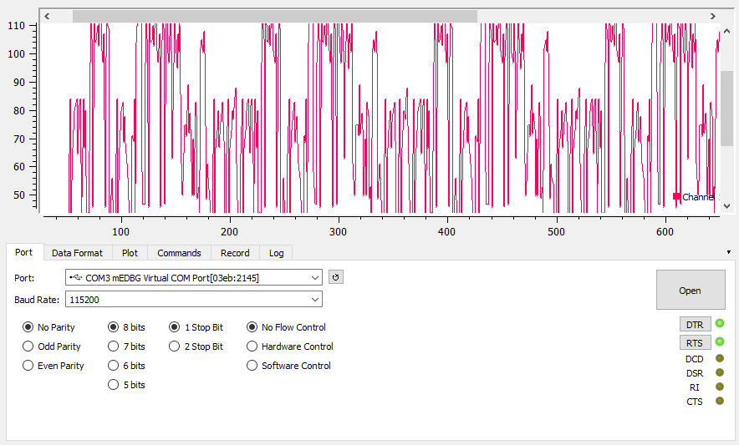

This shows the data visualizer for the COM port which will show the current temperature from the LM35 connected to the MCU.

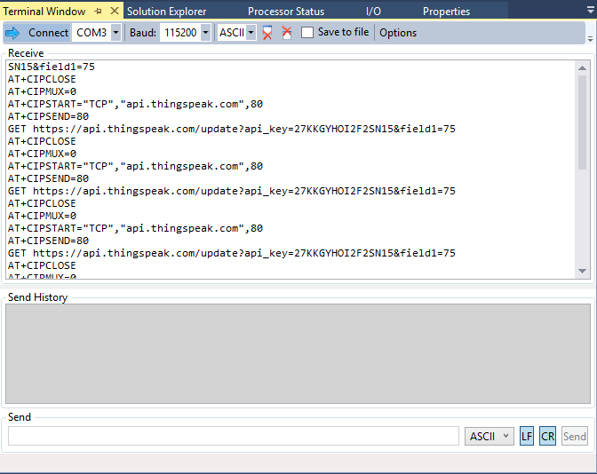

This shows the picture of the terminal while the program is debugging.

1. **SCREENSHOT OF EACH DEMO (BOARD SETUP)**

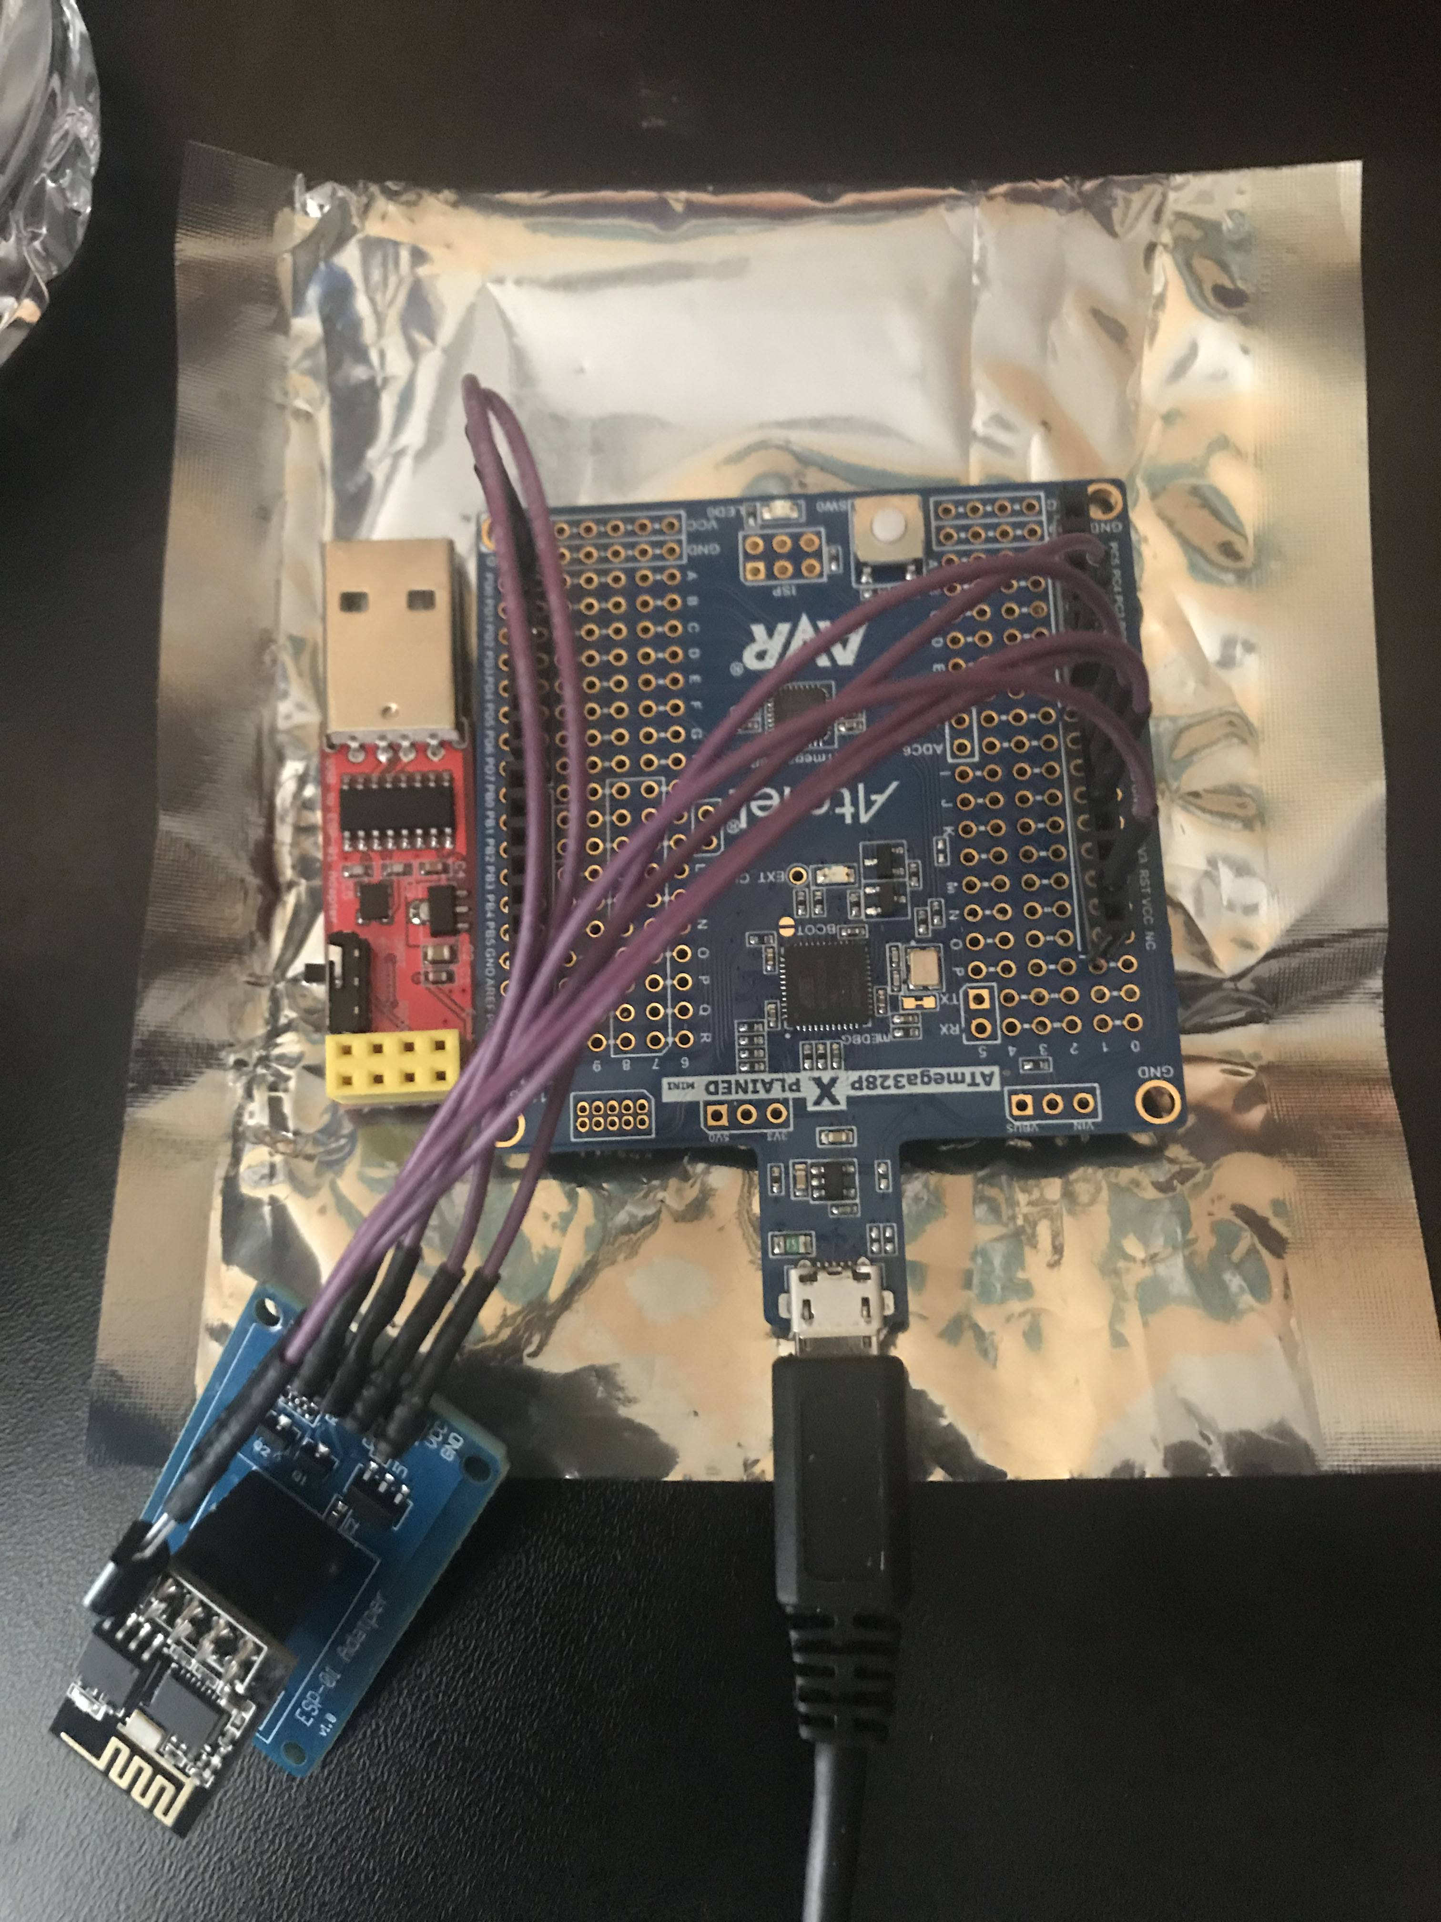

This shows the board setup. The USB to ESP-01 Adapter (Red) is also included because it was used to program the board. This picture shows the ESP-01 Adapter (Blue), the ESP-01 Module (Black), LM35, and the Atmega328P Xplained Mini Board.

1. **VIDEO LINKS OF EACH DEMO**

Youtube Link: <https://youtu.be/vP7QWbRvAXY>

ThingSpeak Link: <https://thingspeak.com/channels/754795>

1. **GITHUB LINK OF THIS DA**

<https://github.com/Ber-geb/effective-octo-reaction>

**Student Academic Misconduct Policy**

<http://studentconduct.unlv.edu/misconduct/policy.html>

“This assignment submission is my own, original work”.

Serak Gebremedhin