CPE301 – SPRING 2019

MIDTERM II

Student Name: Serak Gebremedhin

Student #: 2000862766

Student Email: gebremed@unlv.nevada.edu

Primary Github address: <https://github.com/Ber-geb/effective-octo-reaction>

Directory: effective-octo-reaction/Midterms/Midterm_II

Submit the following for all Labs:

1. In the document, for each task submit the modified or included code (only) with highlights and justifications of the modifications. Also, include the comments.
2. Use the previously create a Github repository with a random name (no CPE/301, Lastname, Firstname). Place all labs under the root folder ESD301/Midterm, sub-folder named LABXX, with one document and one video link file for each lab, place modified asm/c files named as LabXX-TYY.asm/c.
3. If multiple asm/c files or other libraries are used, create a folder LabXX-TYY and place these files inside the folder.
4. The folder should have a) Word document (see template), b) source code file(s) and other include files, c) text file with youtube video links (see template).

1. **COMPONENTS LIST AND CONNECTION BLOCK DIAGRAM w/ PINS**

List of Components used:

Breadboard

Atmega328P Xplained MiniBoard

USB to ESP-01 Adapter

ESP-01 Adapter (Blue)

ESP8266-01 (Black)

APDS9660

Block diagram with pins used in the Atmega328P:

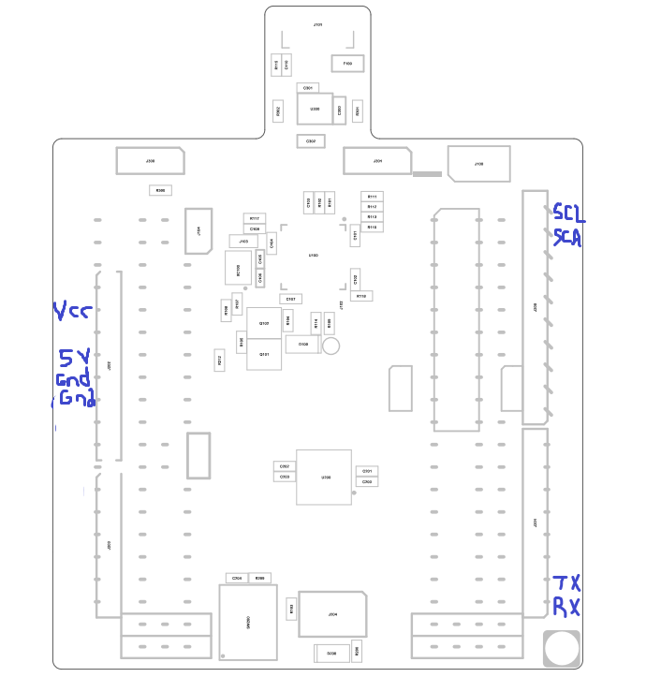

This shows the Xplained Mini Assembly Drawing. The areas of the drawing drawn in blue indicate which pins were used.

1. **INITIAL/MODIFIED/DEVELOPED CODE OF TASK 1/A**

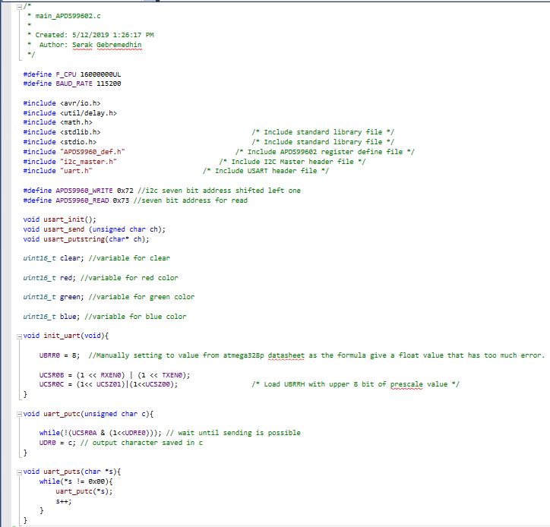

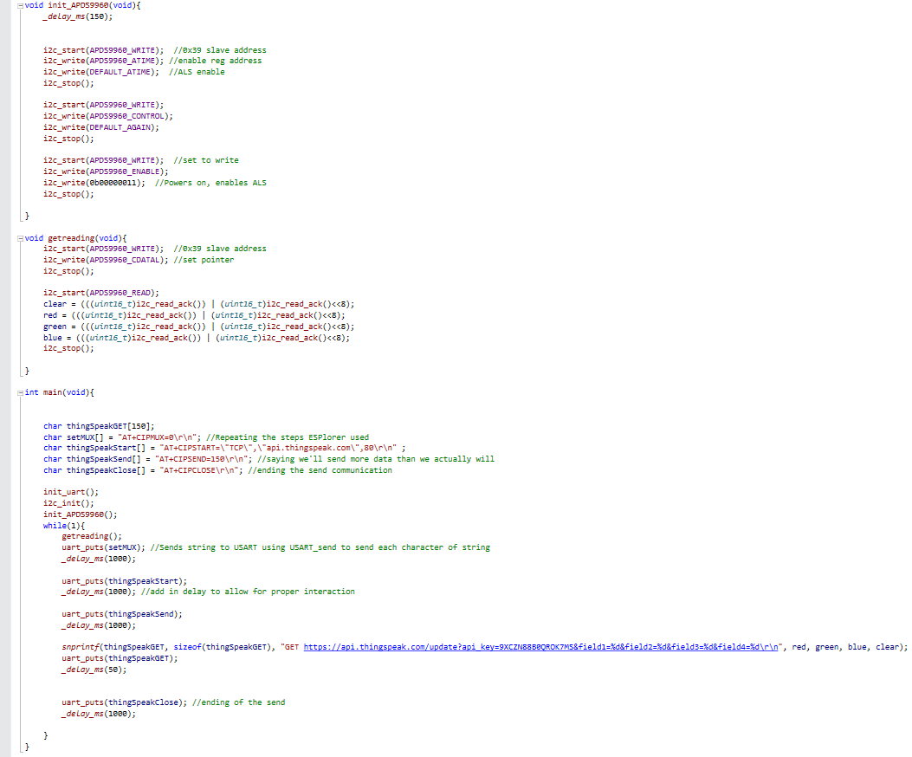

This shows the C source code that was modified for all the tasks.

1. **DEVELOPED MODIFIED CODE OF TASK 2/A from TASK 1/A**

The picture shown previously shows all the modified code for this project.

1. **SCHEMATICS**

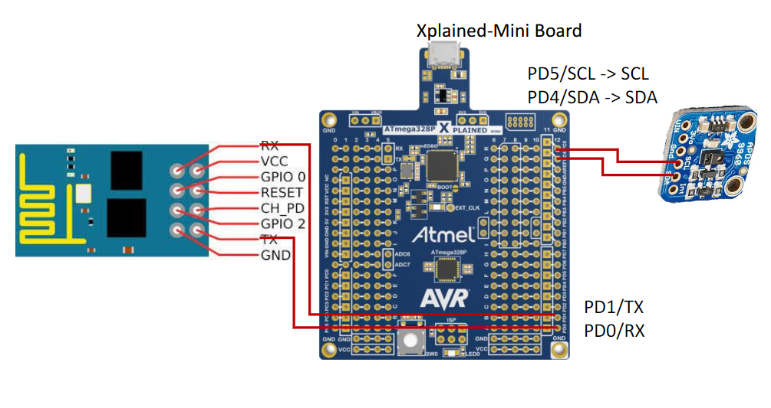

This shows the schematic for the Midterm II project.

1. **SCREENSHOTS OF EACH TASK OUTPUT (ATMEL STUDIO OUTPUT)**

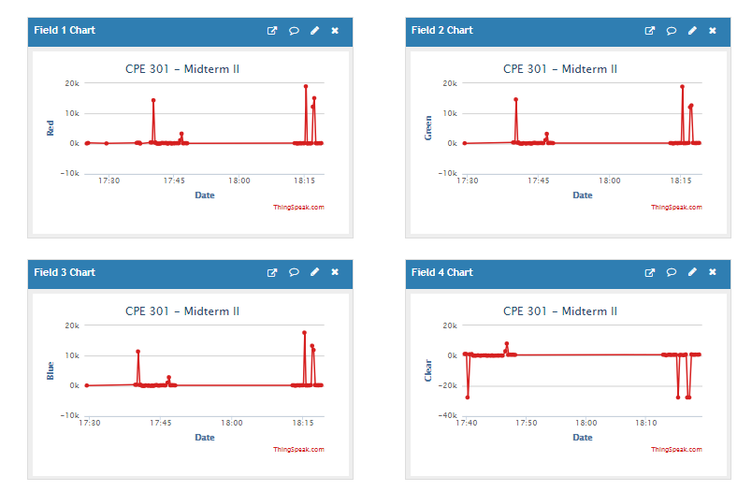

This shows the field charts on ThingsSpeak. The channel is public. The channel id is 779530, the author name is sgeb123, and the link is provided on this document below.

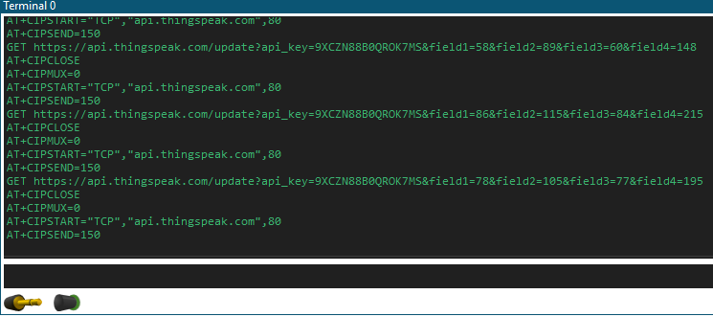

This shows the terminal output on Atmel Studio. The ESP01 module is receiving commands and sending the data from the APDS9660 sensor to ThingSpeak.

1. **SCREENSHOT OF EACH DEMO (BOARD SETUP)**

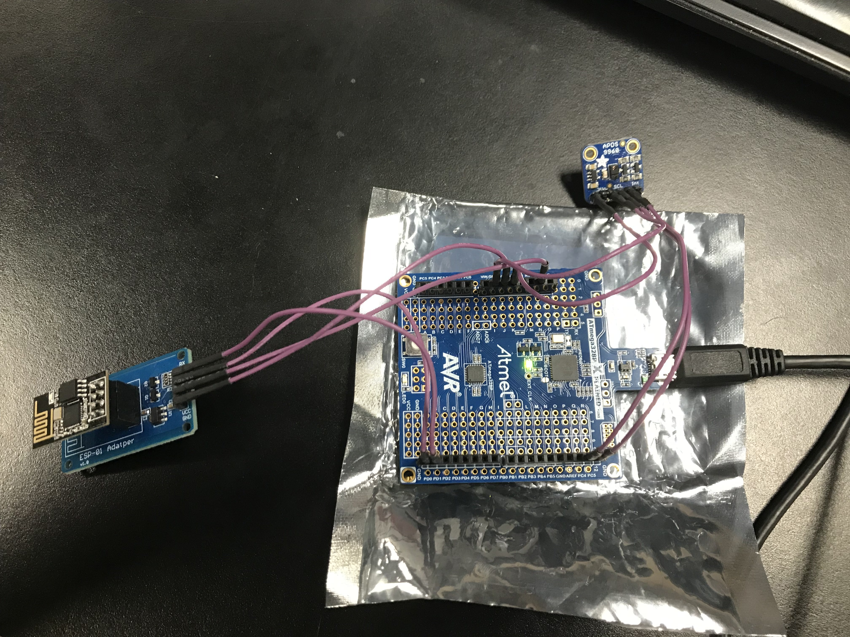

This shows the board setup. This picture shows the ESP-01 Adapter (Blue), the ESP-01 Module (Black), APDS9660, and the Atmega328P Xplained Mini Board.

1. **VIDEO LINKS OF EACH DEMO**

Youtube Link: <https://youtu.be/1cT0YoL9AXA>

ThingSpeak Link: <https://thingspeak.com/channels/779530>

1. **GITHUB LINK OF THIS DA**

<https://github.com/Ber-geb/effective-octo-reaction>

**Student Academic Misconduct Policy**

<http://studentconduct.unlv.edu/misconduct/policy.html>

“This assignment submission is my own, original work”.

Serak Gebremedhin