**Date Submitted: 12/11/19**

**------------------------------------------------------------------------------------**

**Task 01:**

Youtube Link: https://youtu.be/Sodr39Yg8BQ

**Modified Schematic (if applicable):**

**Runtime Object View (ROV)**

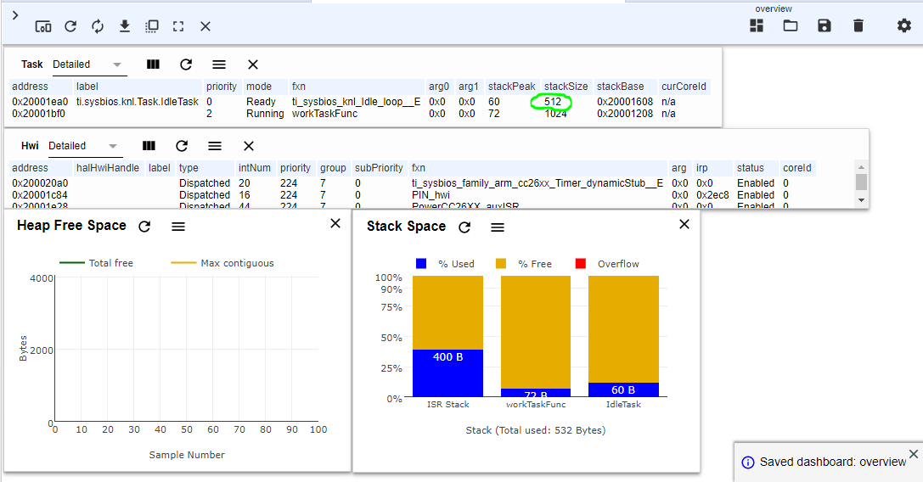

**Execution graphs:**

**Task1:**

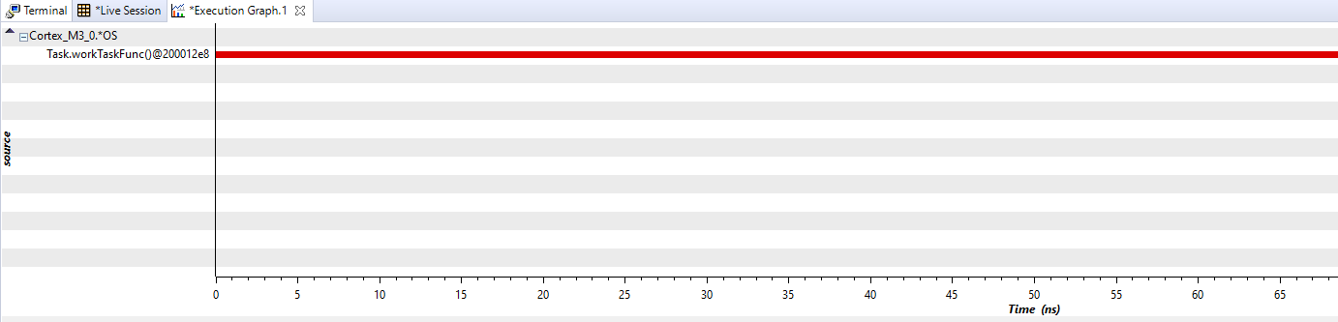

**Task function and idle task:**

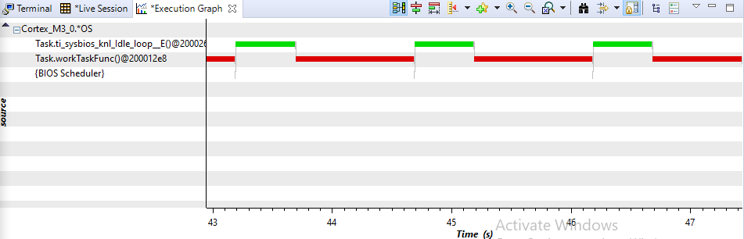

**workTaskFunc and urgendWorkTaskFunk:**

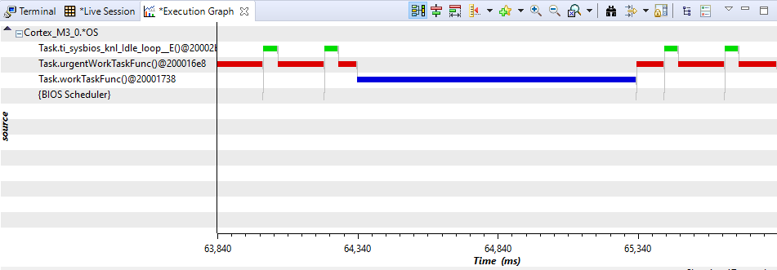

**Modified Code:**

/* TI-RTOS Header files */

**#include** <xdc/std.h>

**#include** <ti/sysbios/BIOS.h>

**#include** <ti/sysbios/knl/Task.h>

**#include** <ti/drivers/GPIO.h>

**#include** <ti/sysbios/knl/Clock.h> //use of 'Clock_tickPeriod'

/* Example/Board Header files */

**#include** "Board.h"

**void** **myDelay**(**int** count);

/* Could be anything, like computing primes */

**#define** FakeBlockingSlowWork() myDelay(12000000)

**#define** FakeBlockingFastWork() myDelay(2000000)

//information regarding each task - how the kernel will act for each task

Task_Struct workTask;

Task_Struct urgentWorkTask;

/* Make sure we have nice 8-byte alignment on the stack to avoid wasting memory */

**#pragma** DATA_ALIGN(workTaskStack, 8)

**#define** STACKSIZE 1024

**static** uint8_t workTaskStack[STACKSIZE];

**static** uint8_t urgentWorkTaskStack[STACKSIZE];

//doUrgentWork will utilize LED 1 (not LED 0)

**void** **doUrgentWork**(**void**)

{

**GPIO_write**(Board_GPIO_LED1, Board_GPIO_LED_OFF);

FakeBlockingFastWork(); /* Pretend to do something useful but time-consuming */

**GPIO_write**(Board_GPIO_LED1, Board_GPIO_LED_ON);

}

**void** **doWork**(**void**)

{

**GPIO_write**(Board_GPIO_LED0, Board_GPIO_LED_OFF);

FakeBlockingSlowWork(); /* Pretend to do something useful but time-consuming */

**GPIO_write**(Board_GPIO_LED0, Board_GPIO_LED_ON);

}

**void** **workTaskFunc**(UArg arg0, UArg afrg1)

{

**while** (1) {

/* Do work */

doWork();

/* Wait a while, because doWork should be a periodic thing, not continuous.*/

//myDelay(24000000);

Task_sleep(500 * (1000/Clock_tickPeriod)); //sleep for 500ms, does not waste CPU cycles

}

}

**void** **urgentWorkTaskFunc**(UArg arg0, UArg afrg1)

{

**while** (1) {

/* Do 'urgent' work */

doUrgentWork();

/* Wait a while, because doWork should be a periodic thing, not continuous.*/

//myDelay(24000000);

Task_sleep(50 * (1000/Clock_tickPeriod)); //sleep for 50ms, does not waste CPU cycles

}

}

/*

* ======== main ========

*

*/

**int** **main**(**void**)

{

Board_initGeneral();

**GPIO_init**();

/* Set up the led task */

Task_Params workTaskParams;

Task_Params_init(&workTaskParams);

workTaskParams.stackSize = STACKSIZE;

workTaskParams.priority = 2;

workTaskParams.stack = &workTaskStack;

//create the task..

Task_construct(&workTask, workTaskFunc, &workTaskParams, NULL);

//set up new task (urgent task)

workTaskParams.priority = 3; //priority previously was 1

workTaskParams.stack = &urgentWorkTaskStack;

//create the new task..

Task_construct(&urgentWorkTask, urgentWorkTaskFunc, &workTaskParams, NULL);

/* Start kernel. */

BIOS_start();

**return** (0);

}

/*

* ======== myDelay ========

* Assembly function to delay. Decrements the count until it is zero

* The exact duration depends on the processor speed.

*/

**__asm**(" .sect \".text:myDelay\"\n"

" .clink\n"

" .thumbfunc myDelay\n"

" .thumb\n"

" .global myDelay\n"

"myDelay:\n"

" subs r0, #1\n"

" bne.n myDelay\n"

" bx lr\n");

**Task 03:**

Youtube Link:

**Modified Schematic (if applicable):**

**Modified Code:**

**// Insert code here**

**------------------------------------------------------------------------------------**