**Date Submitted: 12/11/19**

**LAB2:**

Youtube Link:

**Gui Composer:** [**https://youtu.be/ioe5VlzNEec**](https://youtu.be/ioe5VlzNEec)

**UART:** [**https://youtu.be/7C1wNGooCO0**](https://youtu.be/7C1wNGooCO0)

**Modified Schematic (if applicable):**

**GUI Composer**

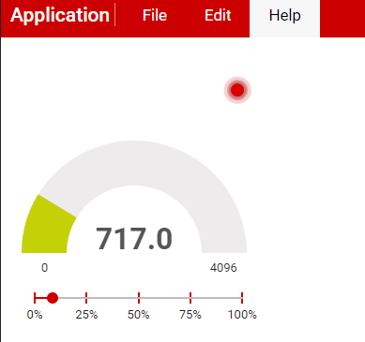

**UART shown with terminal**

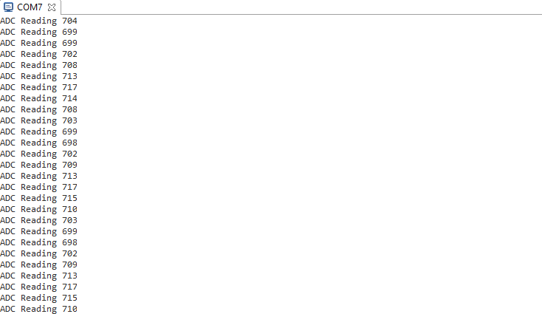

**Modified Code:**

**// Insert code here**

/*

* Copyright (c) 2015-2019, Texas Instruments Incorporated

* All rights reserved.

*

* Redistribution and use in source and binary forms, with or without

* modification, are permitted provided that the following conditions

* are met:

*

* * Redistributions of source code must retain the above copyright

* notice, this list of conditions and the following disclaimer.

*

* * Redistributions in binary form must reproduce the above copyright

* notice, this list of conditions and the following disclaimer in the

* documentation and/or other materials provided with the distribution.

*

* * Neither the name of Texas Instruments Incorporated nor the names of

* its contributors may be used to endorse or promote products derived

* from this software without specific prior written permission.

*

* THIS SOFTWARE IS PROVIDED BY THE COPYRIGHT HOLDERS AND CONTRIBUTORS "AS IS"

* AND ANY EXPRESS OR IMPLIED WARRANTIES, INCLUDING, BUT NOT LIMITED TO,

* THE IMPLIED WARRANTIES OF MERCHANTABILITY AND FITNESS FOR A PARTICULAR

* PURPOSE ARE DISCLAIMED. IN NO EVENT SHALL THE COPYRIGHT OWNER OR

* CONTRIBUTORS BE LIABLE FOR ANY DIRECT, INDIRECT, INCIDENTAL, SPECIAL,

* EXEMPLARY, OR CONSEQUENTIAL DAMAGES (INCLUDING, BUT NOT LIMITED TO,

* PROCUREMENT OF SUBSTITUTE GOODS OR SERVICES; LOSS OF USE, DATA, OR PROFITS;

* OR BUSINESS INTERRUPTION) HOWEVER CAUSED AND ON ANY THEORY OF LIABILITY,

* WHETHER IN CONTRACT, STRICT LIABILITY, OR TORT (INCLUDING NEGLIGENCE OR

* OTHERWISE) ARISING IN ANY WAY OUT OF THE USE OF THIS SOFTWARE,

* EVEN IF ADVISED OF THE POSSIBILITY OF SUCH DAMAGE.

*/

/*

* ======== empty.c ========

*/

/*Include Semaphores*/

**#include** <ti/sysbios/knl/Semaphore.h>

**#include** <ti/sysbios/BIOS.h>

// Main loop Semaphore

Semaphore_Struct semMainLoop;

Semaphore_Handle hSemMainLoop;

/*scif header and macro*/

**#include** "scif.h"

**#define** BV(x) (1 << (x))

/* For usleep() */

**#include** <unistd.h>

**#include** <stdint.h>

**#include** <stddef.h>

/* Driver Header files */

**#include** <ti/drivers/GPIO.h>

// #include <ti/drivers/I2C.h>

// #include <ti/drivers/SPI.h>

// #include <ti/drivers/UART.h>

// #include <ti/drivers/Watchdog.h>

/* Board Header file */

**#include** "Board.h"

/*SC Task Alert Handling*/

**void** **processTaskAlert**(**void**) {

// Clear the ALERT interrupt source

scifClearAlertIntSource();

//Do SC Task processing here

// Fetch 'state.high' variable from SC

uint8_t high = scifTaskData.adcLevelTrigger.state.high;

// Set Red LED state equal to the state.high variable

**GPIO_write**(Board_GPIO_RLED, high);

//Acknowledge the ALERT event

scifAckAlertEvents();

}

/*SC callback functions*/

**void** **scCtrlReadyCallback**(**void**) {

} // scCtrlReadyCallback

**void** **scTaskAlertCallback**(**void**) {

//Post to main loop semaphore

Semaphore_post(hSemMainLoop);

} // scTaskAlertCallback

/*

* ======== mainThread ========

*/

**void** \***tirtosScThread**(**void** *arg0)

{

// Semaphore initialization

Semaphore_Params semParams;

Semaphore_Params_init(&semParams);

Semaphore_construct(&semMainLoop, 0, &semParams);

hSemMainLoop = Semaphore_handle(&semMainLoop);

/* 1 second delay */

//uint32_t time = 1;

/* Call driver init functions */

**GPIO_init**();

// I2C_init();

// SPI_init();

// UART_init();

// Watchdog_init();

/* Configure the LED pin */

**GPIO_setConfig**(Board_GPIO_LED0, GPIO_CFG_OUT_STD | GPIO_CFG_OUT_LOW);

/* Turn on user LED */

**GPIO_write**(Board_GPIO_LED0, Board_GPIO_LED_ON);

/*SC Driver Initialization*/

// Initialize the Sensor Controller

scifOsalInit(); //init OSAL of the scif framework

scifOsalRegisterCtrlReadyCallback(scCtrlReadyCallback); //init CTRL ready callback

scifOsalRegisterTaskAlertCallback(scTaskAlertCallback); //init Task Alert callback

scifInit(&scifDriverSetup); //init SC task driver

// Set the Sensor Controller task tick interval to 1 second

uint32_t rtc_Hz = 1; // 1Hz RTC

scifStartRtcTicksNow(0x00010000 / rtc_Hz);

//bits 31:16 represent the seconds, bits 15:0 represent 1/65536 of a second

// Configure Sensor Controller tasks

scifTaskData.adcLevelTrigger.cfg.threshold = 600; //set threshold value

//Start Sensor Controller task

scifStartTasksNbl(BV(SCIF_ADC_LEVEL_TRIGGER_TASK_ID)); //execute task

**while** (1) {

// Wait on sem indefinitely

Semaphore_pend(hSemMainLoop, BIOS_WAIT_FOREVER);

// Call process function

processTaskAlert();

}

}