**Date Submitted: 12/11/19**

**Youtube:**

[**https://youtu.be/I2ssZnWopPY**](https://youtu.be/I2ssZnWopPY)

**Images:**

The sensor (COM 7) and collector (COM 8) is initialized on Tera Term – Task 3 on TI 15.4 Stack Project Zero:

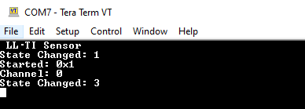

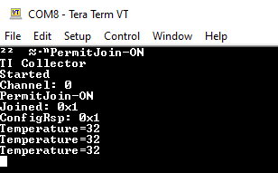

The sensor portable app temperature samples (x20) – Task 1 on Using Stack and Portable App to Create a Remote Sensor:

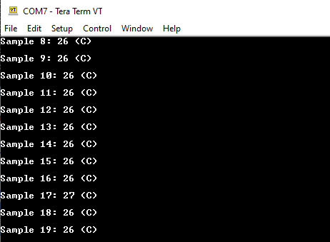

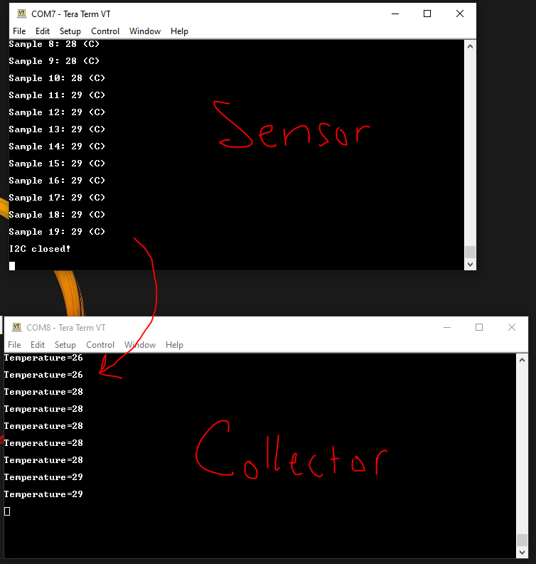

**Temperature.c:**

/*

* Copyright (c) 2018-2019, Texas Instruments Incorporated

* All rights reserved.

*

* Redistribution and use in source and binary forms, with or without

* modification, are permitted provided that the following conditions

* are met:

*

* * Redistributions of source code must retain the above copyright

* notice, this list of conditions and the following disclaimer.

*

* * Redistributions in binary form must reproduce the above copyright

* notice, this list of conditions and the following disclaimer in the

* documentation and/or other materials provided with the distribution.

*

* * Neither the name of Texas Instruments Incorporated nor the names of

* its contributors may be used to endorse or promote products derived

* from this software without specific prior written permission.

*

* THIS SOFTWARE IS PROVIDED BY THE COPYRIGHT HOLDERS AND CONTRIBUTORS "AS IS"

* AND ANY EXPRESS OR IMPLIED WARRANTIES, INCLUDING, BUT NOT LIMITED TO,

* THE IMPLIED WARRANTIES OF MERCHANTABILITY AND FITNESS FOR A PARTICULAR

* PURPOSE ARE DISCLAIMED. IN NO EVENT SHALL THE COPYRIGHT OWNER OR

* CONTRIBUTORS BE LIABLE FOR ANY DIRECT, INDIRECT, INCIDENTAL, SPECIAL,

* EXEMPLARY, OR CONSEQUENTIAL DAMAGES (INCLUDING, BUT NOT LIMITED TO,

* PROCUREMENT OF SUBSTITUTE GOODS OR SERVICES; LOSS OF USE, DATA, OR PROFITS;

* OR BUSINESS INTERRUPTION) HOWEVER CAUSED AND ON ANY THEORY OF LIABILITY,

* WHETHER IN CONTRACT, STRICT LIABILITY, OR TORT (INCLUDING NEGLIGENCE OR

* OTHERWISE) ARISING IN ANY WAY OUT OF THE USE OF THIS SOFTWARE,

* EVEN IF ADVISED OF THE POSSIBILITY OF SUCH DAMAGE.

*/

/*

* ======== i2ctmp116.c ========

*/

**#include** <stdint.h>

**#include** <stddef.h>

**#include** <unistd.h>

/* Driver Header files */

**#include** <ti/drivers/GPIO.h>

**#include** <ti/drivers/I2C.h>

**#include** <ti/display/Display.h>

/* Example/Board Header files */

**#include** "Board.h"

**#define** TASKSTACKSIZE 640

/*

* ======== TMP Registers ========

*/

**#define** Si7021_TMP_REG 0xE3

**#define** Si7021_HUM_REG 0xE5

**#define** Si7021_ADDR 0x40;

**static** Display_Handle display;

/*

* ======== mainThread ========

*/

**void** \***mainThread**(**void** *arg0)

{

uint16_t sample;

uint16_t temperature,temperaturef;

uint8_t txBuffer[1];

uint8_t rxBuffer[2];

I2C_Handle i2c;

I2C_Params i2cParams;

I2C_Transaction i2cTransaction;

/* Call driver init functions */

Display_init();

**GPIO_init**();

**I2C_init**();

/* Configure the LED and if applicable, the TMP116_EN pin */

**GPIO_setConfig**(Board_GPIO_LED0, GPIO_CFG_OUT_STD | GPIO_CFG_OUT_LOW);

**#ifdef** Board_GPIO_TMP116_EN

**GPIO_setConfig**(Board_GPIO_TMP116_EN, GPIO_CFG_OUT_STD | GPIO_CFG_OUT_HIGH);

/* 1.5 ms reset time for the TMP116 */

sleep(1);

**#endif**

/* Open the HOST display for output */

display = Display_open(Display_Type_UART, NULL);

**if** (display == NULL) {

**while** (1);

}

/* Turn on user LED */

**GPIO_write**(Board_GPIO_LED0, Board_GPIO_LED_ON);

Display_printf(display, 0, 0, "Starting the i2ctmp example.");

/* Create I2C for usage */

**I2C_Params_init**(&i2cParams);

i2cParams.bitRate = *I2C_400kHz*;

i2c = **I2C_open**(Board_I2C_TMP, &i2cParams);

**if** (i2c == NULL) {

Display_printf(display, 0, 0, "Error Initializing I2C\n");

**while** (1);

}

**else** {

Display_printf(display, 0, 0, "I2C Initialized!\n");

}

/* Common I2C transaction setup */

i2cTransaction.writeBuf = txBuffer;

i2cTransaction.writeCount = 1;

i2cTransaction.readBuf = rxBuffer;

i2cTransaction.readCount = 2;

/* Try Si7021 */

txBuffer[0] = Si7021_TMP_REG;

i2cTransaction.slaveAddress = Si7021_ADDR;

**if** (!**I2C_transfer**(i2c, &i2cTransaction)) {

/* Could not resolve a sensor, error */

Display_printf(display, 0, 0, "Error. No TMP sensor found!");

**while**(1);

}

**else** {

Display_printf(display, 0, 0, "Detected Si7021 sensor.");

}

/* Take 20 samples and print them out onto the console */

**for** (sample = 0; sample < 20; sample++) {

**if** (**I2C_transfer**(i2c, &i2cTransaction)) {

/*

* Extract degrees C from the received data;

* see Si7021 datasheet

*/

temperature = (rxBuffer[0] << 8) | (rxBuffer[1]);

temperaturef = (((175.72 * temperature)/ 65536) - 46.85);

Display_printf(display, 0, 0, "Sample %u: %d (C)",

sample, temperaturef);

}

**else** {

Display_printf(display, 0, 0, "I2C Bus fault.");

}

/* Sleep for 1 second */

sleep(1);

}

**I2C_close**(i2c);

Display_printf(display, 0, 0, "I2C closed!");

**return** (NULL);

}