**Date Submitted: 09/24/2019**

**Task 00: Execute provided code**

**Youtube Link:**

<https://youtu.be/tfFwKN7x-zY>

**------------------------------------------------------------------------------------**

**Task 01:**

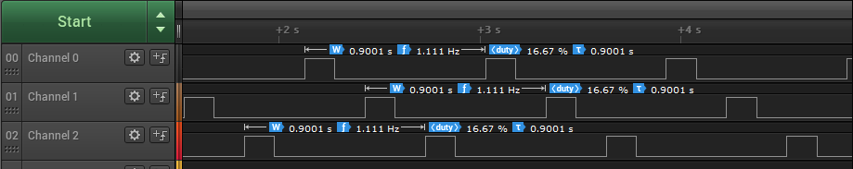

Youtube Link:

<https://youtu.be/5gl26b-mw8s>

**Modified Code:**

**// Insert code here**

**#include** <stdint.h>

**#include** <stdbool.h>

**#include** "inc/hw_memmap.h"

**#include** "inc/hw_types.h"

**#include** "driverlib/sysctl.h"

**#include** "driverlib/gpio.h"

uint8_t ui8PinData=2; //R = 2, G = 8, B = 4

**int** **main**(**void**)

{

**SysCtlClockSet**(SYSCTL_SYSDIV_15|SYSCTL_USE_PLL|SYSCTL_XTAL_16MHZ|SYSCTL_OSC_MAIN);

//delay = Delay time(seconds)/(1/SysClk*3) where SysClk = (400M/2)/15 and Delay time = 0.5 s

**SysCtlPeripheralEnable**(SYSCTL_PERIPH_GPIOF);

**GPIOPinTypeGPIOOutput**(GPIO_PORTF_BASE, GPIO_PIN_1|GPIO_PIN_2|GPIO_PIN_3);

//Selecting GPIO pins as output pins

**while**(1)

{

**GPIOPinWrite**(GPIO_PORTF_BASE, GPIO_PIN_1|GPIO_PIN_2|GPIO_PIN_3, ui8PinData);

**SysCtlDelay**(2222222.222); //calculated delay on time

**GPIOPinWrite**(GPIO_PORTF_BASE, GPIO_PIN_1|GPIO_PIN_2|GPIO_PIN_3, 0x00);

**SysCtlDelay**(2222222.222); // calculated delay off time

**if**(ui8PinData==8) {ui8PinData=2;} **else** {ui8PinData=ui8PinData*2;} //switch to other led

//50% duty cycle

}

}

**------------------------------------------------------------------------------------**

**Task 02a:**

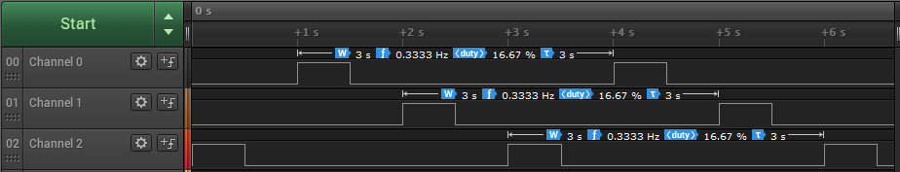

Youtube Link:

<https://youtu.be/Ep0y8chsmyg>

**Modified Code:**

**// Insert code here**

**#include** <stdint.h>

**#include** <stdbool.h>

**#include** "inc/hw_memmap.h"

**#include** "inc/hw_types.h"

**#include** "driverlib/sysctl.h"

**#include** "driverlib/gpio.h"

uint8_t ui8PinData=4; //R = 2, G = 8, B = 4

**int** **main**(**void**)

{

**SysCtlClockSet**(SYSCTL_SYSDIV_15|SYSCTL_USE_PLL|SYSCTL_XTAL_16MHZ|SYSCTL_OSC_MAIN);

//delay = Delay time(seconds)/(1/SysClk*3) where SysClk = (400M/2)/15 and Delay time = 0.5 s

**SysCtlPeripheralEnable**(SYSCTL_PERIPH_GPIOF);

**GPIOPinTypeGPIOOutput**(GPIO_PORTF_BASE, GPIO_PIN_1|GPIO_PIN_2|GPIO_PIN_3);

//Selecting GPIO pins as output pins

**while**(1)

{

**GPIOPinWrite**(GPIO_PORTF_BASE, GPIO_PIN_1| GPIO_PIN_2| GPIO_PIN_3, ui8PinData);

**SysCtlDelay**(2222222.222); //calculated delay on time

**GPIOPinWrite**(GPIO_PORTF_BASE, GPIO_PIN_1|GPIO_PIN_2|GPIO_PIN_3, 0x00);

**SysCtlDelay**(2222222.222); // calculated delay off time

**if**(ui8PinData==4) {ui8PinData=8;} //BGR sequence

**else** **if** (ui8PinData==8) {ui8PinData=2;}

**else** {ui8PinData=4;}

}

}

**------------------------------------------------------------------------------------Task 02b:**



Youtube Link:

<https://youtu.be/Ow0215id8XE>

**Modified Code:**

**// Insert code here**

**#include** <stdint.h>

**#include** <stdbool.h>

**#include** "inc/hw_memmap.h"

**#include** "inc/hw_types.h"

**#include** "driverlib/sysctl.h"

**#include** "driverlib/gpio.h"

uint8_t ui8PinData=2; //R = 2, G = 8, B = 4

**int** **main**(**void**)

{

**SysCtlClockSet**(SYSCTL_SYSDIV_15|SYSCTL_USE_PLL|SYSCTL_XTAL_16MHZ|SYSCTL_OSC_MAIN);

//delay = Delay time(seconds)/(1/SysClk*3) where SysClk = (400M/2)/15 and Delay time = 0.5 s

**SysCtlPeripheralEnable**(SYSCTL_PERIPH_GPIOF);

**GPIOPinTypeGPIOOutput**(GPIO_PORTF_BASE, GPIO_PIN_1|GPIO_PIN_2|GPIO_PIN_3);

//Selecting GPIO pins as output pins

**while**(1)

{

**GPIOPinWrite**(GPIO_PORTF_BASE, GPIO_PIN_1| GPIO_PIN_2| GPIO_PIN_3, ui8PinData);

**SysCtlDelay**(2222222.222); //calculated delay on time

**GPIOPinWrite**(GPIO_PORTF_BASE, GPIO_PIN_1|GPIO_PIN_2|GPIO_PIN_3, 0x00);

**SysCtlDelay**(2222222.222); //calculated delay off time

**if**(ui8PinData==2) {ui8PinData=8;} //R => current state

**else** **if** (ui8PinData==8) {ui8PinData=4;} //G

**else** **if** (ui8PinData==4) {ui8PinData=10;} //B

**else** **if** (ui8PinData==10) {ui8PinData=12;} //RB

**else** **if** (ui8PinData==12) {ui8PinData=14;} //GB

**else** **if** (ui8PinData==14) {ui8PinData=2;} //RGB

}

}

**------------------------------------------------------------------------------------**