CPE 403 ADV EMB SYS DES F 2019

TITLE: TIRTOS TIVAC Assignment

Youtube Link: https://youtu.be/9pXOSxHbD2Y

GOAL:

* Create ADC task to run every 10th instance of HWI
* Create UART diplay task to run every 20th instance of HWI
* Create Switch/Read Task to run every 30th instance of HWI
* Repeat the process above every 30 ms

DELIVERABLES:

The project will show an LED that is affected by the PWM signal that takes the ADC value generated every 10th instance of the HWI. Also, a terminal will be shown that is connected to the same port as the TIVAC TM4C123GH6PM MCU to show the UART signals being transmitted/received. Every time SW0/SW1 is pressed, the duty cycle will change. Since the period of the PWM is very small, a logic analyzer will be shown which will convey when the switch is pressed to affect the PWM signal of the LED.

COMPONENTS:

TIVAC TM4C123GH6PM MCU

* Logic Analyzer
* Jumper Wires
* Potentiometer

SCHEMATICS:

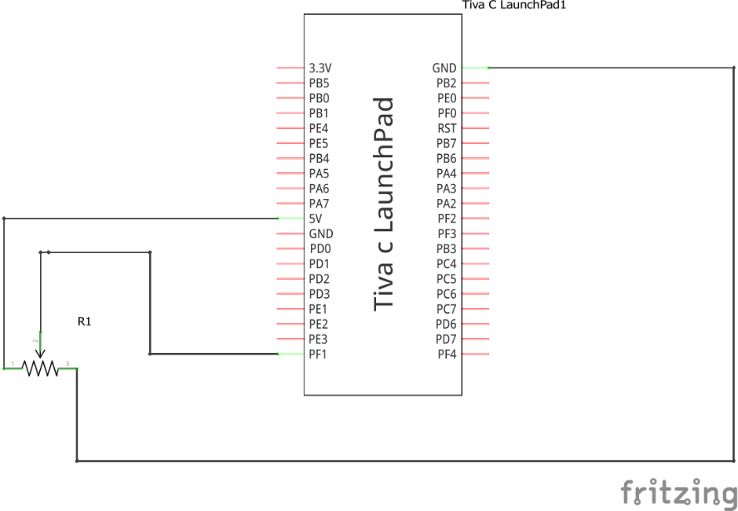

IIMPLEMENTATION:

UART and GPIO will be initialized as well as the ADC. This is the major initializations made for the assignment. The code below will show these initializations.

Picture of the terminal displaying ADC value:

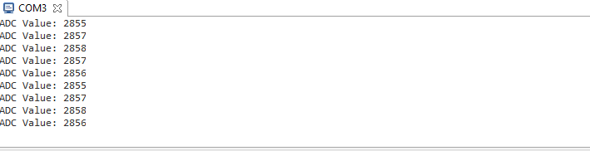

Picture of the Logic Analyzer displaying the LED PWM:

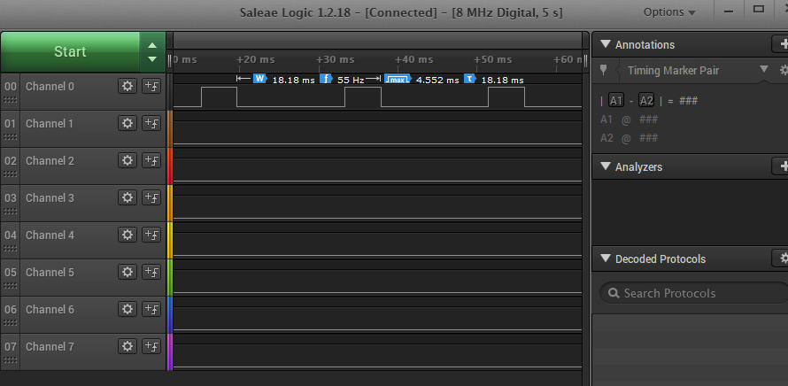

CODE:

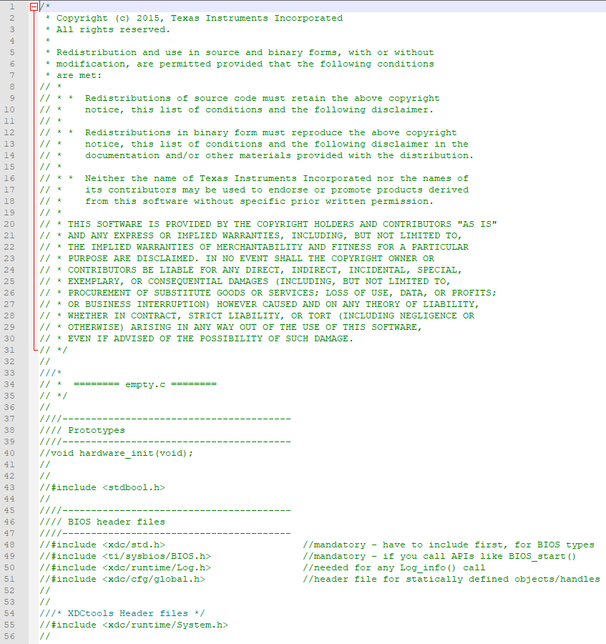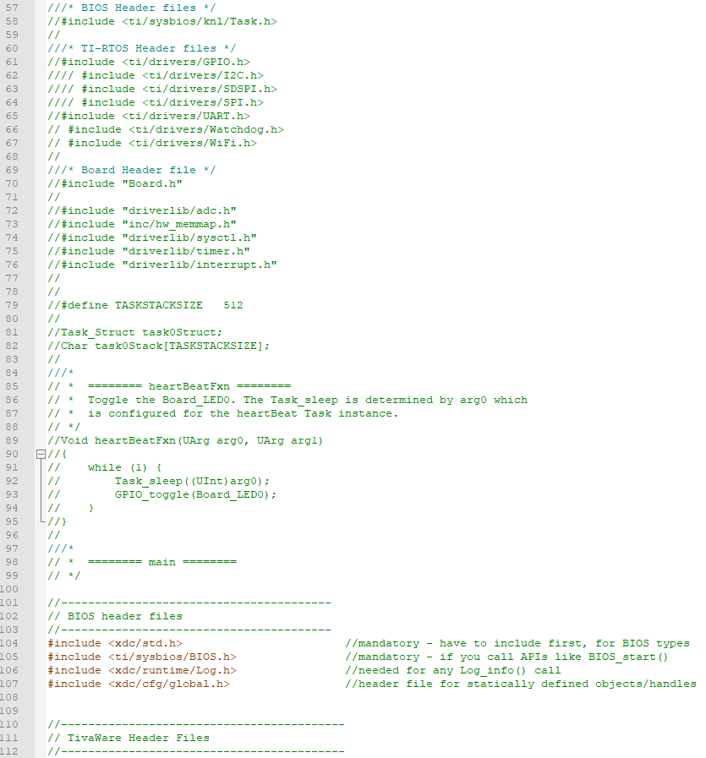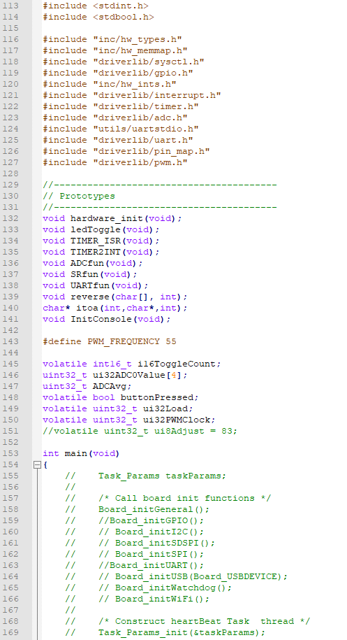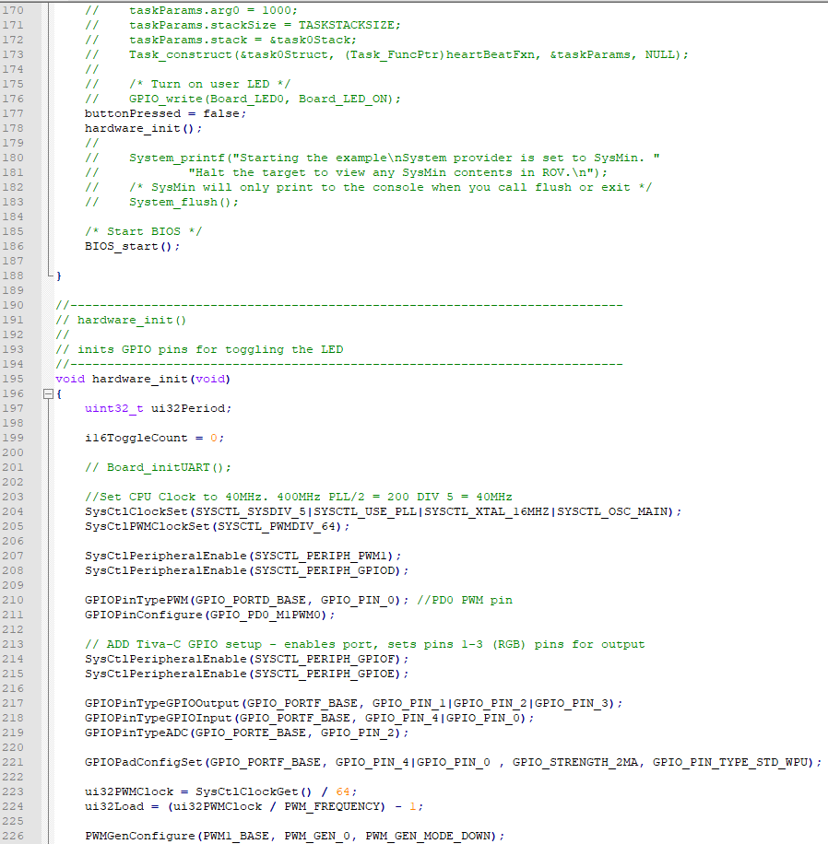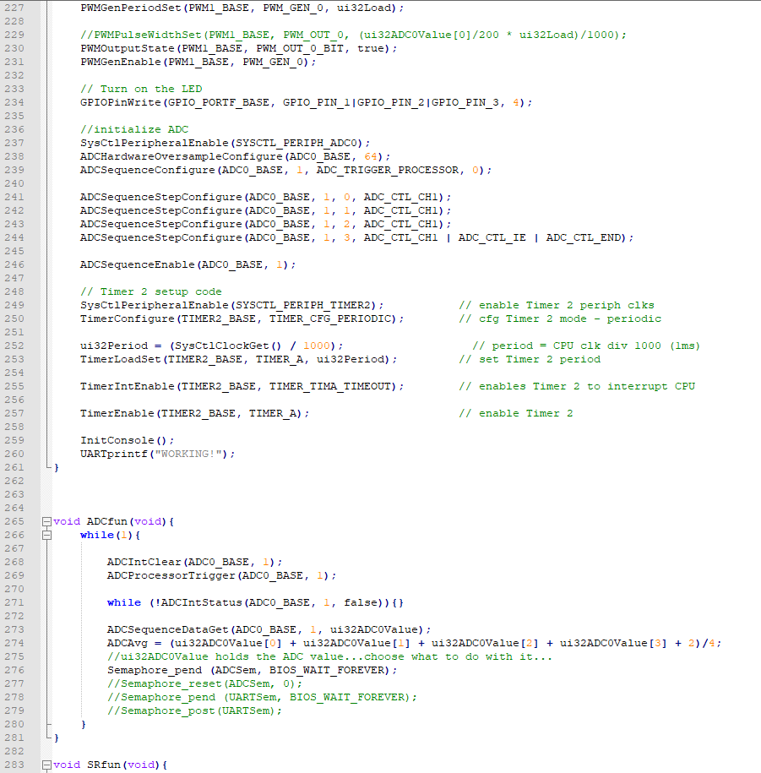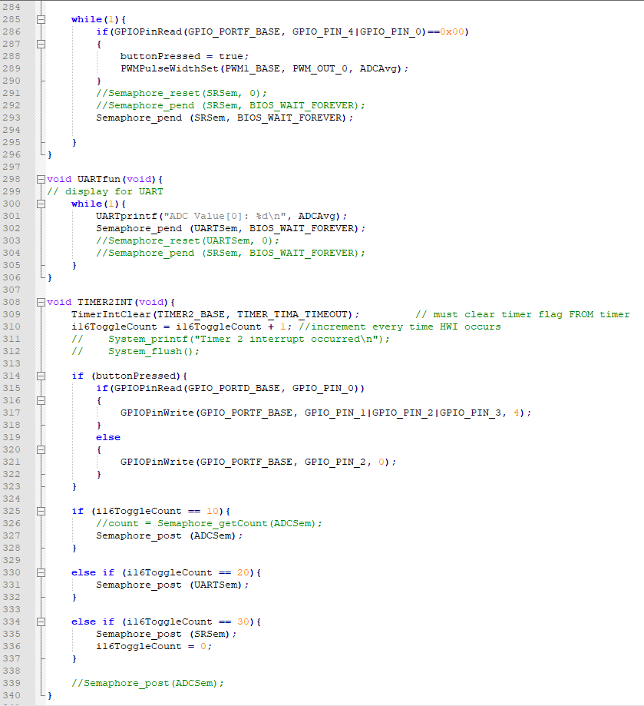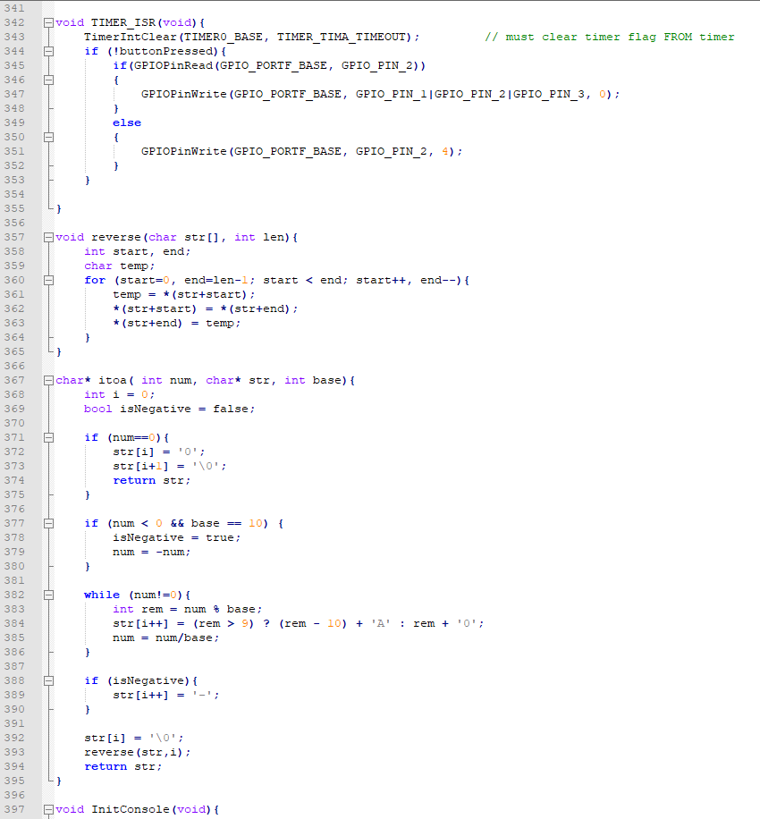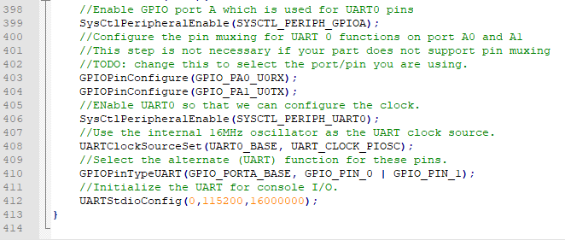

Name: Serak Gebremedhin Page 1/1