C++ Code Report
Overall Code Design
Before any code was written, it was important to design how the project would be structured. Below is a brief flow chart to show how the code interacts and function as a whole. This flowchart would aid in structuring my code out into separate files as well as understand how each process would relate to each other to run things in a correct order.
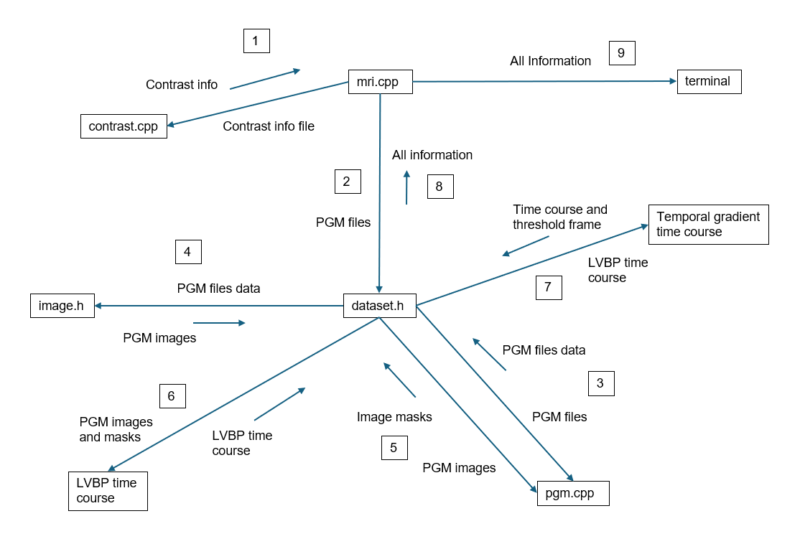
Main File
The mri.cpp file acts as the main function of the code, calling to the other files, as well as where the final information is displayed to the terminal. Starting from a main function and branching off to separate files can help make code clearer to understand and develop with.
Contrast Information
The first step implemented would be getting the contrast information from the contrast_info.txt file. This file contained the name and dosage of the contrast agent, I implemented a simple struct to store this information within a single variable. This struct can also be changed for different structures within an input file.
PGM Images
The PGM files would need to be stored as images, which requires multiple pieces of information to be stored to represent the image. Using the fMRI project as a template, I created an image class which could store the image dimensions and data. Using operator overloading of brackets, this would allow for easier interactivity with the image information. This interaction would become useful when creating masks from the images.
PGM Files Dataset
Similarly to the image header, I would use a class to store the data of the PGM files. This would ensure that I would be able to store multiple pieces of information in a single place, as well as being able to query the data and feed it to other functions. Again operator overloading, this time for square brackets, was used for ease of interacting with the information. Once the PGM file data has been extracted from the pgm.cpp file, it then it passed through the image class to create images from the data.
Mask Creation
I created a function that would input the images from the dataset and produce the binary mask that would highlight the LVBP region. The bracket operator overloading implemented from the image class made this task simple as each specific pixel required to be overwritten could be referenced easily. Each binary mask would then be stored as a separate variable as a member of the dataset class.
LVBP Time Course
To find the average signal time course within the LVBP region would require both member variables in the dataset class, the PGM images and their corresponding masks. Using Boolean logic of identifying the LVBP region within the mask, I was then able to use the corresponding coordinates in the image to find the average signal S[d] for that frame. This could then be collated into a single variable as a vector of floating-point numbers to then be called from the main file.
Temporal Gradient Time Course
I created a new function to find the temporal gradient. This would require the average signal time course from the previous function as well as creating a new struct for the output. The output would contain both the gradient time course, stored as a vector of floats and an integer of the frame which first exceeded the threshold. Therefore, I decided to create a struct for this within the dataset class to then be able to call each part individually whilst storing it as a single variable. More Boolean logic was used to find when the threshold would be first exceeded whilst then being unable to enter the same if statement once it had first been breached to ensure that following iterations wouldn’t override this.
Displaying to the Terminal
The final part would be to present the appropriate information in the main file on the terminal. Using the terminal graphics header, the image slice and the time courses could be shown on the terminal. Meanwhile, the other information could be pasted in word form to the terminal. The main file was kept as minimal as possible, with only a few small calculations completed here. This was a conscious effort to keep the code easy to understand and not clutter the file with other functionality which could be implemented in its own workspace. The other functionality mainly focussed on getting in the input files and outputting the final information to the terminal.

