MARMARA UNIVERSITY

FACULTY OF ENGINEERING

DPT. OF ELECTRICAL AND ELECTRONICS ENGINEERING

EE4049 POWER SYSTEM PROTECTION

PROJECT REPORT

INDIA JULY 2012 BLACKOUT

GROUP NO: 7

REPORT SUBMISSION DATE: 31.05.2021

1. **Scale of Outages**

The July of 2012 was a tough interval of the year for India because the government and the electrical engineers were facing serious sequential outages which lead life to stop because metros, trains, hospitals were lack of electricity. The outages last around two days, that is, 30 and 31 July 2012 and affected 350 million people on first day, 670 million people on the second day were out of electricity [1]. Briefly 21 out of 28 Indian states faced problems to access stable electricity. As a result of all these situations this major outage can be named as the worst in history that the world ever seen.

1. **Indian Electricity Grid and Generation of Electricity**

India is one of the most crowded countries, in that way the electricity demand of citizens increases day by day. To supply stable connection with least interruptions the grids, regions and electricity generation methods are very important to plan.

In India, five different grids are designed to operate, these regions are classified as [1][2]:

1. **Northern Grid**
2. **North-Eastern Grid**
3. **Eastern Grid**
4. **Western Grid**
5. **Southern Grid**

These grids and their locations on the map are given in the Figure 1.

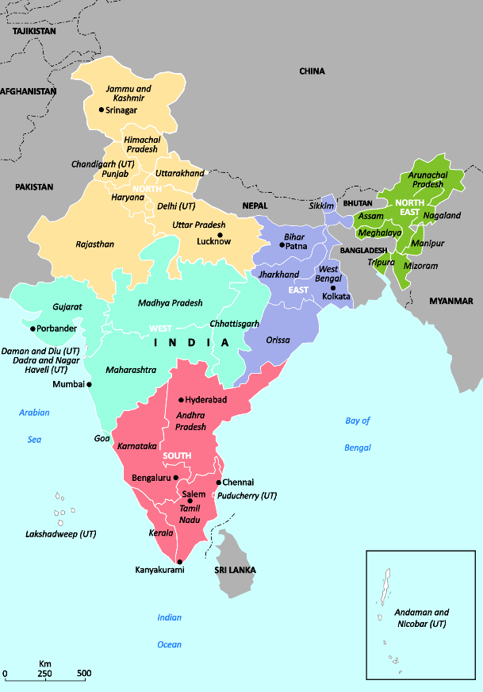

Figure 1: Indian Electricity Grids (Retrieved from Reference [1])

In Indian electricity **coal-fired thermal power plants** have huge role, such that **two-third** of total generated electricity in India comes from these thermal power plants.

The coal mines that are used to feed thermal power plants are positioned in **Eastern** region mostly [1], thereby so do coal-fired thermal power plants to decrease the time that passes in transportation of coals and the price [2].

Another important source to generate electricity is **hydroelectricity** which takes **one-tenth** of total generation, and they are mostly positioned in **Northern** and **North-Eastern** grid regions [1]. So that, using the given information it can be said that Indian power generation mainly relies on **thermal** and **hydro** [2].

In contrast, **North**, **West,** and **South** regions are the regions that are of **heaviest loads** on the electricity grid [1][2].

To fulfil all the demand across India many engineers are designing electricity supply veins part by part. These veins are designed by using **400-kV transmission lines** and **765-kV lines** mostly [1].

In early nineties Indian engineers planned to connect all these grids given in Figure 1 together to create **national grid**. Yet in the coming years all regional grids have connected each other except **Southern** region. This combined grid without Southern regional grid is called **North-East-West (NEW) Grid** [1][2]. Main idea behind this interconnectivity was to ease power distribution, and to de-stress the transmission lines. Also, in the **NEW Grid** design it is planned to connect **thermal power plants** in the East to the **loads** in the West and North.

Besides the electricity supply in India is planned to work properly always at a frequency of 50 Hz to provide essential efficient operation frequency of household devices and industrial regions [1].

1. **Some Brief Technical Details**

Load on grid has remarkable effect on the frequency if **load exceeds supply**. In such condition frequency generated by different sources, in other words frequency of supplied electricity or grid **tends to** **reduce.** But in practical usage we do not desire frequency to be waved, stable frequency is always desired. To overcome frequency reduction problem, electricity generators or suppliers in the interconnected regions start working harder to supply more power into the network in which more power is required [1].

This increased supplied power burden on the generators and on the transmission lines results in more **thermal stresses** than before [1]. If the safety limits that are determined by the engineer are exceeded protective equipment across grid takes lead and shutdowns electricity in related lines and may also cut interconnection between lines and generator.

These shutdowns may be resulted in the increased stress and burden on the other generators and transmission lines which would cause blackout eventually. In the year 2012, sequence of such events resulted in outages in India.

1. **What Was the Origin of the Event? How Did It Start First?**

Throughout the July of 2012 the NEW grid was operating in a stressed and unsafe situation. One source of this stress is that the failure of South-West monsoon rains led to huge increase of agricultural demand in Northern region [1]. Also, at the same time an excess power in Western region resulted in very high outflows of power to the Northern region [2].

It is seen that the system was running unbalanced, on the top of it only two of four 400-kV high-capacity West-North interconnections were available [2]. One of these not available lines was being upgraded to 765 kV since 28 July, and the other was underwent a forced outage the next day due to equipment failure. Lack of these two lines pushed the other two to work at their edges of capacity limits. [1] [2]

On 29 July, one of critical lines in the grid faced breakout at around 1500 hours which was 36 hours before the major outage. Nevertheless, no serious actions to decrease demand in Northern region were taken by people who are in charge. Instead of taking any action the surplus power coming from Western region is detoured via states of India to fulfil needs in the Northern region. At this point, the decisions are up to state government-owned utilities.

On power systems and distribution lines that are positioned in the area, noticing the frequency changes in the transmission lines is duty of states. To observe frequency changes in the line these states are responsible to use special relay type that is called **Frequency Relays**. These relays disconnect the excess loads in the transmission line in case of emergency (Load Shedding).

Maintenance of these relays is very important event to keep the stability, security, and selectivity of the distribution system at the proper level. Yet, these frequency relays are taken into maintenance seldom, because of the political pressure on the states these relays are kept in service despite any problems. The security of the transmission line decreases in case of non-maintained relays, thereby the risk of occurrence of failure increases. Therefore, in case of any failure in the transmission line these non-maintained relays may not send signals to circuit breakers to trip and then may lead to cascaded breakouts or shutdowns in the related transmission line, and in July 2012 what observed is that.

1. **What are prior system conditions for blackout 1 and blackout 2? [9][14]**

1.blackout: Prior System Conditions

* Western and Eastern regions were exporting power to the Northern region before the event:

1. ER to NR export was 2585 MW.
2. WR to NR export was 2862 MW.

* There were several lines that were partially out of service near the WR-NR interface before the outage. The system was in an unsafe state.
* Instructions for dropping loads from the NR freight distribution center were ignored by the states in NR.

2. blackout: Prior System Conditions

* Many lines were out of service prior to the outage. The system was in an unsafe state.
* Again, NR was importing power from the Western and Eastern regions.

1. ER to NR export was 1825 MW.
2. WR to NR export was 2100 MW.

* Instructions for dropping loads from the NR freight distribution center were ignored by the states in NR.

1. **How was the situation escalated and became a major disturbance/blackout? What happened in which sequence?**

BLACKOUT 1: [1][9]

* One of the Bina-Gwalior 400kV lines is overloaded has switched to protection and power surge.
* 220 kV and 132 kV lines are triggered and connected many lines are disabled.
* The system took 16 hours to reboot.

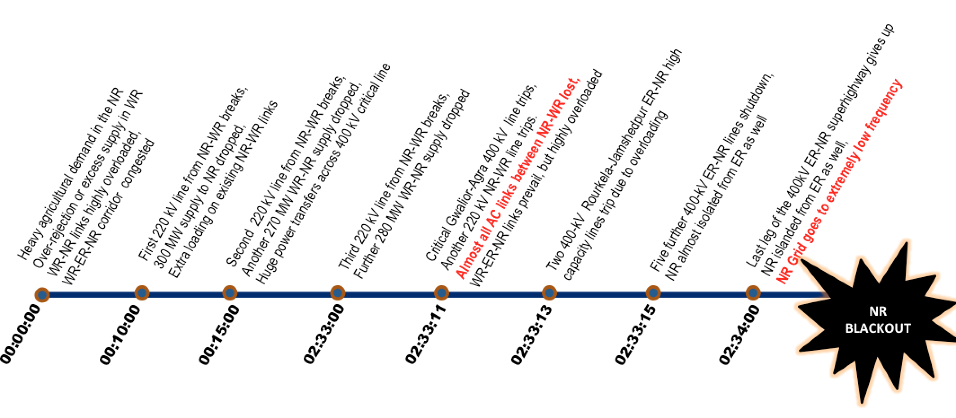

Figure 2: First Blackout (Retrieved from Reference [1])

BLACKOUT 2: [1][15]

* As a result of overloading of the region where Bina-Gwalior-Agra cities are located, it was seen that the voltage level of 400 kV decreased to 362 kV in the building area and as a result of overloading, the north and west regions were separated from each other with the distance relay.
* With the separation of the load, a power fluctuation occurred, and it became an island and a voltage increase occurred in the energized area.
* As a result of this high voltage, generator trips have occurred due to the high frequency.
* Although a few small island-like regions survived electrically, most of the region collapsed.

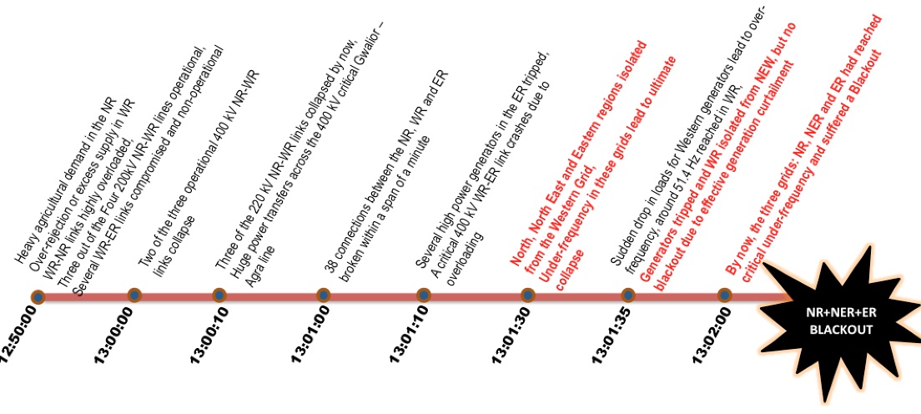

Figure 3: Second Blackout (Retrieved from Reference [1])

1. **What is the Frequency Separation for blackout 1 and blackout 2?**

Blackout1: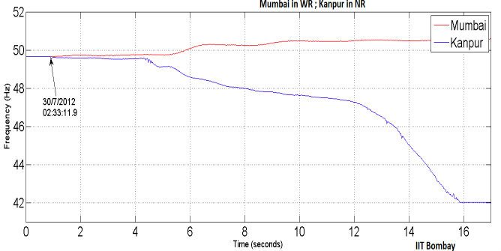 Rise in frequency in WR close to 51 Hz indicates inadequate primary frequency response from generators.

Figure 4: Frequency Rise in WR (Blackout 1) [16]

Blackout 2: Frequency separation between NR and rest of the NEW grid

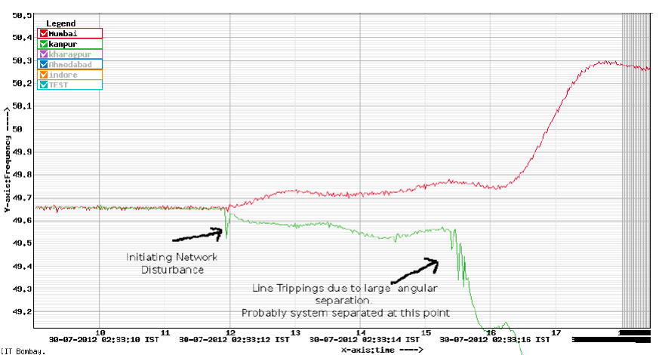

Figure 5: Frequencies of NR and NEW Grid (Blackout 2) [17]

* Millions of people affected during power outages. Its effects daily life and economy in a bad way of the North India.

1. **Impacts**

The first outage started at 02:35 IST on 30 July and it affected more than 300 million people for 14 hours and the second one started at 13:02 IST on 31 July affected 700 million people which is almost half of the entire population of India and almost %10 of the entire world population. It is partially finished on 2 August, one of the northern states of India Uttar Pradesh was being supplied about 7 GW power, however demand was between 9 and 9.7 GW. [1] [10]

Huge number of trains stopped working, and thousands of people were stuck on the railway. These stranded passengers can be seen from Kashmir to Nagaland.

New Delhi, Kolkata and many other cities had traffic jams due to the fact that traffic lights were non-operational.

Surgical operations delayed, when the back-up generators failed, many doctors and nurses operate lifesaving equipments manually.

In Delhi, drivers honked their horns impatiently because of high humidity levels and long-time waiting. This makes noise pollution.

In West Bengal due to power cut, hundreds of miners trapped in mines for many hours because their elevator system stopped working.

After the Chief Minister announced that return of the power would take 12 hours, government workers were sent to their houses.

Independent Power Producers Association of India said that: "There will obviously be some agitation in urban areas, which have become very reliant on electricity … There could be riots; there could be protests." [7]

Fortunately, any permanent damages not occurred however overall transformation systems, healthcare systems, industry and social life were affected. Economy of India severely affected due to these reasons. [1][7]

One of the Harvard Business School professors, Tarun Khanna, for impact of the Indian’s national economy said that “Companies adapt around infrastructural difficulties in all developing countries, routinely. They have to. But systemic disruption is bound to be a drag. It becomes very hard, because systemic disruption means that not only do you have to compensate for outages in your own location, you have to worry about your suppliers. You will not have access to any of their stuff, and your customers won’t have access to any of your stuff. The entire supply chain goes down. It’s very different form a normal situation which is to say, we have planned power outages”. [12]

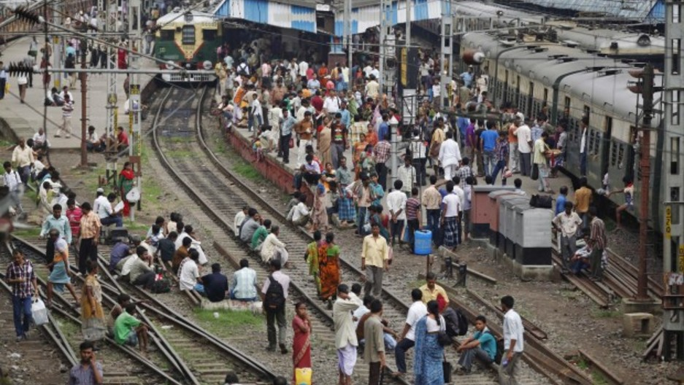

Figure 6: Passengers stranded on the rail station in Kolkata July 31, 2012 [13]

1. **Who were the responsible parties of this event?**

After the events, the vast majority of the Indian people held the government as responsible. According to DW's report, “The dominant opinion is that this government is not capable of managing crises. At the same time, it is trying to whitewash the disaster and is busy defending itself instead of taking responsibility for the incident.” [3]

Team Anna, the supporters of anti-corruption activist Anna Hazare, charged that this grid failure was a conspiracy to suppress the indefinite fast movement started on 25 July 2012 for the Jan Lokpal Bill and targeting Sharad Pawar. [4]

1. **Investigation**

The three-member investigation committee consisted of S. C. Shrivastava, A. Velayutham and A. S. Bakshi, and issued its report on 16 August 2012. It concluded that four factors were responsible for the two days of blackout:

* Weak inter-regional power transmission corridors due to multiple existing outages (both scheduled and forced);
* High loading on 400 kV Bina–Gwalior–Agra link;
* Inadequate response by State Load Dispatch Centers (SLDCs) to the instructions of Regional Load Dispatch Centres (RLDCs) to reduce over-drawal by the Northern Region utilities and under-drawal/excess generation by the Western Region utilities;
* Loss of 400 kV Bina–Gwalior link due to mis-operation of its protection system.

The committee also offered a number of recommendations to prevent further failures, including an audit of the protection systems.[4]

1. **Penalties**

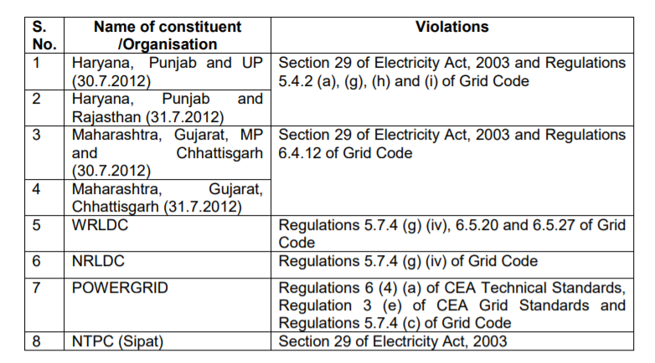Based on the findings of report and after hearing the concerned parties, the Commission came to the conclusion that the following constituents have violated the various provisions of the Electricity Act, 2003, Central Electricity Regulatory Commission (Indian Electricity Grid Code) Regulations, 2010 (Grid Code), Central Electricity Authority (Technical Standards for Connectivity to the Grid) Regulations, (CEA Technical Standards) and Central Electricity Authority (Grid Standard) Regulations, 2010 ( CEA Grid Standards) as mentioned against each: [5]

Table 1: Table of violated rules and related organisations

For a grid disturbance costing billions of dollars and spread over two days during 30th and 31 st July,2012, Central Regulator in its recent order dated 14.12.2015 decided to impose penalty on Central Transmission Utility POWERGRID, two Regional System operators of Northern and Western India and eight State Load Dispatchers. The order came after a long delay of 40 months after the event and amount of penalties are too little to acts as effective deterrent. Penalties are meagre ranging from $757(INR 50000) on WRLDC and NRLDC and $1515 (INR 100000) on other. As usual the collective crimes had been handled softly and penalties are disproportionate to the consequence of noncompliance of Electricity Act, 2003, Grid standards of CEA and various Regulations and procedure of Central Commission. Copy of the Commission order can be accessed at [following link](http://cercind.gov.in/2015/orders/SO008.pdf). [6]

1. **How the Event Could Be Prevented, or How Its Negative Impacts Could Be Reduced?**

Preventive Measures to Overcome Power Outages are as follows:

* Implementing and integrating smarter and newer forms of supply
* Developing and exploiting Renewable energy sources and low carbon baseload technologies
* Energy-efficient buildings
* Cost-effective energy savings
* 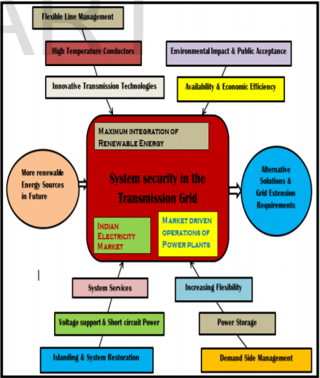Properly educating and giving technically sound training to operators in power plants [9]

Figure 7: Simplified Figure Depicting Preventive Measures Against Power Fail

1. **Causes of Power Outages and Effective Ways to Prevent Them**

In general, more high-voltage lines must be built to catch up with the rising demand imposed by ever more air conditioners, computers, and rechargeable gadgets, but even more important, the power grid must be made smarter. Most of the equipment that minds the flow of electricity dates back to the 1970s. This control system is not good enough to track disturbances in real-time or to respond automatically to isolate problems. Furthermore, the information that operators receive at central control stations is sparse, making it impossible for them to react fast enough to stop the large cascades that do start. A self-healing smart grid—one that is aware of nascent trouble and can reconfigure itself to resolve the problem—could reduce blackouts dramatically, as well as contain the chaos that could be triggered by terrorist sabotage. It would also allow more efficient wheeling of power, saving utilities and their customers millions of dollars during routine operation. The technology to build this smart grid largely exists, and recent demonstration projects are proving its worth.

1. **What Can India Do to Help Eliminate Such Wide-Ranging Outages In the Future?**

The Government needs to make an assessment of how best to address the power needs to meet future growth and prevent such massive power failures. It is kind of different for India, it needs a radical transformation of its energy system to the use of renewable energy, especially solar, to end the “massive power grid outages.”

For economic as well as environmental reasons India needs to shift to non-polluting renewable sources of energy. Renewable energy is the most attractive investment because it will provide long-term economic growth for India.

India needs to consider developing targets for electrification, which includes renewable off-grid options and/or renewable energy-powered mini-grids. This will take the substantial electrical load off the existing power grid while at the same time reducing the need for installing additional transmission and distribution systems.

The deployment of large-scale solar and wind projects needs to continue at a pace to affect the smooth transition from fossil fuels. This is happening already, but more rapid project development is required going forward. [8]

To improve and standardize the power sector and reduce the current power shortages, necessary steps and precautions should be taken to minimize and if possible, eliminate these problems. The steps should comprise measures that not only dampen the impact of the power losses on production and revenue generation but also stress cost reductions, advanced and efficient technologies in power generation, good management of the available power supply. Strict guidelines should be implemented, and fines should be imposed for power wastage, theft, and losses in transmission.[9]

**References**

1. Anubhav RATH, Indian Blackouts of July 2012: What Happened and Why? (30 November 2016), Retrieved from:

<https://medium.com/clean-energy-for-billions/indian-blackouts-of-july-2012-what-happened-and-why-639e31fb52ad>

1. Shuran LIU, Hui DENG, Su GUO, Analyses and Discussions of the Blackout in Indian Power Grid (1 August 2012), Retrieved from:

<https://www.researchgate.net/publication/323174680_Analyses_and_Discussions_of_the_Blackout_in_Indian_Power_Grid>

1. Retrieved from:

<https://www.dw.com/en/experts-discuss-the-reasons-behind-indias-blackout/a-16139644>

1. Retrieved from:

<https://web.archive.org/web/20120801001542/http://ibnlive.in.com/news/team-anna-calls-grid-failure-a-conspiracy-targets-pawar/276445-37-64.html>

1. Retrieved from:

<http://cercind.gov.in/2015/orders/SO008.pdf>

1. Retrieved from:

<https://www.linkedin.com/pulse/blackout-india-2012-too-little-penalty-learning-from-history-vijay/>

1. Helen Pidd (2012, July), “India blackouts leave 700 million without power”, Retrieved from: <https://www.theguardian.com/world/2012/jul/31/india-blackout-electricity-power-cuts>
2. Retrieved from:

<http://www.renewableenergyfocus.com/view/29650/10-steps-to-prevent-indias-blackouts/>

1. <http://www.ijoart.org/docs/Power-cut-off-and-Power-Blackout-in-India-a-Major-threat--An-Overview.pdf>
2. HT Correspondent (2012 August), “Northern power grid was again on verge of tripping”, Retrieved from:

<https://www.hindustantimes.com/lucknow/northern-power-grid-was-again-on-verge-of-tripping/story-UdLuJBv40an7RgkTmPxzbP.html>

1. Retrieved from:

<https://www.scientificamerican.com/article/preventing-blackouts-power-grid/>

1. Sarah Green Carmichael, What the Blackout Means for India’s Economy, August 01, 2012, Retrieved from:

[https://hbr.org/2012/08/what-the-blackout-means-for-in#](https://hbr.org/2012/08/what-the-blackout-means-for-in)

1. India Power Outages: Living Through the Blackout, Retrieved from:

<https://www.pri.org/stories/2012-08-01/india-power-outages-living-through-blackout>

1. Retrieved from:

<https://www.mdpi.com/1996-1073/12/4/682/pdf>

1. Retrieved from:

<https://www.emo.org.tr/ekler/54e004f9eb1733e_ek.pdf>

1. Retrieved from:

<http://www.cercind.gov.in/2012/orders/Final_Report_Grid_Disturbance.pdf>

1. Retrieved from:

<https://www.slideshare.net/giridaran123/blackout-v2>

**Date:** 31/05/2021

**GROUP NO:** 7

Group Member 1: Berat Asrın CAFEROĞLU, 150718056, 1-Scale of Outages 2- Indian Electricity Grid and Generation of Electricity 3- Some Brief Technical Details 4- What Was the Origin of the Event? How Did It Start First?

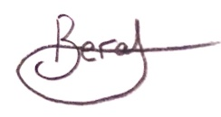

Group Member 2: Senem AKPUNAR, 150716061, 9- Who were the responsible parties of this event? 10- Investigation 11- Penalties



Group Member 3: Bengi ANIL, 150716003, 12- How the Event Could Be Prevented, or How Its Negative Impacts Could Be Reduced? 13- Causes of Power Outages and Effective Ways to Prevent Them 14- What Can India Do to Help Eliminate Such Wide-Ranging Outages In the Future?

Group Member 4: Mert ÇETİN, 150716023, 8- Impacts, and research of the effects on the daily life of Indians



Group Member 5: Gülay KOCABAŞ, 150717853, 5- What is prior system conditions for blackout 1 and blackout 2? 6- How the situation was escalated and became a major disturbance/blackout? What happened in which sequence? 7- What is the Frequency Separation for blackout 1 and blackout 2?

