**Banking API Documentation**

**Berat Asrın CAFEROĞLU**

Contents

**1.** **Technologies Used in Development** 1

**2.** **User Side** 1

**2.1.** **Create User** 1

**2.2.** **Get All Users** 2

**2.3.** **Update User** 3

**3.** **Account Side** 4

**3.1.** **Create Account** 4

**3.2.** **Get All Accounts of User** 5

**3.3.** **Remove Account** 6

**3.4.** **Transfer Balance** 7

**4.** **Database (MongoDB) Structure Explanation** 9

# **Technologies Used in Development**

In this project, **Java Programming Language** is utilized with **Spring Boot Framework** in order to design the API. On the other hand, as you know the data should be stored using some database, so that, **MongoDB** is preferred in terms of ease of use, and **Spring Data** is used to get/create/update/delete the data. Also, encapsulation is an essential topic in object-oriented programming, yet developers struggle while coding constructors, getters, and setters. In that sense, **Lombok** is used to create them using annotations.

# **User Side**

## **Create User**

Each user has their own properties as follows: name, surname, Turkish identification number (TCKN), and email. So, in process of creating a new user, we need to get these parameters in the request. In this function, there are important points that I would like to mention. First, before creating a new user we are searching for TCKN to find out that if any user has the same identification number. In case of conflict, API throws a message and does not create the user. Otherwise, I mean if the TCKN does not exist in the MongoDB database, the user is created successfully, and a unique primary key is assigned to the user.

**URL: localhost:8080/user/create**

**HTTP Method: POST**

**Required Body Parameters: tckn (String), name (String), surname (String), email (String)**

metin içeren bir resim

Açıklama otomatik olarak oluşturuldu

Figure 1: Create user request and response body

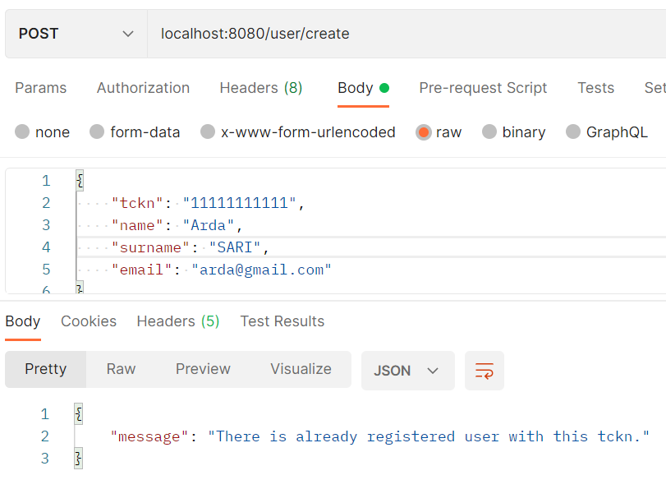

Figure 2: Error message when the same tckn is entered

## **Get All Users**

Using this function, we are able to see all registered users without giving any request body.

**URL: localhost:8080/user/get_all**

**HTTP Method: GET**

**Required Body Parameters: No need**

**metin içeren bir resim

Açıklama otomatik olarak oluşturuldu**

Figure 3: All users

## **Update User**

This function is designed to update the information in the database related to the user. It allows users to update names, surnames, and emails. But does not allow updating TCKN. Here in this function, the user that will be updated is found by their “userId” which was defined as the primary key. But, the most important thing about this function is if the request body contains “tckn” the function returns a special message.

**URL: localhost:8080/user/update**

**HTTP Method: PUT**

**Required Body Parameters: userId (String), name (String), surname (String), email (String)**

Please remember that “6376795c6a07951601dfc292” was userId of “Berat Asrın CAFEROĞLU”. Now we will update this user via the given URL.

metin içeren bir resim

Açıklama otomatik olarak oluşturuldu

Figure 4: User is updated

metin içeren bir resim

Açıklama otomatik olarak oluşturuldu

Figure 5: User is updated except TCKN

# **Account Side**

## **Create Account**

This function is designed to open new accounts for users in the bank. While creating an account currency type and balance need to be given in the request body. Yet, according to my design, there are two ways to find the user who will be the owner of the account. The first way is by entering “userId”, and the second is by entering “userTckn”. Either way, the account will be created, but one of these parameters must be in request body.

**URL: localhost:8080/account/create**

**HTTP Method: POST**

**Required Body Parameters: userTckn (String) or userId(String) (One of them must be given), balance (float), currency (String)**

**metin içeren bir resim

Açıklama otomatik olarak oluşturuldu**

Figure 6: Create new account using userTckn

**metin içeren bir resim

Açıklama otomatik olarak oluşturuldu**

Figure 7: Create new account using userId

## **Get All Accounts of User**

This function allows us to get the accounts of the specified user.

**URL: localhost:8080/account/user/get_all**

**HTTP Method: GET**

**Required Body Parameters: userTckn (String) or userId(String) (One of them should be given)**

metin içeren bir resim

Açıklama otomatik olarak oluşturuldu

Figure 8: Accounts of user

metin içeren bir resim

Açıklama otomatik olarak oluşturuldu

Figure 9: Accounts of user

## **Remove Account**

An account can be deleted via this function by giving its accountId.

**URL: localhost:8080/account/delete**

**HTTP Method: DEL**

**Required Body Parameters: accountId (String)**

**metin içeren bir resim

Açıklama otomatik olarak oluşturuldu**

Figure 10: Account with given accountId is deleted

## **Transfer Balance**

This function is used to transfer balance between accounts if they have same type of currency. If the currencies are different, then, the transaction is not done. On the other hand, if these two accounts have the same currency but the account which sends the money does not have enough balance, then, again transaction is not done. Beyond these, if the transaction is between different users, their TCKNs are given in the message.

**URL: localhost:8080/account/transfer**

**HTTP Method: POST**

**Required Body Parameters: fromAccountId (String), toAccountId (String), amount (Float)**

metin içeren bir resim

Açıklama otomatik olarak oluşturuldu

Figure 11: Balance transfer between accounts

metin içeren bir resim

Açıklama otomatik olarak oluşturuldu

Figure 12: Balance transfer error due to different currencies

metin içeren bir resim

Açıklama otomatik olarak oluşturuldu

Figure 13: Balance transfer between different users

metin içeren bir resim

Açıklama otomatik olarak oluşturuldu

Figure 14: Not enough balance

# **Database (MongoDB) Structure Explanation**

In this section, I would like to explain database structure that I have designed shortly. The most common part is creating a database name, so, the database that is used in this project is named “banking_database” as shown in Figure 15.

After that, in this project, we have mainly 2 entities (users, and accounts) that should be stored. Therefore, collections named “users”, and “accounts” are created as shown in Figure 16.

Finally stored data in them are shown in Figure 17, and Figure 18.

tablo içeren bir resim

Açıklama otomatik olarak oluşturuldu

Figure 15: Database name: banking_database

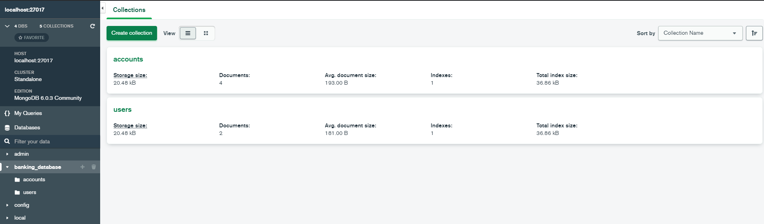

Figure 16: Collections in database

metin içeren bir resim

Açıklama otomatik olarak oluşturuldu

Figure 17: Accounts collection

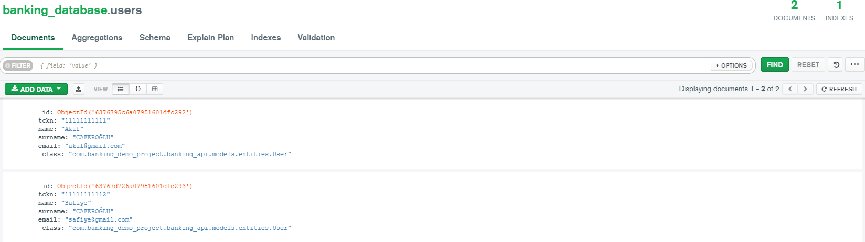

Figure 18: Users collection