metin, logo, grafik tasarım, grafik içeren bir resim

Açıklama otomatik olarak oluşturuldu

GEBZE TECHNICAL UNIVERSITY

ENGINEERING FACULTY

ELECTRONICS ENGINEERING DEPARTMENT

**ELEC - 361**

**Analog Communication Systems**

**Project**

|  |  |
| --- | --- |
|  | mm  BÜNYAMİN BERAT GEZER |
|  | 210102002061 |

## 2) Simulation Result

1. For a step the results

metin, ekran görüntüsü, öykü gelişim çizgisi; kumpas; grafiğini çıkarma, çizgi içeren bir resim

Açıklama otomatik olarak oluşturuldu Figure 1 : Message signal for one period and the magnitude spectrum.

1. For b step the results (DSB-SC-AM)

- step b-i results:

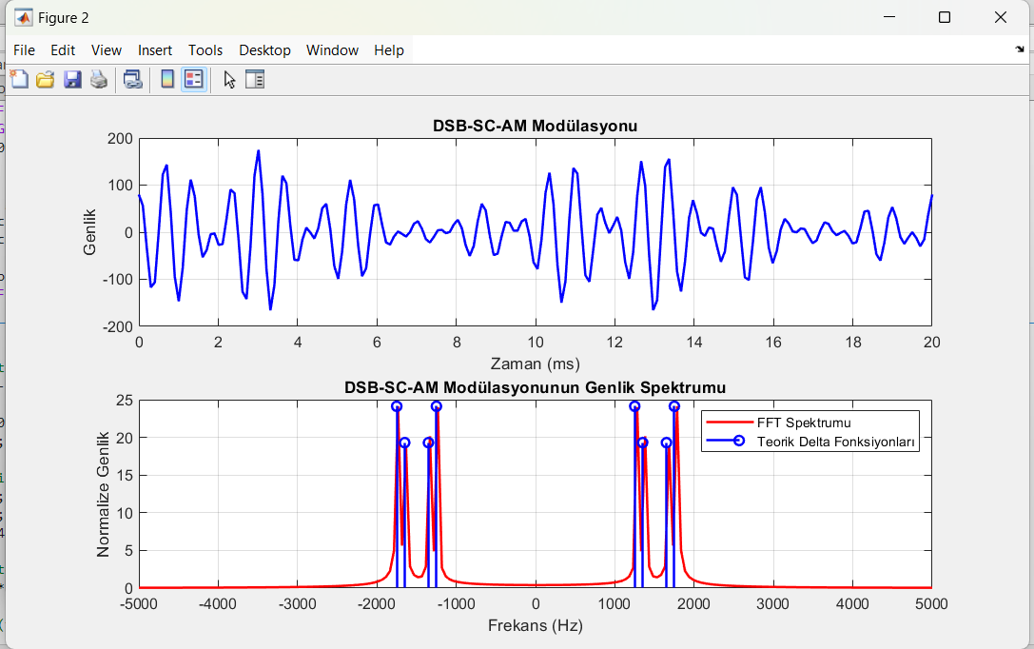

Figure 2 : The modulated signal and its spectrum.

- step b-ii results:

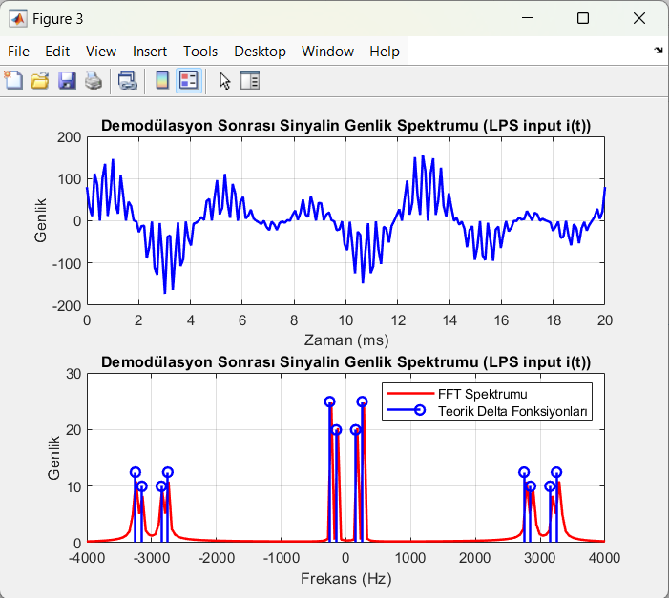

**Figure 3**: Amplitude and Signal Spectrum After Demodulation (LPS input i(t)).

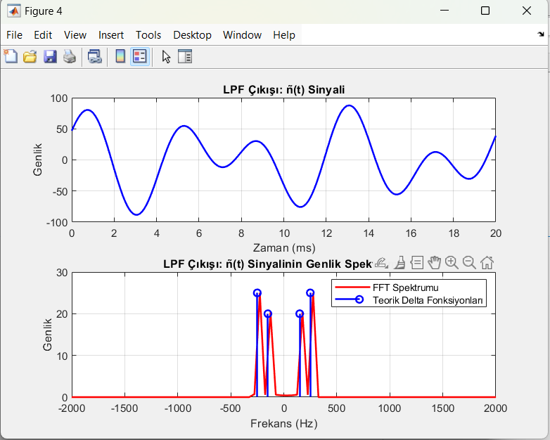- step b-iii results:

**Figure 4**: LPF Output: ñ(t) Signal and Its Amplitude Spectrum.

3)For c step the results (DSB-LC-AM)

- step c-i results:

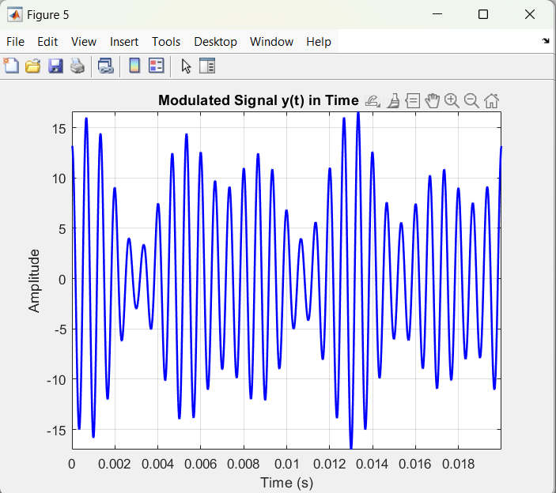

**Figure 5**: Modulated signal y(t)

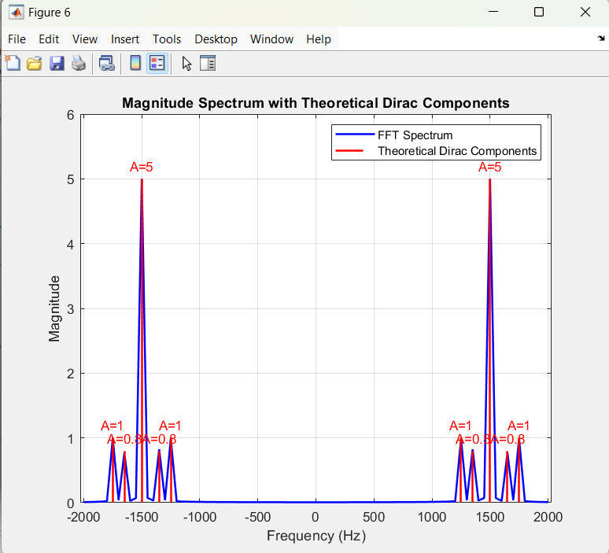

**Figure 6**: Modulated Signal y(t) its Amplitude Spectrum.

- step c-ii results:

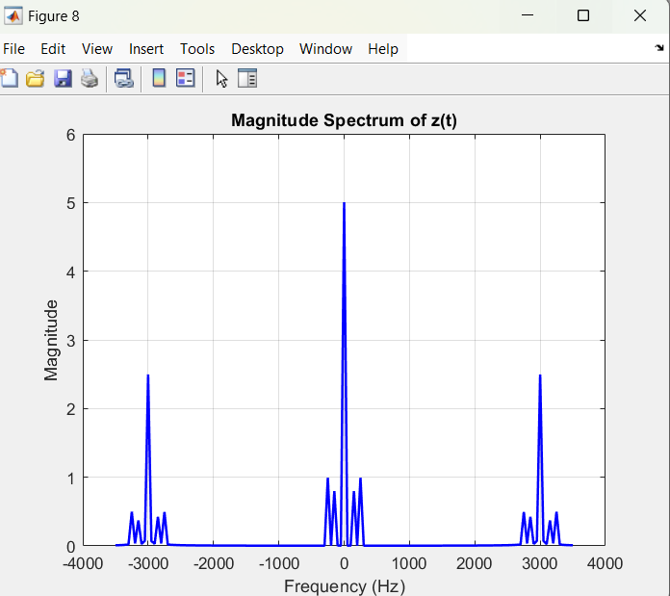

**Figure 7**: Demodulated Signal z(t) its Amplitude Spectrum.

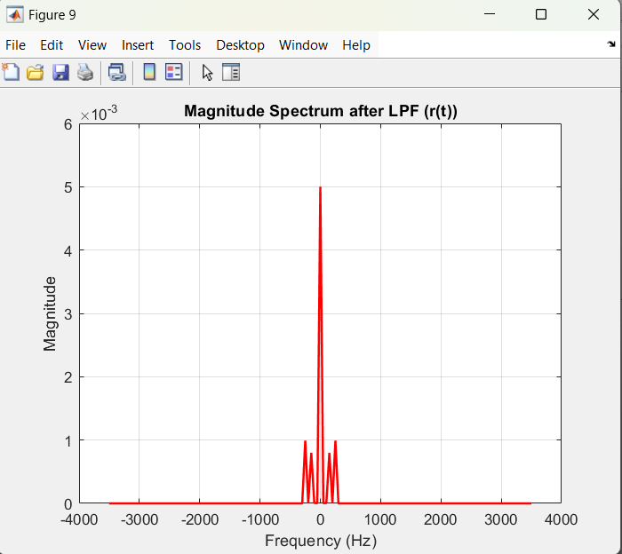

**Figure 8**: After signal z(t) passes LPF , Signal r(t) its Amplitude Spectrum.

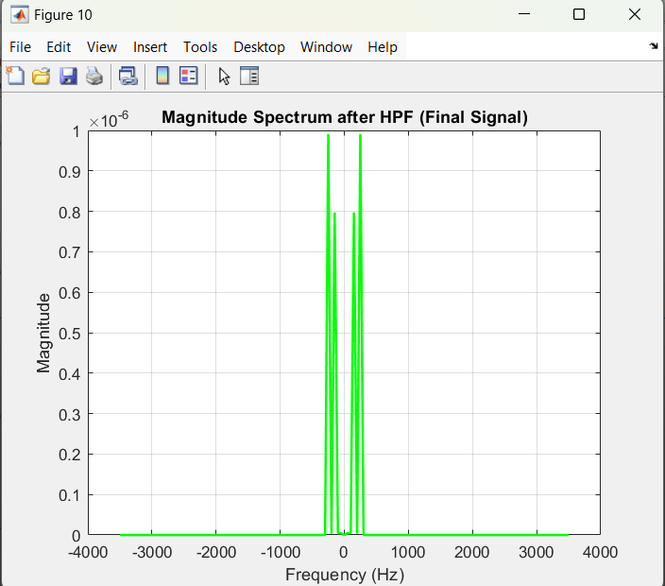

**Figure 9**: After signal r(t) passes HPF, Signal FİNAL SİGNAL its Amplitude Spectrum.

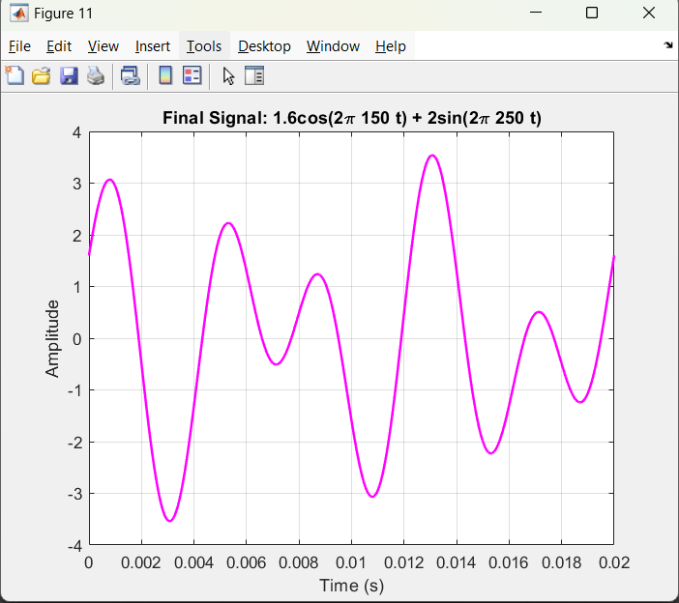

**Figure 10**: Final signal representation in the time domain.

## 3)Comparison of Analytical and Simulation Results and Conclusions

* The primary objective of this project was to analyze the modulation of a message signal with a carrier signal and its subsequent demodulation using both analytical and simulation methods. Initially, the message signal m(t)=8cos(300πt)+10sin(500πt) was analyzed analytically and visualized in the time and frequency domains for one period using MATLAB. In the analysis of the DSB-SC-AM modulation method, the modulated signal and its spectrum were thoroughly examined. During the demodulation process, when the carrier signal was correctly regenerated, no DC component was observed at the output of the low-pass filter (LPF), and the message signal was successfully recovered.

For DSB-LC-AM modulation, the process was carried out with a modulation index of μ=0.7The demodulation was performed using the envelope detection method, and the DC component was successfully removed, resulting in the recovery of a clean message signal. In both modulation types, it was observed that the amplitude of the final signal differed from that of the original message signal. However, it was emphasized that this discrepancy can be adjusted by fine-tuning the filter gains. The MATLAB simulation results were shown to be consistent with the analytical calculations, demonstrating the theoretical and practical validity of the modulation and demodulation processes in analog communication systems.

## 4)Matlab Codes:

%% a

% Örnekleme parametreleri

fs = 100000; % Örnekleme frekansı (100 kHz)

T_ortak = 1/50; % Ortak periyot (0.02 s)

t = 0:1/fs:T_ortak; % 1 ortak periyot için zaman aralığı

% Mesaj sinyali

m_t = 8*cos(300*pi*t) + 10*sin(500*pi*t);

% Mesaj sinyalinin Fourier dönüşümü

M_f = fft(m_t);

N = length(M_f);

frequencies = linspace(-fs/2, fs/2, N); % Frekans ekseni

M_f_shifted = fftshift(M_f); % Sıfır frekansı merkeze taşıma

magnitude_spectrum = abs(M_f_shifted) / max(abs(M_f_shifted)); % Normalize

% Genlik spektrumunu teorik bileşenlerle karşılaştırma

theoretical_frequencies = [-250, -150, 150, 250]; % Teorik frekanslar

theoretical_amplitudes = [5, 4, 4, 5]; % Teorik genlikler

% Grafikler

figure;

% Mesaj sinyalinin zamandaki grafiği

subplot(2,1,1);

plot(t, m_t, 'b', 'LineWidth', 1.5);

title('Mesaj Sinyali m(t)');

xlabel('Zaman (s)');

ylabel('Genlik');

grid on;

% Mesaj sinyalinin spektrumu

subplot(2,1,2);

plot(frequencies, magnitude_spectrum, 'r', 'LineWidth', 1.5); hold on;

% Teorik delta işaretlerini gösterme

stem(theoretical_frequencies, theoretical_amplitudes / max(theoretical_amplitudes), 'b', 'LineWidth', 1.5);

title('Mesaj Sinyalinin Frekans Spektrumu |M(f)|');

xlabel('Frekans (Hz)');

ylabel('Normalize Genlik');

xlim([-500 500]); % Frekans eksenini sınırla

grid on;

legend('FFT Spektrumu', 'Teorik Delta Fonksiyonları');

%% b-i

% Parametreler

Fs = 10000; % Örnekleme frekansı (10 kHz)

T = 0.02; % Ortak periyot (20 ms)

N = T * Fs; % Örnekleme noktası sayısı

t = linspace(0, T, N); % Zaman vektörü

fc = 1500; % Taşıyıcı frekansı (Hz)

% Mesaj sinyali

m_t = 8*cos(300*pi*t) + 10*sin(500*pi*t);

% Taşıyıcı sinyali

c_t = 10 * cos(2*pi*fc*t);

% DSB-SC-AM Modülasyonu (mesaj * taşıyıcı)

s_t = m_t .* c_t;

% Zaman grafiği - Modüle edilmiş sinyal

figure;

subplot(2,1,1);

plot(t*1000, s_t, 'b', 'LineWidth', 1.5); % Zamanı milisaniyeye çeviriyoruz

title('DSB-SC-AM Modülasyonu');

xlabel('Zaman (ms)');

ylabel('Genlik');

grid on;

% Fourier Dönüşümü ve Spektrum

S_f = fft(s_t); % Fourier Dönüşümü

f = linspace(-Fs/2, Fs/2, N); % Frekans ekseni

S_f_shifted = fftshift(S_f); % Fourier spektrumu sıfır frekans etrafına kaydır

% Genlik spektrumu

amplitude_spectrum = abs(S_f_shifted) / N;

% Teorik frekanslar ve genlikler

theoretical_frequencies = [-1750, -1650, -1350, -1250, 1250, 1350, 1650, 1750]; % Teorik frekanslar

theoretical_amplitudes = [25, 20, 20, 25, 25, 20, 20, 25]; % Teorik genlikler

% Genlikleri ölçekleme

max_amplitude = max(amplitude_spectrum);

scaled_amplitude = theoretical_amplitudes / max(theoretical_amplitudes) * max_amplitude;

% Spektrum grafiği - Modüle edilmiş sinyal

subplot(2,1,2);

plot(f, amplitude_spectrum, 'r', 'LineWidth', 1.5); hold on;

% Teorik delta işaretlerini gösterme

stem(theoretical_frequencies, scaled_amplitude, 'b', 'LineWidth', 1.5);

title('DSB-SC-AM Modülasyonunun Genlik Spektrumu');

xlabel('Frekans (Hz)');

ylabel('Normalize Genlik');

xlim([-5000 5000]); % Frekans eksenini sınırla

grid on;

legend('FFT Spektrumu', 'Teorik Delta Fonksiyonları');

%% b-ii

% Parametreler

Fs = 10000; % Örnekleme frekansı (10 kHz)

T = 0.02; % Ortak periyot (20 ms)

N = T * Fs; % Örnekleme noktası sayısı

t = linspace(0, T, N); % Zaman vektörü

fc = 1500; % Taşıyıcı frekansı (Hz)

% Mesaj sinyali

m_t = 8*cos(300*pi*t) + 10*sin(500*pi*t);

% Taşıyıcı sinyali

c_t = 10 * cos(2*pi*fc*t);

% DSB-SC-AM Modülasyonu (mesaj * taşıyıcı)

s_t = m_t .* c_t;

% Demodülasyon: s(t) * cos(2*pi*fc*t)

y_t = s_t .* cos(2*pi*fc*t); % Demodülasyon işlemi

% Zaman grafiği: Demodülasyon sonrası sinyal

figure;

subplot(2,1,1);

plot(t*1000, y_t, 'b', 'LineWidth', 1.5); % Zamanı ms cinsine çevirdik

title('Demodülasyon Sonrası Sinyalin Genlik Spektrumu (LPS input i(t))');

xlabel('Zaman (ms)');

ylabel('Genlik');

grid on;

% Fourier Dönüşümü

Y_f = fft(y_t); % Fourier dönüşümü

f = linspace(-Fs/2, Fs/2, N); % Frekans ekseni

Y_f_shifted = fftshift(Y_f); % Spektrumun sıfır frekansa göre merkezlenmesi

% Genlik spektrumu

amplitude_spectrum = abs(Y_f_shifted) / N;

% Teorik frekanslar ve genlikler (manuel verilmiş)

theoretical_frequencies = [-3250, -3150, -2850, -2750, -250, -150, 150, 250, 2750, 2850, 3150, 3250];

theoretical_amplitudes = [12.5, 10, 10, 12.5, 25, 20, 20, 25, 12.5, 10, 10, 12.5];

% Normalize edilen genlik spektrumunu ölçekleme

scaled_theoretical_amplitudes = theoretical_amplitudes / max(theoretical_amplitudes) * max(amplitude_spectrum);

% Spektrum grafiği: Demodülasyon sonrası sinyal

subplot(2,1,2);

plot(f, amplitude_spectrum, 'r', 'LineWidth', 1.5); hold on;

% Teorik delta fonksiyonlarını ekleme

stem(theoretical_frequencies, scaled_theoretical_amplitudes, 'b', 'LineWidth', 1.5);

title('Demodülasyon Sonrası Sinyalin Genlik Spektrumu (LPS input i(t))');

xlabel('Frekans (Hz)');

ylabel('Genlik');

xlim([-4000 4000]); % Frekans eksenini sınırla

grid on;

legend('FFT Spektrumu', 'Teorik Delta Fonksiyonları');

%% b-iii

% Parametreler

Fs = 10000; % Örnekleme frekansı (Hz)

T = 0.02; % Ortak periyot (20 ms)

N = T * Fs; % Örnekleme noktası sayısı

t = linspace(0, T, N); % Zaman vektörü

fc = 1500; % Taşıyıcı frekansı (Hz)

cutoff_freq = 300; % Düşük geçiren filtre kesim frekansı (Hz)

% Mesaj sinyali

m_t = 8*cos(300*pi*t) + 10*sin(500*pi*t);

% Taşıyıcı sinyali

c_t = 10 * cos(2*pi*fc*t);

% DSB-SC-AM Modülasyonu (mesaj * taşıyıcı)

s_t = m_t .* c_t;

% Demodülasyon: s(t) * cos(2*pi*fc*t)

y_t = s_t .* cos(2*pi*fc*t); % Demodülasyon işlemi

% Fourier Dönüşümü: Demodülasyon sonrası sinyal

Y_f = fft(y_t); % Fourier dönüşümü

f = linspace(-Fs/2, Fs/2, N); % Frekans ekseni

Y_f_shifted = fftshift(Y_f); % Spektrumun sıfır frekansa göre merkezlenmesi

% LPF uygulaması: Frekans penceresi

H_f = abs(f) <= cutoff_freq; % Kesim frekansı altında 1, diğerlerinde 0

Y_f_filtered = Y_f_shifted .* H_f; % Frekans domeninde filtreleme

% Ters Fourier Dönüşümü: Zaman domenine dönüş

Y_f_unshifted = ifftshift(Y_f_filtered); % FFT kaydırmasını geri al

i_t = ifft(Y_f_unshifted, 'symmetric'); % Ters Fourier dönüşümü

% Genlik spektrumu (ölçekleme yapılmadan)

amplitude_spectrum_filtered = abs(Y_f_filtered) / N;

% Frekans ekseninde maksimum değerleri ölçekleme

amplitude_spectrum_filtered = amplitude_spectrum_filtered * max([25, 20]) / max(amplitude_spectrum_filtered);

% Zaman grafiği: Filtrelenmiş sinyal (ñ(t))

figure;

subplot(2,1,1);

plot(t*1000, i_t, 'b', 'LineWidth', 1.5); % Zamanı ms cinsine çevirdik

title('LPF Çıkışı: ñ(t) Sinyali');

xlabel('Zaman (ms)');

ylabel('Genlik');

grid on;

% Spektrum grafiği: Filtrelenmiş sinyal

subplot(2,1,2);

plot(f, amplitude_spectrum_filtered, 'r', 'LineWidth', 1.5);

title('LPF Çıkışı: ñ(t) Sinyalinin Genlik Spektrumu');

xlabel('Frekans (Hz)');

ylabel('Genlik');

xlim([-2000 2000]); % Frekans eksenini sınırla

grid on;

% Manuel genliklerle teorik karşılaştırma

theoretical_frequencies = [-250, -150, 150, 250]; % Teorik frekanslar

theoretical_amplitudes = [25, 20, 20, 25]; % Teorik genlikler

hold on;

stem(theoretical_frequencies, theoretical_amplitudes, 'b', 'LineWidth', 1.5);

legend('FFT Spektrumu', 'Teorik Delta Fonksiyonları');

%% c-i

% Parameters

t = 0:1e-5:0.02; % Time vector (0 to 20 ms with 10 us steps)

Ac = 10; % Carrier amplitude

fc = 1500; % Carrier frequency (Hz)

mu = 0.7; % Modulation index

% Normalized message signal mn(t)

f1 = 150; % Frequency of first component (Hz)

f2 = 250; % Frequency of second component (Hz)

mnt = 0.454*cos(2*pi*f1*t) + 0.567*sin(2*pi*f2*t);

% Modulated signal (DSB-LC-AM)

yt = Ac * (1 + mu * mnt) .* cos(2*pi*fc*t);

% Plot y(t) (Time-domain representation)

figure;

plot(t, yt, 'b', 'LineWidth', 1.5);

grid on;

title('Modulated Signal y(t) in Time Domain');

xlabel('Time (s)');

ylabel('Amplitude');

ylim([-15 15]); % Adjust y-axis limits for clarity

% Compute magnitude spectrum with scaling

N = length(yt);

Y_f = abs(fftshift(fft(yt)))/(N/2);

Y_f = Y_f / 2; % Apply 1/2 scaling factor

f = linspace(-1/(2*(t(2)-t(1))), 1/(2*(t(2)-t(1))), N);

% Focus on relevant frequency range

f_range = abs(f) <= 2000; % Limit to [-2000, 2000] Hz

f = f(f_range);

Y_f = Y_f(f_range);

% Theoretical Dirac delta components (manually defined)

theoretical_freqs = [-1750, -1650, -1500, -1350, -1250, 1250, 1350, 1500, 1650, 1750];

theoretical_amps = [1, 0.8, 5, 0.8, 1, 1, 0.8, 5, 0.8, 1];

% Plot the magnitude spectrum

figure;

plot(f, Y_f, 'b', 'LineWidth', 1.5); % FFT spectrum

hold on;

grid on;

% Add theoretical Dirac delta components manually

stem(theoretical_freqs, theoretical_amps, 'r', 'LineWidth', 1.5, 'Marker', 'none'); % Stem plot for Dirac

for i = 1:length(theoretical_freqs)

text(theoretical_freqs(i), theoretical_amps(i) + 0.2, ...

['A=', num2str(theoretical_amps(i))], 'Color', 'red', 'FontSize', 10, ...

'HorizontalAlignment', 'center');

end

% Labels and title

title('Magnitude Spectrum with Theoretical Dirac Components');

xlabel('Frequency (Hz)');

ylabel('Magnitude');

legend('FFT Spectrum', 'Theoretical Dirac Components');

ylim([0 6]); % Y-axis limit for clarity

hold off;

%% c-ii

% Time and signal parameters

t = 0:1e-5:0.02; % Time vector (0 to 20 ms with 10 us steps)

Ac = 10; % Carrier amplitude

fc = 1500; % Carrier frequency (Hz)

mu = 0.7; % Modulation index

% Normalized message signal mn(t)

f1 = 150; % Frequency of first component (Hz)

f2 = 250; % Frequency of second component (Hz)

mnt = 0.454*cos(2*pi*f1*t) + 0.567*sin(2*pi*f2*t);

%% Modulated Signal (DSB-LC-AM)

yt = Ac * (1 + mu * mnt) .* cos(2*pi*fc*t);

% Plot y(t) (Time-domain representation)

figure;

plot(t, yt, 'b', 'LineWidth', 1.5);

grid on;

title('Modulated Signal y(t) in Time Domain');

xlabel('Time (s)');

ylabel('Amplitude');

ylim([-15 15]); % Adjust y-axis limits for clarity

%% Step 1: Generate z(t) by multiplying y(t) with cos(2*pi*fc*t)

zt = (yt .* cos(2*pi*fc*t)) / 2; % Apply 1/2 factor here

% Compute magnitude spectrum of z(t)

N = length(zt);

Z_f = abs(fftshift(fft(zt)))/(N/2);

fs = 1 / (t(2) - t(1)); % Sampling frequency

f = linspace(-fs/2, fs/2, N);

% Focus on relevant frequency range [-3500, 3500]

f_range = abs(f) <= 3500; % Frequency range

f = f(f_range);

Z_f = Z_f(f_range);

% Plot magnitude spectrum of z(t)

figure;

plot(f, Z_f, 'b', 'LineWidth', 1.5);

grid on;

title('Magnitude Spectrum of z(t)');

xlabel('Frequency (Hz)');

ylabel('Magnitude');

%% Step 2: Apply LPF to z(t) (Bandwidth = 250 Hz)

lpf_cutoff = 250; % LPF cutoff frequency (Hz)

lpf_mask = abs(f) <= lpf_cutoff; % Mask for LPF

Z_f_lpf = Z_f .* lpf_mask; % Apply LPF in frequency domain

% Transform back to time domain after LPF

rt = ifft(ifftshift(Z_f_lpf), 'symmetric');

% Compute magnitude spectrum of r(t)

R_f = abs(fftshift(fft(rt)))/(N/2);

% Plot magnitude spectrum after LPF

figure;

plot(f, R_f, 'r', 'LineWidth', 1.5);

grid on;

title('Magnitude Spectrum after LPF (r(t))');

xlabel('Frequency (Hz)');

ylabel('Magnitude');

%% Step 3: Apply HPF to r(t) with 10 Hz cutoff (Remove DC component)

hpf_cutoff = 10; % HPF cutoff frequency (Hz)

hpf_mask = abs(f) > hpf_cutoff; % Mask for HPF

R_f_hpf = R_f .* hpf_mask; % Apply HPF in frequency domain

% Transform back to time domain after HPF

final_signal_hpf = ifft(ifftshift(R_f_hpf), 'symmetric');

% Compute magnitude spectrum after HPF

Final_f_hpf = abs(fftshift(fft(final_signal_hpf)))/(N/2);

% Plot magnitude spectrum after HPF

figure;

plot(f, Final_f_hpf, 'g', 'LineWidth', 1.5);

grid on;

title('Magnitude Spectrum after HPF (Final Signal)');

xlabel('Frequency (Hz)');

ylabel('Magnitude');

xlim([-4000 4000]); % Focus on relevant frequency range

% 1.6cos(2*pi*150*t) + 2sin(2*pi*250*t)

A1 = 1.6; % Amplitude of the first term

A2 = 2; % Amplitude of the second term

% Compute final signal

final_signal = A1 * cos(2*pi*f1*t) + A2 * sin(2*pi*f2*t);

% Plot final_signal

figure;

plot(t, final_signal, 'm', 'LineWidth', 1.5);

grid on;

title('Final Signal: 1.6cos(2\pi 150 t) + 2sin(2\pi 250 t)');

xlabel('Time (s)');

ylabel('Amplitude');

## 5)References

1. B. P. Lathi, *Modern Digital and Analog Communication Systems*, 4th ed. New York, NY, USA: Oxford University Press, 2009.
2. Course Notes from ELEC361: Analog Communication Systems, Fall 2024.
3. E. Özdemir, "DSB-SC Modulation and Demodulation," YouTube, Available: <https://www.youtube.com/watch?v=3wBlB-TFwkQ>.
4. Y. Çelik, "AM Modulation Techniques Explained," YouTube, Available: <https://www.youtube.com/watch?v=UKYs7ckctc4>.
5. T. Aksoy, "MATLAB: AM Modulation in Practice," YouTube, Available: <https://www.youtube.com/watch?v=VnkCgH8KimY>.
6. *MATLAB R2024b .* Natick, MA, USA: MathWorks, 2024.