ELEC-237

ELECTRONICS LABORATORY-I

FINAL

EXPERIMENT

Operational-Amplifier

Name:………………………………………………………………………………….

Surname: ……………………………………….……………………………….

Student ID:…………………………………….............................................

Section:.............................................................................................................

Date:........................................................................................................................

*OBJECTIVE:* To learn about the basic properties and applications of summing, differential, and integrator configurations, and to observe the changes in output voltage and gain with variations in resistances and frequencies.



DEPARTMENT OF ELECTRONICS ENGINEERING

GEBZE TECHNICAL UNIVERSITY

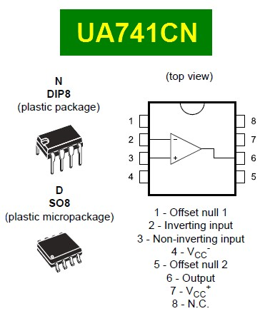

Figure 1. UA741CN Opamp with pin connections.

1. Differential Amplifier

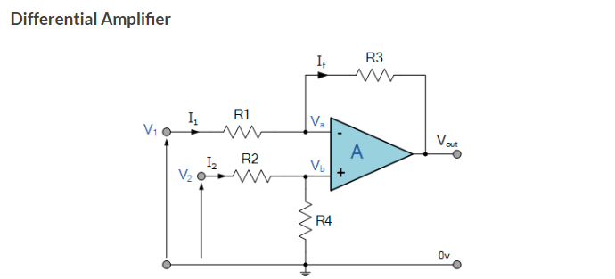

Figure 2. Differential Amplifier experiment setup.

# 1.1 Measurement Using a Subtractor Op-Amp Circuit

a) In this experiment, a subtractor op-amp circuit will be constructed and the output voltage will be measured. Carefully set up the op-amp circuit on a breadboard using resistors R1 (4.7k Ω), R2 (100 kΩ), R3 (5.6k Ω), and R4 (10k Ω). Set the input voltage V1 to 5V and V2 to 10V. Connect the op-amp's positive and negative supply voltages to ±10V. Measure the output voltage Vout using a multimeter. Note the output voltage and compare it with the theoretical values to evaluate the results. Then, change all resistors to 10k Ω, set V1 to 5V and V2 to 10V, and repeat the experiment. Finally, set V1 to 10V and V2 to 5V and repeat the experiment.

Table 1. DC voltage measurements.

|  |  |  |  |  |
| --- | --- | --- | --- | --- |
| V1 | V2 | Vout | VA | VB |
| +5V | +10V | ……. | ……. | ……. |
| +5V | +10V | ……. | ……. | ……. |
| +10V | +5V |  |  |  |

# Subtractor Amplifier with a Fixed Gain:

diyagram, çizgi, öykü gelişim çizgisi; kumpas; grafiğini çıkarma, teknik çizim içeren bir resim

Açıklama otomatik olarak oluşturuldu

Figure 2. Subtractor Amplifier with a Fixed Gain.

* Apply voltage V1=5, V2=10 circuit.
  + 1. Select R1 and R2 as 10k Ω and R3 and R4 as 1 kΩ. Integrate these resistors into the circuit, then reconstruct the circuit. Supply the op-amp with +10V and -10V, and measure the output voltage. Put your measurement results to Table 2, column
    2. change only R1 and R2 1 kΩ, then reconstruct the circuit and observe the output voltage.. Put your measurement results to Table 2, column
    3. Without disassembling the circuit, change R1 to 10 kΩ ,R2 to 100 kΩ, R3 to 5.6 kΩ , R4 to 2.7 kΩ then supply the op-amp with +10V and -10V. Measure the output voltage again and record the measurement in Table 2.
    4. Calculate T and put your result table . T is equal A .
    5. Note your observation in your experiment note field.
    6. NOTE : A (V1-V2)= VOUT .

Table 2. DC gain changes.

|  |  |  |
| --- | --- | --- |
|  | VOUT | T |
| A (R1=R2 10k Ω |R3=R4  1 k Ω ) | ……. | ……. |
| B (R1 and R2 1 k Ω) | ……. | ……. |
| C (R1 = 10 kΩ , R2 = 100 kΩ , R3 = 5.6 kΩ ,R4 = 2.7 kΩ) | ……. | ……. |

* 1. Instrumentation Amplifer:

diyagram, çizgi, plan, metin içeren bir resim

Açıklama otomatik olarak oluşturuldu



a) Set the input voltages to V2 = 8V and V1 = 5V and carefully integrate them into the circuit. Choose the resistor values as R1 = 1kΩ, R2 = 10kΩ, R3 = 10kΩ, and R4 = 10kΩ, and carefully integrate them into the op-amp. Do not forget to power the op-amp with a +10V positive supply and a -10V negative supply. Tip: You can use a voltage divider method to obtain 8V! Note the Vout values and potentiometer resistance in Table 1.3. Observe the change in Vout with the potentiometer and write your observations in the "Your Observation" section below.

Table 1.3. Instrumentation Amplifer: measurements.

|  |  |  |
| --- | --- | --- |
|  | Potentiometer resistance(kΩ) | Vout |
| potentiometer to 1 kΩ | ……. | ……. |
| potentiometer to 5 kΩ | ……. | ……. |
| potentiometer to 10 kΩ | ……. | ……. |

Note your observations here:

...............................................................................................................................................................................

...............................................................................................................................................................................

...............................................................................................................................................................................

...............................................................................................................................................................................

...............................................................................................................................................................................

### 2.1 Non-inverting Summing Amplifier :

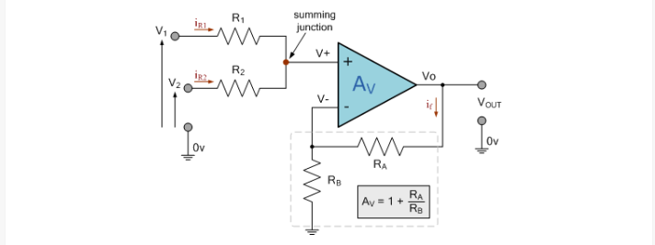



* **Select V1 = 2V and V2 = 1V and integrate them into the circuit. Hint: You can use the voltage divider principle!**

a) Select R1 = R2 = 10 kΩ as in the given circuit. Set RA = 10kΩ and RB = 100k Ω, and construct the circuit. Record the value at the V+ terminal and the Vout value Calculate the gain (Av) and add it to the table 4 . in the table below (do not forget to supply the op-amp with +10V and -10V!).

b) Change only the RB value in the circuit constructed in part a to 10 kΩ, measure Vout ,V+ voltage and repeat the experiment Calculate the gain (Av) and add it to the table. Write your observations in the space provided below. Record your measurements in Table 4 below. Write your observations in the space provided below.

Hint : V+.[1+(RA/RB)]=Vout

Table 4. Non-inverting Summing Amplifier measurements.

|  |  |  |  |
| --- | --- | --- | --- |
|  | V+ | Vout | AV |
| A( R1 = R2 = 10 kΩ RA = 10kΩ and RB = 100k Ω) | ……. | ……. | ……. |
| B(RB = 10kΩ) | ……. | ……. | ……. |

# NOTES

...............................................................................................................................................................................

...............................................................................................................................................................................

...............................................................................................................................................................................

...............................................................................................................................................................................

...............................................................................................................................................................................

...............................................................................................................................................................................

...............................................................................................................................................................................

...............................................................................................................................................................................

...............................................................................................................................................................................

...............................................................................................................................................................................

...............................................................................................................................................................................

...............................................................................................................................................................................

...............................................................................................................................................................................

...............................................................................................................................................................................

...............................................................................................................................................................................

...............................................................................................................................................................................

...............................................................................................................................................................................

...............................................................................................................................................................................

..............................................................................................................................................................

...............................................................................................................................................................................

...............................................................................................................................................................................

...............................................................................................................................................................................

...............................................................................................................................................................................

...............................................................................................................................................................................