# BSM304-Bilgisayar Mimarisi Lab. Çalışması (CPE304-Computer Architecture Lab. Study)

**TEMEL BİLGİSAYAR TASARIMI (BASIC COMPUTER DESIGN) - 4 BİT KAYDEDİCİ DEVRESİ (4 BIT REGISTER CIRCUIT)**

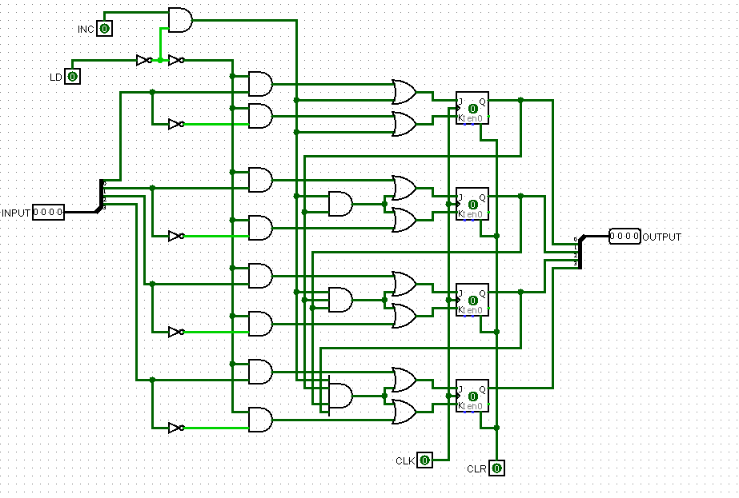

* İşlem Tablosu (Operation Table)

|  |  |  |  |  |  |  |
| --- | --- | --- | --- | --- | --- | --- |
| **CLK** | **INPUT (A)** | **INC** | **LD** | **CLR** | **OUTPUT (Q)** | **OPERATİON** |
| x | A | x | x | 1 | Q = 0 | Clear |
| 1 | A | 0 | 0 | 0 | Q = Q | No Change |
| 1 | A | 0 | 1 | 0 | Q = A | Load INPUT |
| 1 | A | 1 | 0 | 0 | Q = Q + 1 | Increment |