Hello everyone,
First of all, I would like to introduce myself. My name is Funda Demir, and I am an Electrical and Electronics Engineer. This semester, I will be teaching the Optimization course. Since this is my first year teaching this course, unfortunately I do not have clear information about the pass–fail statistics from previous semesters. However, I obtained the lecture notes from the instructor who taught the course last year and reviewed both these notes and the relevant textbooks.
Based on my review, I observed that the course has been taught in a highly theory-oriented manner, almost like a mathematics course, and that the midterm and final exams were prepared accordingly. The course content was usually written on the board and students took notes in that way.
This semester, I would like to make a change in how the course is delivered. As future engineers, it is essential for you to learn the theoretical foundations of optimization. However, even though there is no separate “application” hour in the course schedule, I would like to also show you the practical applications of the theoretical concepts. I believe that seeing how the formulas we use work in real-life engineering problems makes learning much more effective and permanent.
For this reason, I will not teach the course by writing everything on the board, as this method takes a significant amount of time. Instead, I will present the lectures using slides, and I will share these slides with you. In addition, I will show you the coding implementations of the formulas we learn theoretically. In this way, we will cover the course both theoretically and practically.The course will include:
- One midterm exam
- One final exam
- A group-based application project
In the application project, each group will be expected to solve a selected optimization problem.
My goal is to help you learn this course not only through formulas and proofs, but also by understanding it from an engineering perspective. I have several PDF books related to optimization, which you may use as supplementary resources throughout the course. In addition, there will be one main textbook that we will follow regularly during the semester.
I kindly ask you to follow the course regularly. I believe that if you study consistently, you will be able to learn this course comfortably and successfully.
There are also free certification programs offered by MATLAB. One of them is called MATLAB Onramp. By following the videos and answering the questions, you can earn a certificate. I will also require you to complete this and will add it as a component of your final grade. For now, I am researching this. Let’s make some progress with the topics first. I will share the code with you.
I would also like to share one important point with you. I do not have much experience or practice in speaking English. Therefore, I kindly ask for your understanding and support during the lectures. Please do not focus on possible language or speaking mistakes I may make. What matters most is that the content is delivered clearly and correctly.
I wish all of us a productive and successful semester based on mutual understanding. I will decide on this matter as we make progress.

OPTIMIZATION
Week 1: Introduction to Optimization
1. Introduction
Optimization is an interdisciplinary field that plays a fundamental role in solving engineering and scientific problems. In the context of computer engineering, optimization lies at the core of decision-making processes in many areas such as algorithm design, machine learning, network systems, embedded systems, and artificial intelligence.
A computer engineer is often in search of the “best solution.” This solution may refer to the fastest algorithm, the system with the lowest energy consumption, the model with the highest accuracy, or the architecture with the minimum cost. At this point, optimization enables the mathematical modeling of the problem and its systematic solution.
2. Definition of Optimization
Optimization is the problem of finding the best value of a function defined for a specific purpose under given conditions.
Mathematically, optimization problems are considered in two main forms:
- Minimization: The minimum value of the objective function is sought.
- Maximization: The maximum value of the objective function is sought.
In general terms, an optimization problem consists of an objective function and constraints that restrict this function.
2.1. What is an Optimization Problem?
In an optimization problem, the goal is to maximize or minimize a function. This function is called the objective function or performance index. It may represent quantities such as cost, profit, efficiency, size, shape, weight, or output. For most organizations, minimizing cost or maximizing profit is a primary objective. Some types of equipment, such as air conditioners or refrigerators, are designed according to different optimization criteria to provide higher efficiency in order to reduce the user’s energy consumption. However, this higher efficiency usually results in a higher cost for the user. In aerospace applications, minimizing weight is one of the most important criteria.
The variables appearing in the objective function are called design variables or decision variables. In structural optimization problems, these variables are usually the dimensions of a structure or material properties. Due to practical constraints, design variables can only take values within specified lower and upper bounds. For example, the maximum capacity of a machine is limited to a certain value. Design variables can be continuous (real-valued), discrete, binary, or integer. Although the majority of design variables in optimization problems are continuous, some variables may be discrete. For instance, pipe diameters are manufactured in standard sizes such as 1, 2, or 5 inches. If pipe diameter is used as a design variable in an optimization problem, it must be treated as a discrete variable. Otherwise, a physically meaningless value such as 3.25 inches could be obtained. Typical objective functions and design variables from different disciplines are given in Table 1.1.
Discipline | Design Variables | Objective Function
Manufacturing | Productivity from different machines | Minimize cost
Corporate (Company) | Capital obtained from projects | Maximize net present value
Airline | Different aircraft, different routes | Maximize profit
Aerospace | Propellant ratios at different stages | Maximize payload
Agriculture | Different crops | Maximize yield
Biology | Gene interactions | Network stability
Electronics | Device dimensions | Minimize power consumption
Portfolio | Investment in stocks/bonds | Maximize return
Thermal Systems | Dimensions and material properties | Minimize heat load
TABLE 1.1 Typical Optimization Problems

An optimization problem can be expressed mathematically as follows:
Minimize:
$$f\left(x\right) (1.1)$$
Subject to:
$$g_{i}\left(x\right)≤0i=1,2,…,m<n (1.2) \\ h_{j}\left(x\right)=0j=1,2,…,r<n (1.3)$$
Here, $x$is a vector consisting of $n$design variables and is defined as:
$$x=[x_{1} x_{2} … x_{n}]^{T}$$
The functions $f$, $g_{i}$, and $h_{j}$are differentiable functions. The design variables are bounded by lower bounds $x^{l}$and upper bounds $x^{u}$. The functions $g_{i}$are called inequality constraints, while the functions $h_{j}$are called equality constraints. As an example from the aerospace industry, the dimensions of a spacecraft being restricted to fit inside the rocket fairing can be given. Such limitations constitute the constraints of the optimization problem. Constraints are functions of the design variables.
In general, the number of equality and inequality constraints is less than the number of design variables ($n$). If the design variables satisfy all constraints, they form the feasible set, and each element in this set is called a feasible point. The design variables at which the objective function $f(x)$attains its minimum value are denoted by $x^{*}$. If an optimization problem has no constraints, it is called an unconstrained optimization problem. If the objective function and all constraints are linear with respect to the variables $x$, such problems are called Linear Programming Problems (LPP).
1.3 Modeling of an Optimization Problem
Modeling refers to the mathematical representation of observations related to a problem using the fundamental building blocks of mathematics, such as addition, subtraction, multiplication, division, functions, and numbers with appropriate units. The observations mentioned here are data obtained by varying certain parameters through experiments related to the problem under consideration. Mathematical models also enable the prediction of the behavior of a problem for different input values. If the model does not produce the expected results, it must be improved by conducting new experiments.
A mathematical model is not unique for different problems, since observational data may be defined as discrete data over certain intervals or may be continuous, and may vary in different forms (for example, linear or quadratic) depending on changes in the input parameters. Below, some simple mathematical models of different physical phenomena are presented.
The relationship between the pressure (P), volume (V), and temperature (T) of a gas is given by Boyle’s law as follows:
$$P⋅V=kT (1.4)$$
where $k$ is a constant. Using this mathematical model, the behavior of the gas (e.g., pressure) can be predicted for different input parameters (e.g., temperature) when the volume of the gas is kept constant.
As an example from economics, a mathematical model for the supply–demand problem can be considered. The price of a product is to be determined so as to maximize profit. When the price of the product is set high, the profit per unit increases; however, demand may decrease. Similarly, when the price is set low, the profit per unit decreases, but demand may increase. In general, demand (D) is expressed as a function of price (P) as follows:
$$D=c_{1}+c_{2}P^{2}(1.5)$$
where $c_{1}$and $c_{2}$are constants.
Some problems can be expressed mathematically in the form of differential equations. A differential equation contains an unknown function and its derivatives. Since a derivative represents the rate of change of a function, a differential equation describes a continuously varying quantity and its rate of change. For example, the change in the temperature of an object with respect to time is proportional to the difference between the temperature of the object ($T$) and the ambient temperature ($T_{s}$), and can be expressed by the following differential equation:
$$\frac{dT}{dt}=-k(T-T_{s})(1.6)$$
Equation (1.6) is also known as Newton’s law of cooling. The solution of a differential equation is a function that satisfies the equation for all values of the independent variable within its domain. During an experiment, the independent variables are varied, and the dependent variable responds depending on the nature of the experiment. A differential equation may have more than one solution; these are called general solutions. One of these solutions is referred to as a particular solution. In many cases, differential equations have closed-form solutions. For example, the solution of the differential equation representing Newton’s law of cooling is given as:
$$T\left(t\right)=T_{s}+\left(T_{0}-T_{s}\right)e^{-kt} (1.7)$$
However, not every problem has a closed-form solution; for such problems, numerical simulation methods are used.
Therefore, through modeling, both the objective function and the constraint functions of an optimization problem can be formulated. Subsequently, different optimization techniques can be applied to solve these problems. The following examples demonstrate how an optimization problem can be formulated by defining objective and constraint functions.
Example 1.1: Diet Problem
In a diet problem, an individual must meet daily nutritional requirements at the minimum possible cost using an available food menu. The available foods are milk, fruit juice, fish, French fries, and chicken. The nutritional requirements to be satisfied include protein, vitamins, calcium, calories, and carbohydrates. Table 1.2 presents the cost per serving of each food item (in dollars), the amount of each nutrient per serving, and the minimum daily nutritional requirements in the last column.
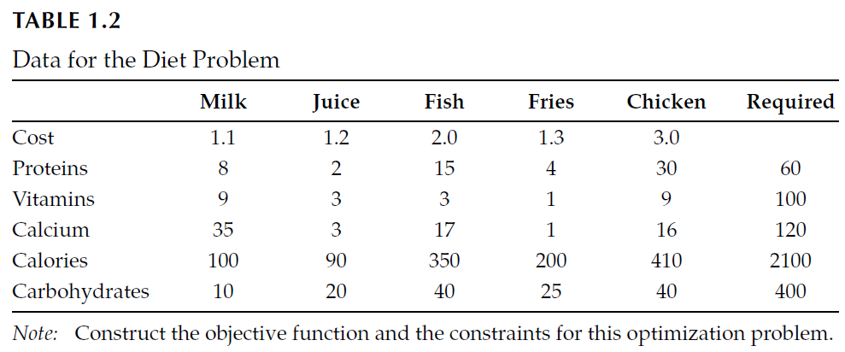
The first step is to select the design variables for the problem. In this problem, it is appropriate to choose the amounts of milk, fruit juice, fish, French fries, and chicken as the design variables. Let these variables be denoted by $x_{1},x_{2},x_{3},x_{4},$and $x_{5}$, respectively.
The objective function and the constraints are functions of these design variables. In this problem, the objective function is to minimize the total cost of the purchased food items. For example, if $x_{3}$represents the amount of fish and its unit price is 2 dollars, then the total cost of fish is $2x_{3}$. Similarly, the costs of the other food items can be calculated. Accordingly, the total cost is expressed as:
$$1.1x_{1}+1.2x_{2}+2x_{3}+1.3x_{4}+3x_{5}$$
This objective function is a linear function.
Meeting the nutritional requirements is defined as a constraint. For example, if the minimum protein requirement is 60 units, this constraint can be written as:
$$8x_{1}+2x_{2}+15x_{3}+4x_{4}+30x_{5}≥60(1.8)$$
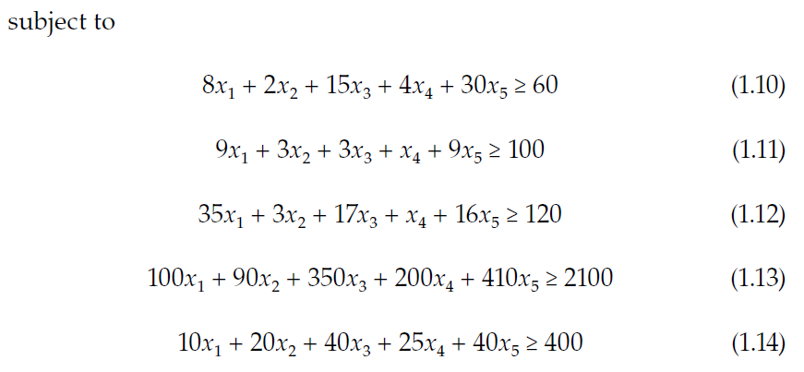
Similarly, constraints can be written for the other nutrients. Thus, the diet problem is formulated as follows:
Example 1.2: Cylindrical Can Design
A beverage manufacturer wishes to produce a cylindrical can with a volume of 330 mL. The objective is to determine the dimensions of the can such that the amount of material used is minimized.
The design variables are the radius ($x_{1}$) and the height ($x_{2}$) of the can, measured in millimeters. A cylindrical can consists of a curved lateral surface and two circular end caps. The lateral surface area is $2πx_{1}x_{2}$, and the area of the two circular caps is $2πx_{1}^{2}$. Accordingly, the total surface area to be minimized is:
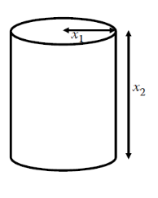
Surface area of the can:
$$2πx_{1}x_{2}+2πx_{1}^{2} (1.15)$$
Volume of the can:
$$πx_{1}^{2}x_{2}$$
which must be equal to $330\text{ mL}=330,000{\text{ mm}}^{3}$.
The optimization problem is formulated as follows:
Minimize:
$$2πx_{1}x_{2}+2πx_{1 }^{2}(1.15)$$
Subject to:
$$πx_{1}^{2}x_{2}=330,000 (1.16)$$
In this problem, the constraint is an equality constraint; that is, the volume must be exactly 330 mL—neither more nor less.
Example 1.3: Re-entry Capsule Shape Optimization
The shape of a re-entry capsule consists of a spherical nose, a conical body, and a flared aft section (Figure 1.3). The design variables defining the capsule configuration are the nose radius ($R_{n}$), cone length ($l_{1}$), cone angle ($θ_{1}$), flare length ($l_{2}$), and flare angle ($θ_{2}$).
By varying the design variables, the total surface area of the capsule ($A$) is to be minimized. In order to accommodate the electronic equipment, the capsule volume must be at least $1 {\text{m}}^{3}$. The design variables are defined within specified lower and upper bounds:

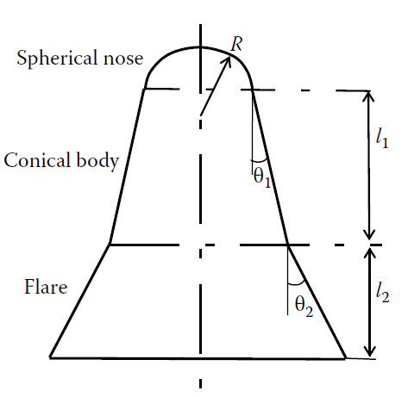
- $R_{n}$: 0.4 – 0.6 m
- $l_{1},l_{2}$: 0.4 – 0.8 m
- $θ_{1}$: 22° – 27°
- $θ_{2}$: $\left(θ_{1} + 5)^{∘}\right.$– $\left(θ_{1} + 10)^{∘}\right.$
The total surface area and volume of the capsule are calculated using the following equations:
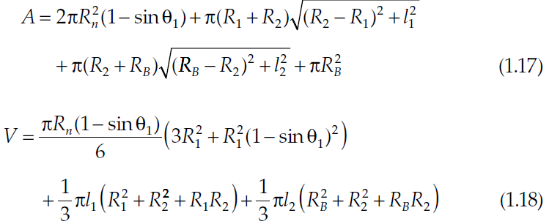
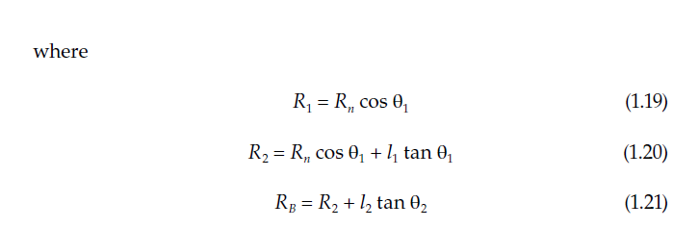
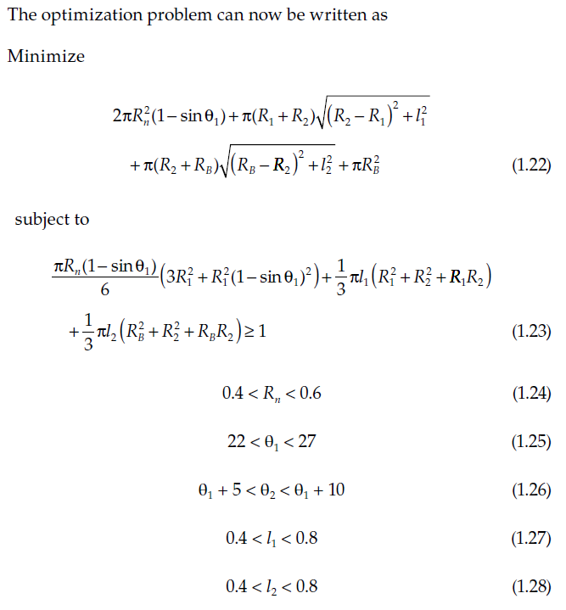

Example 1.4
The optimal diameter ($d$) of a solid steel shaft whose mass ($M$) is to be minimized is to be determined. At the same time, the first natural frequency of the shaft in a cantilever beam configuration must be greater than 20 Hz. This problem will be formulated as an optimization problem by defining the objective function and the constraint.
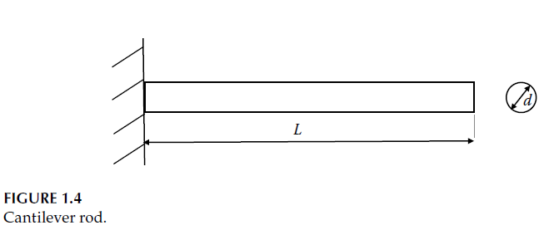
Let the length of the shaft be $L$(Figure 1.4) and its density be $ρ$. The mass of the shaft is given by:
$$M=\left(\frac{πd^{2}}{4}\right)Lρ(1.29)$$
In this problem:
- Design variable: $d$(shaft diameter)
- Objective: Minimize the mass of the shaft
- Constraint: The first bending (cantilever) natural frequency must be greater than 20 Hz
Accordingly, the optimization problem is formulated as follows:
Minimize:
$$M(d)=\left(\frac{πd^{2}}{4}\right)Lρ$$
For this problem, the shaft length is given as $L=1$m and the density is $ρ=7800 {\text{kg/m}}^{3}$.
The first natural frequency of a cantilever shaft is given by:
$$f_{1}=\left(\frac{3.5156}{2π}\right)\sqrt{\frac{EI}{kL^{4}}} (1.30)$$
Here, $E$is Young’s modulus of steel, with a value of $2×{10}^{11} {\text{N/m}}^{2}$, and $k$represents the mass per unit length.
The area moment of inertia ($I$) of the shaft is defined as:
$$I=\frac{πd^{4}}{64} (1.31)$$
Based on this information, the optimization problem can be written as:
Minimize:
$$M\left(d\right)=\left(\frac{π}{4}\right)d^{2}Lρ (1.32)$$
Subject to:
$$\left(\frac{3.5156}{2π}\right)\sqrt{\frac{EI}{kL^{4}}}≥20 (1.33)$$
Note: At this stage, it is not necessary to know the formulas and detailed calculations. For now, the main objective is to understand that, when solving an optimization problem, we use a mathematical model of the system. In accordance with the objective, we determine the maximum or minimum value of the objective function and include the relevant constraints of the problem.
1.4 Solution by the Graphical Method
After formulating optimization problems in the previous section, it is natural to seek their solutions. The graphical method is a simple and intuitive technique used to find the optimal solution for problems with at most two or three design variables. When more than three design variables are involved, representing the optimization problem graphically becomes quite complicated.
In the optimization problem given in Example 1.2, two design variables ($x_{1}$ and $x_{2}$) must be determined such that the total surface area is minimized while satisfying the equality constraint. To plot the graph for this problem, a MATLAB® code named graph_examp12.m, provided at the end of the book, was used.
In the code, the variable $x_{1}$was varied between 1 and 100 mm, and the variable $x_{2}$was varied between 1 and 200 mm. The surface area was calculated as a function of $x_{1}$and $x_{2}$, and contour curves of the objective function were plotted (Figure 1.5). Subsequently, the constraint function was plotted on the same graph and indicated by a star (*) symbol. Since this problem is an equality-constrained optimization problem, the minimum value of the objective function corresponds to the contour curve with the smallest value that is tangent to the constraint curve.
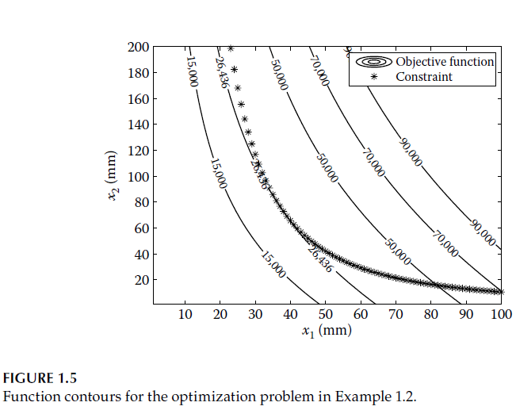
The minimum value of the objective function is 26,436 mm², which corresponds to the design variables $x_{1}=37.45$mm and $x_{2}=74.9$mm. It can be observed that, at the minimum point, the height of the can is twice its radius. This result can also be proven analytically using basic differential calculus methods.
Similarly, in the optimization problem given in Example 1.4, there is only a single design variable, namely the shaft diameter ($d$). This problem can also be solved using the graphical method. For this purpose, a MATLAB code named graph_examp14.m has been written.
When the code is executed, the graph shown in Figure 1.6 is obtained. As the value of the objective function (along the y-axis) decreases with decreasing values of the design variable (along the x-axis), the value of the constraint function also decreases as the design variable decreases. In the optimization problem, it is specified that the value of the constraint must be equal to or greater than 20 Hz.
Therefore, the optimal solution corresponds to $d=0.0283$m. At this point, the value of the objective function (the mass) is 4.94 kg, and the value of the constraint function is 20 Hz.
