2. Week
1.5 Convexity
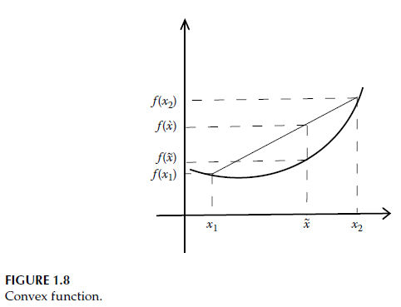
Consider two design points $x_{1}$and $x_{2}$belonging to the set $S$. If the entire line segment connecting these two points also lies within the set $S$, then $S$is called a convex set. On the other hand, if the line segment connecting $x_{1}$and $x_{2}$does not lie entirely within the set $S$, then the set is referred to as a non-convex set. Examples of convex and non-convex sets are shown in Figure 1.7.
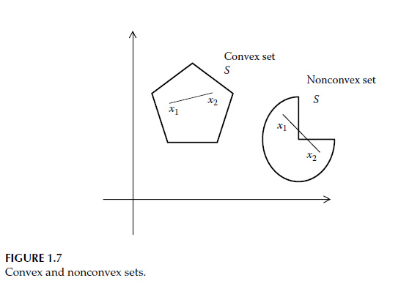
In optimization problems, it is often necessary to examine whether a function is convex. Consider a single-variable function $f(x)$shown in Figure 1.8 and two points on this function, $x_{1}$and $x_{2}$. The corresponding function values at these points are $f(x_{1})$and $f(x_{2})$, respectively. Now, consider an arbitrary point $\tilde{x}$located on the line segment connecting $x_{1}$and $x_{2}$.
If the value $f(\tilde{x})$is less than or equal to the function value at the corresponding point $\hat{x}$on the straight line connecting $f(x_{1})$and $f(x_{2})$, then the function $f(x)$is called a convex function; that is, this condition must hold for convexity.
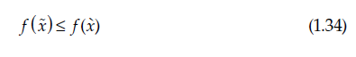
Example: Very Simple Numerical Example
Convex Function
$$f(x)=x^{2} \\ x_{1}=-1⇒f(x_{1})=1 \\ x_{2}=1⇒f(x_{2})=1$$Midpoint:
$$\hat{x}=0⇒f(0)=0$$
Value on the straight line between $f(x_{1})$and $f(x_{2})$:
$$\frac{1}{2}(1+1)=1$$Result:
$$0≤1✓\text{Convex}$$
Example of a Non-Convex Function
$$f(x)=-x^{2} \\ f(0)=0$$Value on the straight line:
$$-1 \\ 0≰-1⇒\text{Not convex}$$In other words, a function is convex if it lies below the line segment connecting any two of its points.
Functions such as $x^{2}$, $e^{x}$, etc., are examples of convex functions. If $f(x)$is a convex function, then $e^{f(x)}$is also a convex function. Therefore, the functions $e^{x^{2}}$and $e^{e^{x}}$are also convex.
To verify that these functions are indeed convex, their graphs can be plotted in MATLAB (see convexity.m) as shown in Figure 1.9.
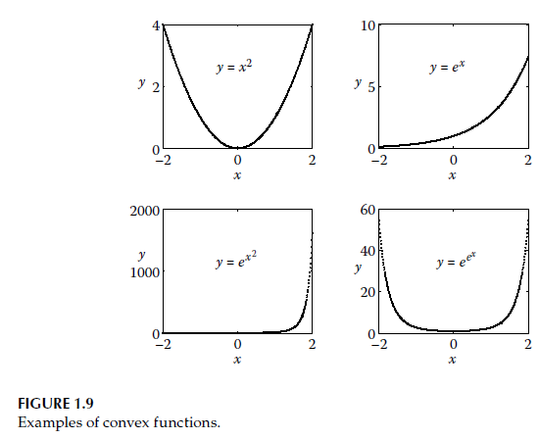
The concept of convexity is important because it implies that a function has only a single minimum. Therefore, a convex function has a global minimum.
If a function is not convex (non-convex), the obtained optimum point may be a local optimum (see Figure 1.10). Functions that have more than one minimum or maximum are called multimodal functions.
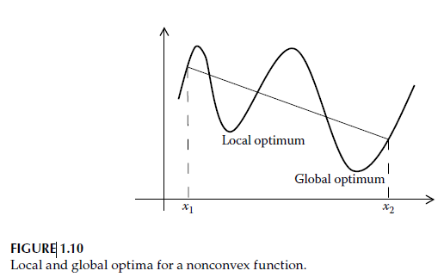
Traditional gradient-based algorithms often struggle to find the global optimum solution. Moreover, due to the presence of constraints, the designer may need to search for an alternative solution instead of the global optimum. For example, at the global optimum, the design variables may make manufacturing difficult, or the required material may be too expensive.
Therefore, the designer’s task is challenging: it is not only about finding the global optimum solution, but also about identifying possible local optimum solutions.
Let us explain this with a simple and concrete example.
Example: Cylindrical Can Design
Problem
We are designing a cylindrical can.
Objective:
→ Minimize the amount of material used (surface area)
Design variables:
- $x_{1}$: radius
- $x_{2}$: height
Constraint:
→ The volume of the can is fixed (for example, 330000 mm³)
1️⃣ Global Optimum (Mathematically Optimal)
When this problem is solved, the global optimum is obtained under the condition:
$$x_{2}=2x_{1}$$At this point:
- The surface area is minimized mathematically.
- A gradient-based algorithm can easily find this solution.
2️⃣ However, Practical Issues Arise
Suppose that at the optimum:
$$x_{1}=25\text{ mm},x_{2}=50\text{ mm}$$However:
- This height-to-radius ratio causes manufacturing difficulties.
- Sealing the lid becomes challenging.
- A thin wall thickness is required → special alloy is needed.
- The cost increases significantly
Mathematically, this solution is optimal; however, from an engineering perspective, it may not be practical or suitable.
3️⃣ What Happens with an Alternative (Local Optimum) Solution?
The designer may do the following:
- Slightly increase the radius
- Slightly decrease the height
For example:
$$x_{1}=30\text{ mm},x_{2}=37\text{ mm}$$
This solution:
- Has a slightly larger surface area
- But:
  - Standard sheet thickness can be used
  - Manufacturing becomes easier
  - The cost is significantly reduced
➡️ This is a local optimum.
4️⃣ Why Do Gradient-Based Methods Struggle?
A gradient-based method:
- Moves in the direction of the steepest descent
- Converges to a single point
- Depends on the initial starting point
- Does not automatically search for alternative solutions
For this reason, designers also want to identify local optima other than the global optimum.
5️⃣ A Very Simple Real-Life Analogy
- Global optimum:
→ The shortest path (a mountain road)
- Local optimum:
→ A slightly longer but paved and safer road
Navigation systems suggest the shortest path. However, drivers do not always choose it.
The global optimum may be mathematically the best solution; however, due to manufacturing, cost, and practical constraints, designers often prefer more feasible local optimum solutions. Dont forget the differences of these two terms.
Another point about this subject:
If $f(x)$is a convex function, then $-f(x)$is a concave function. Similarly, if $f(x)$is a concave function, then $-f(x)$is a convex function. In Figure 1.11, both the convex and concave forms of the function $y=e^{x}$are illustrated.
In general, optimization algorithms are developed to minimize the objective function. As discussed earlier, convexity plays an important role when searching for minimum points. However, in some optimization problems, the objective function $f(x)$may need to be maximized.
A maximization problem can be converted into a minimization problem by changing the sign of the objective function to $-f(x)$.
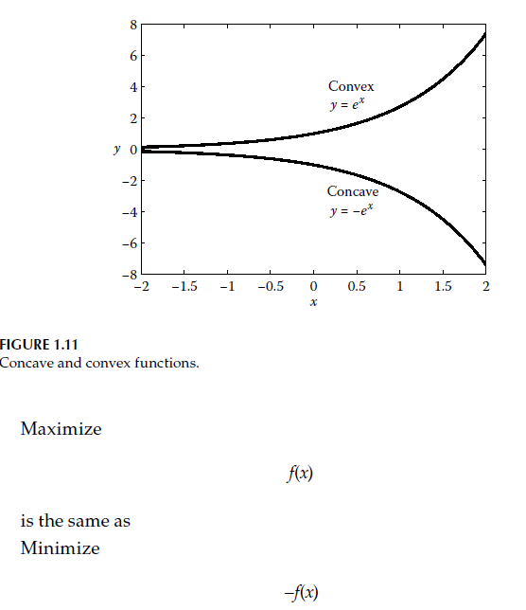
1.6 Gradient Vector, Directional Derivative, and Hessian Matrix
The derivative or gradient of a function $f(x)$at point $x$is generally denoted by $f^{'}(x)$, and it represents the slope of the tangent at that point (see Figure 1.12). That is,
$$f^{'}\left(x\right)=\tan{θ} (1.35)$$
where $θ$ is the angle between the tangent line and the horizontal axis.
In the direction of the gradient, the change in the function value is maximum. Therefore, gradient information provides the search direction required to find the maximum or minimum of a function.
$$y=e^{x} \\ y=-e^{x}$$
Since most optimization problems are generally nonlinear, the derivative $f^{'}(x)$often needs to be computed numerically. To calculate the derivative of a function at a specific point, the forward difference, backward difference, and central difference methods can be used.
If the value of the function $f(x)$at point $x$is known, the value of the function at a neighboring point $x+Δx$can be expressed using the Taylor series expansion as follows:
$$f(x+Δx)=f(x)+Δxf^{'}(x)+\frac{\left(Δx)^{2}\right.}{2!}f^{''}(x)+\frac{\left(Δx)^{3}\right.}{3!}f^{'''}(x)+⋯(1.36)$$
If Equation (1.36) is rearranged, we obtain:
$$\frac{f(x+Δx)-f(x)}{Δx}=f^{'}(x)+\frac{Δx}{2}f^{''}(x)+\frac{\left(Δx)^{2}\right.}{3!}f^{'''}(x)+⋯(1.37)$$
The forward difference formula used to compute the derivative of a function can be written as:
$$f^{'}(x)=\frac{f(x+Δx)-f(x)}{Δx}+O(Δx)(1.38)$$
Explanation: What does $f(x+Δx)$mean?
It represents the value of the function after moving forward from point $x$by an amount $Δx$.
That is:
- $x$→ independent variable
- $Δx$→ a very small increment
- $x+Δx$→ a point slightly ahead of $x$
- $f(x+Δx)$→ the value of the function at this new point
The term $O(Δx)$indicates that this formula has first-order accuracy.
Similarly, the backward difference formula can be written in a comparable way.
Using the forward and backward difference formulas, the central difference formula can be derived as:
$$f^{'}(x)=\frac{f(x+Δx)-f(x-Δx)}{2Δx}+O(Δx^{2})(1.40)$$
Since the central difference formula has second-order accuracy, it provides higher accuracy than the forward or backward difference methods when computing derivatives.
Similarly, the second derivative can be calculated using:
$$f^{''}(x)=\frac{f(x+Δx)-2f(x)+f(x-Δx)}{\left(Δx)^{2}\right.}(1.41)$$
Note:
Physical / Geometrical Meaning
- First derivative → slope (rate of increase or decrease)
- Second derivative → rate of change of the slope (whether the curve is concave upward or downward)
Why Is This Important in Optimization?
At a point:
- If $f^{'}(x)=0$→ critical point
- If $f^{''}(x)>0$→ local minimum
- If $f^{''}(x)<0$→ local maximum
- If $f^{''}(x)=0$→ test is inconclusive (may be an inflection point)
Example
Now consider the following function:
$$f\left(x\right)=2\sin\left(5x\right)+3x^{3}-2x^{2}+3x-5 (1.42)$$
Let us compute the first and second derivatives of this function using the central difference formula, where $x$varies between 0.1 and 1.0 and $Δx=0.01$.
The analytical derivatives are:
$$f^{'}(x)=10cos⁡(5x)+9x^{2}-4x+3 \\ f^{''}(x)=-50sin⁡(5x)+18x-4$$
Our function is:
$$f(x)=2sin⁡(5x)+3x^{3}-2x^{2}+3x-5$$Let us write the central difference formula:
$$f^{'}\left(x\right)=\frac{f\left(x+Δx\right)-f\left(x-Δx\right)}{2Δx} f^{'}(x)≈\frac{f(x+0.01)-f(x-0.01)}{0.02}f^{'}(x)$$
Now, we write the expressions for $f(x+0.01)$and $f(x-0.01)$.
$$f(x+0.01)$$
$$f(x+0.01)=2sin⁡(5(x+0.01))+3(x+0.01)^{3}-2(x+0.01)^{2}+3(x+0.01)-5$$
$$f(x-0.01)$$
$$f(x-0.01)=2sin⁡(5(x-0.01))+3(x-0.01)^{3}-2(x-0.01)^{2}+3(x-0.01)-5$$
Central Difference Result (General Form)
This expression provides the numerical derivative.
For this purpose, a MATLAB code named derivative.m was written, and the obtained results were plotted in Figure 1.13.
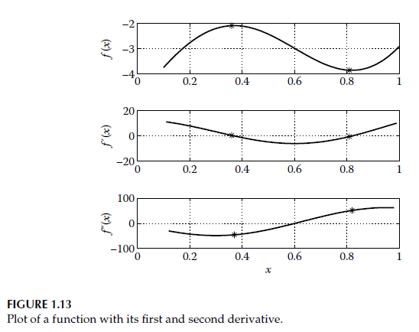
In Figure 1.13, the upper plot shows the variation of $f(x)$with respect to $x$. It is observed that the function has one maximum and one minimum point, and these points are indicated with an asterisk (*).
In the second plot, the derivative of the function is drawn. It is noteworthy that at the maximum and minimum points of the function, $f^{'}(x)=0$.
From the third plot, it is observed that at the minimum point $f^{''}(x)≥0$, while at the maximum point $f^{''}(x)≤0$. The second derivative provides information about the curvature of the function.
For some functions, for example $f(x)=x^{3}$, at the point $x=0$, both $f^{'}(x)=0$and $f^{''}(x)=0$. In such cases, it is necessary to examine higher-order derivatives. In this example, $f^{'''}(x)=6$, which is nonzero.
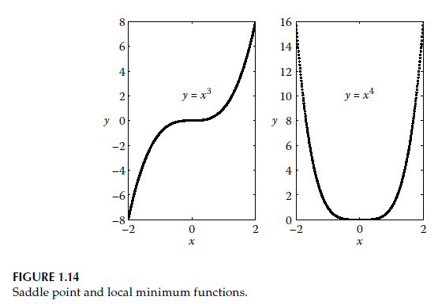
If the first nonzero higher-order derivative is denoted by $n$:
- If $n$is odd, then $x^{*}$is an inflection point or a saddle point.
- If $n$is even, then $x^{*}$is a local optimum point.

Therefore, for the function $f(x)=x^{3}$, the point $x^{*}=0$is an inflection point, since the first nonzero derivative is of odd order (the third derivative).
Similarly, it can be shown that the function $f(x)=x^{4}$has a local minimum at $x^{*}=0$. These two functions are plotted in Figure 1.14.

So far, we have considered derivatives of single-variable functions only. The gradient is a vector that consists of the partial derivatives of a function with respect to its design variables $\left(x_{1},x_{2},…,x_{n}\right)$, and it is mathematically expressed as:
$$∇f=\left[\begin{aligned}\frac{∂f}{∂x_{1}} \\ \frac{∂f}{∂x_{2}} \\ ⋮ \\ \frac{∂f}{∂x_{n}}\end{aligned}\right](1.43)$$
For Example 1.2, let us plot the tangent and the gradient at a given point $\left(x_{1} , x_{2}\right)$on the contour (level curve) of a function.
In the single-variable case, it was previously shown that the tangent and the gradient at any point of a function are the same (see Figure 1.12).
However, in the case of two variables, the tangent is different for each contour (level curve) of the function, and the function value remains constant along the tangent direction. That is, along a tangent direction,
$$\frac{∂f}{∂x_{1}}Δx_{1}+\frac{∂f}{∂x_{2}}Δx_{2}=0(1.44)$$
holds true.
The gradient is perpendicular to the tangent direction. To demonstrate this, a MATLAB code named grad.m was written, and when executed, it produced the output shown in Figure 1.15.
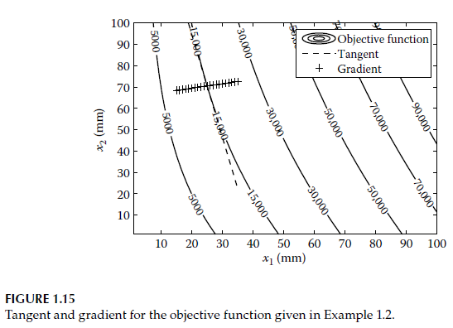
On the contour (level curve) of the function with value 15,000, the point $\left(25 , 70.493\right)$was selected, where the tangent and the gradient were to be plotted. Using Equation (1.44), the following expression can be written:
$$Δx_{2}=-\frac{∂f/∂x_{1}}{∂f/∂x_{2}} Δx_{1}(1.45)$$
Using the incremental relationship given in Equation (1.45), a tangent can be drawn at the point $\left(25 , 70.493\right)$.
If the slope of the tangent is denoted by $m_{t}$, then the slope of the gradient $m_{g}$can be calculated from the following relation:
$$m_{g} m_{t}=-1 (1.46)$$
Now, consider the functions $f_{1}(x_{1},x_{2},x_{3})$, $f_{2}(x_{1},x_{2},x_{3})$, and $f_{3}(x_{1},x_{2},x_{3})$, each depending on three variables $x_{1},x_{2},x_{3}$. The gradients of these functions can be collected into a single matrix called the Jacobian matrix (J), which is mathematically expressed as:
$$[J]=\left[\begin{matrix}\frac{∂f_{1}}{∂x_{1}} & \frac{∂f_{1}}{∂x_{2}} & \frac{∂f_{1}}{∂x_{3}} \\ \frac{∂f_{2}}{∂x_{1}} & \frac{∂f_{2}}{∂x_{2}} & \frac{∂f_{2}}{∂x_{3}} \\ \frac{∂f_{3}}{∂x_{1}} & \frac{∂f_{3}}{∂x_{2}} & \frac{∂f_{3}}{∂x_{3}}\end{matrix}\right](1.47)$$
In constrained optimization problems, moving in the direction of the gradient may sometimes lead into an infeasible region. In such cases, it is desirable to move along a different search direction, and the rate of change of the function in that direction must be known.
The directional derivative gives the instantaneous rate of change of a function in a specified direction. If $u$is a unit vector, then the directional derivative of $f(x)$in the direction of $u$is expressed as:
$$∇f(x)^{T}u$$
The Hessian matrix (H) represents the second derivatives of a function with multiple variables. For a three-variable function $f(x_{1},x_{2},x_{3})$, the Hessian matrix is written as:
$$[H]=\left[\begin{matrix}\frac{∂^{2}f}{∂x_{1}^{2}} & \frac{∂^{2}f}{∂x_{1}∂x_{2}} & \frac{∂^{2}f}{∂x_{1}∂x_{3}} \\ \frac{∂^{2}f}{∂x_{2}∂x_{1}} & \frac{∂^{2}f}{∂x_{2}^{2}} & \frac{∂^{2}f}{∂x_{2}∂x_{3}} \\ \frac{∂^{2}f}{∂x_{3}∂x_{1}} & \frac{∂^{2}f}{∂x_{3}∂x_{2}} & \frac{∂^{2}f}{∂x_{3}^{2}}\end{matrix}\right](1.48)$$
At a minimum point of a function, the Hessian matrix must be positive definite. A matrix is positive definite if all of its eigenvalues are positive.
For a square matrix, there exists a nonzero vector such that when it is multiplied by the matrix, the resulting vector differs from the original vector only by a scalar multiple. This nonzero vector is called an eigenvector, and the scalar multiplier is called an eigenvalue.
Now, let us examine the eigenvalues of the following matrix by running the MATLAB code positive_definite.m:
$$H=\left[\begin{matrix}2 & 1 & 1 \\ 1 & 2 & 1 \\ 0 & 2 & 3\end{matrix}\right](1.49)$$
The eigenvalues of the matrix are 1, 1.5858, and 4.4142.
Since all eigenvalues are positive, this matrix is positive definite.
Explanation: Example of Finding Eigenvalues
Steps to Find Eigenvalues
1. Form the characteristic matrix
$$A-λI$$
where
- $I$is the identity matrix
- $λ$is the eigenvalue (unknown scalar)
2. Set the determinant equal to zero
$$det⁡(A-λI)=0$$
This equation is called the characteristic equation.
3. Solve the equation
The roots of the resulting polynomial are the eigenvalues of the matrix.

Example (2×2 Matrix)
$$A=\left[\begin{matrix}2 & 1 \\ 1 & 2\end{matrix}\right]$$
Step 1
$$A-λI=\left[\begin{matrix}2-λ & 1 \\ 1 & 2-λ\end{matrix}\right]$$
Step 2
$$det⁡(A-λI)=(2-λ)^{2}-1$$
Step 3
$$\left(2-λ)^{2}-1=0\right. \\ λ^{2}-4λ+3=0 \\ (λ-3)(λ-1)=0$$
Eigenvalues:
$$λ_{1}=3,λ_{2}=1$$
Example 1.5
For the following function, write the gradient and the Hessian matrix:
$$f(x)=x_{1}^{2}+x_{1}x_{2}+x_{2}^{2}+x_{3}^{2}-x_{2}x_{3}+4x_{1}+5x_{2}+2x_{3}$$
Also, find the directional derivative of the function at the point $\left(1 , 1 , 1\right)$in the direction:
$$d=\left[\begin{aligned}1 \\ 2 \\ 3\end{aligned}\right]$$
Partial Derivatives
$$\frac{∂f}{∂x_{1}}=2x_{1}+x_{2}+4 \\ \frac{∂f}{∂x_{2}}=x_{1}+2x_{2}-x_{3}+5 \\ \frac{∂f}{∂x_{3}}=2x_{3}-x_{2}+2$$
Gradient Vector
$$∇f(x)=\left[\begin{aligned}2x_{1}+x_{2}+4 \\ x_{1}+2x_{2}-x_{3}+5 \\ 2x_{3}-x_{2}+2\end{aligned}\right]$$
Hessian Matrix
The Hessian matrix consists of second partial derivatives and is symmetric:
$$H=\left[\begin{matrix}2 & 1 & 0 \\ 1 & 2 & -1 \\ 0 & -1 & 2\end{matrix}\right]$$
Unit Vector in the Direction of $d$
Since $d=(1,2,3)$,
The directional derivative is taken with a unit vector, which is why we normalize it:
$$∥d∥=\sqrt{1^{2}+2^{2}+3^{2}}=\sqrt{1+4+9}=\sqrt{14} \\ u=\frac{d}{∥d∥}=\frac{1}{\sqrt{14}}\left[\begin{aligned}1 \\ 2 \\ 3\end{aligned}\right]=\left[\begin{aligned}1/\sqrt{14} \\ 2/\sqrt{14} \\ 3/\sqrt{14}\end{aligned}\right]$$
$$∥d∥=\sqrt{1^{2}+2^{2}+3^{2}}=\sqrt{14} \\ u=\frac{d}{∥d∥}=\left[\begin{aligned}\frac{1}{\sqrt{14}} \\ \frac{2}{\sqrt{14}} \\ \frac{3}{\sqrt{14}}\end{aligned}\right]$$
Directional Derivative at (1,1,1)
The directional derivative formula is:
$$∇f(x)^{T}u$$
First compute the gradient at (1,1,1):
$$∇f(1,1,1)=\left[\begin{aligned}2+1+4 \\ 1+2-1+5 \\ 2-1+2\end{aligned}\right]=\left[\begin{aligned}7 \\ 7 \\ 3\end{aligned}\right]$$
Thus,
$$∇f(1,1,1)^{T}=[ 773 ]$$
And we find before:
$$u=\left[\begin{aligned}1/\sqrt{14} \\ 2/\sqrt{14} \\ 3/\sqrt{14}\end{aligned}\right]$$
Now compute the inner product:
$$7⋅\frac{1}{\sqrt{14}}+7⋅\frac{2}{\sqrt{14}}+3⋅\frac{3}{\sqrt{14}}=\frac{7+14+9}{\sqrt{14}}=\frac{30}{\sqrt{14}}$$
Therefore, the directional derivative is:
$$\boxed{\frac{30}{\sqrt{14}}}$$
1.7 Linear and Quadratic Approximations
In optimization, the quadratic (second-order) approximation of a function is frequently preferred because certain solution methods, such as Newton’s method, exhibit faster convergence for this type of function. As discussed in a previous section, the Taylor series expansion can be used to obtain either a linear or a quadratic approximation of a function by appropriately selecting the number of terms retained in the series.
To illustrate the linear and quadratic approximations of the function $e^{-x}$, a MATLAB code named quadr.m was written (see Figure 1.16).
The Taylor series expansion can easily be extended to a function of $n$variables and is expressed as:
$$f(x+Δx)=f(x)+∇f(x)^{T}Δx+\frac{1}{2}Δx^{T}HΔx+⋯(1.50)$$
For the linear approximation, only the gradient term is used and the Hessian term is neglected.
For the quadratic approximation, the Hessian term is included in addition to the gradient term.
As in Example 1.2, for a two-variable function, a MATLAB code named quadr_examp12.m was written to obtain the quadratic approximation of the function. When the code is executed, the quadratic approximations of the function are plotted together with the function’s contour curves (see Figure 1.17).
For this function, the gradient and Hessian are given as follows:
$$∇f\left(x\right)=\left[\begin{aligned}2x_{1}+4x_{2} \\ 4x_{1}+2x_{2}\end{aligned}\right] (1.51)$$
(The Hessian matrix is provided immediately after the corresponding expression.)
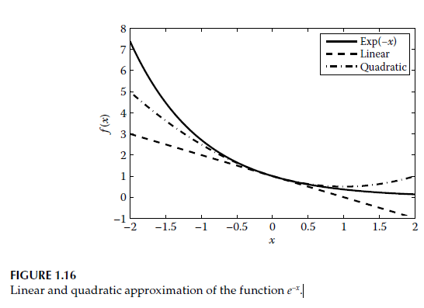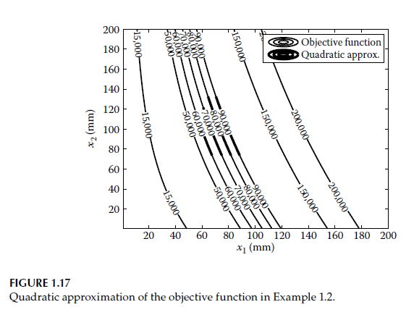
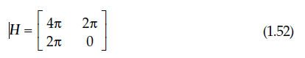
Example 1.6
Construct the linear and quadratic approximations of the function
$$f(x)=3x_{2}-\frac{x_{1}}{x_{2}}$$
at the point
$$x_{0}=(2,1)$$
Function Value at the Point
$$f(2,1)=3(1)-\frac{2}{1} \\ =3-2=1$$
Gradient Calculation (Step by Step)
🔹 Partial derivative with respect to $x_{1}$
Given:
$$f=3x_{2}-\frac{x_{1}}{x_{2}}$$
Taking the derivative with respect to $x_{1}$:
- $3x_{2}$→ constant (does not contain $x_{1}$) → derivative is 0
- $-x_{1}/x_{2}$→ treat $x_{2}$as constant
$$\frac{∂f}{∂x_{1}}=-\frac{1}{x_{2}}$$
🔹 Partial derivative with respect to $x_{2}$
Rewrite:
$$\frac{x_{1}}{x_{2}}=x_{1}x_{2}^{-1}$$
Derivative:
$$\frac{d}{dx_{2}}(x_{2}^{-1})=-1x_{2}^{-2}$$
Therefore:
$$\frac{∂f}{∂x_{2}}=3-\left( − \frac{x_{1}}{x_{2}^{2}}\right) \\ =3+\frac{x_{1}}{x_{2}^{2}}$$Gradient
$$∇f(x)=\left[\begin{aligned}-\frac{1}{x_{2}} \\ 3+\frac{x_{1}}{x_{2}^{2}}\end{aligned}\right]$$
Evaluate at (2,1)
$$∇f(2,1)=\left[\begin{aligned}-1 \\ 3+\frac{2}{1^{2}}\end{aligned}\right]=\left[\begin{aligned}-1 \\ 5\end{aligned}\right]$$

Hessian Matrix Calculation
The Hessian is the matrix of second derivatives.

$$\frac{∂^{2}f}{∂x_{1}^{2}}$$
$$\frac{∂}{∂x_{1}}\left( − \frac{1}{x_{2}}\right)=0$$
Because it does not depend on $x_{1}$.

$$\frac{∂^{2}f}{∂x_{1}∂x_{2}}$$
$$\frac{∂}{∂x_{2}}\left( − \frac{1}{x_{2}}\right)=-(-1)x_{2}^{-2}=\frac{1}{x_{2}^{2}}$$
$$\frac{∂^{2}f}{∂x_{2}^{2}}$$
Starting from:
$$\frac{∂f}{∂x_{2}}=3+\frac{x_{1}}{x_{2}^{2}}$$
Derivative:
$$\frac{∂^{2}f}{∂x_{2}^{2}}=x_{1}(-2)x_{2}^{-3}=-\frac{2x_{1}}{x_{2}^{3}}$$
Hessian
$$H=\left[\begin{matrix}0 & \frac{1}{x_{2}^{2}} \\ \frac{1}{x_{2}^{2}} & -\frac{2x_{1}}{x_{2}^{3}}\end{matrix}\right]$$
At the point (2,1):
$$H(2,1)=\left[\begin{matrix}0 & 1 \\ 1 & -4\end{matrix}\right]$$
Linear Approximation
Formula:
$$l(x)=f(x_{0})+∇f(x_{0})^{T}(x-x_{0}) \\ =1+[-15]\left[\begin{aligned}x_{1}-2 \\ x_{2}-1\end{aligned}\right]$$
Multiplying:
$$=-1(x_{1}-2)+5(x_{2}-1) \\ =-x_{1}+2+5x_{2}-5 \\ =-x_{1}+5x_{2}-3$$
Adding the constant 1:
$$\boxed{l(x)=-x_{1}+5x_{2}-2}$$
Quadratic Approximation
Formula:
$$q(x)=l(x)+\frac{1}{2}(x-x_{0})^{T}H(x_{0})(x-x_{0})$$
First:
$$(x-x_{0})=\left[\begin{aligned}x_{1}-2 \\ x_{2}-1\end{aligned}\right]$$
Compute:
$$\left[\begin{matrix}x_{1}-2 & x_{2}-1\end{matrix}\right]\left[\begin{matrix}0 & 1 \\ 1 & -4\end{matrix}\right]\left[\begin{aligned}x_{1}-2 \\ x_{2}-1\end{aligned}\right]$$
First matrix multiplication:
$$=\left[\begin{aligned}x_{2}-1 \\ \left(x_{1}-2)-4(x_{2}-1\right)\end{aligned}\right]$$
Now multiply with the left vector:
$$=(x_{1}-2)(x_{2}-1)+(x_{2}-1)((x_{1}-2)-4(x_{2}-1)) \\ =2(x_{1}-2)(x_{2}-1)-4(x_{2}-1)^{2}$$
Multiply by $\frac{1}{2}$:
$$=(x_{1}-2)(x_{2}-1)-2(x_{2}-1)^{2}$$
Final Result
$$\boxed{q(x)=-x_{1}+5x_{2}-2+(x_{1}-2)(x_{2}-1)-2(x_{2}-1)^{2}}$$

