The main affordances of Cisco Webex are hosting and attending virtual meetings. These meetings can be scheduled or impromptu and offer various tools for communication such as a chat, voice calls, video calls and screen sharing.

For this particular example, we will analyze the use case of hosting a meetup and a different user joining it.

While meetings can be attended as a guest, without authentication, the same cannot be said about hosting a meeting. To host a meeting the user must first sign in/ sign up.

Let’s go to Webex.com to analyze the sign up process.

To create an account: Click on the big white button ‘Sign Up, It’s free’.

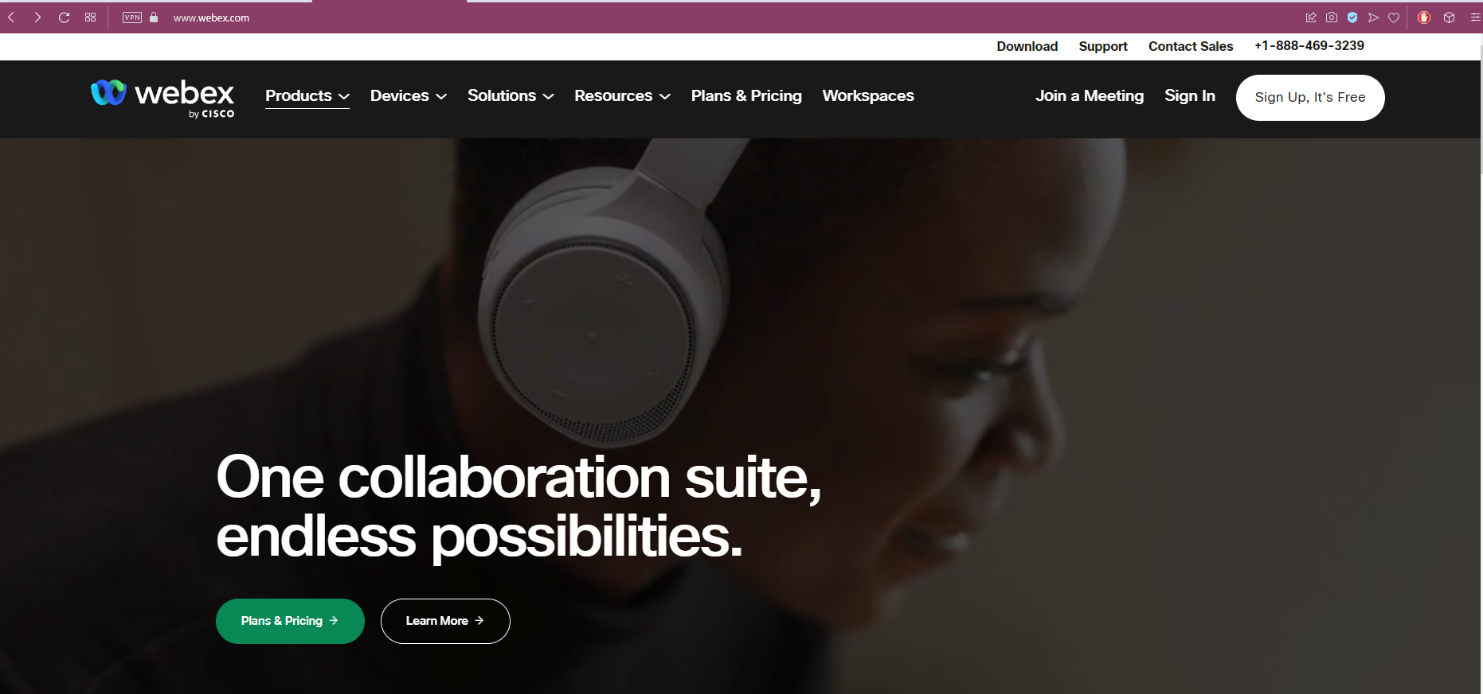

Generally speaking, users have come to have certain expectations in regards the placement of the signing in / signing up. Generally these buttons are visible, and placed in the top right quadrant of the screen. Once this button is clicked the on boarding process begins.

It is quite well known that the process of onboarding people as authenticated users is a significant bottleneck for most applications, as most people perceive the work required as not worth it.

One thing of note throughout this process of creating an account is that Webex is trying ‘convince’ the user that the process is easy and streamlined, and requires only a minimal amount of effort from the users end.

The work of signing up is split into bite sized chunks and displayed one at a time, likely to avoid overburdening the user. The 3 white lines that indicate the step are constantly in the center of the screen likely serve as a sort of finish line that the user can see getting closer to.

Input an email address:

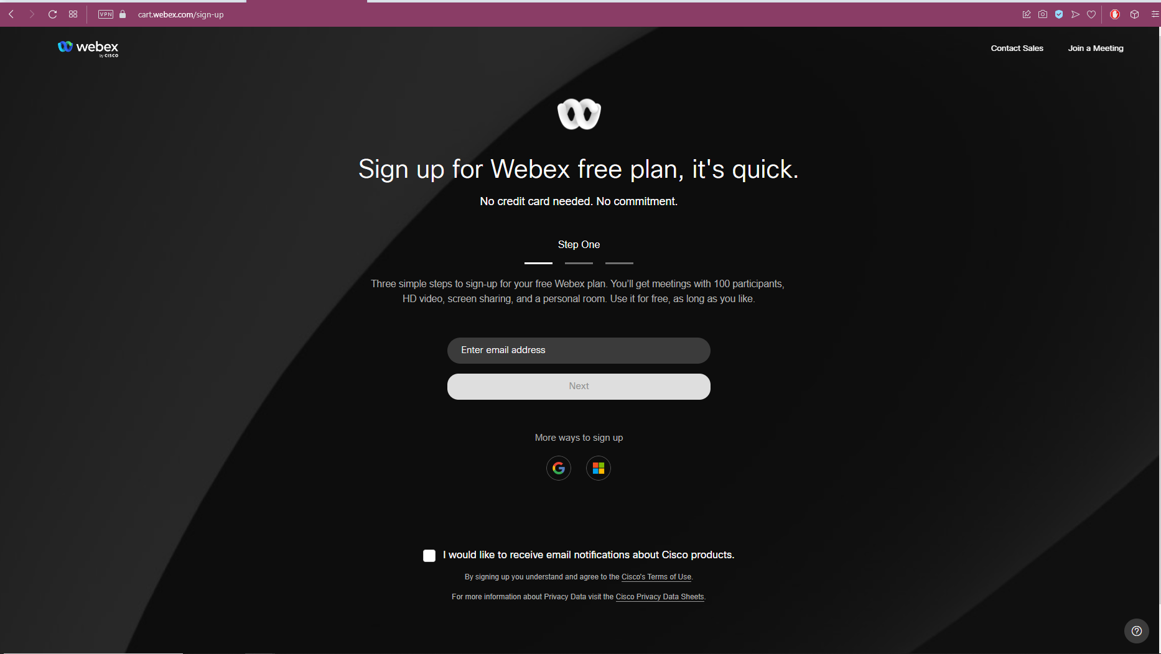

Input the verification code sent to you via email:

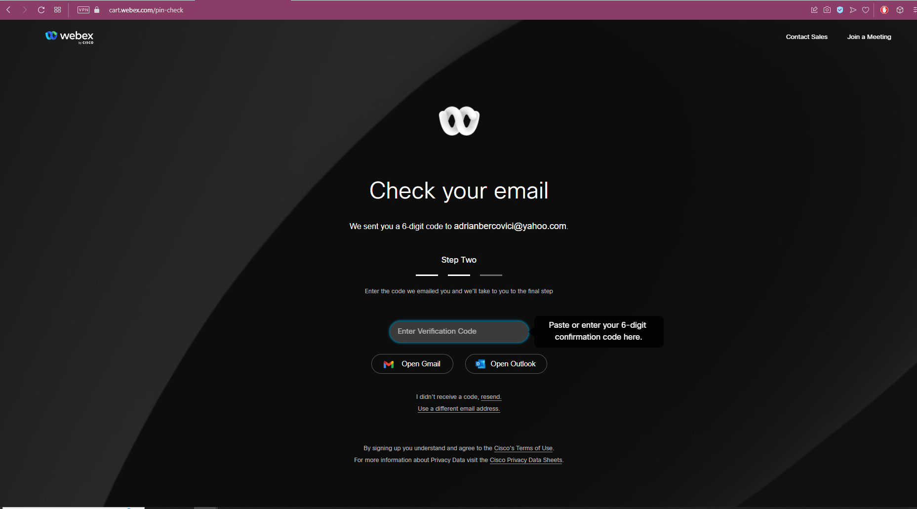

Verification code in email box:

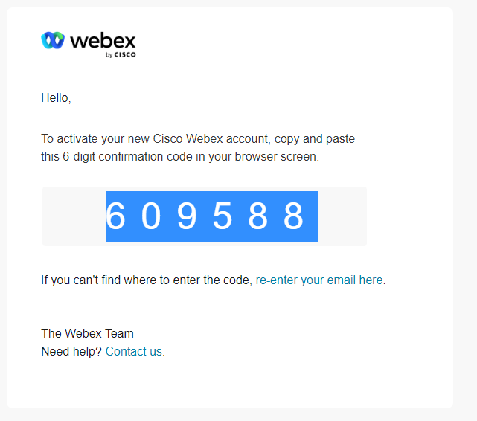

Set up the other credentials:

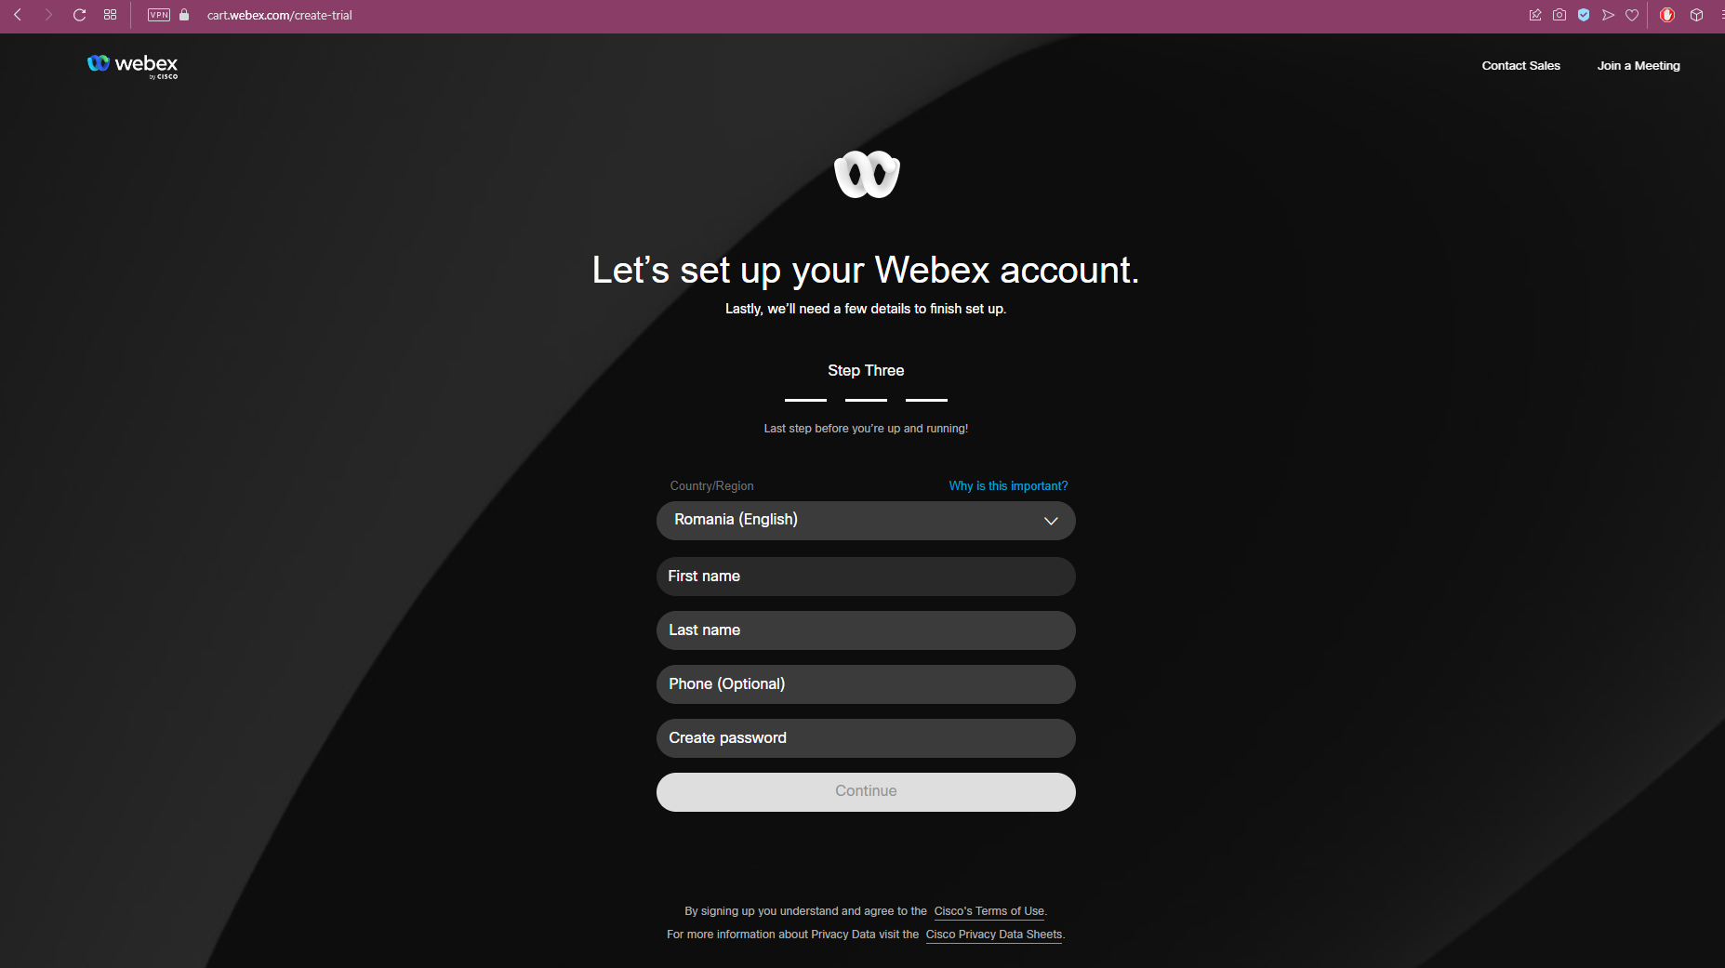

Password requirement window:

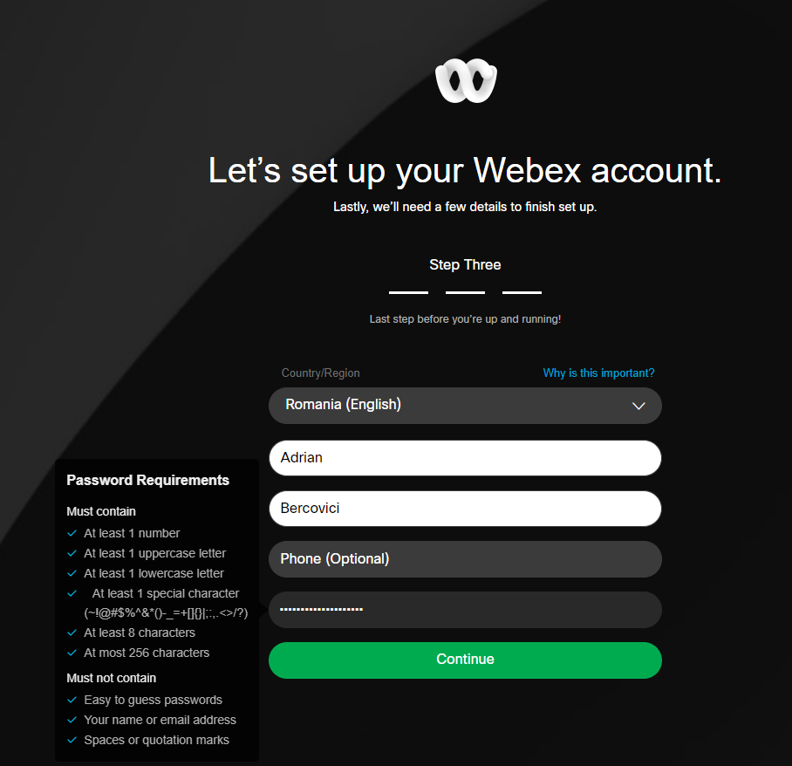

One thing of note here is the password requirements window. This gives the user a detailed breakdown of the security requirements, and constantly updates as they are fulfilled/unfulfilled. This prevents situation where the user has to input multiple passwords and be hit with multiple messages of ‘this password doesn’t meet requirement X’.

Now that you are authenticated, you can host a meeting either by downloading the client or by using the browser:

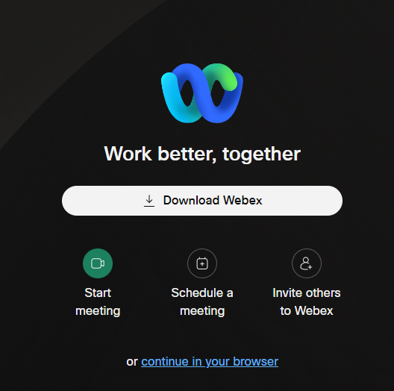

The screen above is concise and uses easy to ready visual metaphors that most users will likely be very familiar with.

-The arrow pointing downward into a bar is easy to recognize as the download action. The large white button strongly draws the user’s eye to it. This is because in order to actually host a meeting, you need to have the standalone app installed.

-In contrast ‘Continue in your browser’ has no associated icon to it and is less contrasting than any other element on the screen.

-The Camera icon is something most people will easily associate with ‘going live’ or starting the live interaction with other users. This icon is also the only green one currently on screen, drawing attention to it and adding to the ‘live’ aspect of it

-The calendar icon is naturally associated with scheduling

-The human plus icon is also naturally associated with adding people to a group.

In browser dashboard:

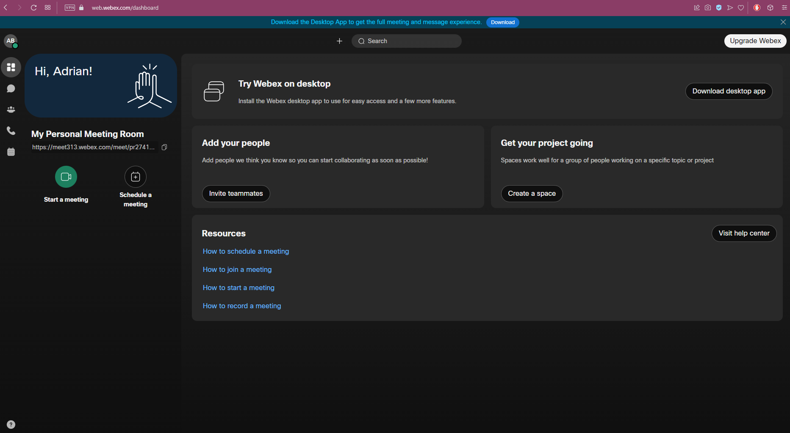

Interestingly, the most important information is condensed to the left of the screen, and a significantly larger portion of the screen is reserved for not-as-important information. This left side serves as a navigation menu, while the right side displays information from the selected submenu.

Lets focus our attention on the left side of the screen:

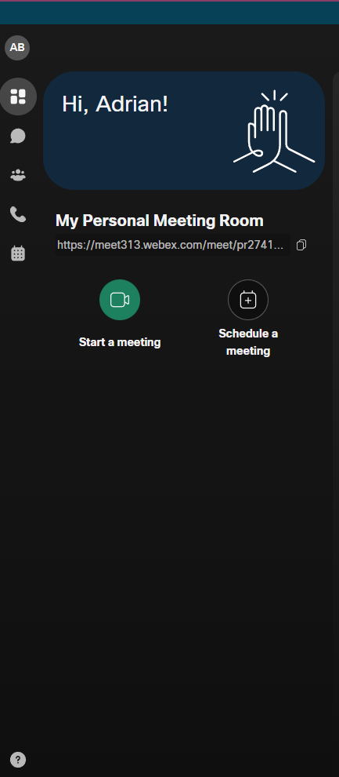

The eyes of the user are naturally drawn the point of contrast on the start meeting button. In its vicinity, there are 2 more vital pieces of UI – the ‘My Personal Room Code:’ and ‘Schedule meeting.’

The unique ‘My Personal Room Code:’ can be used by other people to access the meeting, and is naturally a very important piece of information

Some new visual metaphors that appear on this page are:

-The two pages one on top of the other has become a common association with copying data to the clipboard.

-The chat bubble is also well cemented into popular consciousness as the ‘messages’ icon

-The group of people icon is associated with groups or teams

-The phone head is deeply associated with calls, though likely an increasing number of people has no idea why that is

By using the MyPersonalRoomCode, anyone can join the meeting, by pasting it into their browser. This will cause a popup to appear that tries to open the Webex application.

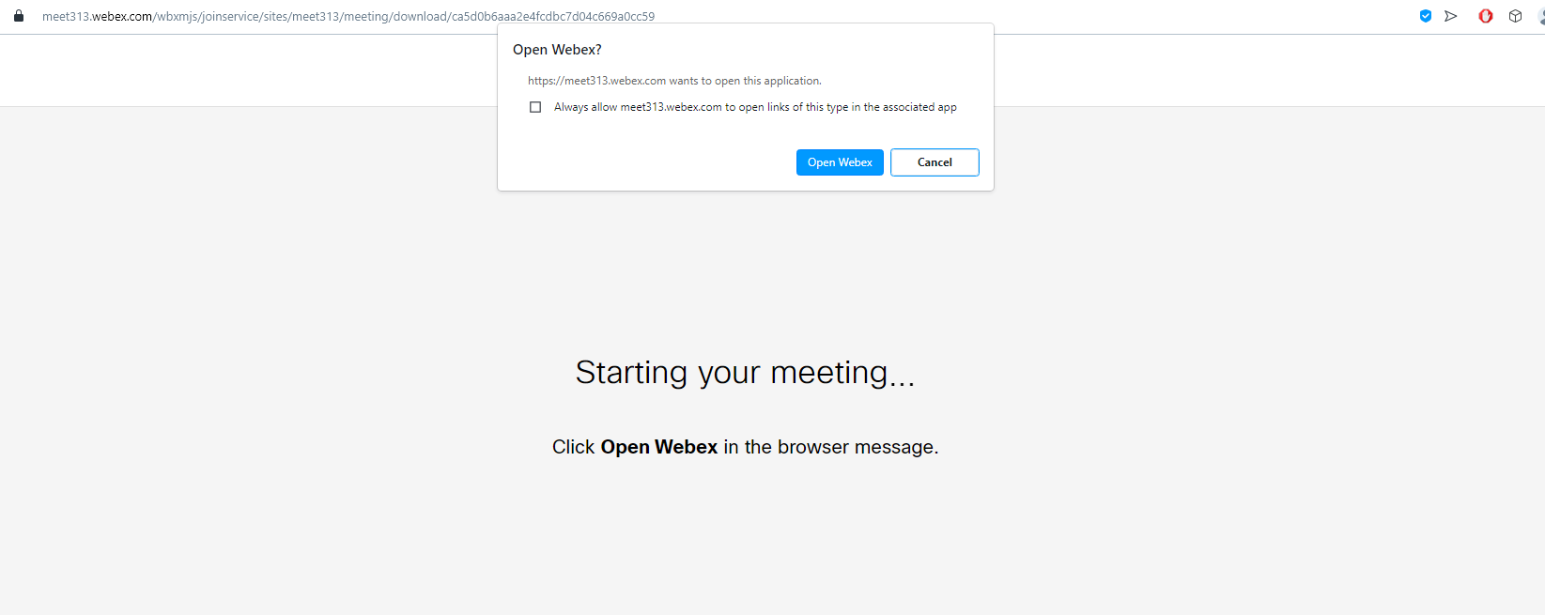

In order to join, it is not necessary to be an authenticated user. Instead you can join as a guest.

Once the user has joined, this is the core of the Webex meetup GUI.

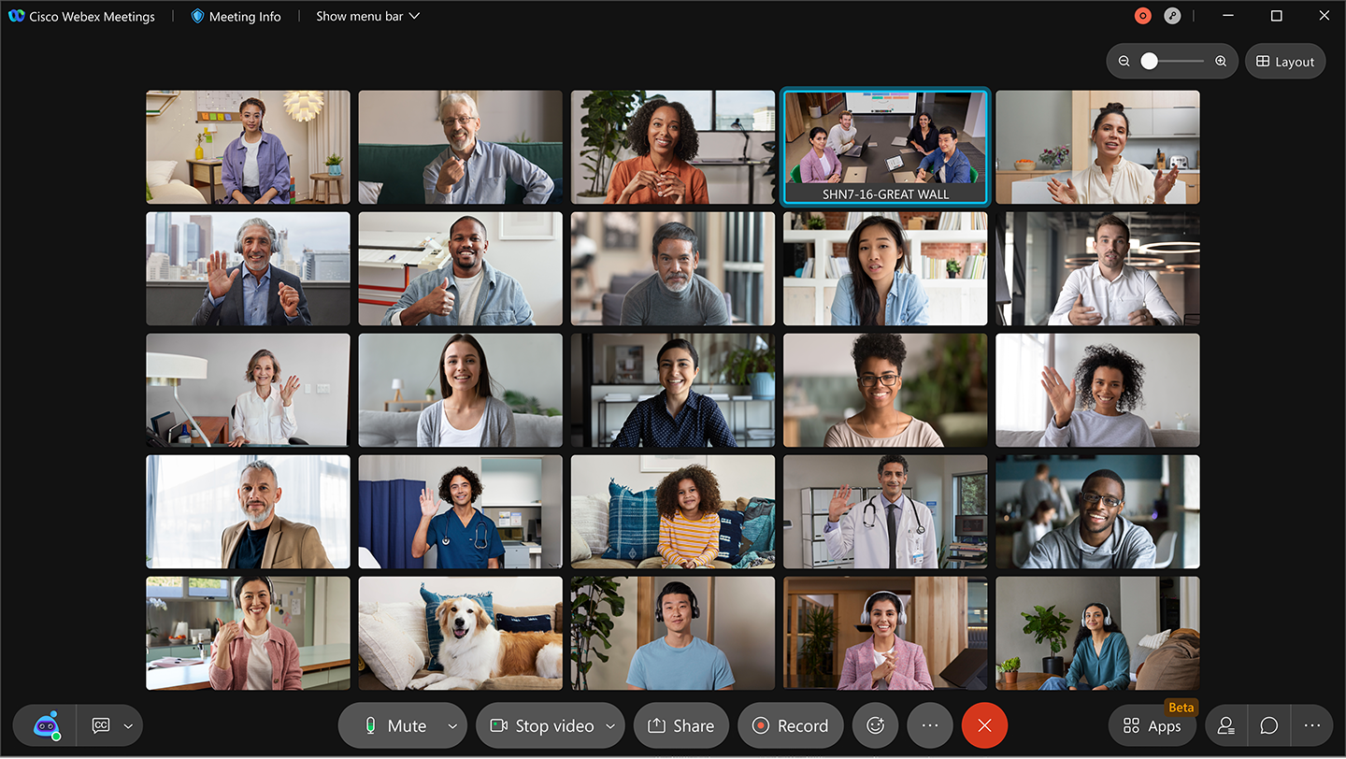

Some visual metaphors of note here are:

-the red X that clearly indicates how to leave the meetup

-the microphone that indicates whether or not the user is muted, and if he is currently speaking

-the camera that indicates if his face cam is on

-The smiley face indicates how to use emotes such as raising your hand

Command line interfaces tend to be less accessible then graphical user interfaces, and they tend to be used by people of a more technical background such as programmers.

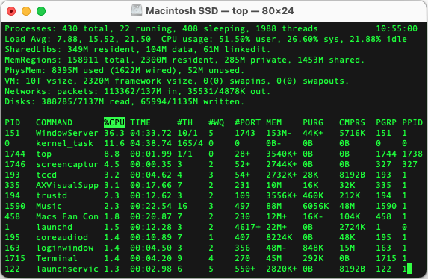

It is important for commands in CLIs to be short and intuitive, and as much as possible work on what the user already knows.

Since most users of command line interfaces are programmers, it would likely be advisable to use programming concepts as metaphors, such as class.attribute, get, set, do etc.

Consider the scenario from the first segment, the use case of hosting a meeting. The CLI use case could go something like this:

//user is not authenticated

User:>> startmeeting

Server:>>You must first sign in or sign up to run this command. Use sign_in or sign_up

User:>> sign_up

Server:>>[SIGNUP 1/3] input a valid email:

User:>><emailaddress>

Server:>> [SIGNUP 2/3] A six digit code has been sent to your specified email. Please write it down:

User:>><# # # # # #>

Server:>>[SIGNUP 3/3] Input your: FirstName, LastName, PhoneNumber (optional=’-’), password (password security requirements)

User:>> first name, last name, -, password

Server:>> [SIGN UP COMPLETE] You can now login using sign_in

User:>>sign_in <<email>> <<password>>

User:get mprc

//gets the room code so it can be shared

User: startmeeting

Other parameters can also easily be inputted into these commands such as whether the meeting is encrypted, if the meeting can let users in without the host manually admitting them, max quality of the video feed etc.

Ex:

User:>>startmeeting encrypted=’e2e’ auto_allow=’false’ max_quality=’480’

Generally CiscoWebex is pretty balanced in terms of how much it throws at once at the user.

From personal experience, it would seem navigating the settings menus in order to remove the beep that is played when a user joins or leaves a meeting is quite unintuitive.

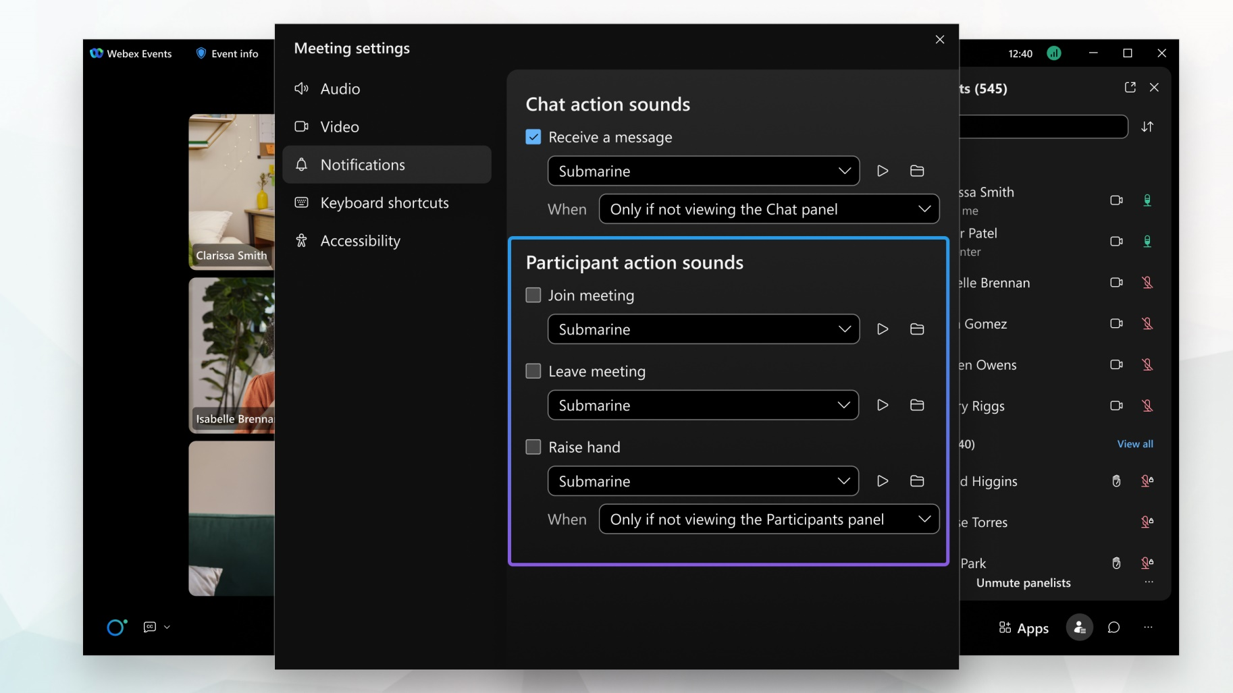

*Fritt’s Law refers to the time it takes to point at a target on a computer screen. It states that the time it takes to move a pointing device(a mouse) to a target is a function of the target’s size and the starting distance. In other words, the larger and closer a target is, the easier it is to reach.

*Hick’s Law refers to the fact that the amount of time required for a person to make a decision increases with the possible amount of choices. In other words, the more options there are, the harder it is to decide.

*Steerig’s Law refers to the time it takes to steer a moving object such as a cursor through a series of targets. The less targets there are and the wider they are, the less time will be required.