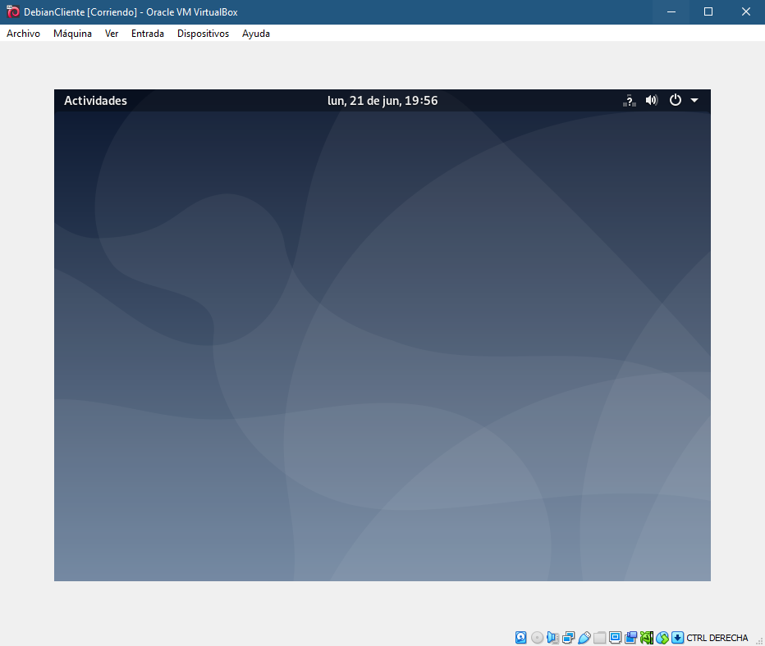

$su -
$apt update
$apt install task-xfce-desktop
$systemctl set-default graphical.target
$reboot
