**Use Case Requirement Analysis**

**Team members:**

1. Bereket Abraham ID: 109671
2. Kaleb Workneh ID: 109670
3. Samrawit Haile ID: 109666
4. Senait Habte ID: 109707
5. Yosief Teklemariam ID: 109633

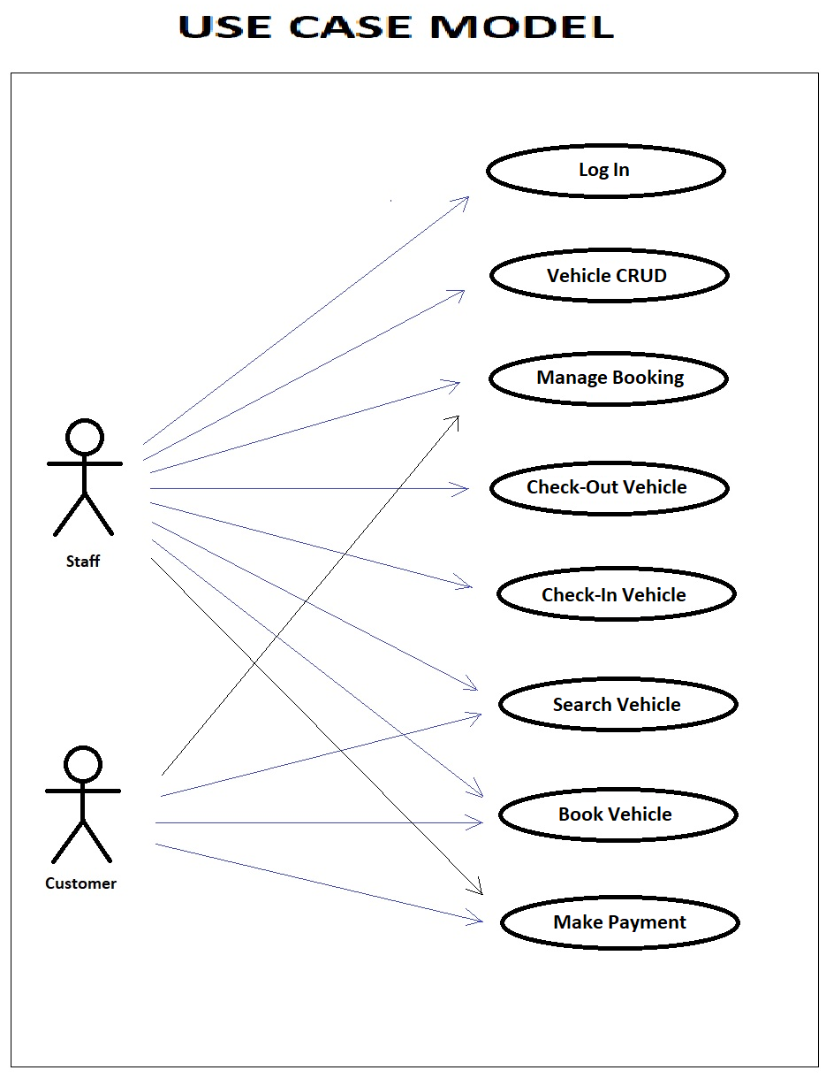

**Use Case Description**

|  |  |  |  |
| --- | --- | --- | --- |
| **Use Case Number 1** | | | |
| **1** | **Name** | Staff Log In | |
|  | **Brief Description** | This use case allows staffs to login and logout in the system | |
| **2** | **Actors** | Staff | |
| **3** | **Pre-conditions** | | |
|  | **3.1** The staff should be on the Login home page | | |
| **4** | **Basic Flow** | | |
|  | *User Actions* | | *System Actions* |
|  | **4.1** A staff fills in his credentials | | The system verifies the staff's credentials and allows him to login if it matches |
| **5** | **Post-Conditions** | | |
|  | **5.1** The staff will be logged in to the system to perform CRUD operations | | |
| **6** | **Business Rules** | | |
|  | **6.1** Only staff with valid credentials can log in | | |
| **7** | **Non-Functional Requirements** - NONE | | |

|  |  |  |  |
| --- | --- | --- | --- |
| **Use Case Number 2** | | | |
| **1** | **Name** | Vehicle CRUD - Add Vehicle | |
|  | **Brief Description** | This use case will allow a staff to add a new vehicle record | |
| **2** | **Actors** | Staff | |
| **3** | **Pre-conditions** | | |
|  | **3.1** The staff must be logged in to the system | | |
| **4** | **Basic Flow** | | |
|  | *User Actions* | | *System Actions* |
|  | The staff calls for the insert vehicle command | | The system displays the vehicle registration form so that the staff can fill in and save the new vehicle details to the database |
|  | The staff fills in the insert vehicle form and selects submit | | The system checks business rules, updates the database with the new vehicle information and shows success confirmation |
| **5** | **Post-Conditions** | | |
|  | **5.1** New vehicle data will be added the system and the vehicle will become available for booking | | |
| **6** | **Business Rules** | | |
|  | **6.1.** New vehicle to be added should have unique ID | | |
|  | **6.2.** New vehicle to be added should be ready for booking by a customer | | |
| **7** | **Non-Functional Requirements** - NONE | | |

|  |  |  |  |
| --- | --- | --- | --- |
| **Use Case Number 3** | | | |
| **1** | **Name** | Vehicle CRUD - Delete Vehicle | |
|  | **Brief Description** | This use case will allow a staff to delete an existing vehicle record | |
| **2** | **Actors** | Staff | |
| **3** | **Pre-conditions** | | |
|  | **3.1** The staff must be logged in to the system | | |
| **4** | **Basic Flow** | | |
|  | *User Actions* | | *System Actions* |
|  | The staff requests to view a list of vehicles. | | The system displays the list of registered operational vehicles |
|  | The staff selects the vehicle to remove and selects delete | | The system prompts for delete confirmation |
|  | The staff confirms delete | | The system removes the vehicle from the list |
| **5** | **Post-Conditions** | | |
|  | **5.1** Selected vehicle will be removed from database and will no longer be available for booking | | |
| **6** | **Business Rules** | | |
|  | **6.1.** Vehicles with mileage more than 50,000 miles should be removed from the system | | |
|  | **6.2.** Vehicles with bad conditions should be removed from the system | | |
| **7** | **Non-Functional Requirements** - NONE | | |

|  |  |  |  |
| --- | --- | --- | --- |
| **Use Case Number 4** | | | |
| **1** | **Name** | Vehicle CRUD - View Vehicle | |
|  | **Brief Description** | This use case will allow a staff to view an existing vehicle record | |
| **2** | **Actors** | Staff | |
| **3** | **Pre-conditions** | | |
|  | **3.1** The staff must be logged in to the system | | |
| **4** | **Basic Flow** | | |
|  | *User Actions* | | *System Actions* |
|  | The staff requests to view a list of vehicles. | | The system displays the list of registered operational vehicles |
|  | The staff selects the vehicle to view | | The system displays detail information of the selected vehicle |
| **5** | **Post-Conditions** | | |
|  |  | | |
| **6** | **Business Rules** | | |
|  |  | | |
| **7** | **Non-Functional Requirements** - NONE | | |

|  |  |  |  |
| --- | --- | --- | --- |
| **Use Case Number 5** | | | |
| **1** | **Name** | Vehicle CRUD - Update Vehicle Info | |
|  | **Brief Description** | This use case will allow a staff to modify an existing vehicle record | |
| **2** | **Actors** | Staff | |
| **3** | **Pre-conditions** | | |
|  | **3.1** The staff must be logged in to the system | | |
| **4** | **Basic Flow** | | |
|  | *User Actions* | | *System Actions* |
|  | The staff requests to view a list of vehicles. | | The system displays the list of registered operational vehicles |
|  | The staff selects the vehicle to update and selects modify | | The system displays an editable form with the vehicle detail information |
|  | The staff modifies the information they want to change and selects save | | The system updates the vehicle information and displays success confirmation |
| **5** | **Post-Conditions** | | |
|  | **5.1** Selected vehicle data will be modified on the system | | |
| **6** | **Business Rules** | | |
|  | **6.1.** The unique system vehicle number should not be modifiable | | |
| **7** | **Non-Functional Requirements** - NONE | | |

|  |  |  |  |
| --- | --- | --- | --- |
| **Use Case Number 6** | | | |
| **1** | **Name** | Search Vehicle | |
| **2** | **Brief Description** | This use case will allow a staff or a customer to search for available vehicles for some specific time period | |
| **3** | **Actors** | Staff, Customer | |
| **4** | **Pre-conditions** | | |
|  | **3.1** The staff or customer should be on the website homepage | | |
| **5** | **Basic Flow** | | |
|  | *User Actions* | | *System Actions* |
|  | **5.1** The staff or customer fills in the start and end dates on the homepage and select search vehicles | | The system displays the available vehicles with details like vehicle specification and price |
|  |  | |  |
| **6** | **Post-Conditions** | | |
|  | **5.1** Staff or customer will be provided a list of vehicles to select for booking | | |
|  |  | | |
| **7** | **Business Rules** | | |
|  | **6.1** The system should display only available vehicles in the specified time period | | |
| **8** | **Non-Functional Requirements** - NONE | | |

|  |  |  |  |
| --- | --- | --- | --- |
| **Use Case Number 7** | | | |
| **1** | **Name** | Book Vehicle | |
| **2** | **Brief Description** | This use case will allow a staff or a customer to book a specific vehicle for some specific time | |
| **3** | **Actors** | Staff, Customer | |
| **4** | **Pre-conditions** | | |
|  | **4.1** The staff or customer should first a do search by inserting the desired start and end dates on the site homepage | | |
| **5** | **Basic Flow** | | |
|  | *User Actions* | | *System Actions* |
|  | **5.1** The staff or customer selects the desired vehicle from the list displayed from search | | The system will display the detail booking information including vehicle details, dates and price. |
|  | **5.2** The staff or customer reviews the displayed information and selects reserve | | The system will display the customer information form |
|  | **5.3** The staff or customer will fill in the customer information form and clicks submit | | **5.3.1.** The system checks if all the business rules are met and adds the new reservation to the system  **5.3.2.** Systemdisplays booking confirmation page with unique booking no that can be used to retrieve reservation and an option to make payment  **5.3.3.** System will send confirmation email to customer |
| **6** | **Post-Conditions** | | |
|  | **5.1** New booking will be added to the system | | |
| **7** | **Business Rules** | | |
|  | **6.1** Customer should have a valid driver's license | | |
|  | **6.2** Customer should provide a valid payment information | | |

|  |  |  |  |
| --- | --- | --- | --- |
| **Use Case Number 8** | | | |
| **1** | **Name** | Retrieve Booking | |
| **2** | **Brief Description** | This use case will allow a staff or a customer to view a booking | |
| **3** | **Actors** | Staff, Customer | |
| **4** | **Pre-conditions** | | |
|  | **4.1** The staff or customer should be on the website homepage | | |
| **5** | **Basic Flow** | | |
|  | *User Actions* | | *System Actions* |
|  | **5.1** The staff or customer selects retrieve booking | | The system will prompt for unique booking number |
|  | **5.2** The staff or customer fills and submits the Booking Number | | The system will display the booking information along with options to manage booking. |
| **6** | **Post-Conditions** | | |
|  |  | | |
| **7** | **Business Rules** | | |
|  |  | | |

|  |  |  |  |
| --- | --- | --- | --- |
| **Use Case Number 9** | | | |
| **1** | **Name** | Make Payment | |
| **2** | **Brief Description** | This use case will allow a staff or a customer to make payment for a booking | |
| **3** | **Actors** | Staff, Customer | |
| **4** | **Pre-conditions** | | |
|  | **4.1** The staff or customer should either be on a booking confirmation or a retrieved booking page | | |
| **5** | **Basic Flow** | | |
|  | *User Actions* | | *System Actions* |
|  | **5.1** The staff or customer selects the make payment option | | The system will display the detail booking information including vehicle details, dates and price and prompts for payment confirmation. |
|  | **5.2** The staff or customer reviews the displayed information and selects pay | | **5.2.1.** The system processes the payment using the payment information on booking and displays payment success if payment goes through  **5.2.2.** System updates payment status for booking |
| **6** | **Post-Conditions** | | |
|  | **5.1** Booking payment status updated | | |
| **7** | **Business Rules** | | |
|  | **6.1** Payment information should be valid | | |

|  |  |  |  |
| --- | --- | --- | --- |
| **Use Case Number 10** | | | |
| **1** | **Name** | Manage Booking | |
| **2** | **Brief Description** | This use case will allow a staff or a customer to modify a booking date, vehicle type or both | |
| **3** | **Actors** | Staff, Customer | |
| **4** | **Pre-conditions** | | |
|  | **4.1** The staff or customer should be on a retrieved booking page | | |
| **5** | **Basic Flow** | | |
|  | *User Actions* | | *System Actions* |
|  | **5.1** The staff or customer selects the manage booking option | | The system will display an editable detail booking information. |
|  | **5.2** The staff or customer makes the changes and selects submit | | **5.2.1.** The system checks all business rules are satisfied and if the change is possible  **5.2.2.** System updates reservation with the new information and saves it. |
| **6** | **Post-Conditions** | | |
|  | **6.1** Booking record updated | | |
| **7** | **Business Rules** | | |
|  | **7.1** No changes can be made within less than 24 Hrs. of pickup | | |

|  |  |  |  |
| --- | --- | --- | --- |
| **Use Case Number 11** | | | |
| **1** | **Name** | Manage Booking – Cancel Reservation | |
| **2** | **Brief Description** | This use case will allow a staff or a customer to cancel a booking | |
| **3** | **Actors** | Staff, Customer | |
| **4** | **Pre-conditions** | | |
|  | **4.1** The staff or customer should be on a retrieved booking page | | |
| **5** | **Basic Flow** | | |
|  | *User Actions* | | *System Actions* |
|  | **5.1** The staff or customer selects the manage booking option | | The system will display cancel booking option |
|  | **5.2** The staff or customer selects cancel booking | | **5.2.1.** The system checks all business rules are satisfied  **5.2.2.** System removes reservation from the system |
| **6** | **Post-Conditions** | | |
|  | **6.1** Booking record removed | | |
| **7** | **Business Rules** | | |
|  | **7.1** No cancellation within less than 24 Hrs. of pickup | | |
|  | **7.2** No cancellation if payment is already made | | |