**VOPC**

**And**

**Collaboration Diagrams**

**Team members:**

1. Bereket Abraham ID: 109671

2. Kaleb Workneh ID: 109670

3. Samrawit Haile ID: 109666

4. Senait Habte ID: 109707

5. Yosief Teklemariam ID: 109633

Page Break

**VOPC Diagrams**

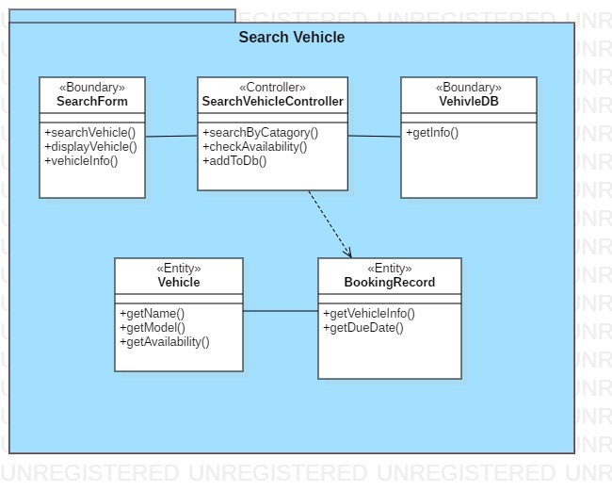

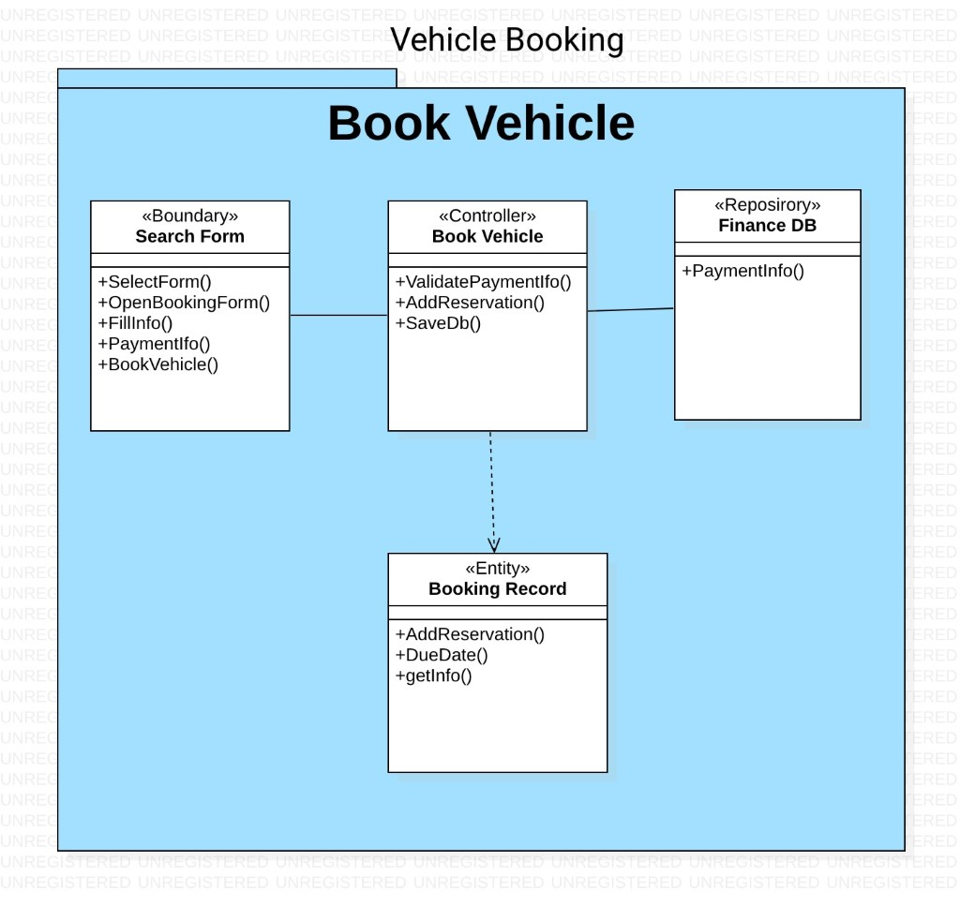

**Collaboration Diagrams**

