FREQUENCIES VARIABLES=age bmi gravida parity menapausalsitutation indication operationtime
hospitalizationtime
/NTILES=4
/STATISTICS=STDDEV MINIMUM MAXIMUM MEAN MEDIAN
/ORDER=ANALYSIS.

Frequencies

Notes
Output Created |  | 07-JAN-2025 23:43:33
Comments
Input | Data | C:\Users\eralp\Desktop\suture techniques.sav
Input | Active Dataset | DataSet1
Input | Filter | <none>
Input | Weight | <none>
Input | Split File | <none>
Input | N of Rows in Working Data File | 208
Missing Value Handling | Definition of Missing | User-defined missing values are treated as missing.
Missing Value Handling | Cases Used | Statistics are based on all cases with valid data.
Syntax |  | FREQUENCIES VARIABLES=age bmi gravida parity menapausalsitutation indication operationtime  hospitalizationtime  /NTILES=4  /STATISTICS=STDDEV MINIMUM MAXIMUM MEAN MEDIAN  /ORDER=ANALYSIS.
Resources | Processor Time | 00:00:00,02
Resources | Elapsed Time | 00:00:00,02

Statistics
 |  | age | bmi | gravida | parity | premanopoz:1 postmenopoz: 2
N | Valid | 208 | 208 | 208 | 208 | 208
N | Missing | 0 | 0 | 0 | 0 | 0
Mean |  | 49,74 | 30,03 | 3,39 | 2,72 | 1,27
Median |  | 49,00 | 30,00 | 3,00 | 3,00 | 1,00
Std. Deviation |  | 5,441 | 4,898 | 1,870 | 1,519 | ,447
Minimum |  | 40 | 20 | 0 | 0 | 1
Maximum |  | 65 | 46 | 10 | 10 | 2
Percentiles | 25 | 45,25 | 26,00 | 2,00 | 2,00 | 1,00
Percentiles | 50 | 49,00 | 30,00 | 3,00 | 3,00 | 1,00
Percentiles | 75 | 53,00 | 33,00 | 4,00 | 3,00 | 2,00

Statistics
 |  | auk:1 pmk:2 pmek:3 | minute | day
N | Valid | 208 | 208 | 208
N | Missing | 0 | 0 | 0
Mean |  | 1,40 | 100,65 | 2,00
Median |  | 1,00 | 90,00 | 2,00
Std. Deviation |  | ,695 | 36,419 | ,476
Minimum |  | 1 | 37 | 1
Maximum |  | 3 | 240 | 4
Percentiles | 25 | 1,00 | 75,00 | 2,00
Percentiles | 50 | 1,00 | 90,00 | 2,00
Percentiles | 75 | 2,00 | 120,00 | 2,00

Frequency Table

age
 |  | Frequency | Percent | Valid Percent | Cumulative Percent
Valid | 40 | 2 | 1,0 | 1,0 | 1,0
Valid | 41 | 7 | 3,4 | 3,4 | 4,3
Valid | 42 | 6 | 2,9 | 2,9 | 7,2
Valid | 43 | 1 | ,5 | ,5 | 7,7
Valid | 44 | 16 | 7,7 | 7,7 | 15,4
Valid | 45 | 20 | 9,6 | 9,6 | 25,0
Valid | 46 | 16 | 7,7 | 7,7 | 32,7
Valid | 47 | 11 | 5,3 | 5,3 | 38,0
Valid | 48 | 21 | 10,1 | 10,1 | 48,1
Valid | 49 | 16 | 7,7 | 7,7 | 55,8
Valid | 50 | 12 | 5,8 | 5,8 | 61,5
Valid | 51 | 12 | 5,8 | 5,8 | 67,3
Valid | 52 | 12 | 5,8 | 5,8 | 73,1
Valid | 53 | 7 | 3,4 | 3,4 | 76,4
Valid | 54 | 4 | 1,9 | 1,9 | 78,4
Valid | 55 | 8 | 3,8 | 3,8 | 82,2
Valid | 56 | 8 | 3,8 | 3,8 | 86,1
Valid | 57 | 5 | 2,4 | 2,4 | 88,5
Valid | 58 | 8 | 3,8 | 3,8 | 92,3
Valid | 59 | 6 | 2,9 | 2,9 | 95,2
Valid | 60 | 2 | 1,0 | 1,0 | 96,2
Valid | 61 | 3 | 1,4 | 1,4 | 97,6
Valid | 62 | 1 | ,5 | ,5 | 98,1
Valid | 63 | 1 | ,5 | ,5 | 98,6
Valid | 64 | 2 | 1,0 | 1,0 | 99,5
Valid | 65 | 1 | ,5 | ,5 | 100,0
Valid | Total | 208 | 100,0 | 100,0

bmi
 |  | Frequency | Percent | Valid Percent | Cumulative Percent
Valid | 20 | 2 | 1,0 | 1,0 | 1,0
Valid | 21 | 5 | 2,4 | 2,4 | 3,4
Valid | 22 | 3 | 1,4 | 1,4 | 4,8
Valid | 23 | 4 | 1,9 | 1,9 | 6,7
Valid | 24 | 12 | 5,8 | 5,8 | 12,5
Valid | 25 | 15 | 7,2 | 7,2 | 19,7
Valid | 26 | 16 | 7,7 | 7,7 | 27,4
Valid | 27 | 14 | 6,7 | 6,7 | 34,1
Valid | 28 | 16 | 7,7 | 7,7 | 41,8
Valid | 29 | 11 | 5,3 | 5,3 | 47,1
Valid | 30 | 16 | 7,7 | 7,7 | 54,8
Valid | 31 | 14 | 6,7 | 6,7 | 61,5
Valid | 32 | 14 | 6,7 | 6,7 | 68,3
Valid | 33 | 18 | 8,7 | 8,7 | 76,9
Valid | 34 | 10 | 4,8 | 4,8 | 81,7
Valid | 35 | 7 | 3,4 | 3,4 | 85,1
Valid | 36 | 10 | 4,8 | 4,8 | 89,9
Valid | 37 | 6 | 2,9 | 2,9 | 92,8
Valid | 38 | 5 | 2,4 | 2,4 | 95,2
Valid | 39 | 4 | 1,9 | 1,9 | 97,1
Valid | 40 | 3 | 1,4 | 1,4 | 98,6
Valid | 42 | 2 | 1,0 | 1,0 | 99,5
Valid | 46 | 1 | ,5 | ,5 | 100,0
Valid | Total | 208 | 100,0 | 100,0

gravida
 |  | Frequency | Percent | Valid Percent | Cumulative Percent
Valid | 0 | 11 | 5,3 | 5,3 | 5,3
Valid | 1 | 13 | 6,3 | 6,3 | 11,5
Valid | 2 | 41 | 19,7 | 19,7 | 31,3
Valid | 3 | 55 | 26,4 | 26,4 | 57,7
Valid | 4 | 46 | 22,1 | 22,1 | 79,8
Valid | 5 | 15 | 7,2 | 7,2 | 87,0
Valid | 6 | 14 | 6,7 | 6,7 | 93,8
Valid | 7 | 7 | 3,4 | 3,4 | 97,1
Valid | 8 | 2 | 1,0 | 1,0 | 98,1
Valid | 9 | 2 | 1,0 | 1,0 | 99,0
Valid | 10 | 2 | 1,0 | 1,0 | 100,0
Valid | Total | 208 | 100,0 | 100,0

parity
 |  | Frequency | Percent | Valid Percent | Cumulative Percent
Valid | 0 | 11 | 5,3 | 5,3 | 5,3
Valid | 1 | 23 | 11,1 | 11,1 | 16,3
Valid | 2 | 64 | 30,8 | 30,8 | 47,1
Valid | 3 | 63 | 30,3 | 30,3 | 77,4
Valid | 4 | 27 | 13,0 | 13,0 | 90,4
Valid | 5 | 13 | 6,3 | 6,3 | 96,6
Valid | 6 | 2 | 1,0 | 1,0 | 97,6
Valid | 7 | 2 | 1,0 | 1,0 | 98,6
Valid | 8 | 1 | ,5 | ,5 | 99,0
Valid | 9 | 1 | ,5 | ,5 | 99,5
Valid | 10 | 1 | ,5 | ,5 | 100,0
Valid | Total | 208 | 100,0 | 100,0

premanopoz:1 postmenopoz: 2
 |  | Frequency | Percent | Valid Percent | Cumulative Percent
Valid | 1 | 151 | 72,6 | 72,6 | 72,6
Valid | 2 | 57 | 27,4 | 27,4 | 100,0
Valid | Total | 208 | 100,0 | 100,0

auk:1 pmk:2 pmek:3
 |  | Frequency | Percent | Valid Percent | Cumulative Percent
Valid | 1 | 150 | 72,1 | 72,1 | 72,1
Valid | 2 | 33 | 15,9 | 15,9 | 88,0
Valid | 3 | 25 | 12,0 | 12,0 | 100,0
Valid | Total | 208 | 100,0 | 100,0

minute
 |  | Frequency | Percent | Valid Percent | Cumulative Percent
Valid | 37 | 1 | ,5 | ,5 | ,5
Valid | 40 | 1 | ,5 | ,5 | 1,0
Valid | 45 | 2 | 1,0 | 1,0 | 1,9
Valid | 50 | 3 | 1,4 | 1,4 | 3,4
Valid | 55 | 1 | ,5 | ,5 | 3,8
Valid | 60 | 31 | 14,9 | 14,9 | 18,8
Valid | 65 | 1 | ,5 | ,5 | 19,2
Valid | 70 | 5 | 2,4 | 2,4 | 21,6
Valid | 72 | 1 | ,5 | ,5 | 22,1
Valid | 75 | 12 | 5,8 | 5,8 | 27,9
Valid | 80 | 12 | 5,8 | 5,8 | 33,7
Valid | 83 | 1 | ,5 | ,5 | 34,1
Valid | 85 | 1 | ,5 | ,5 | 34,6
Valid | 90 | 44 | 21,2 | 21,2 | 55,8
Valid | 95 | 4 | 1,9 | 1,9 | 57,7
Valid | 100 | 3 | 1,4 | 1,4 | 59,1
Valid | 102 | 1 | ,5 | ,5 | 59,6
Valid | 105 | 5 | 2,4 | 2,4 | 62,0
Valid | 110 | 4 | 1,9 | 1,9 | 63,9
Valid | 120 | 40 | 19,2 | 19,2 | 83,2
Valid | 125 | 1 | ,5 | ,5 | 83,7
Valid | 130 | 4 | 1,9 | 1,9 | 85,6
Valid | 135 | 3 | 1,4 | 1,4 | 87,0
Valid | 140 | 3 | 1,4 | 1,4 | 88,5
Valid | 150 | 7 | 3,4 | 3,4 | 91,8
Valid | 160 | 2 | 1,0 | 1,0 | 92,8
Valid | 170 | 1 | ,5 | ,5 | 93,3
Valid | 180 | 7 | 3,4 | 3,4 | 96,6
Valid | 187 | 1 | ,5 | ,5 | 97,1
Valid | 190 | 1 | ,5 | ,5 | 97,6
Valid | 195 | 3 | 1,4 | 1,4 | 99,0
Valid | 210 | 1 | ,5 | ,5 | 99,5
Valid | 240 | 1 | ,5 | ,5 | 100,0
Valid | Total | 208 | 100,0 | 100,0

day
 |  | Frequency | Percent | Valid Percent | Cumulative Percent
Valid | 1 | 21 | 10,1 | 10,1 | 10,1
Valid | 2 | 167 | 80,3 | 80,3 | 90,4
Valid | 3 | 18 | 8,7 | 8,7 | 99,0
Valid | 4 | 2 | 1,0 | 1,0 | 100,0
Valid | Total | 208 | 100,0 | 100,0

EXAMINE VARIABLES=age BY suturetechnique
/PLOT BOXPLOT STEMLEAF NPPLOT
/COMPARE GROUPS
/STATISTICS DESCRIPTIVES
/CINTERVAL 95
/MISSING LISTWISE
/NOTOTAL.

Explore

Notes
Output Created |  | 07-JAN-2025 23:50:17
Comments
Input | Data | C:\Users\eralp\Desktop\suture techniques.sav
Input | Active Dataset | DataSet1
Input | Filter | <none>
Input | Weight | <none>
Input | Split File | <none>
Input | N of Rows in Working Data File | 208
Missing Value Handling | Definition of Missing | User-defined missing values for dependent variables are treated as missing.
Missing Value Handling | Cases Used | Statistics are based on cases with no missing values for any dependent variable or factor used.
Syntax |  | EXAMINE VARIABLES=age BY suturetechnique  /PLOT BOXPLOT STEMLEAF NPPLOT  /COMPARE GROUPS  /STATISTICS DESCRIPTIVES  /CINTERVAL 95  /MISSING LISTWISE  /NOTOTAL.
Resources | Processor Time | 00:00:05,56
Resources | Elapsed Time | 00:00:02,48

continue:1, anchorflow suture:2

Case Processing Summary
 | continue:1, anchorflow suture:2 | Cases
 | continue:1, anchorflow suture:2 | Valid |  | Missing |  | Total
 | continue:1, anchorflow suture:2 | N | Percent | N | Percent | N
age | 1 | 120 | 100,0% | 0 | 0,0% | 120
age | 2 | 88 | 100,0% | 0 | 0,0% | 88

Case Processing Summary
 | continue:1, anchorflow suture:2 | Cases
 | continue:1, anchorflow suture:2 | Total
 | continue:1, anchorflow suture:2 | Percent
age | 1 | 100,0%
age | 2 | 100,0%

Descriptives
 | continue:1, anchorflow suture:2 |  |  | Statistic | Std. Error
age | 1 | Mean |  | 49,51 | ,479
age | 1 | 95% Confidence Interval for Mean | Lower Bound | 48,56
age | 1 | 95% Confidence Interval for Mean | Upper Bound | 50,46
age | 1 | 5% Trimmed Mean |  | 49,29
age | 1 | Median |  | 49,00
age | 1 | Variance |  | 27,529
age | 1 | Std. Deviation |  | 5,247
age | 1 | Minimum |  | 40
age | 1 | Maximum |  | 65
age | 1 | Range |  | 25
age | 1 | Interquartile Range |  | 6
age | 1 | Skewness |  | ,713 | ,221
age | 1 | Kurtosis |  | ,353 | ,438
age | 2 | Mean |  | 50,06 | ,609
age | 2 | 95% Confidence Interval for Mean | Lower Bound | 48,85
age | 2 | 95% Confidence Interval for Mean | Upper Bound | 51,27
age | 2 | 5% Trimmed Mean |  | 49,91
age | 2 | Median |  | 49,00
age | 2 | Variance |  | 32,606
age | 2 | Std. Deviation |  | 5,710
age | 2 | Minimum |  | 41
age | 2 | Maximum |  | 63
age | 2 | Range |  | 22
age | 2 | Interquartile Range |  | 10
age | 2 | Skewness |  | ,416 | ,257
age | 2 | Kurtosis |  | -,828 | ,508

Tests of Normality
 | continue:1, anchorflow suture:2 | Kolmogorov-Smirnovª |  |  | Shapiro-Wilk
 | continue:1, anchorflow suture:2 | Statistic | df | Sig. | Statistic | df
age | 1 | ,114 | 120 | ,001 | ,959 | 120
age | 2 | ,108 | 88 | ,014 | ,952 | 88

Tests of Normality
 | continue:1, anchorflow suture:2 | Shapiro-Wilkª
 | continue:1, anchorflow suture:2 | Sig.
age | 1 | ,001
age | 2 | ,003

a. Lilliefors Significance Correction

age

Stem-and-Leaf Plots

age Stem-and-Leaf Plot for
suturetechnique= 1

Frequency Stem & Leaf

6,00 4 . 001111
2,00 4 . 23
20,00 4 . 44444444444555555555
18,00 4 . 666666666677777777
23,00 4 . 88888888888889999999999
15,00 5 . 000000011111111
11,00 5 . 22222222333
8,00 5 . 44555555
7,00 5 . 6666777
5,00 5 . 88899
2,00 6 . 11
3,00 Extremes (>=64)

Stem width: 10
Each leaf: 1 case(s)

age Stem-and-Leaf Plot for
suturetechnique= 2

Frequency Stem & Leaf

13,00 4 . 1112222244444
34,00 4 . 5555555555566666677788888888999999
19,00 5 . 0000011112222333344
17,00 5 . 55666677888889999
5,00 6 . 00123

Stem width: 10
Each leaf: 1 case(s)

Normal Q-Q Plots

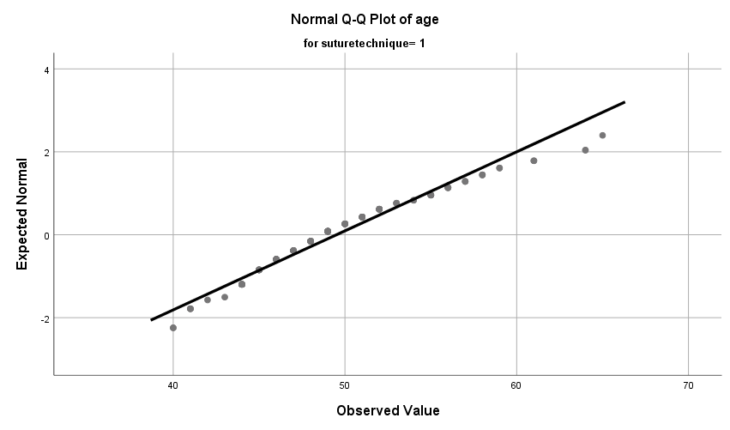

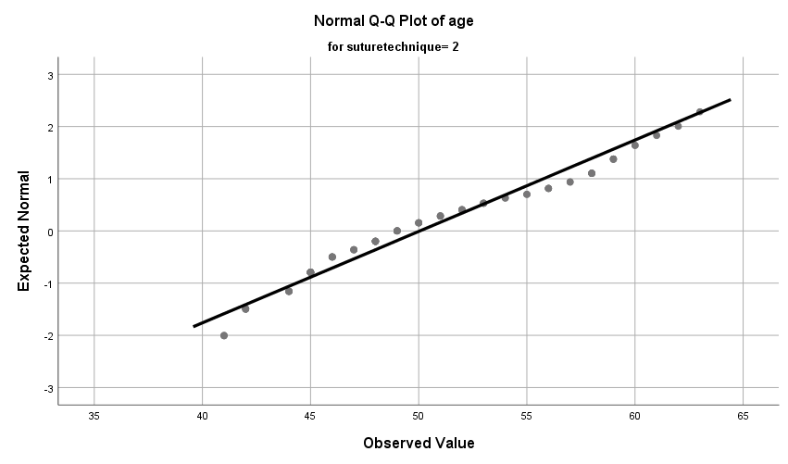

Detrended Normal Q-Q Plots

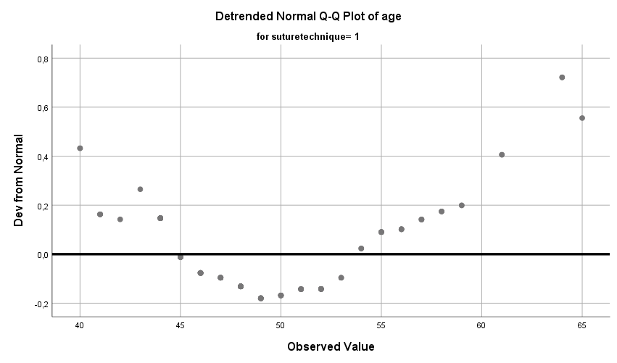

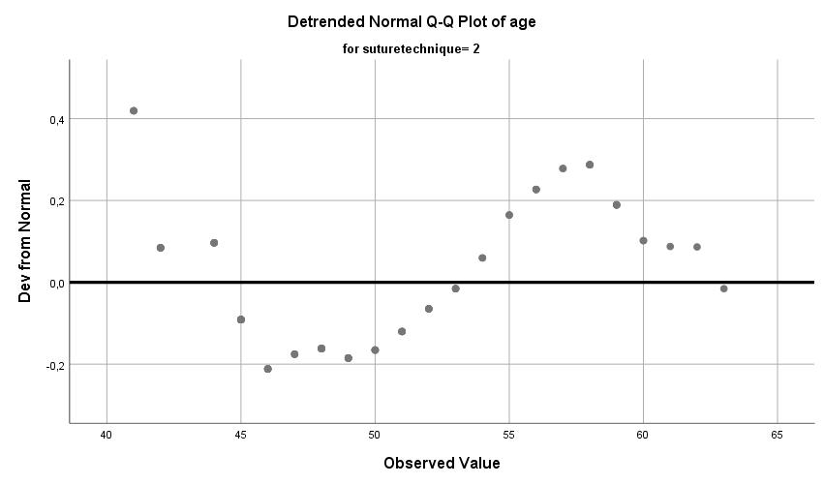

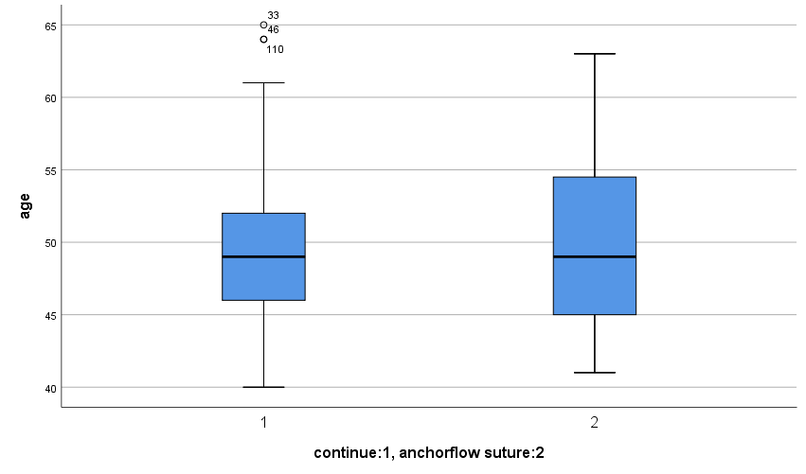

T-TEST GROUPS=suturetechnique(1 2)
/MISSING=ANALYSIS
/VARIABLES=age bmi gravida parity menapausalsitutation indication operationtime
hospitalizationtime
/CRITERIA=CI(.95).

T-Test

Notes
Output Created |  | 07-JAN-2025 23:53:34
Comments
Input | Data | C:\Users\eralp\Desktop\suture techniques.sav
Input | Active Dataset | DataSet1
Input | Filter | <none>
Input | Weight | <none>
Input | Split File | <none>
Input | N of Rows in Working Data File | 208
Missing Value Handling | Definition of Missing | User defined missing values are treated as missing.
Missing Value Handling | Cases Used | Statistics for each analysis are based on the cases with no missing or out-of-range data for any variable in the analysis.
Syntax |  | T-TEST GROUPS=suturetechnique(1 2)  /MISSING=ANALYSIS  /VARIABLES=age bmi gravida parity menapausalsitutation indication operationtime  hospitalizationtime  /CRITERIA=CI(.95).
Resources | Processor Time | 00:00:00,02
Resources | Elapsed Time | 00:00:00,01

Group Statistics
 | continue:1, anchorflow suture:2 | N | Mean | Std. Deviation
age | 1 | 120 | 49,51 | 5,247
age | 2 | 88 | 50,06 | 5,710
bmi | 1 | 120 | 30,54 | 5,002
bmi | 2 | 88 | 29,33 | 4,690
gravida | 1 | 120 | 3,45 | 1,772
gravida | 2 | 88 | 3,32 | 2,003
parity | 1 | 120 | 2,82 | 1,539
parity | 2 | 88 | 2,59 | 1,490
premanopoz:1 postmenopoz: 2 | 1 | 120 | 1,24 | ,430
premanopoz:1 postmenopoz: 2 | 2 | 88 | 1,32 | ,468
auk:1 pmk:2 pmek:3 | 1 | 120 | 1,34 | ,655
auk:1 pmk:2 pmek:3 | 2 | 88 | 1,48 | ,742
minute | 1 | 120 | 103,98 | 37,559
minute | 2 | 88 | 96,13 | 34,500
day | 1 | 120 | 2,02 | ,502
day | 2 | 88 | 1,99 | ,442

Group Statistics
 | continue:1, anchorflow suture:2 | Std. Error Mean
age | 1 | ,479
age | 2 | ,609
bmi | 1 | ,457
bmi | 2 | ,500
gravida | 1 | ,162
gravida | 2 | ,214
parity | 1 | ,141
parity | 2 | ,159
premanopoz:1 postmenopoz: 2 | 1 | ,039
premanopoz:1 postmenopoz: 2 | 2 | ,050
auk:1 pmk:2 pmek:3 | 1 | ,060
auk:1 pmk:2 pmek:3 | 2 | ,079
minute | 1 | 3,429
minute | 2 | 3,678
day | 1 | ,046
day | 2 | ,047

Independent Samples Test
 |  | Levene's Test for Equality of Variances |  | t-test for Equality of Means
 |  | F | Sig. | t
age | Equal variances assumed | 2,063 | ,152 | -,717
age | Equal variances not assumed |  |  | -,708
bmi | Equal variances assumed | ,449 | ,504 | 1,772
bmi | Equal variances not assumed |  |  | 1,790
gravida | Equal variances assumed | 1,347 | ,247 | ,501
gravida | Equal variances not assumed |  |  | ,492
parity | Equal variances assumed | ,205 | ,651 | 1,059
parity | Equal variances not assumed |  |  | 1,064
premanopoz:1 postmenopoz: 2 | Equal variances assumed | 5,652 | ,018 | -1,221
premanopoz:1 postmenopoz: 2 | Equal variances not assumed |  |  | -1,205
auk:1 pmk:2 pmek:3 | Equal variances assumed | 5,056 | ,026 | -1,394
auk:1 pmk:2 pmek:3 | Equal variances not assumed |  |  | -1,367
minute | Equal variances assumed | 1,145 | ,286 | 1,541
minute | Equal variances not assumed |  |  | 1,561
day | Equal variances assumed | ,218 | ,641 | ,418
day | Equal variances not assumed |  |  | ,427

Independent Samples Test
 |  | t-test for Equality of Means
 |  | df | Sig. (2-tailed) | Mean Difference
age | Equal variances assumed | 206 | ,474 | -,548
age | Equal variances not assumed | 178,154 | ,480 | -,548
bmi | Equal variances assumed | 206 | ,078 | 1,212
bmi | Equal variances not assumed | 194,005 | ,075 | 1,212
gravida | Equal variances assumed | 206 | ,617 | ,132
gravida | Equal variances not assumed | 173,693 | ,623 | ,132
parity | Equal variances assumed | 206 | ,291 | ,226
parity | Equal variances not assumed | 190,927 | ,289 | ,226
premanopoz:1 postmenopoz: 2 | Equal variances assumed | 206 | ,224 | -,077
premanopoz:1 postmenopoz: 2 | Equal variances not assumed | 178,007 | ,230 | -,077
auk:1 pmk:2 pmek:3 | Equal variances assumed | 206 | ,165 | -,136
auk:1 pmk:2 pmek:3 | Equal variances not assumed | 173,295 | ,173 | -,136
minute | Equal variances assumed | 206 | ,125 | 7,850
minute | Equal variances not assumed | 195,812 | ,120 | 7,850
day | Equal variances assumed | 206 | ,676 | ,028
day | Equal variances not assumed | 199,147 | ,670 | ,028

Independent Samples Test
 |  | t-test for Equality of Means
 |  | Std. Error Difference | 95% Confidence Interval of the Difference
 |  | Std. Error Difference | Lower
age | Equal variances assumed | ,765 | -2,056
age | Equal variances not assumed | ,775 | -2,077
bmi | Equal variances assumed | ,684 | -,136
bmi | Equal variances not assumed | ,677 | -,123
gravida | Equal variances assumed | ,263 | -,386
gravida | Equal variances not assumed | ,268 | -,397
parity | Equal variances assumed | ,213 | -,195
parity | Equal variances not assumed | ,212 | -,193
premanopoz:1 postmenopoz: 2 | Equal variances assumed | ,063 | -,200
premanopoz:1 postmenopoz: 2 | Equal variances not assumed | ,064 | -,202
auk:1 pmk:2 pmek:3 | Equal variances assumed | ,097 | -,327
auk:1 pmk:2 pmek:3 | Equal variances not assumed | ,099 | -,331
minute | Equal variances assumed | 5,094 | -2,194
minute | Equal variances not assumed | 5,028 | -2,066
day | Equal variances assumed | ,067 | -,104
day | Equal variances not assumed | ,066 | -,102

Independent Samples Test
 |  | t-test for Equality of Means
 |  | 95% Confidence Interval of the Difference
 |  | Upper
age | Equal variances assumed | ,959
age | Equal variances not assumed | ,980
bmi | Equal variances assumed | 2,560
bmi | Equal variances not assumed | 2,548
gravida | Equal variances assumed | ,650
gravida | Equal variances not assumed | ,661
parity | Equal variances assumed | ,646
parity | Equal variances not assumed | ,644
premanopoz:1 postmenopoz: 2 | Equal variances assumed | ,047
premanopoz:1 postmenopoz: 2 | Equal variances not assumed | ,049
auk:1 pmk:2 pmek:3 | Equal variances assumed | ,056
auk:1 pmk:2 pmek:3 | Equal variances not assumed | ,060
minute | Equal variances assumed | 17,894
minute | Equal variances not assumed | 17,766
day | Equal variances assumed | ,160
day | Equal variances not assumed | ,158

EXAMINE VARIABLES=age BY suturetechnique
/PLOT BOXPLOT STEMLEAF NPPLOT
/COMPARE GROUPS
/STATISTICS DESCRIPTIVES
/CINTERVAL 95
/MISSING LISTWISE
/NOTOTAL.

Explore

Notes
Output Created |  | 07-JAN-2025 23:57:25
Comments
Input | Data | C:\Users\eralp\Desktop\suture techniques.sav
Input | Active Dataset | DataSet1
Input | Filter | <none>
Input | Weight | <none>
Input | Split File | <none>
Input | N of Rows in Working Data File | 208
Missing Value Handling | Definition of Missing | User-defined missing values for dependent variables are treated as missing.
Missing Value Handling | Cases Used | Statistics are based on cases with no missing values for any dependent variable or factor used.
Syntax |  | EXAMINE VARIABLES=age BY suturetechnique  /PLOT BOXPLOT STEMLEAF NPPLOT  /COMPARE GROUPS  /STATISTICS DESCRIPTIVES  /CINTERVAL 95  /MISSING LISTWISE  /NOTOTAL.
Resources | Processor Time | 00:00:03,86
Resources | Elapsed Time | 00:00:01,33

continue:1, anchorflow suture:2

Case Processing Summary
 | continue:1, anchorflow suture:2 | Cases
 | continue:1, anchorflow suture:2 | Valid |  | Missing |  | Total
 | continue:1, anchorflow suture:2 | N | Percent | N | Percent | N
age | 1 | 120 | 100,0% | 0 | 0,0% | 120
age | 2 | 88 | 100,0% | 0 | 0,0% | 88

Case Processing Summary
 | continue:1, anchorflow suture:2 | Cases
 | continue:1, anchorflow suture:2 | Total
 | continue:1, anchorflow suture:2 | Percent
age | 1 | 100,0%
age | 2 | 100,0%

Descriptives
 | continue:1, anchorflow suture:2 |  |  | Statistic | Std. Error
age | 1 | Mean |  | 49,51 | ,479
age | 1 | 95% Confidence Interval for Mean | Lower Bound | 48,56
age | 1 | 95% Confidence Interval for Mean | Upper Bound | 50,46
age | 1 | 5% Trimmed Mean |  | 49,29
age | 1 | Median |  | 49,00
age | 1 | Variance |  | 27,529
age | 1 | Std. Deviation |  | 5,247
age | 1 | Minimum |  | 40
age | 1 | Maximum |  | 65
age | 1 | Range |  | 25
age | 1 | Interquartile Range |  | 6
age | 1 | Skewness |  | ,713 | ,221
age | 1 | Kurtosis |  | ,353 | ,438
age | 2 | Mean |  | 50,06 | ,609
age | 2 | 95% Confidence Interval for Mean | Lower Bound | 48,85
age | 2 | 95% Confidence Interval for Mean | Upper Bound | 51,27
age | 2 | 5% Trimmed Mean |  | 49,91
age | 2 | Median |  | 49,00
age | 2 | Variance |  | 32,606
age | 2 | Std. Deviation |  | 5,710
age | 2 | Minimum |  | 41
age | 2 | Maximum |  | 63
age | 2 | Range |  | 22
age | 2 | Interquartile Range |  | 10
age | 2 | Skewness |  | ,416 | ,257
age | 2 | Kurtosis |  | -,828 | ,508

Tests of Normality
 | continue:1, anchorflow suture:2 | Kolmogorov-Smirnovª |  |  | Shapiro-Wilk
 | continue:1, anchorflow suture:2 | Statistic | df | Sig. | Statistic | df
age | 1 | ,114 | 120 | ,001 | ,959 | 120
age | 2 | ,108 | 88 | ,014 | ,952 | 88

Tests of Normality
 | continue:1, anchorflow suture:2 | Shapiro-Wilkª
 | continue:1, anchorflow suture:2 | Sig.
age | 1 | ,001
age | 2 | ,003

a. Lilliefors Significance Correction

age

Stem-and-Leaf Plots

age Stem-and-Leaf Plot for
suturetechnique= 1

Frequency Stem & Leaf

6,00 4 . 001111
2,00 4 . 23
20,00 4 . 44444444444555555555
18,00 4 . 666666666677777777
23,00 4 . 88888888888889999999999
15,00 5 . 000000011111111
11,00 5 . 22222222333
8,00 5 . 44555555
7,00 5 . 6666777
5,00 5 . 88899
2,00 6 . 11
3,00 Extremes (>=64)

Stem width: 10
Each leaf: 1 case(s)

age Stem-and-Leaf Plot for
suturetechnique= 2

Frequency Stem & Leaf

13,00 4 . 1112222244444
34,00 4 . 5555555555566666677788888888999999
19,00 5 . 0000011112222333344
17,00 5 . 55666677888889999
5,00 6 . 00123

Stem width: 10
Each leaf: 1 case(s)

Normal Q-Q Plots

Detrended Normal Q-Q Plots

NPAR TESTS
/M-W= age BY suturetechnique(1 2)
/MISSING ANALYSIS.

NPar Tests

Notes
Output Created |  | 07-JAN-2025 23:58:52
Comments
Input | Data | C:\Users\eralp\Desktop\suture techniques.sav
Input | Active Dataset | DataSet1
Input | Filter | <none>
Input | Weight | <none>
Input | Split File | <none>
Input | N of Rows in Working Data File | 208
Missing Value Handling | Definition of Missing | User-defined missing values are treated as missing.
Missing Value Handling | Cases Used | Statistics for each test are based on all cases with valid data for the variable(s) used in that test.
Syntax |  | NPAR TESTS  /M-W= age BY suturetechnique(1 2)  /MISSING ANALYSIS.
Resources | Processor Time | 00:00:00,02
Resources | Elapsed Time | 00:00:00,00
Resources | Number of Cases Allowedª | 449389

a. Based on availability of workspace memory.

Mann-Whitney Test

Ranks
 | continue:1, anchorflow suture:2 | N | Mean Rank | Sum of Ranks
age | 1 | 120 | 102,42 | 12290,50
age | 2 | 88 | 107,34 | 9445,50
age | Total | 208

Test Statisticsª
 | age
Mann-Whitney U | 5030,500
Wilcoxon W | 12290,500
Z | -,583
Asymp. Sig. (2-tailed) | ,560

a. Grouping Variable: continue:1, anchorflow suture:2

NPAR TESTS
/M-W= bmi BY suturetechnique(1 2)
/MISSING ANALYSIS.

NPar Tests

Notes
Output Created |  | 08-JAN-2025 00:01:22
Comments
Input | Data | C:\Users\eralp\Desktop\suture techniques.sav
Input | Active Dataset | DataSet1
Input | Filter | <none>
Input | Weight | <none>
Input | Split File | <none>
Input | N of Rows in Working Data File | 208
Missing Value Handling | Definition of Missing | User-defined missing values are treated as missing.
Missing Value Handling | Cases Used | Statistics for each test are based on all cases with valid data for the variable(s) used in that test.
Syntax |  | NPAR TESTS  /M-W= bmi BY suturetechnique(1 2)  /MISSING ANALYSIS.
Resources | Processor Time | 00:00:00,02
Resources | Elapsed Time | 00:00:00,01
Resources | Number of Cases Allowedª | 449389

a. Based on availability of workspace memory.

Mann-Whitney Test

Ranks
 | continue:1, anchorflow suture:2 | N | Mean Rank | Sum of Ranks
bmi | 1 | 120 | 110,88 | 13305,00
bmi | 2 | 88 | 95,81 | 8431,00
bmi | Total | 208

Test Statisticsª
 | bmi
Mann-Whitney U | 4515,000
Wilcoxon W | 8431,000
Z | -1,787
Asymp. Sig. (2-tailed) | ,074

a. Grouping Variable: continue:1, anchorflow suture:2

NPAR TESTS
/M-W= gravida BY suturetechnique(1 2)
/MISSING ANALYSIS.

NPar Tests

Notes
Output Created |  | 08-JAN-2025 00:03:50
Comments
Input | Data | C:\Users\eralp\Desktop\suture techniques.sav
Input | Active Dataset | DataSet1
Input | Filter | <none>
Input | Weight | <none>
Input | Split File | <none>
Input | N of Rows in Working Data File | 208
Missing Value Handling | Definition of Missing | User-defined missing values are treated as missing.
Missing Value Handling | Cases Used | Statistics for each test are based on all cases with valid data for the variable(s) used in that test.
Syntax |  | NPAR TESTS  /M-W= gravida BY suturetechnique(1 2)  /MISSING ANALYSIS.
Resources | Processor Time | 00:00:00,00
Resources | Elapsed Time | 00:00:00,03
Resources | Number of Cases Allowedª | 449389

a. Based on availability of workspace memory.

Mann-Whitney Test

Ranks
 | continue:1, anchorflow suture:2 | N | Mean Rank | Sum of Ranks
gravida | 1 | 120 | 107,74 | 12928,50
gravida | 2 | 88 | 100,09 | 8807,50
gravida | Total | 208

Test Statisticsª
 | gravida
Mann-Whitney U | 4891,500
Wilcoxon W | 8807,500
Z | -,924
Asymp. Sig. (2-tailed) | ,356

a. Grouping Variable: continue:1, anchorflow suture:2

NPAR TESTS
/M-W= parity BY suturetechnique(1 2)
/MISSING ANALYSIS.

NPar Tests

Notes
Output Created |  | 08-JAN-2025 00:04:27
Comments
Input | Data | C:\Users\eralp\Desktop\suture techniques.sav
Input | Active Dataset | DataSet1
Input | Filter | <none>
Input | Weight | <none>
Input | Split File | <none>
Input | N of Rows in Working Data File | 208
Missing Value Handling | Definition of Missing | User-defined missing values are treated as missing.
Missing Value Handling | Cases Used | Statistics for each test are based on all cases with valid data for the variable(s) used in that test.
Syntax |  | NPAR TESTS  /M-W= parity BY suturetechnique(1 2)  /MISSING ANALYSIS.
Resources | Processor Time | 00:00:00,00
Resources | Elapsed Time | 00:00:00,01
Resources | Number of Cases Allowedª | 449389

a. Based on availability of workspace memory.

Mann-Whitney Test

Ranks
 | continue:1, anchorflow suture:2 | N | Mean Rank | Sum of Ranks
parity | 1 | 120 | 108,46 | 13015,50
parity | 2 | 88 | 99,10 | 8720,50
parity | Total | 208

Test Statisticsª
 | parity
Mann-Whitney U | 4804,500
Wilcoxon W | 8720,500
Z | -1,144
Asymp. Sig. (2-tailed) | ,253

a. Grouping Variable: continue:1, anchorflow suture:2

NPAR TESTS
/M-W= menapausalsitutation BY suturetechnique(1 2)
/MISSING ANALYSIS.

NPar Tests

Notes
Output Created |  | 08-JAN-2025 00:04:57
Comments
Input | Data | C:\Users\eralp\Desktop\suture techniques.sav
Input | Active Dataset | DataSet1
Input | Filter | <none>
Input | Weight | <none>
Input | Split File | <none>
Input | N of Rows in Working Data File | 208
Missing Value Handling | Definition of Missing | User-defined missing values are treated as missing.
Missing Value Handling | Cases Used | Statistics for each test are based on all cases with valid data for the variable(s) used in that test.
Syntax |  | NPAR TESTS  /M-W= menapausalsitutation BY suturetechnique(1 2)  /MISSING ANALYSIS.
Resources | Processor Time | 00:00:00,02
Resources | Elapsed Time | 00:00:00,01
Resources | Number of Cases Allowedª | 449389

a. Based on availability of workspace memory.

Mann-Whitney Test

Ranks
 | continue:1, anchorflow suture:2 | N | Mean Rank | Sum of Ranks
premanopoz:1 postmenopoz: 2 | 1 | 120 | 101,13 | 12136,00
premanopoz:1 postmenopoz: 2 | 2 | 88 | 109,09 | 9600,00
premanopoz:1 postmenopoz: 2 | Total | 208

Test Statisticsª
 | premanopoz:1 postmenopoz: 2
Mann-Whitney U | 4876,000
Wilcoxon W | 12136,000
Z | -1,219
Asymp. Sig. (2-tailed) | ,223

a. Grouping Variable: continue:1, anchorflow suture:2

NPAR TESTS
/M-W= operationtime BY suturetechnique(1 2)
/MISSING ANALYSIS.

NPar Tests

Notes
Output Created |  | 08-JAN-2025 00:05:35
Comments
Input | Data | C:\Users\eralp\Desktop\suture techniques.sav
Input | Active Dataset | DataSet1
Input | Filter | <none>
Input | Weight | <none>
Input | Split File | <none>
Input | N of Rows in Working Data File | 208
Missing Value Handling | Definition of Missing | User-defined missing values are treated as missing.
Missing Value Handling | Cases Used | Statistics for each test are based on all cases with valid data for the variable(s) used in that test.
Syntax |  | NPAR TESTS  /M-W= operationtime BY suturetechnique(1 2)  /MISSING ANALYSIS.
Resources | Processor Time | 00:00:00,02
Resources | Elapsed Time | 00:00:00,02
Resources | Number of Cases Allowedª | 449389

a. Based on availability of workspace memory.

Mann-Whitney Test

Ranks
 | continue:1, anchorflow suture:2 | N | Mean Rank | Sum of Ranks
minute | 1 | 120 | 109,63 | 13155,00
minute | 2 | 88 | 97,51 | 8581,00
minute | Total | 208

Test Statisticsª
 | minute
Mann-Whitney U | 4665,000
Wilcoxon W | 8581,000
Z | -1,449
Asymp. Sig. (2-tailed) | ,147

a. Grouping Variable: continue:1, anchorflow suture:2

NPAR TESTS
/M-W= hospitalizationtime BY suturetechnique(1 2)
/MISSING ANALYSIS.

NPar Tests

Notes
Output Created |  | 08-JAN-2025 00:06:18
Comments
Input | Data | C:\Users\eralp\Desktop\suture techniques.sav
Input | Active Dataset | DataSet1
Input | Filter | <none>
Input | Weight | <none>
Input | Split File | <none>
Input | N of Rows in Working Data File | 208
Missing Value Handling | Definition of Missing | User-defined missing values are treated as missing.
Missing Value Handling | Cases Used | Statistics for each test are based on all cases with valid data for the variable(s) used in that test.
Syntax |  | NPAR TESTS  /M-W= hospitalizationtime BY suturetechnique(1 2)  /MISSING ANALYSIS.
Resources | Processor Time | 00:00:00,00
Resources | Elapsed Time | 00:00:00,01
Resources | Number of Cases Allowedª | 449389

a. Based on availability of workspace memory.

Mann-Whitney Test

Ranks
 | continue:1, anchorflow suture:2 | N | Mean Rank | Sum of Ranks
day | 1 | 120 | 105,02 | 12602,00
day | 2 | 88 | 103,80 | 9134,00
day | Total | 208

Test Statisticsª
 | day
Mann-Whitney U | 5218,000
Wilcoxon W | 9134,000
Z | -,209
Asymp. Sig. (2-tailed) | ,835

a. Grouping Variable: continue:1, anchorflow suture:2

DESCRIPTIVES VARIABLES=hctchanges suturationtime
/STATISTICS=MEAN STDDEV MIN MAX.

Descriptives

Notes
Output Created |  | 08-JAN-2025 00:40:47
Comments
Input | Data | C:\Users\eralp\Desktop\suture techniques.sav
Input | Active Dataset | DataSet1
Input | Filter | <none>
Input | Weight | <none>
Input | Split File | <none>
Input | N of Rows in Working Data File | 223
Missing Value Handling | Definition of Missing | User defined missing values are treated as missing.
Missing Value Handling | Cases Used | All non-missing data are used.
Syntax |  | DESCRIPTIVES VARIABLES=hctchanges suturationtime  /STATISTICS=MEAN STDDEV MIN MAX.
Resources | Processor Time | 00:00:00,00
Resources | Elapsed Time | 00:00:00,00

Descriptive Statistics
 | N | Minimum | Maximum | Mean | Std. Deviation
hctchanges | 208 | -53,2 | 11,6 | 4,314 | 4,6706
minute | 208 | 6 | 21 | 12,05 | 3,044
Valid N (listwise) | 208

DESCRIPTIVES VARIABLES=hctchanges suturationtime
/STATISTICS=MEAN STDDEV MIN MAX.

Descriptives

Notes
Output Created |  | 08-JAN-2025 00:41:14
Comments
Input | Data | C:\Users\eralp\Desktop\suture techniques.sav
Input | Active Dataset | DataSet1
Input | Filter | <none>
Input | Weight | <none>
Input | Split File | <none>
Input | N of Rows in Working Data File | 223
Missing Value Handling | Definition of Missing | User defined missing values are treated as missing.
Missing Value Handling | Cases Used | All non-missing data are used.
Syntax |  | DESCRIPTIVES VARIABLES=hctchanges suturationtime  /STATISTICS=MEAN STDDEV MIN MAX.
Resources | Processor Time | 00:00:00,00
Resources | Elapsed Time | 00:00:00,01

Descriptive Statistics
 | N | Minimum | Maximum | Mean | Std. Deviation
hctchanges | 208 | -53,2 | 11,6 | 4,314 | 4,6706
minute | 208 | 6 | 21 | 12,05 | 3,044
Valid N (listwise) | 208

DESCRIPTIVES VARIABLES=hctchanges suturationtime
/STATISTICS=MEAN STDDEV MIN MAX.

Descriptives

Notes
Output Created |  | 08-JAN-2025 00:42:33
Comments
Input | Data | C:\Users\eralp\Desktop\suture techniques.sav
Input | Active Dataset | DataSet1
Input | Filter | <none>
Input | Weight | <none>
Input | Split File | <none>
Input | N of Rows in Working Data File | 223
Missing Value Handling | Definition of Missing | User defined missing values are treated as missing.
Missing Value Handling | Cases Used | All non-missing data are used.
Syntax |  | DESCRIPTIVES VARIABLES=hctchanges suturationtime  /STATISTICS=MEAN STDDEV MIN MAX.
Resources | Processor Time | 00:00:00,00
Resources | Elapsed Time | 00:00:00,01

Descriptive Statistics
 | N | Minimum | Maximum | Mean | Std. Deviation
hctchanges | 208 | ,2 | 11,6 | 4,625 | 2,2877
minute | 208 | 6 | 21 | 12,05 | 3,044
Valid N (listwise) | 208

NPAR TESTS
/M-W= suturationtime BY suturetechnique(1 2)
/MISSING ANALYSIS.

NPar Tests

Notes
Output Created |  | 08-JAN-2025 00:43:20
Comments
Input | Data | C:\Users\eralp\Desktop\suture techniques.sav
Input | Active Dataset | DataSet1
Input | Filter | <none>
Input | Weight | <none>
Input | Split File | <none>
Input | N of Rows in Working Data File | 223
Missing Value Handling | Definition of Missing | User-defined missing values are treated as missing.
Missing Value Handling | Cases Used | Statistics for each test are based on all cases with valid data for the variable(s) used in that test.
Syntax |  | NPAR TESTS  /M-W= suturationtime BY suturetechnique(1 2)  /MISSING ANALYSIS.
Resources | Processor Time | 00:00:00,00
Resources | Elapsed Time | 00:00:00,01
Resources | Number of Cases Allowedª | 449389

a. Based on availability of workspace memory.

Mann-Whitney Test

Ranks
 | continue:1, anchorflow suture:2 | N | Mean Rank | Sum of Ranks
minute | 1 | 120 | 131,81 | 15817,00
minute | 2 | 88 | 67,26 | 5919,00
minute | Total | 208

Test Statisticsª
 | minute
Mann-Whitney U | 2003,000
Wilcoxon W | 5919,000
Z | -7,643
Asymp. Sig. (2-tailed) | ,000

a. Grouping Variable: continue:1, anchorflow suture:2

EXAMINE VARIABLES=operationtime suturationtime BY suturetechnique
/PLOT BOXPLOT STEMLEAF NPPLOT
/COMPARE GROUPS
/STATISTICS DESCRIPTIVES
/CINTERVAL 95
/MISSING LISTWISE
/NOTOTAL.

Explore

Notes
Output Created |  | 08-JAN-2025 00:44:45
Comments
Input | Data | C:\Users\eralp\Desktop\suture techniques.sav
Input | Active Dataset | DataSet1
Input | Filter | <none>
Input | Weight | <none>
Input | Split File | <none>
Input | N of Rows in Working Data File | 223
Missing Value Handling | Definition of Missing | User-defined missing values for dependent variables are treated as missing.
Missing Value Handling | Cases Used | Statistics are based on cases with no missing values for any dependent variable or factor used.
Syntax |  | EXAMINE VARIABLES=operationtime suturationtime BY suturetechnique  /PLOT BOXPLOT STEMLEAF NPPLOT  /COMPARE GROUPS  /STATISTICS DESCRIPTIVES  /CINTERVAL 95  /MISSING LISTWISE  /NOTOTAL.
Resources | Processor Time | 00:00:04,09
Resources | Elapsed Time | 00:00:01,80

continue:1, anchorflow suture:2

Case Processing Summary
 | continue:1, anchorflow suture:2 | Cases
 | continue:1, anchorflow suture:2 | Valid |  | Missing |  | Total
 | continue:1, anchorflow suture:2 | N | Percent | N | Percent | N
minute | 1 | 120 | 100,0% | 0 | 0,0% | 120
minute | 2 | 88 | 100,0% | 0 | 0,0% | 88
minute | 1 | 120 | 100,0% | 0 | 0,0% | 120
minute | 2 | 88 | 100,0% | 0 | 0,0% | 88

Case Processing Summary
 | continue:1, anchorflow suture:2 | Cases
 | continue:1, anchorflow suture:2 | Total
 | continue:1, anchorflow suture:2 | Percent
minute | 1 | 100,0%
minute | 2 | 100,0%
minute | 1 | 100,0%
minute | 2 | 100,0%

Descriptives
 | continue:1, anchorflow suture:2 |  |  | Statistic | Std. Error
minute | 1 | Mean |  | 103,98 | 3,429
minute | 1 | 95% Confidence Interval for Mean | Lower Bound | 97,19
minute | 1 | 95% Confidence Interval for Mean | Upper Bound | 110,76
minute | 1 | 5% Trimmed Mean |  | 101,71
minute | 1 | Median |  | 90,00
minute | 1 | Variance |  | 1410,697
minute | 1 | Std. Deviation |  | 37,559
minute | 1 | Minimum |  | 45
minute | 1 | Maximum |  | 240
minute | 1 | Range |  | 195
minute | 1 | Interquartile Range |  | 40
minute | 1 | Skewness |  | ,931 | ,221
minute | 1 | Kurtosis |  | ,763 | ,438
minute | 2 | Mean |  | 96,13 | 3,678
minute | 2 | 95% Confidence Interval for Mean | Lower Bound | 88,82
minute | 2 | 95% Confidence Interval for Mean | Upper Bound | 103,43
minute | 2 | 5% Trimmed Mean |  | 93,57
minute | 2 | Median |  | 90,00
minute | 2 | Variance |  | 1190,226
minute | 2 | Std. Deviation |  | 34,500
minute | 2 | Minimum |  | 37
minute | 2 | Maximum |  | 210
minute | 2 | Range |  | 173
minute | 2 | Interquartile Range |  | 47
minute | 2 | Skewness |  | 1,054 | ,257
minute | 2 | Kurtosis |  | 1,574 | ,508
minute | 1 | Mean |  | 13,36 | ,258
minute | 1 | 95% Confidence Interval for Mean | Lower Bound | 12,85
minute | 1 | 95% Confidence Interval for Mean | Upper Bound | 13,87
minute | 1 | 5% Trimmed Mean |  | 13,36
minute | 1 | Median |  | 13,20
minute | 1 | Variance |  | 8,007
minute | 1 | Std. Deviation |  | 2,830
minute | 1 | Minimum |  | 6
minute | 1 | Maximum |  | 21
minute | 1 | Range |  | 15
minute | 1 | Interquartile Range |  | 3
minute | 1 | Skewness |  | ,082 | ,221
minute | 1 | Kurtosis |  | ,091 | ,438
minute | 2 | Mean |  | 10,26 | ,250
minute | 2 | 95% Confidence Interval for Mean | Lower Bound | 9,77
minute | 2 | 95% Confidence Interval for Mean | Upper Bound | 10,76
minute | 2 | 5% Trimmed Mean |  | 10,16
minute | 2 | Median |  | 10,00
minute | 2 | Variance |  | 5,498
minute | 2 | Std. Deviation |  | 2,345
minute | 2 | Minimum |  | 6
minute | 2 | Maximum |  | 18
minute | 2 | Range |  | 12
minute | 2 | Interquartile Range |  | 3
minute | 2 | Skewness |  | ,754 | ,257
minute | 2 | Kurtosis |  | 1,007 | ,508

Tests of Normality
 | continue:1, anchorflow suture:2 | Kolmogorov-Smirnovª |  |  | Shapiro-Wilk
 | continue:1, anchorflow suture:2 | Statistic | df | Sig. | Statistic | df
minute | 1 | ,187 | 120 | ,000 | ,923 | 120
minute | 2 | ,150 | 88 | ,000 | ,910 | 88
minute | 1 | ,069 | 120 | ,200* | ,989 | 120
minute | 2 | ,096 | 88 | ,042 | ,962 | 88

Tests of Normality
 | continue:1, anchorflow suture:2 | Shapiro-Wilkª
 | continue:1, anchorflow suture:2 | Sig.
minute | 1 | ,000
minute | 2 | ,000
minute | 1 | ,466
minute | 2 | ,010

*. This is a lower bound of the true significance.
a. Lilliefors Significance Correction

minute

Stem-and-Leaf Plots

minute Stem-and-Leaf Plot for
suturetechnique= 1

Frequency Stem & Leaf

1,00 4 . 5
3,00 5 . 005
17,00 6 . 00000000000000005
8,00 7 . 00055555
7,00 8 . 0000000
31,00 9 . 0000000000000000000000000000055
5,00 10 . 00555
2,00 11 . 00
21,00 12 . 000000000000000000000
5,00 13 . 00055
1,00 14 . 0
7,00 15 . 0000000
2,00 16 . 00
1,00 17 . 0
5,00 18 . 00000
4,00 Extremes (>=187)

Stem width: 10
Each leaf: 1 case(s)

minute Stem-and-Leaf Plot for
suturetechnique= 2

Frequency Stem & Leaf

1,00 0 . 3
3,00 0 . 445
25,00 0 . 6666666666666667777777777
24,00 0 . 888888899999999999999999
6,00 1 . 000011
22,00 1 . 2222222222222222222233
2,00 1 . 44
,00 1 .
2,00 1 . 88
3,00 Extremes (>=195)

Stem width: 100
Each leaf: 1 case(s)

Normal Q-Q Plots

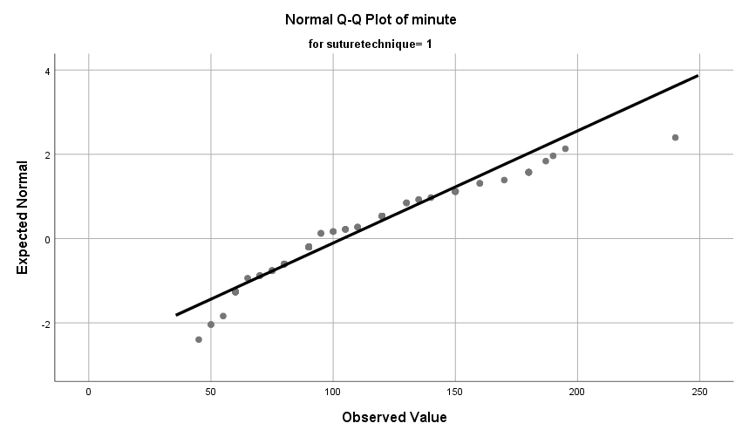

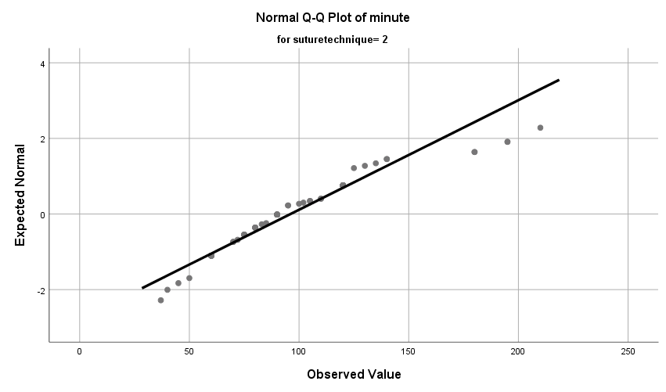

Detrended Normal Q-Q Plots

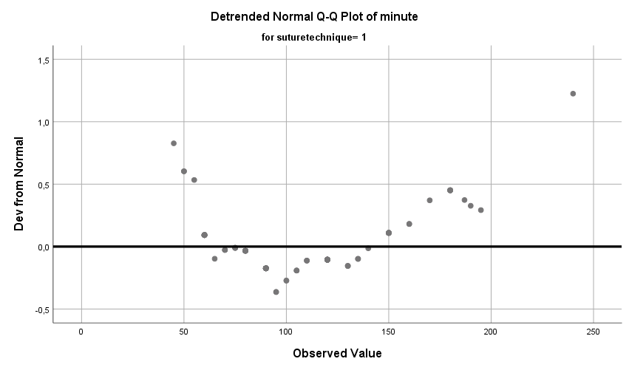

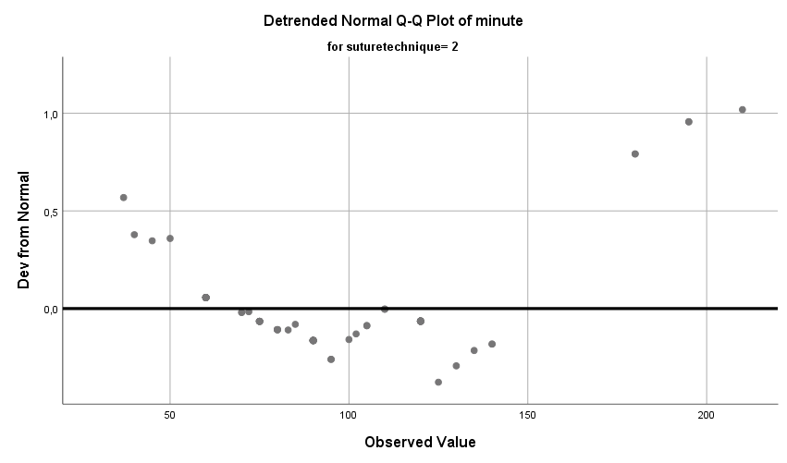

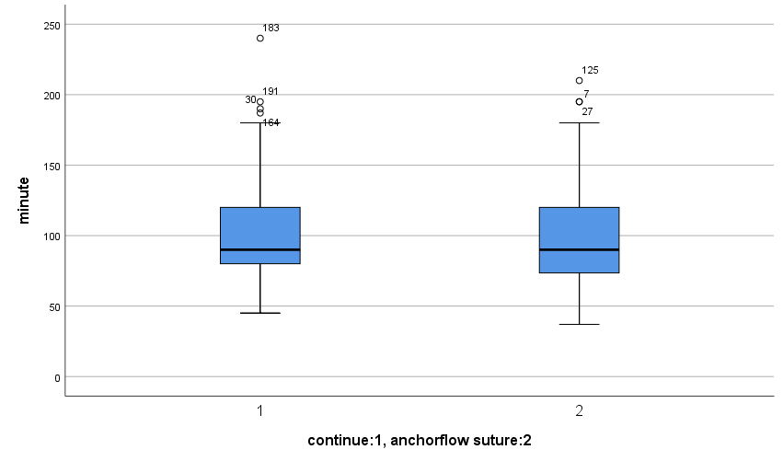

minute

Stem-and-Leaf Plots

minute Stem-and-Leaf Plot for
suturetechnique= 1

Frequency Stem & Leaf

3,00 Extremes (=<7,7)
2,00 7 . 88
2,00 8 . 34
7,00 9 . 1233369
6,00 10 . 012458
10,00 11 . 0012457799
24,00 12 . 000000112233446667778899
17,00 13 . 00011223345567889
20,00 14 . 00011134555555566778
9,00 15 . 001245689
6,00 16 . 335566
4,00 17 . 0189
6,00 18 . 002239
4,00 Extremes (>=19,1)

Stem width: 1
Each leaf: 1 case(s)

minute Stem-and-Leaf Plot for
suturetechnique= 2

Frequency Stem & Leaf

4,00 6 . 0055
6,00 7 . 000005
14,00 8 . 00000445557799
16,00 9 . 0000000115555568
16,00 10 . 0000033555555555
12,00 11 . 000000225558
10,00 12 . 0000011255
2,00 13 . 05
3,00 14 . 013
3,00 15 . 001
2,00 Extremes (>=17,0)

Stem width: 1
Each leaf: 1 case(s)

Normal Q-Q Plots

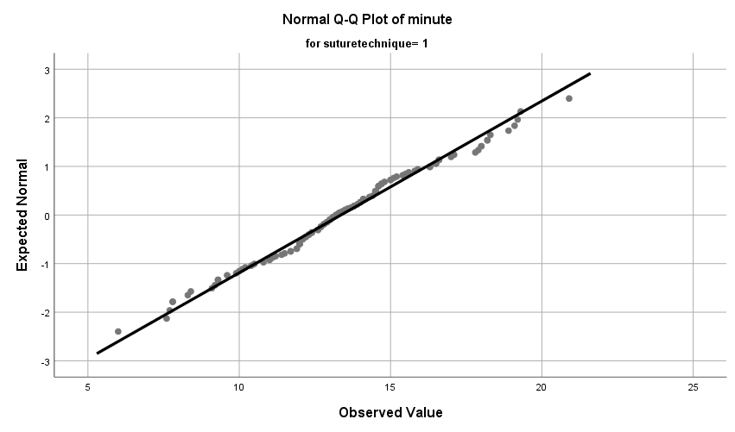

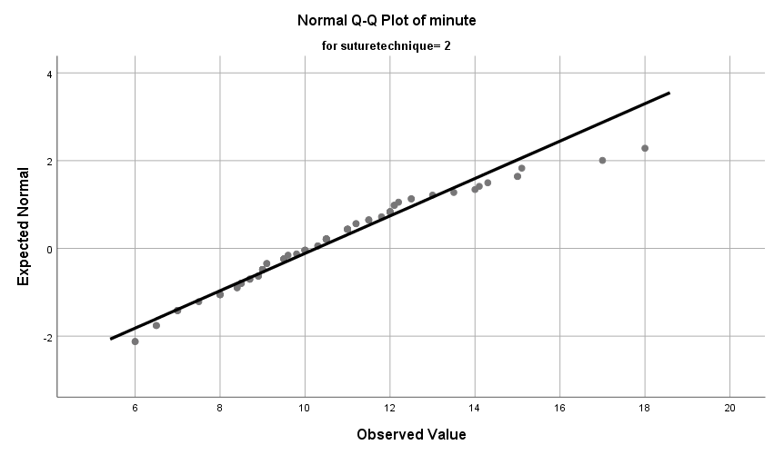

Detrended Normal Q-Q Plots

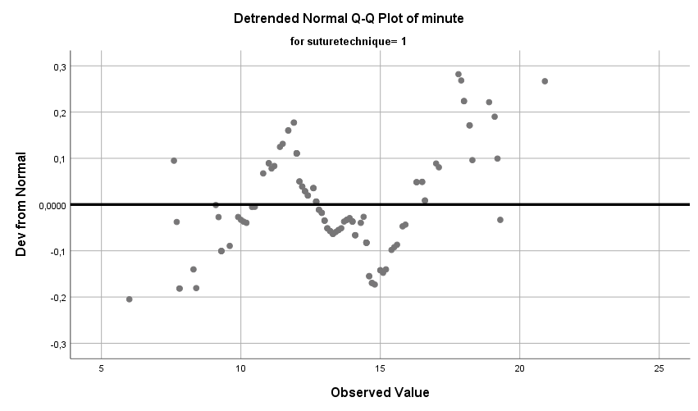

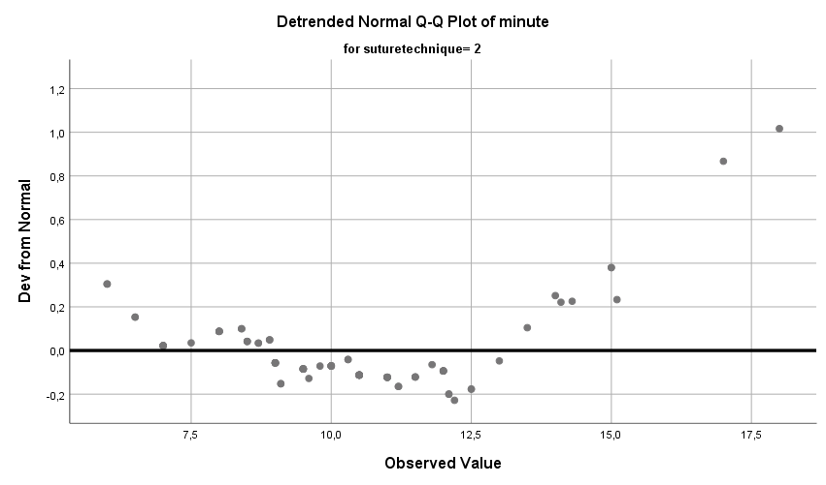

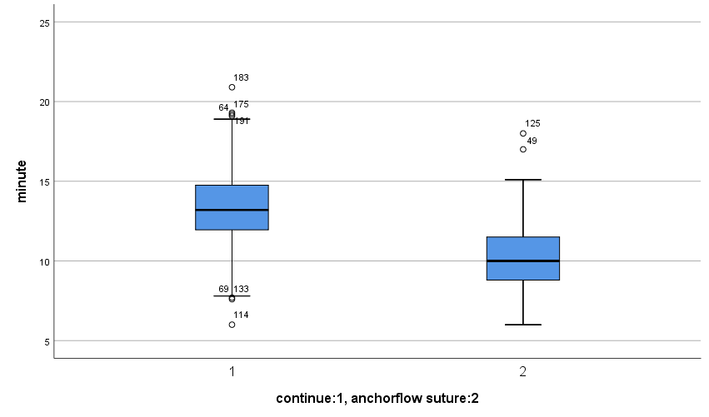

NPAR TESTS
/M-W= hctchanges BY suturetechnique(1 2)
/MISSING ANALYSIS.

NPar Tests

Notes
Output Created |  | 08-JAN-2025 00:45:30
Comments
Input | Data | C:\Users\eralp\Desktop\suture techniques.sav
Input | Active Dataset | DataSet1
Input | Filter | <none>
Input | Weight | <none>
Input | Split File | <none>
Input | N of Rows in Working Data File | 223
Missing Value Handling | Definition of Missing | User-defined missing values are treated as missing.
Missing Value Handling | Cases Used | Statistics for each test are based on all cases with valid data for the variable(s) used in that test.
Syntax |  | NPAR TESTS  /M-W= hctchanges BY suturetechnique(1 2)  /MISSING ANALYSIS.
Resources | Processor Time | 00:00:00,00
Resources | Elapsed Time | 00:00:00,01
Resources | Number of Cases Allowedª | 449389

a. Based on availability of workspace memory.

Mann-Whitney Test

Ranks
 | continue:1, anchorflow suture:2 | N | Mean Rank | Sum of Ranks
hctchanges | 1 | 120 | 107,04 | 12845,00
hctchanges | 2 | 88 | 101,03 | 8891,00
hctchanges | Total | 208

Test Statisticsª
 | hctchanges
Mann-Whitney U | 4975,000
Wilcoxon W | 8891,000
Z | -,711
Asymp. Sig. (2-tailed) | ,477

a. Grouping Variable: continue:1, anchorflow suture:2

