No persistent database was used in the project. A console-based project was created with Maven and JUnit unit tests were applied. When the project runs, a menu appears on the console. Using log.info () instead of System.out.println(), text is printed to the console.

Main Class

Console Output

With the Run method, the menu on the console can be displayed. The methods in the ProductService class are called according to the selection made.

ConsoleUI class run method

The Product Service class has methods to do the related work. This class includes the methods of adding, deleting, listing, purchasing, and searching for products.

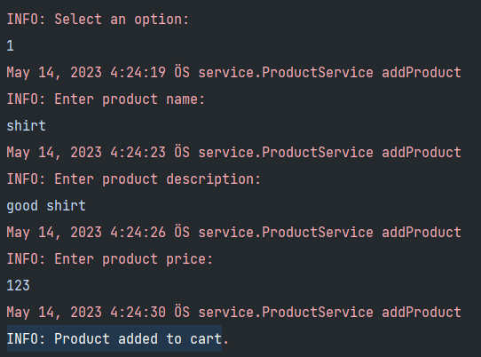Add Product: In order to add a product, input is taken for name, description, price, weight, is digital, values. And the product is added.

Product Added Console Output

Add Product Method

List Product: The products in the cart are listed.

List Product Method Console Output

List Product Method

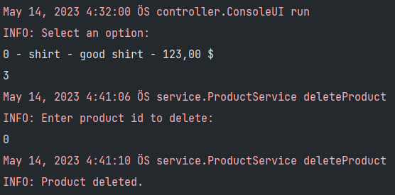Delete Product: The product can be deleted by entering the product id.

Delete Product Method Console Output

Delete Product Method

With this method, it is possible to find the product with the id of the product.

Find Product Method

Find Product Method Console Output

Buy Product:

Calculate Total Weight and Shipping Cost

Input For Payment 1

If the card is empty

Switch-Case For Payment and If Type is Credit Card Option

Output Relevant Data For Credit Card Payment

End of Buy

If Payment Type Is PAYPAL And Output Relevant Data

If Payment Type Is Cash On Delivery And Invalid Message

Shopping Cart Class:

The class that performs the main operations

**UNIT TESTS**

Unit test code coverage rate in the project is 50%.

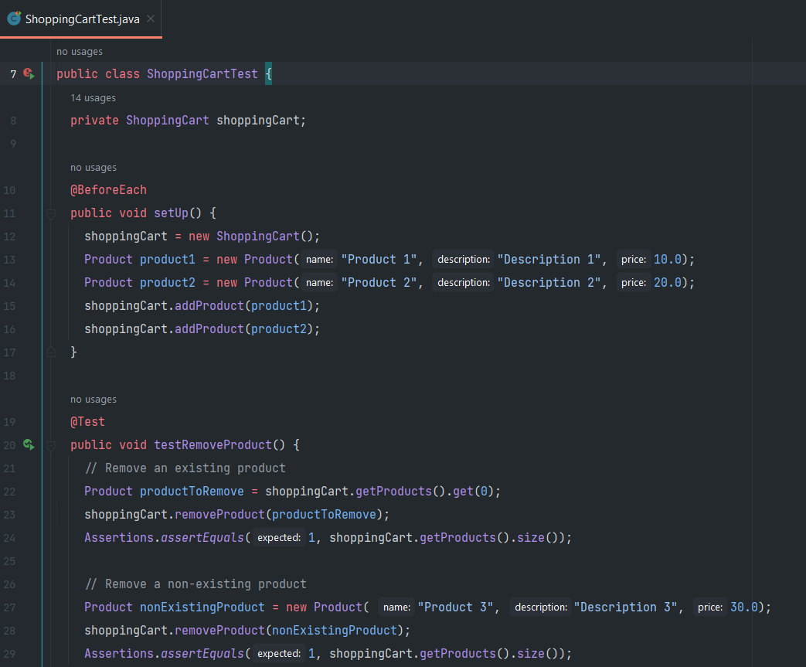

setUp Method

Remove Method Unit Test

Add Product Method Test

Clear Cart Method Test