Social Network Analysis

Jakob Berg

14.06.2020

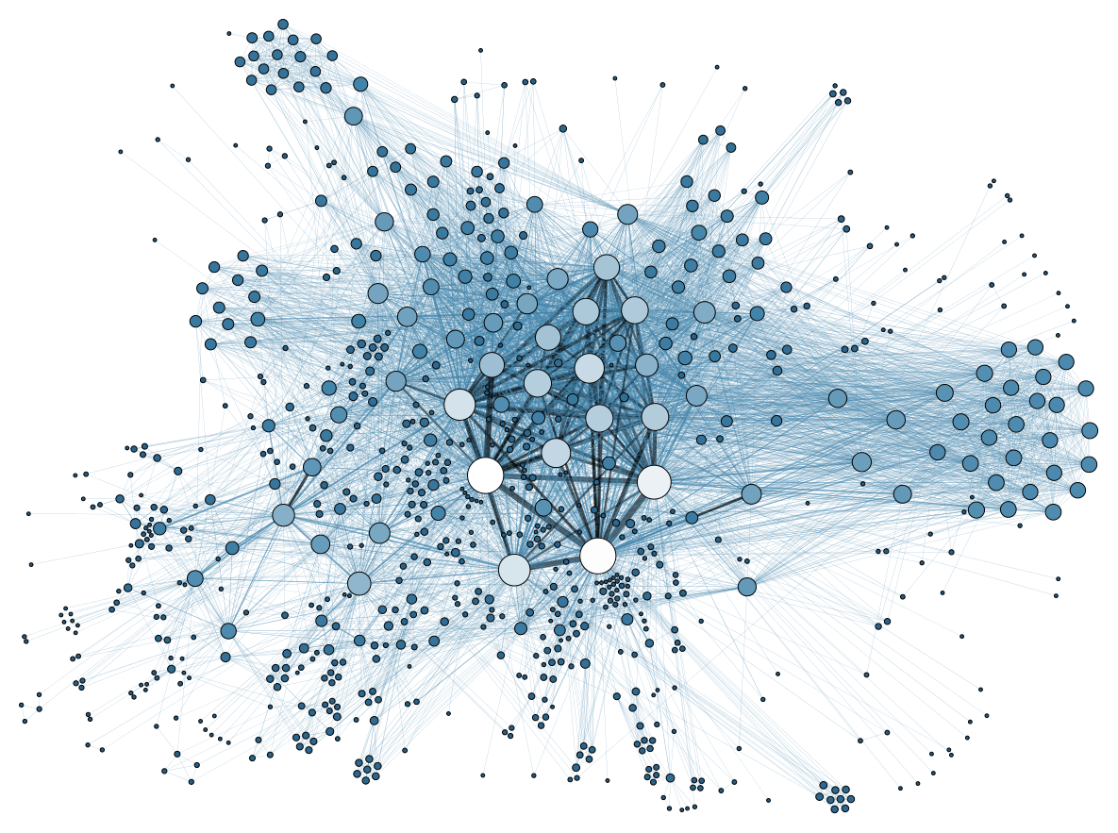

## **Expectations for the course**

* I have different expections to the upcomimg course seperated in two areas:
  + At first I basically just want to improve my R skills and learn new things regarding coding and setting up a daily workflow whilst working in data analysis
  + Secondly I’m very interested in Social Network Analysis as a new area of social studies I wasn’t able to get into until this semester. I heard from a student who analysized how politicians in Germnany had interacted n twitter before umpcoming elections, I would really be interested in doing analysis in this area because I think its obvious that the influence of (digital) social networks on elections and the campaigns has increased drastically.