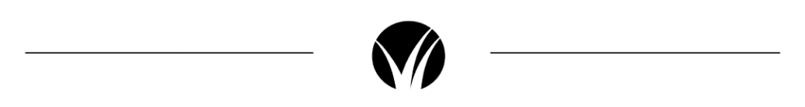

Dear (Name),

I trust this finds you well!  We noticed that you recently rented the property you currently reside in last year and that your lease might be coming due this month/next month/two months.

Have you decided to renew your current lease and stay in this location?

We are experts in the area, as we handle both rental and sales transactions for properties here in (neighborhood or area).

If you are curious to know what the market is doing and what purchasing a property entails, we would love to talk to you.

Call or text anytime, and I hope to hear from you.

Best,

Name and Contact

