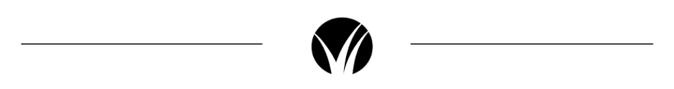

Dear (Name),

We trust this finds you well!  We noticed that you recently rented out your property at (123 ABC Street) last year and that your lease may be coming due this month/next month/two months.

Have you decided if you will renew your current lease?

We are experts in the area, as we handle both rental and sales transactions for properties here in (neighborhood or area).

Inventory is extremely low, so if you are NOT looking to lease your property again and want to test the market, now would be an ideal time to do so and receive top dollar.

If you are not looking to sell but rather are looking to put your property on the market again for rent, we can absolutely assist you with that as well.  We will ensure you do not leave any money on the table while finding you a great tenant.

Kindly let us know if you have an interest in speaking further.  Regardless of the direction you choose to go in, we can provide a complimentary CMA to you, showing exactly what you would net in either scenario.

Call or text anytime, and I hope to hear from you.

Best,

Name and Contact

