Quadrant chart is a variation of bubble chart with data in four quadrants. Quadrant chart plots data with four measures X-Axis, Y-Axis, Radial axis and legend axis.

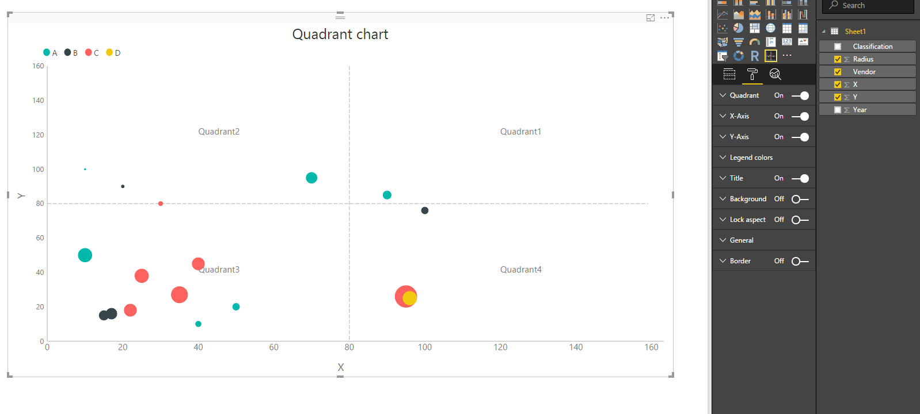

Fig. 1. Quadrant chart and its configurations

**Configurations:**

1. Data and format options
   1. Quadrant: To change names of all the quadrants and division line for x and y axis
      1. Quadrant1
      2. Quadrant2
      3. Quadrant3
      4. Quadrant4
      5. X-Axis division line
      6. Y-Axis division line
   2. X-Axis: To change
      1. Title
      2. Title text
      3. Labels
   3. Y-Axis: To change
      1. Title
      2. Title text
      3. Labels
   4. Legend colors: To change colors of legends

**Applicable Data types:**

1. X-axis: numeric only

2. Y-axis: numeric only

3. Radius-axis: numeric only

4. Legend-axis: any

Only X-axis and Y-axis are compulsory fields. Radius-axis and Legend-axis are optional fields

**Modeling options:**

We can change the format of data type by using Modeling tab.

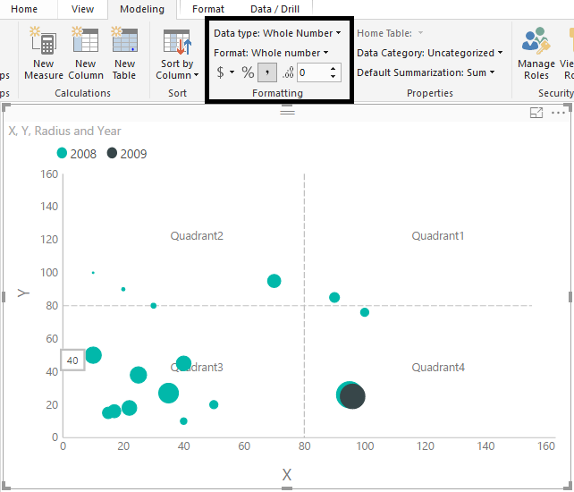 Fig. 2. Quadrant chart with modeling

On changing Modeling >> format option:

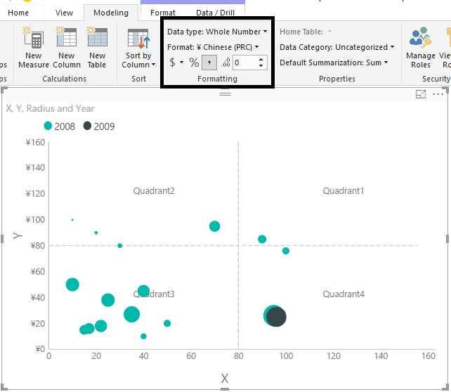

Fig. 3. Quadrant chart with currency modeling

**Tooltip:**

Displays tooltip on each data-point as well on the quadrant and axes labels.

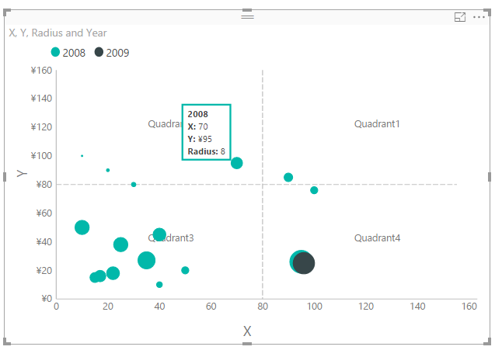

Fig. 4. Tooltip on Quadrant chart