Thermometer is used to represent data in thermometer. It could be a good way to represent data when you have the actual value and the target value (maximum threshold).

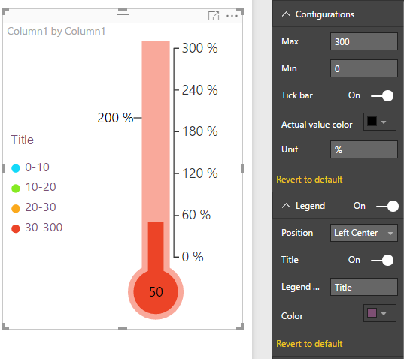

Configurations:

1. Max: To set maximum threshold of thermometer
2. Min: To set minimum threshold of thermometer
3. Tick bar: To enable or disable the thermometer labels (indicators)
4. Actual value color: To set color of actual value displayed in thermometer
5. Unit: To set unit of values

Legend:

1. Position: To customize the positioning of the legend
2. Title: To enable or disable the legend title
3. Legend Name: To set the title of the legend
4. Color: To set the font color of the legend displayed

Range:

There are 4 categories by default. This provides the user an option to select the end value for each range.

Category-1 has the range from minimum value to the value entered by user. Similarly, category-2 has the range end value of Category-1 to the value provided for Category-2.

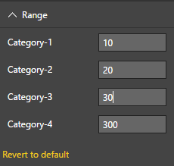Here, range for the four categories is as follows:

Category-1: 0 - 10

Category-2: 10 - 20

Category-3: 20 - 30

Category-4: 30 - 300

Category-1 to 4:

1. Fill: To set the fill color of the specific category
2. Border: To set the fill color of the specific category

