Thermometer is used to represent data in thermometer. It could be a good way to represent data when you have the actual value and the target value (maximum threshold).

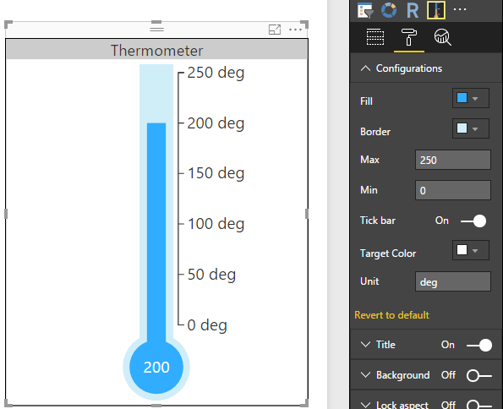

Configurations:

1. Fill: To set color of inner part of the thermometer
2. Border: To set border color of thermometer
3. Max: To set maximum threshold of thermometer
4. Min: To set minimum threshold of thermometer
5. Tick bar: To enable or disable the thermometer labels (indicators)
6. Target Color: To set color of target value
7. Unit: To set unit of values