Thermometer is used to represent data in thermometer. It could be a good way to represent data when you have the actual value and the target value (maximum threshold).

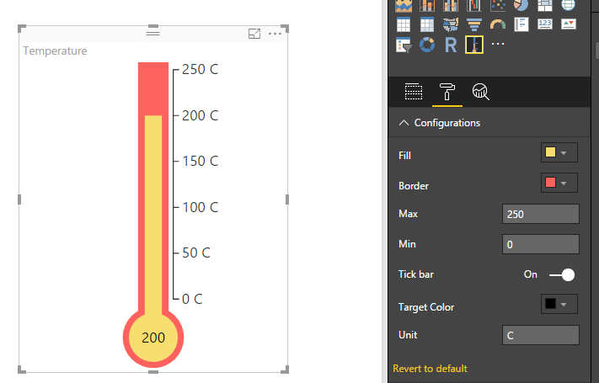

Configurations:

1. Fill: Specify mercury color
2. Border: Specify border color
3. Max: Maximum threshold
4. Min: Minimum threshold
5. Tick bar: To enable or disable the labels (indicators)
6. Target Color: Specify text color
7. Unit: Specify Celsius or Fahrenheit