Quadrant chart is a variation of bubble chart with data in four quadrants. Quadrant chart plots data with four measures X-Axis, Y-Axis, Radial axis and legend axis.

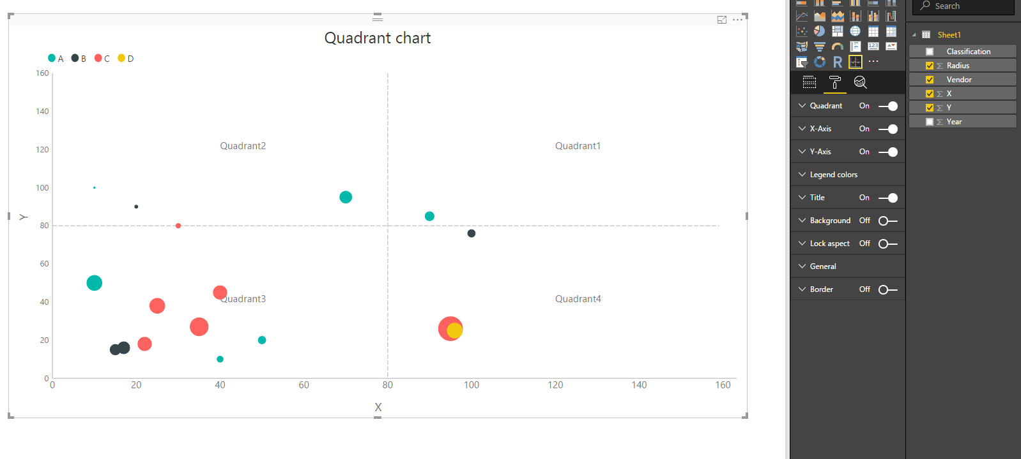

Configurations:

1. Data and format options
   1. Quadrant: To change names of all the quadrants and division line for x and y axis
      1. Quadrant1
      2. Quadrant2
      3. Quadrant3
      4. Quadrant4
      5. X-Axis division line
      6. Y-Axis division line
   2. X-Axis: To change
      1. Title
      2. Title text
      3. Labels
   3. Y-Axis: To change
      1. Title
      2. Title text
      3. Labels
   4. Legend colors: To change colors of legends