Title

Author

12/15/2016

##### Heading5_aka_pagebreak

There is white text above this what makes a page-break fyi

# Heading1

## Heading2

This is an R Markdown document. Markdown is a simple formatting syntax for authoring HTML, PDF, and MS Word documents. For more details on using R Markdown see <http://rmarkdown.rstudio.com>.[1]

When you click the **Knit** button a document will be generated that includes both content as well as the output of any embedded R code chunks within the document. You can embed an R code chunk like this:

summary(cars)

## speed dist   
## Min. : 4.0 Min. : 2.00   
## 1st Qu.:12.0 1st Qu.: 26.00   
## Median :15.0 Median : 36.00   
## Mean :15.4 Mean : 42.98   
## 3rd Qu.:19.0 3rd Qu.: 56.00   
## Max. :25.0 Max. :120.00

## Including Plots

First paragraph.

### Heading 3.

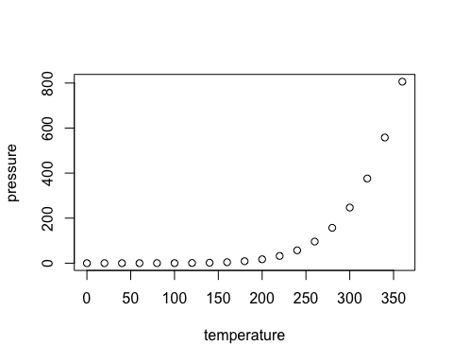

Figure 1

Figure 2

|  |  |
| --- | --- |
| text | intable |
|  |  |

(Bergelson & Swingley, 2013)

Bergelson, E., & Swingley, D. (2013). The acquisition of abstract words by young infants. *Cognition*, *127*(3), 391–7. http://doi.org/10.1016/j.cognition.2013.02.011

1. Text