S7: Figures and Tables with Captions

Erin Campbell & Elika Bergelson

To facilitate review, in addition to uploading the elements separately in accordance to JSLHR guidelines, we have combined all tables and figures from the main manuscript and supplemental materials in a single pdf alongside their titles and captions.

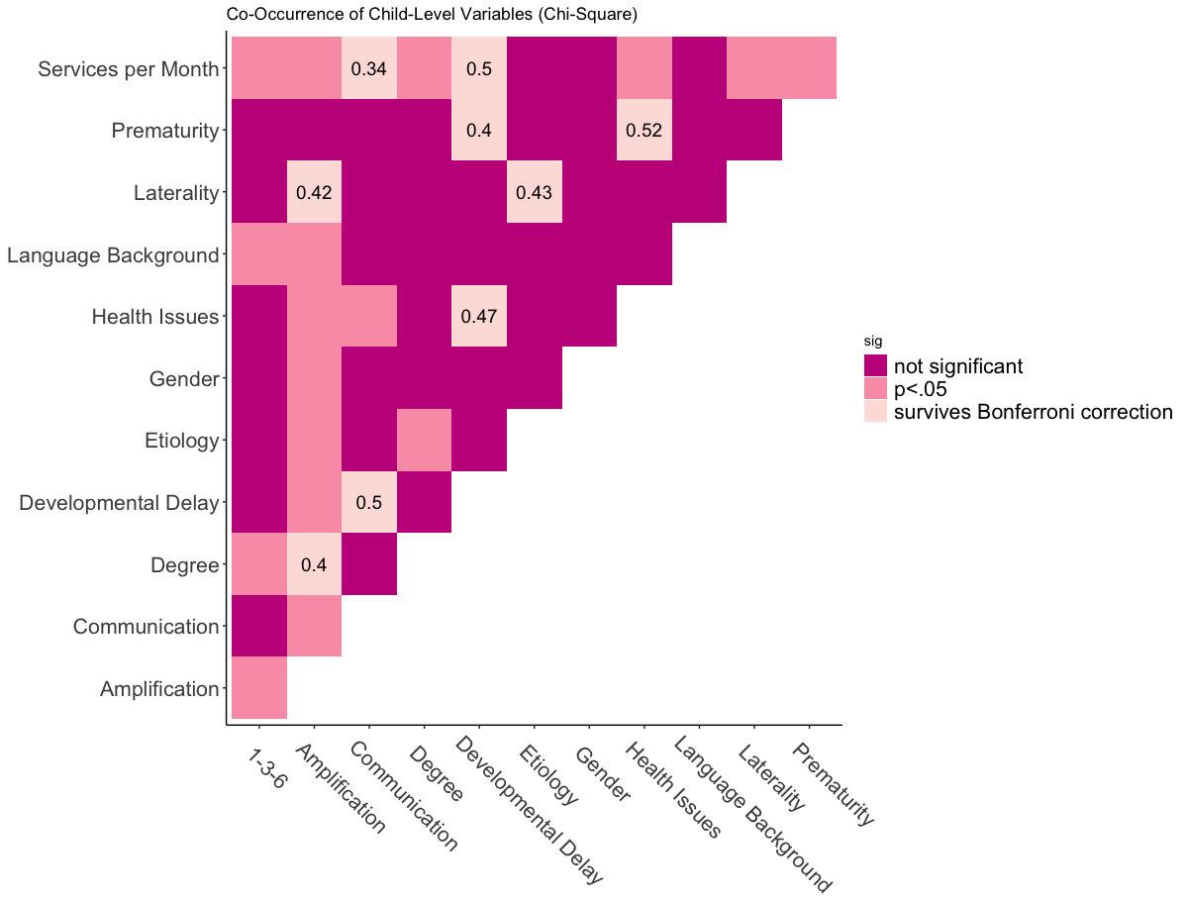

Co-Occurrence of Child-Level Variables (Chi-Square): Results of chi-square tests between variables. X- and y-axes show the variables compared. Color of the square represents significance of the corresponding chi-square test. For tests that survived Bonferroni correction (p<.0007), effect size (Cramer’s V) is given.

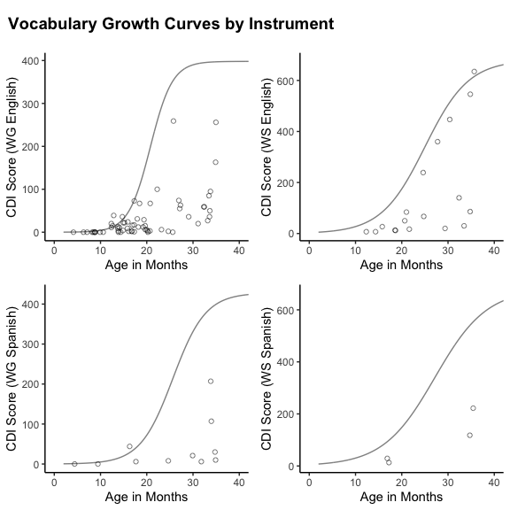

Vocabulary Growth Curves by Instrument: Lines show the growth curves created from WordBank 50th percentile data. Left panels show Words & Gestures; right panels show Words & Sentences. Top row is American English data; bottom row is Mexican Spanish data. Dots represent vocabulary scores of individual DHH children in the sample.

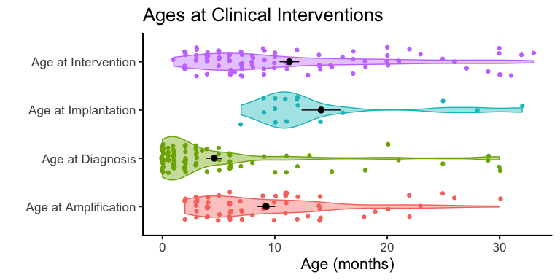

Ages at Clinical Interventions: Age at diagnosis, intervention, amplification, and cochlear implantation across participants. Each dot represents the age that one child received the clinical service; violin width reflects data distribution. Black dots and whiskers show means and standard errors. Not all children received amplification (hearing aids) or implantation (cochlear implants).

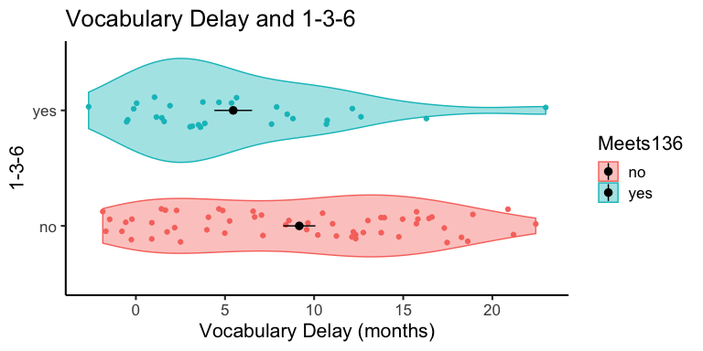

Vocabulary Delay and 1-3-6: Estimated vocabulary delay for children who meet 1-3-6 guidelines for diagnosis/intervention (top) and children who do not (bottom). Each dot represents one child in the sample; violin width reflect data distribution. Black dots and whiskers show means and standard error.

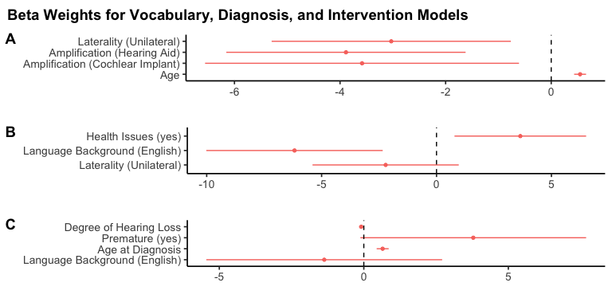

Beta Weights for Vocabulary, Diagnosis, and Intervention Models: Unstandardized coefficients (measured in months) with 95% confidence intervals for the models selected by AIC for: (A) vocabulary delay, (B) age at diagnosis, (C) age at intervention.