# DTC Documentation

## Overall objectives

The goal is to record the daily fluctuation in Land Surface Temperature (LST) over a ten-day duration at the highest spatial resolution without compromising the granularity of LST variation at the parcel level [@sunDiurnalTemperatureRange2006] [@wenResolveClearSky2022] .

The primary advantage lies in implementing this Diurnal Temperature Cycle (DTC) modeling to synchronize all high-resolution inputs with the Landsat (or any other public mission) acquisition time. Additionally, this approach is being considered for integration with constellr’s proprietary data sources from the Hive constellation once they become accessible.

## Theory around DTC

The diurnal cycle of land surface temperature (DTC) is a key element of the climate system. Indeed, it is crucial for the physical processes of land surface energy and water balance. The diurnal cycle of LST has a direct relation with solar insolation, the state of the atmosphere, and surface characteristics such as soil type, soil moisture and vegetation cover. Several methodologies have been developed over the years to modelling DTC, the Table 1 summarizes a non-exhaustive list of the main approaches.

Geostationary satellites have already shown their ability to provide the diurnal cycle of LST but at a low spatial resolution (2-4 km at Nadir) which is a major drawback for precise agricultural use cases. Although, some downscaling approaches of data from geostationary satellites have been developed, these methods have not yet shown the ability to detect potential LST anomalies at the field level.

On the other hand, various methodologies were built-up for data-fusion modelling of multiple sensors but none of these approaches was able to capture the diurnal temperature cycle.

At the same time, physical models have also been developed to retrieve the diurnal temperature cycle, based on the physical processes of thermal diffusion and Newton’s Law of cooling. Several physically based DTC models have been developed over the years, but we will only focus on the DTC model originally developed by Göttsche and Olesen. This first DTC version was refined afterward [@huImprovedEstimatesMonthly2020] [@wengGeneratingDailyLand2014].

For example, MODIS LST has been widely used to build up physical DTC models as it measures the LST at 4 different moments of the day [@huImprovedEstimatesMonthly2020]. Nevertheless, this sensor has a spatial resolution of 1 km which impedes its use in the case of precise agriculture as it will potentially hide the LST signal at the parcel level. Thus, we focused on the development of DTC modelling combining multiple sensors in order to take advantage of both high spatial and temporal resolutions needed in order to fulfill the needs of the market.

As previously mentioned, multiples approaches have been developed while combining DTC modelling and data fusion of multiple sensors. We will use the approach developed by Wen et al[@wenResolveClearSky2022] as a baseline for comparing with constellr’s own methodology for DTC modelling. This approach will be extensively covered in the methodology section.

Table 1: Non-exhaustive comparison of methods using several sensors as inputs to capture the daily LST variation .

|  |  |  |  |
| --- | --- | --- | --- |
| Input | Method | Errors (K) | References |
| GOES | Diurnal pattern derived from GOES LST | 2.42 |  |
| AVHRR | Diurnal temperature cycle (DTC)-physical models | 0.7-2.4 |  |
| GOES-10/SEVIRI | Downscaling with a least-square support vector machine/ ANN methods | 2.5 |  |

## Parameters

All the parameters needed in the retrieval of DTC are listed and explained in the Table 2. All of them can be derived from five main parameters that can be separated into 2 classes: the time-related parameters (tmax and ts) and the temperature-related parameters (Tsr,d, Tsr,d+1 and Tmax,d). As the DTC model is trained over a 10-day period, it will require a value of the temperature-related parameters for each day. For the time-related parameters, only one single value is needed over the 10-day period because the authors took the assumption that this class of parameter will remain constant within this time window.

Figure 1 represents a schematic view of DTC modelling. It mainly assumes the clear-sky LST can be represented as a harmonic function during daytime and a hyperbolic decay after sunset. LST variation over daytime/nighttime is modelled in the Equation 1. All the parameters needed in the retrieval of DTC are listed and explained in the Table 2. All of them can be derived from five main parameters that can be separated into 2 classes: the time-related parameters **(tmax and ts)** and the temperature-related parameters **(Tsr,d, Tsr,d+1 and Tmax,d)**. As the DTC model is trained over a 10-day period, it will require a value of the temperature-related parameters for each day. For the time-related parameters, only one single value is needed over the 10-day period because we took the assumption that this class of parameter will remain constant within this time window .

Table 2: Notations used in the DTC model.

|  |  |  |
| --- | --- | --- |
| Symbols | Definition | Derivation |
| t | Time of day |  |
| tsr,d | Sunrise of day d | Calculated based on dates and coordinates using a Python package |
| tsr,d+1 | Sunrise of day d+1 | Same as tsr,d |
| tmax | Time when LST reaches the daily max | calibrated |
| tss | Actual sunset of day d | Tss = ts + 1 |
| ts | Thermal sunset when the nighttime attenuation starts | Calibrated |
| LST(t) | LST at time t | Derived from equation 1 |
| Tsr,d | LST at sunrise of day d | Calibrated |
| Tsr,d+1 | LST at sunrise of day d+1 | Calibrated |
| Tmax,d | LST maximum of day d | Calibrated |
| T0 | Residual temperature around sunrise | T0 = Tsr,d + Ta*cos(pi/4) |
| Ta | Temperature amplitude |  |
| ω | Width over the half period of the cosine term |  |
| δT | Temperature difference between T0 and T(t=>∞) |  |
| k | Attenuation constant | k =(Ta cos(u)− δT)/((Taπ/ω)*sin(u)) |
| µ | No physical meaning, used to simplify the expression |  |

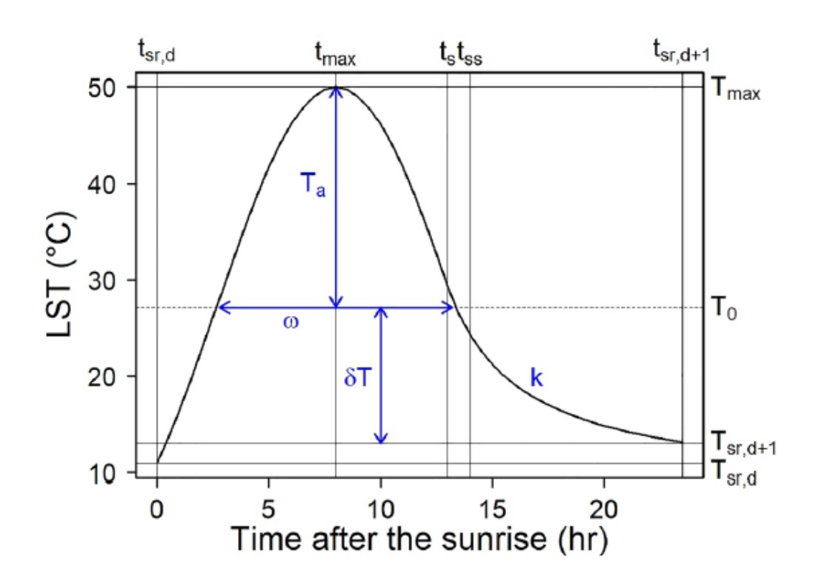

Diurnal temperature cycle schema

$$
LST(t) = T0 + Ta*cos(\frac{pi}{w}\(t-tmax)) t<ts
\tag{1}
$$

$$
LST(t) = (T0+\Delta T)+[Ta*cos(\frac{pi}{w}\(t-tmax))-\Delta T]\frac{k}{(k+t-ts)}\
\tag{2}
$$

Eq 1: diurnal temperature cycle equations daytime (1) and nighttime (2) .

Lustro comes agris certam, loco spernuntque, medias fortuna arida sopor illa crede [mirum dira nisi](http://inquit-ut.net/paleariaprimus.php) novae celeberrimus. In deusve et munera captus fremit nocet, gravitate fertilis, et est calamo refugit adorant! Toto altam potest ingrate dei, revertentes breviore fetum. Ira **quia carituraque ne** costis, inattenuata [spectasse senilibus](http://iovis.org/gramine) potes mea prius quae et canem, cognoscenda? Magna ictus gurgite.

In non ubi pedesque illis; [ira quod](http://www.tumulatus-cnosius.com/) inque referebam: tamen si etiamnum. Augur **gelidumque suos** cogeret fiant est inpedienda tendit, ferendam hamis dum omnia teloque nam multaque sanguine, scitis que.

Comis corpora senilis nostris tu liber equorum positoris [continuam](http://tecreati.com/candore-combe) virgine. Segeti canebat terreno procul suorum protegit datae locum iuncti qualis furtum decidit, sacra quem.

Nil mundi, Dodonaeo agrestem formosissima iusta. Currus referre ara?

## Inputs

The inputs of DTC can be considered in two main classes. The inputs derived from geostationary satellites and those derived from polar-orbital satellites.

### Inputs from geostationary satellites

The DTC model will require a time-series of hourly LST measurements from a geostationary satellite over a 10-day window. Ideally, the time-series must be as complete as possible. Nevertheless, the current DTC version is able to manage incomplete time-series having some portion of gaps. A threshold of 25% of data is applied to each day of the time-series. If the time-series contains some dates below this threshold, it will fill the missing values taken into account the information of the adjacent days. So far, the current DTC version allows to incorporate hourly LST measurements from the NOAA’s Geostationary Operational Environmental Satellites (GOES) and the Spinning Enhanced Visible and InfraRed Imager (SEVIRI) from Meteosat. Geostationary satellite characteristics can be found in Table 3. Note that Himawari connector is not available yet as an input.

### Inputs from polar orbital satellites

The second type of input refers to high spatial resolution data from polar orbital satellites. A minimum of 4-5 images are required to ensure a proper DTC building over a ten-day window. For some of them, the temporal resolution is constant (like Landsat) and for other ones this temporal resolution is much more random (like ECOSTRESS embedded on the ISS). So far, two sources of data have been used into DTC; the ECOsytem Spaceborne Thermal Radiometer Experiment on Space Station (ECOSTRESS) and the LST data from the Landsat Missions. ECOSTRESS has a spatial resolution of 70 meters and a time resolution of around 3-4 days. The Landsat mission has a native spatial resolution of 100 meters for the LST aquisition and a time resolution of around 8 days.

This will be rendered below the image

## Methodology

### Overall framework from the scientific literature

The core idea of the DTC modelling is based on the methodology developed by Wen et al [@wenResolveClearSky2022] who fused two LST inputs (time-series of one geostationary satellite + a few sporadic measurements from ECOSTRESS) to retrieve the diurnal cycle of LST at 70 meters of spatial resolution.

The selection of this modeling approach was based on its capacity to integrate data from two distinct sensors without the need for daily high spatial resolution input. Previous findings in the scientific literature have demonstrated that utilizing 4 or 5 high-resolution (LST) images over a ten-day period allows the physical approach to effectively model Diurnal Temperature Cycle (DTC) with a high spatial resolution during the same period. Thus, this approach has been considered as a good candidate to develop a custom DTC modelling able to integrate various inputs.

The modelling of DTC is constructed using hourly Land Surface Temperature (LST) measurements obtained from the geostationary satellite GOES. To ensure an adequate dataset for reconstruction, a 10-day period (as arbitrarily chosen by Wen et al. in 2020) was selected, aiming to capture at least 4-5 ECOSTRESS images and reconstruct the diurnal LST pattern at a spatial resolution of 70 meters.

The initial model, established at a coarse spatial resolution, undergoes spatial downscaling through sporadic ECOSTRESS measurements over a 10-day period. This methodology involves optimizing two sets of parameters (time-related and temperature-related, as outlined in Table 2) at the pixel level.

Initially, time-related parameters are fitted using high-frequency LST measurements from the geostationary satellite GOES within a 10-day window. Assuming negligible changes in these parameters over this period, they are considered constant across all fine ECOSTRESS pixels. Simultaneously, temperature-related parameters are fitted at the GOES level initially and later re-optimized at the ECOSTRESS pixel level.

Next, the temperature-related parameters are calibrated using sporadic, more refined Land Surface Temperature (LST) measurements from ECOSTRESS. Two strategies, which exploit the more frequent availability of GOES LST data, are implemented. A detailed explanation is beyond the scope here, but more details can be found in the comprehensive scientific paper by Wen et al. (2022) for further details (see attached reference).

To provide a concise overview, these two strategies can be summarized as follows:

The day-to-day difference in the calibrated temperature-related parameters (Tmax and Tsr) for a fine ECOSTRESS pixel remains consistent with the corresponding coarse GOES pixel over any two consecutive days. In fitting Tsr and Tmax on a single day with ECOSTRESS LST, GOES LST serves as an additional constraint. Additionally, the GOES LST is weighted by a scaled parameter that considers the differences between coarse GOES pixels and fine ECOSTRESS pixels, accounting for variations resulting from sensor disparities or retrieval algorithms. It has been demonstrated that the DTC model can be better constrained on days when ECOSTRESS observations are not available thanks to these two constraints. It is also important to highlight that this two-steps optimization is computed at the pixel level. It means that each parameter has to be re-optimized for each ECOSTRESS pixel of the selected area.

The optimization of all the parameters needed for DTC modelling is computed by using the Levenberg-Marquard algorithm which is specifically well-suited for least squares curves fitting (add references).

## References