Creation of Golden AMI Ubuntu 1404 using Cloud Formation Template

- Go to Cloud Formation in AWS console and click on Create Stack

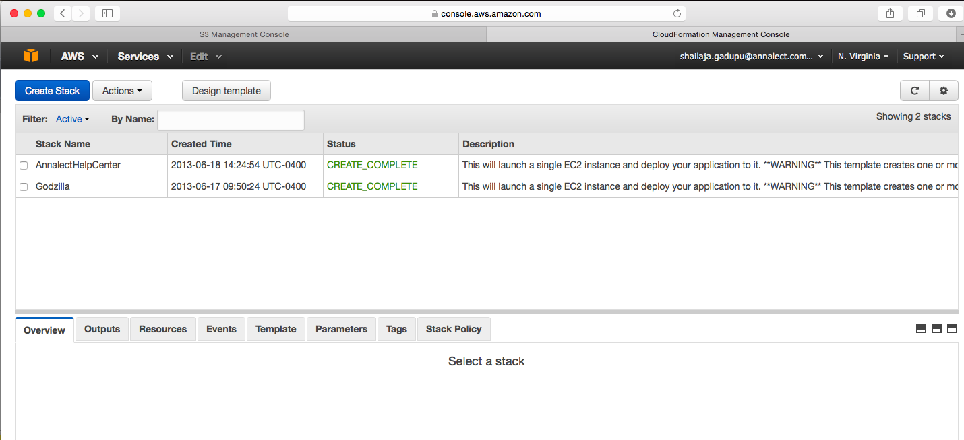

2) Select “Specify an Amazon S3 template URL” and provide the cloud formation template S3 url and click Next.

S3 URL : https://s3.amazonaws.com/Technical_Infrastructure/CloudFormation/Create-GoldenAMI-Ubuntu.json

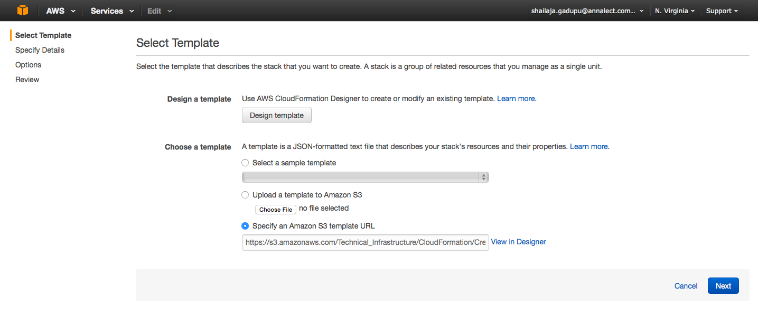
3) Provide the appropriate input parameters like AMI Id, Application, Environment, Instance Type, EC2 Key pair etc., in Next screen and click Next.

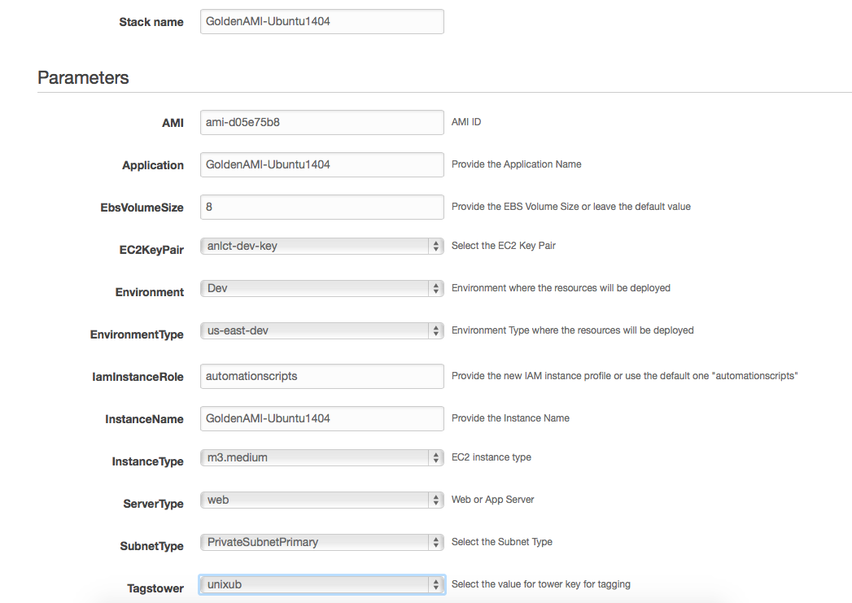
4) Leave the next screen default and Click Next

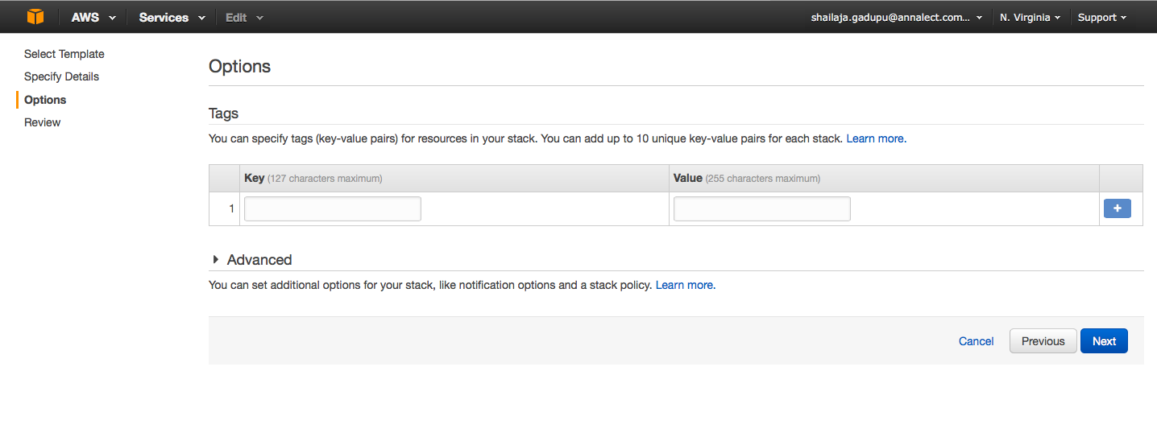

5) Review the parameters, acknowledge the resource creation and Click Create. Once it completes the Stack creation successfully, login to the instance using the EC2 key pair and verify if hardening script run successfully at /var/log/automation.log

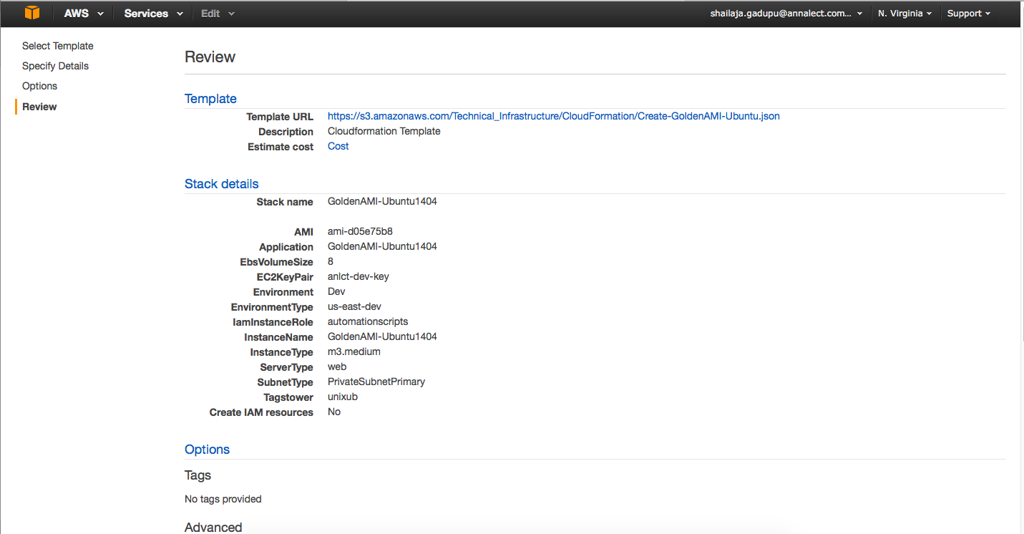

6) Create Image of this EC2 instance and name it GoldenAMI-Ubuntu-1404

