Athena Lake formation Okta – DataGrip Configuration

Step 1 Click on Data Source-Search for AWS Athena

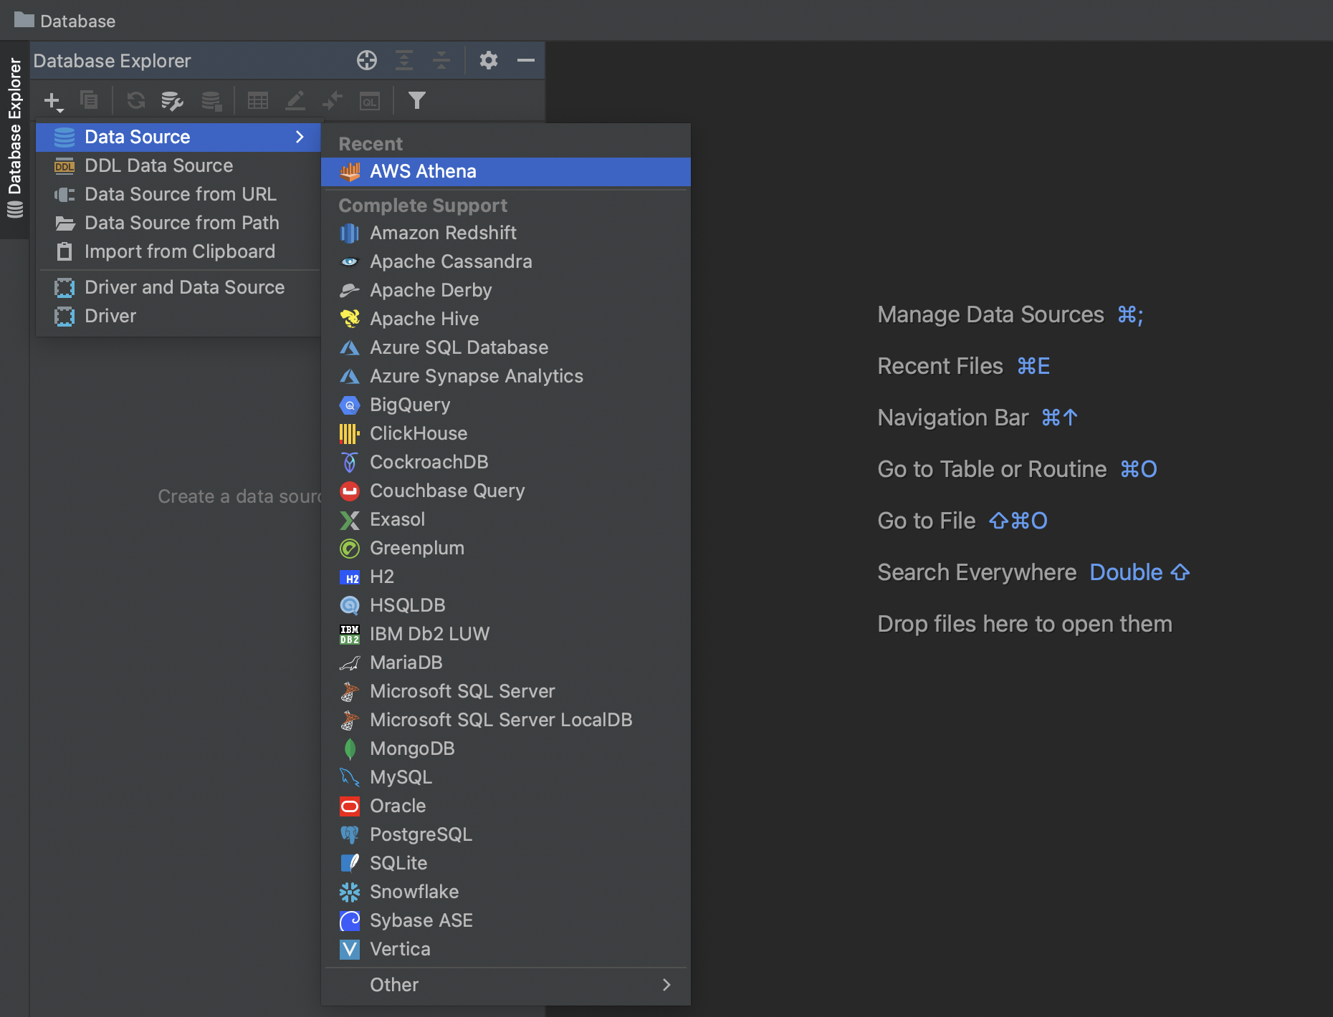

Step 2 Right click on properties
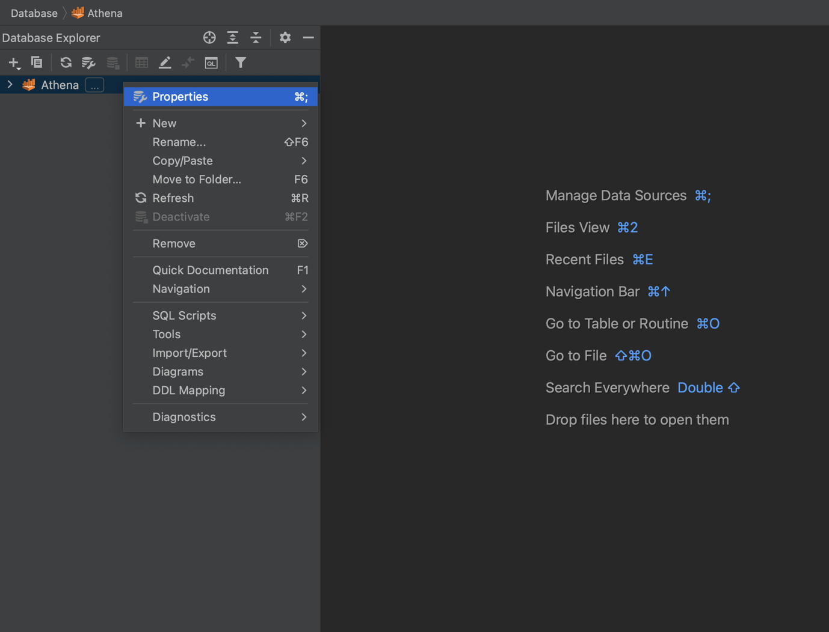

Step 3 Navigate to Drivers Tab and make sure you have Athena latest drivers installed.
In case it is missing please download drivers from below link and map.
( https://s3.amazonaws.com/athena-downloads/drivers/JDBC/SimbaAthenaJDBC-2.0.32.1001/AthenaJDBC42.jar )

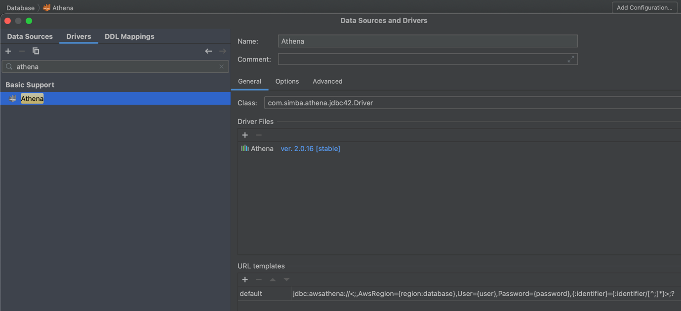
Step 4 Navigate back to Data Sources Advanced (Add Properties )

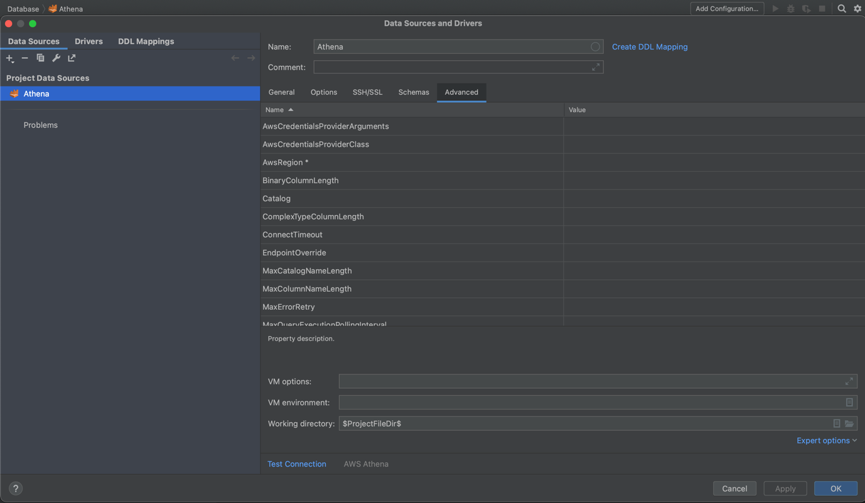

Property List
( Note : If Property is already available, no need to add it again just update the value and make sure there is no extra space ) (Username and Password can be passed from UI)

App_ID | 0oal9si4dovxHjBwq357
LakeFormationEnabled | true
SSL_Insecure | false
idp_host | onewp.okta.com
password | { Password-OneWp }
user | { UserName-OneWp }
AwsCredentialsProviderClass | com.simba.athena.iamsupport.plugin.OktaCredentialsProvider
S3OutputLocation | s3://tio-aue1-analytics-athena-query-results/output
okta_mfa_type | oktaverifywithtotp
Workgroup | analytics
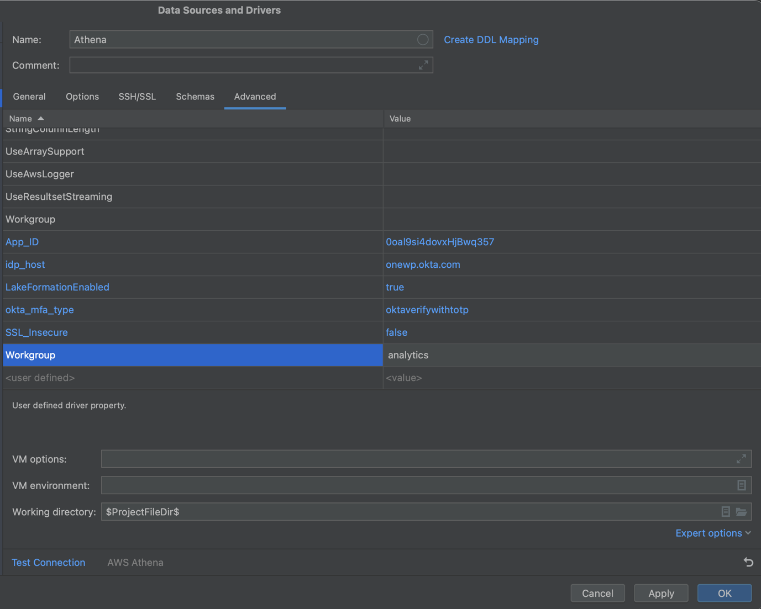

Step 5: Navigate back to General:
User: {UserName-OneWp}
Password: {Password-OneWp}
Region: us-east-1
Update URL: jdbc:awsathena://athena.us-east-1.amazonaws.com:443

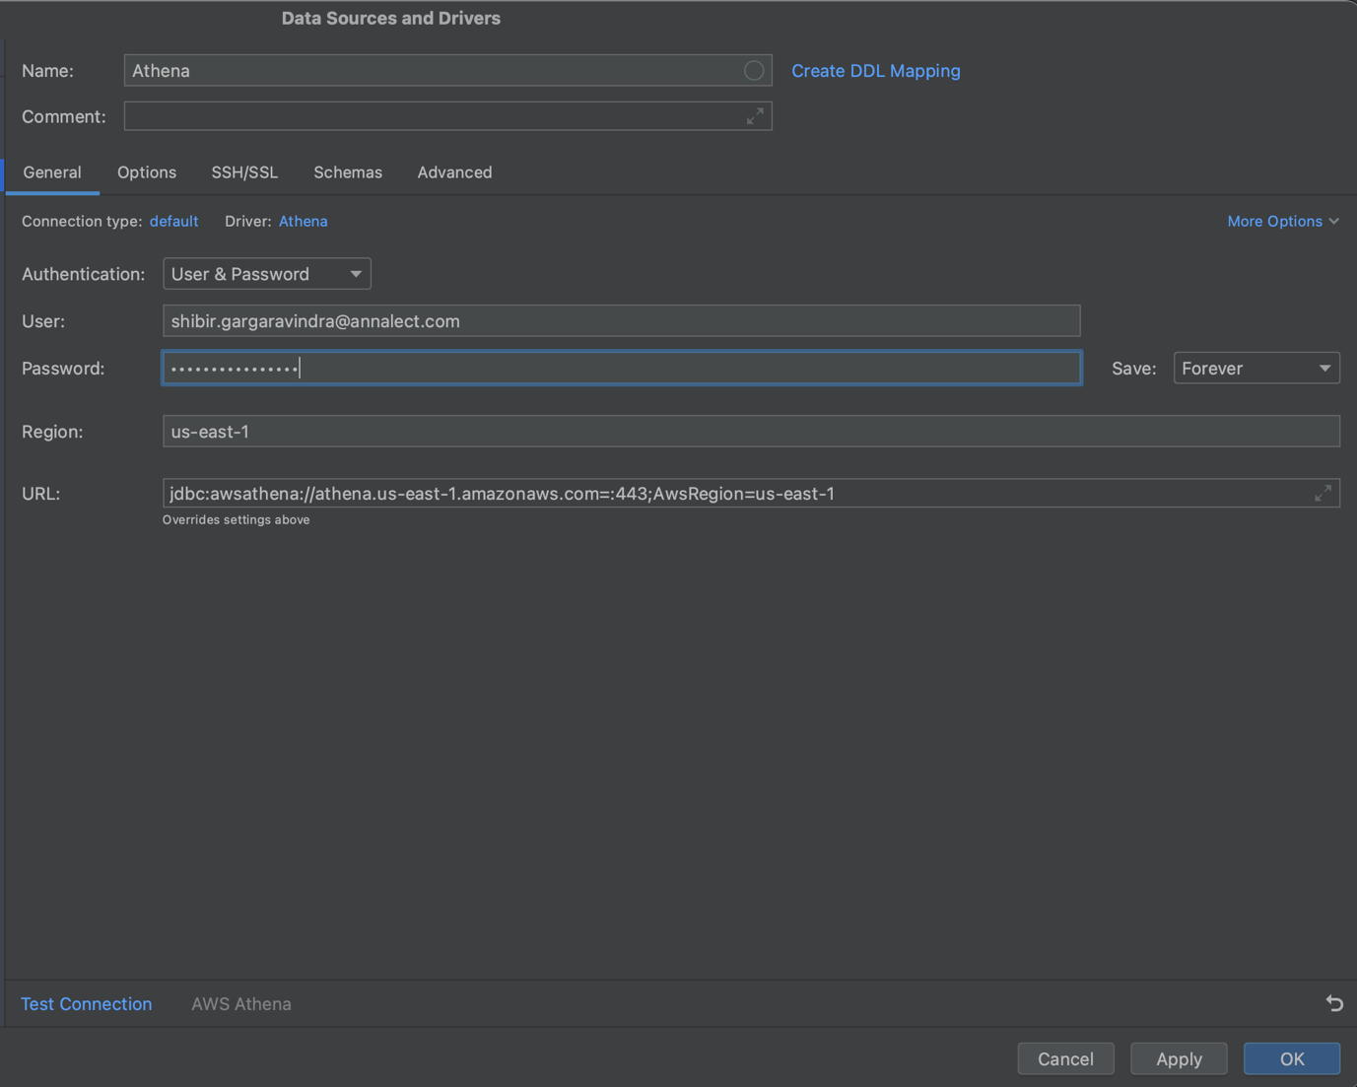
Step 6: Click on test connection and it will prompt for MFA (Passcode onewp okta )

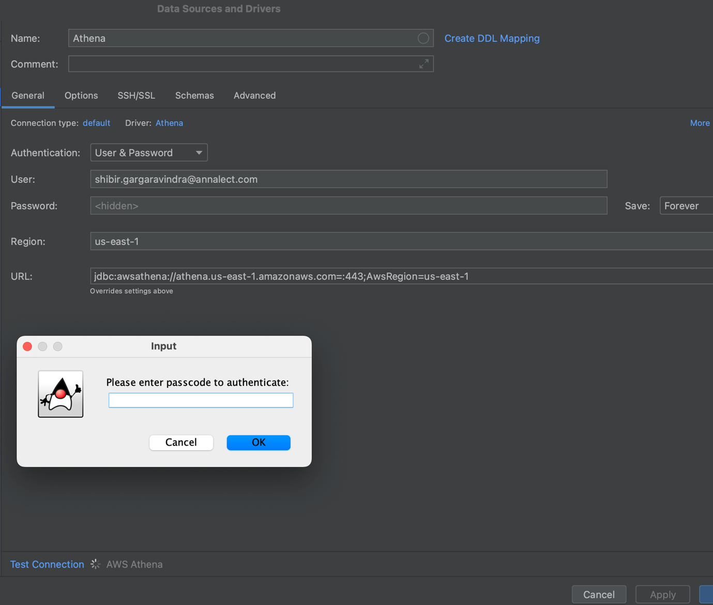
Once connection is successful
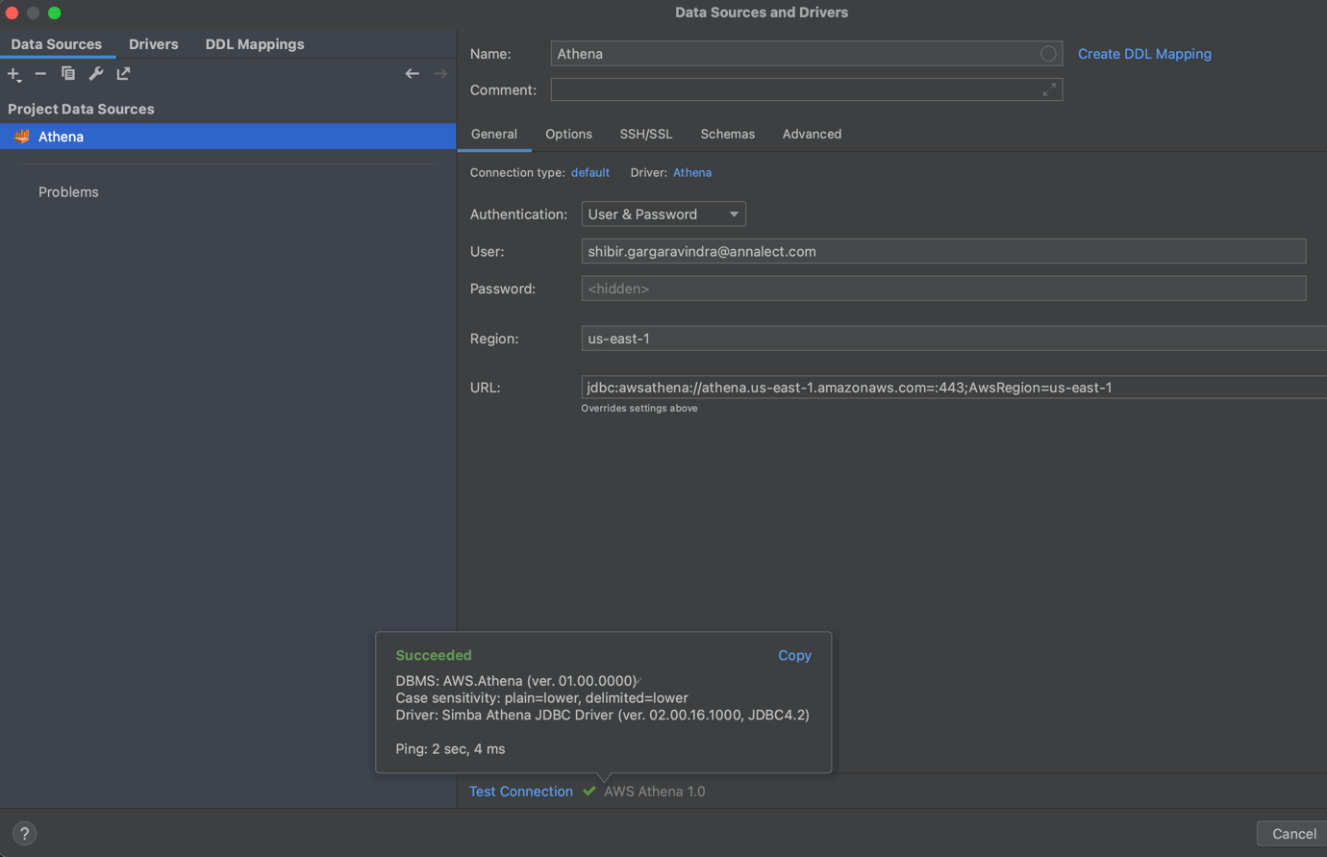
Expand connection you should be able to see database.
