Athena-Lakeformation-Okta – SQL Workbench
Step 1: Click on new database connection

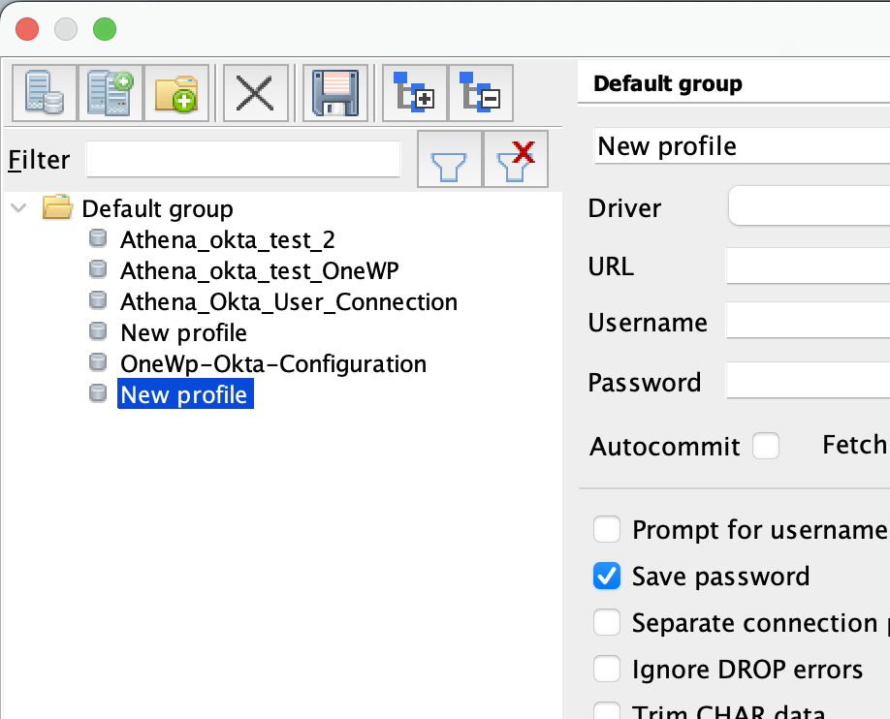

Step 2: Click on Manage DriversClick on new entry

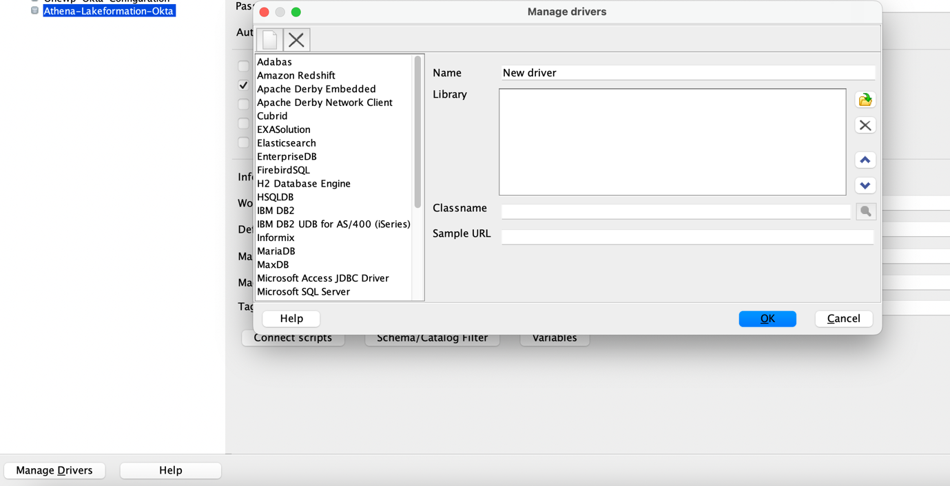
Step 3 : Search for downloaded Drivers-ChooseName it as AthenaClick Ok
( https://s3.amazonaws.com/athena-downloads/drivers/JDBC/SimbaAthenaJDBC-2.0.32.1001/AthenaJDBC42.jar )

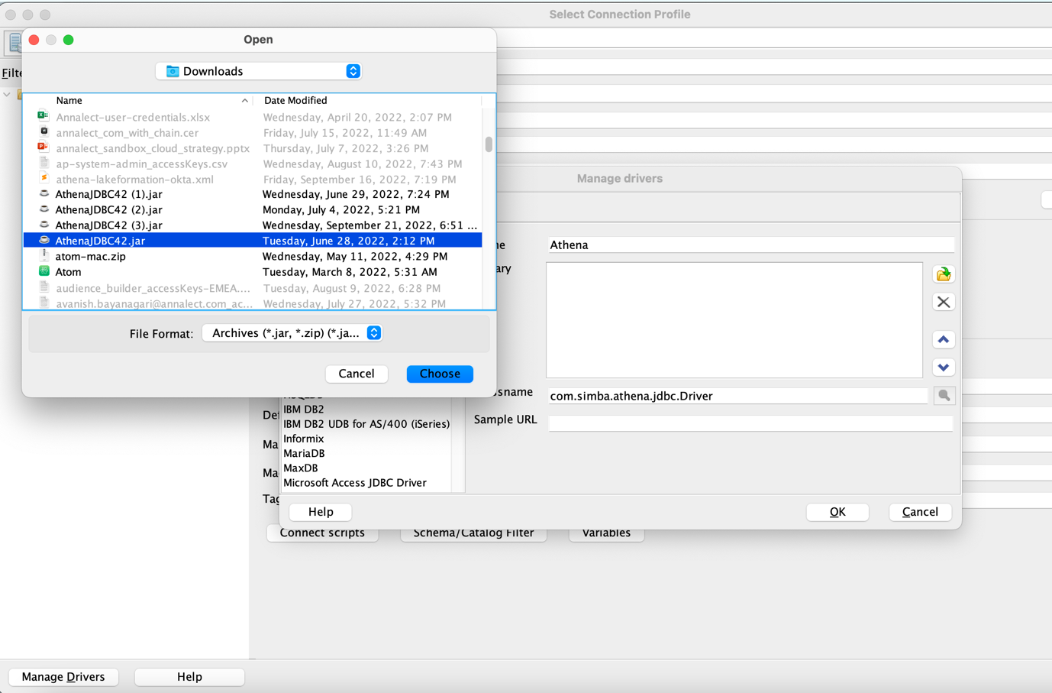
Select and click ok
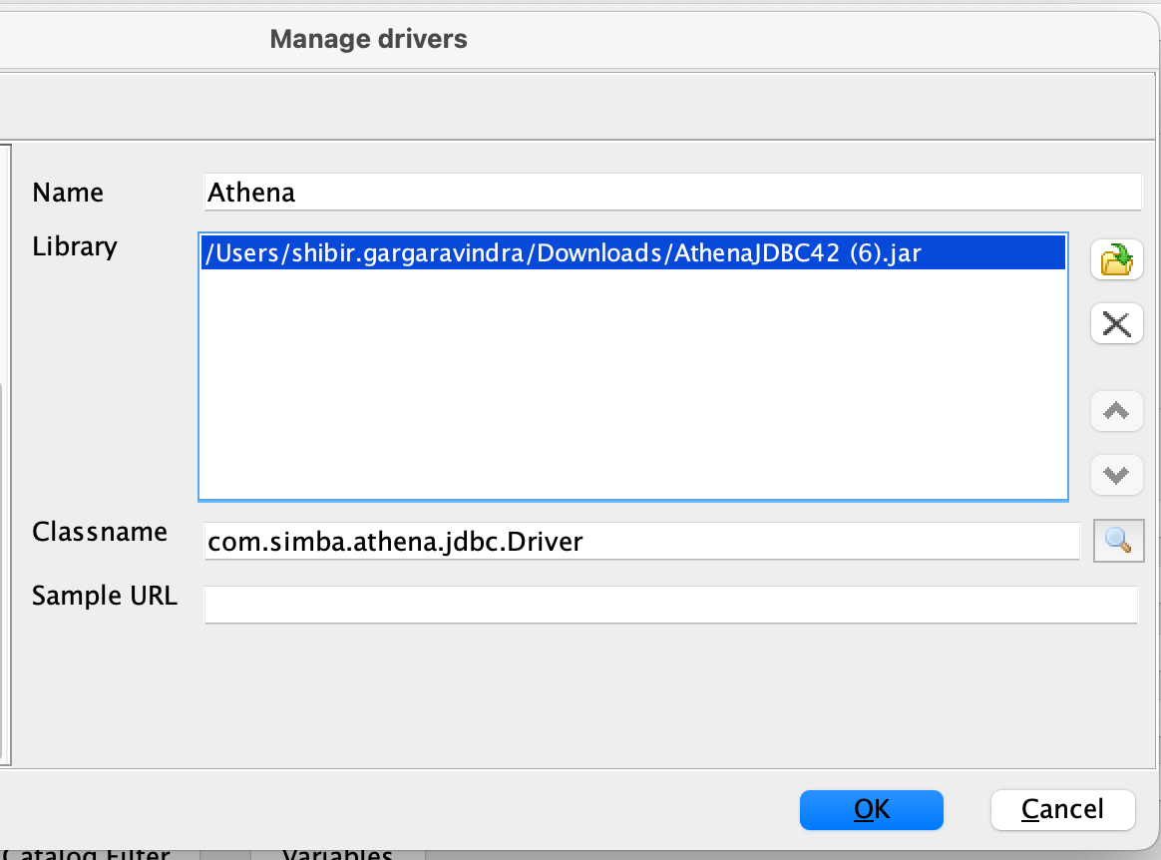

Step 4 :
Name connection : Athena-Lakeformation-Okta
Select Athena Driver from the list

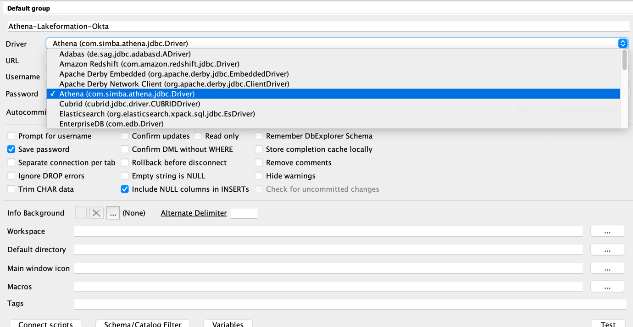

Step 5:
Update URL : jdbc:awsathena://athena.us-east-1.amazonaws.com:443

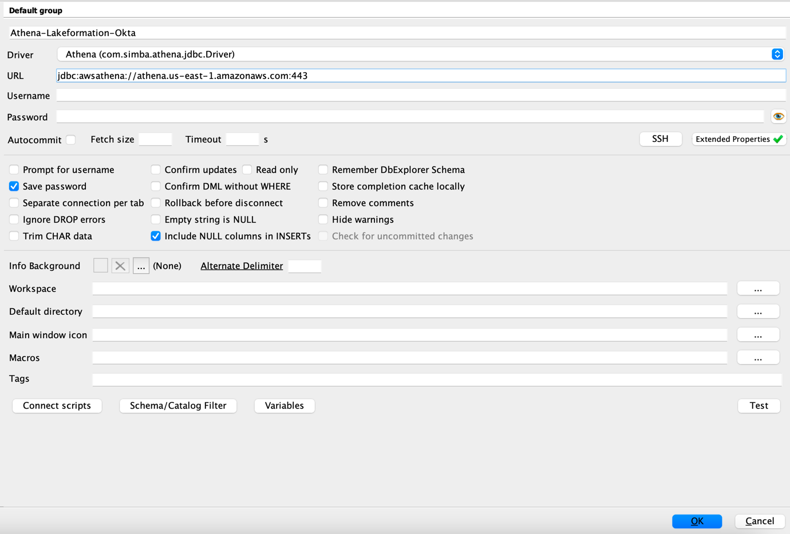

Step 6 : Click on Extended Properties and add extended properties

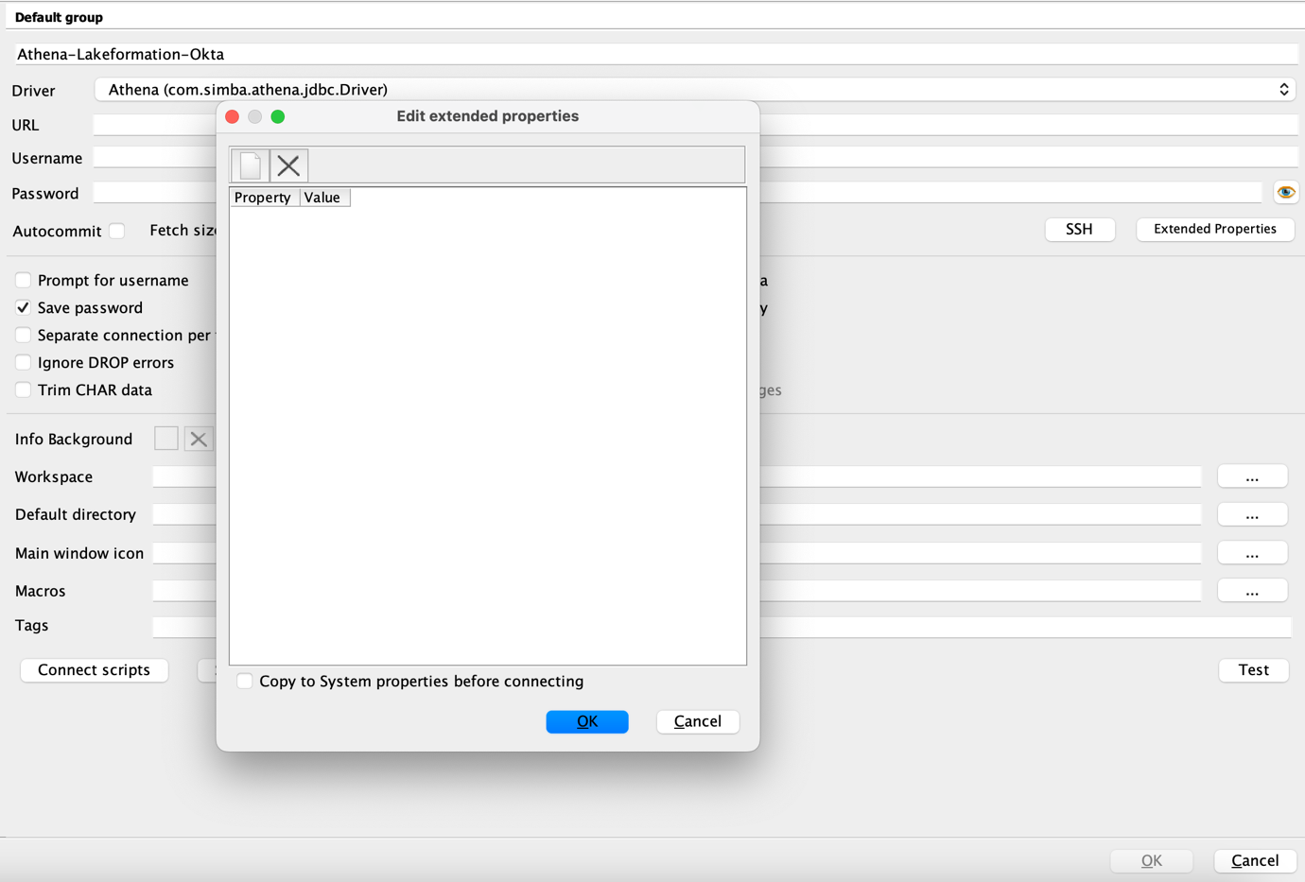
Step 7: Add below Properties
App_ID | 0oal9si4dovxHjBwq357
LakeFormationEnabled | true
SSL_Insecure | false
idp_host | onewp.okta.com
password | { Password-OneWp }
user | { UserName-OneWp }
AwsCredentialsProviderClass | com.simba.athena.iamsupport.plugin.OktaCredentialsProvider
S3OutputLocation | s3://tio-aue1-analytics-athena-query-results/output
okta_mfa_type | oktaverifywithtotp
Workgroup | analytics
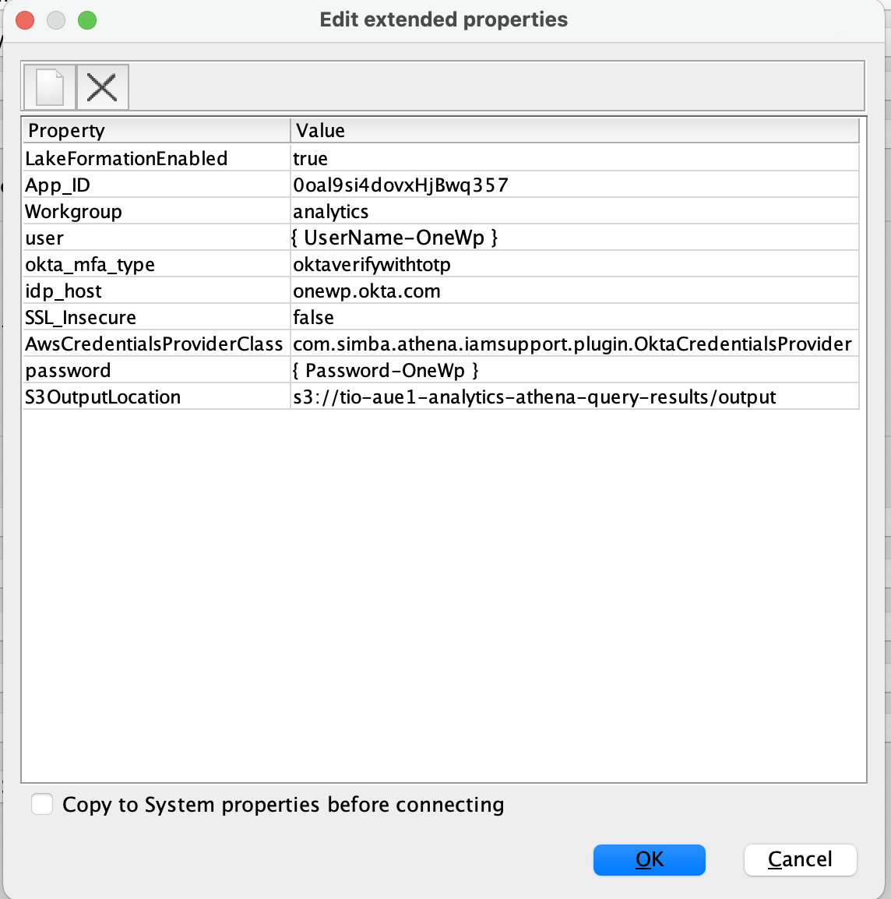

Click on test connection and it will promt for MFA ( Passcode onewp okta )
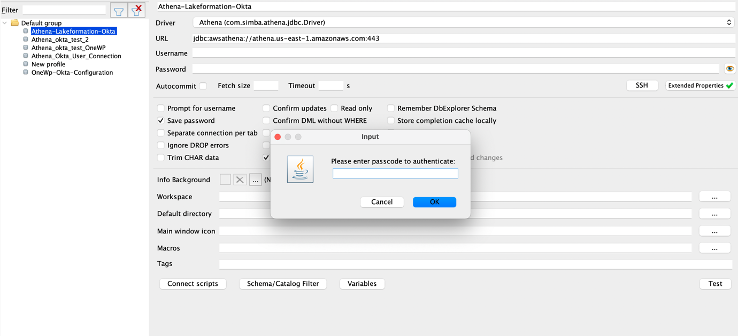
Once connection is established
