Sample Plot Markdown AirHist

MSDS Data Science

January 15, 2018

library(knitr)

# air_hist.R - Unit 2 Live Session Homework

# Note: Please reformat these to place into your RMarkdown submission document.

# You can make sure it works here, but make it easy for your grader via RMD

# You are responsible for the TODOs, but the complete code here will give you

# an idea of what the data look like. Remember, you might need some of this code

# directly in your response file to make it work, even if it’s not TODO!!

# We will be using the built-in dataset airquality which has daily air quality

# measurements in New York from May to September 1973

## 'data.frame': 153 obs. of 6 variables:  
## $ Ozone : int 41 36 12 18 NA 28 23 19 8 NA ...  
## $ Solar.R: int 190 118 149 313 NA NA 299 99 19 194 ...  
## $ Wind : num 7.4 8 12.6 11.5 14.3 14.9 8.6 13.8 20.1 8.6 ...  
## $ Temp : int 67 72 74 62 56 66 65 59 61 69 ...  
## $ Month : int 5 5 5 5 5 5 5 5 5 5 ...  
## $ Day : int 1 2 3 4 5 6 7 8 9 10 ...

# Take only Temp columns

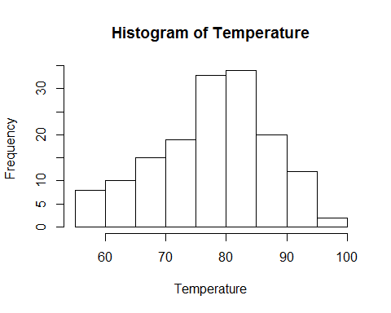

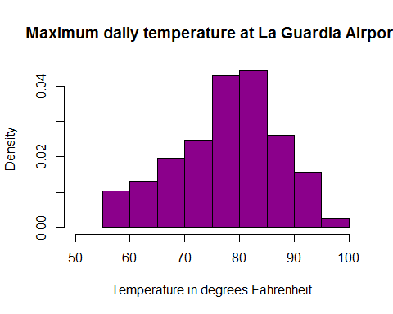

# TODO: Assignment 2, Q2A: Complete the following code to yield a scatterplot with x as Month and y as Temp

# You’re going to customize your plot slightly. Use the help function to assist you if needed.

# Make the x label “Month” and the y label “Temperature”

# Finally, make the title of the plot “Temperature by Month”

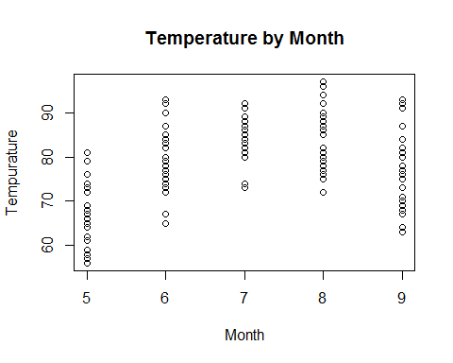

# TODO: Assignment 2, Q2B: Build a scatter plot with x as Temperature and y as Ozone

# Complete the following code:

# Make the x label “Temperature” and the y label “Ozone”,

# Make the title of the plot “Temperature vs Ozone”

