Sample Plot Markdown

MSDS Data Science

January 15, 2018

library(knitr)

## R Markdown

This is an R Markdown document. Markdown is a simple formatting syntax for authoring HTML, PDF, and MS Word documents. For more details on using R Markdown see <http://rmarkdown.rstudio.com>.

When you click the **Knit** button a document will be generated that includes both content as well as the output of any embedded R code chunks within the document. You can embed an R code chunk like this:

summary(cars)

## speed dist   
## Min. : 4.0 Min. : 2.00   
## 1st Qu.:12.0 1st Qu.: 26.00   
## Median :15.0 Median : 36.00   
## Mean :15.4 Mean : 42.98   
## 3rd Qu.:19.0 3rd Qu.: 56.00   
## Max. :25.0 Max. :120.00

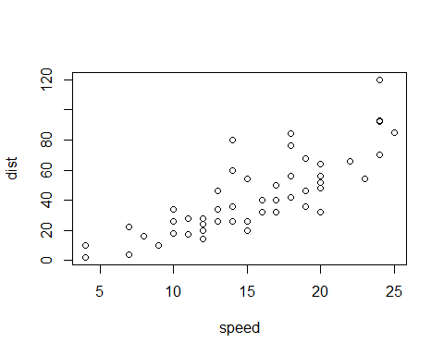

## Including Plots

summary(pressure)

## temperature pressure   
## Min. : 0 Min. : 0.0002   
## 1st Qu.: 90 1st Qu.: 0.1800   
## Median :180 Median : 8.8000   
## Mean :180 Mean :124.3367   
## 3rd Qu.:270 3rd Qu.:126.5000   
## Max. :360 Max. :806.0000

You can also embed plots as default, for example: 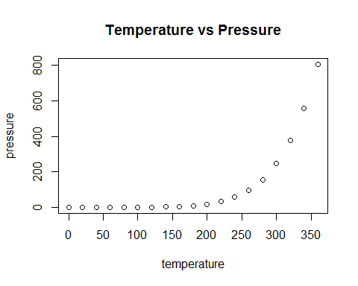

Now flip it!

