**Signal Processing and Machine Learning**

**Project Name: PPG Anlysis**

1. **Introduction**

In this project, the main goal was to analyze and process a PPG (Photoplethysmogram) signal to extract meaningful physiological metrics and visualize cardiac cycle phases.

***1.1 Sliding window***

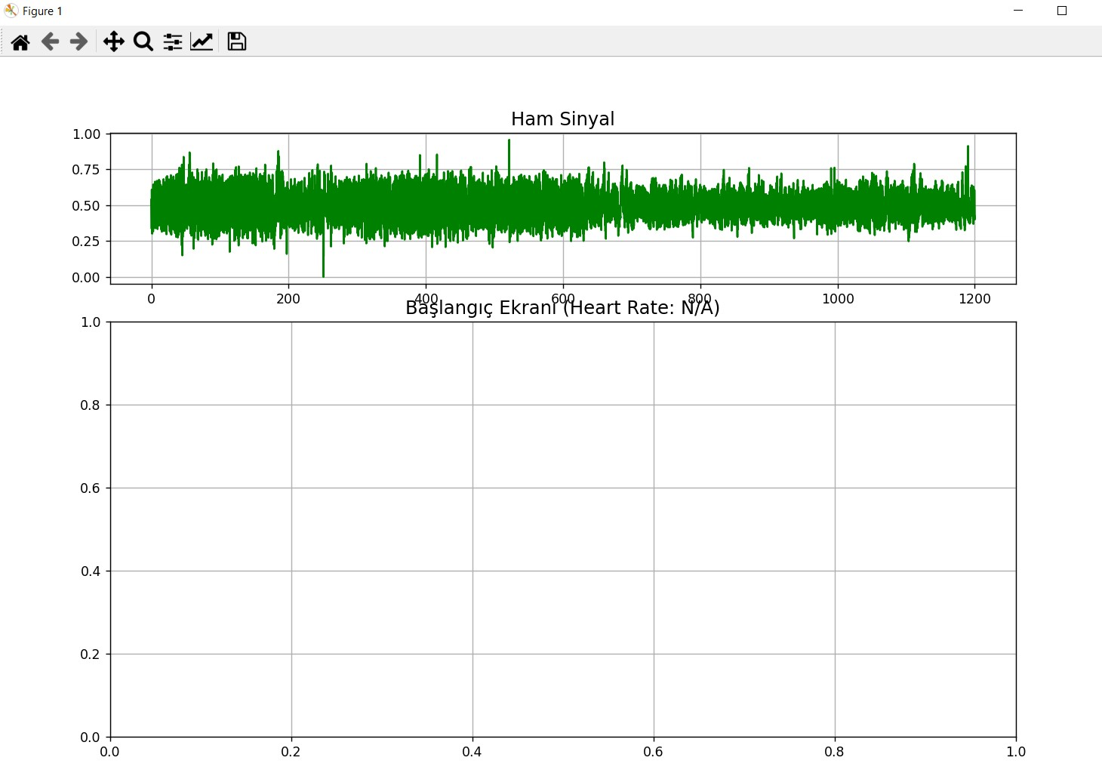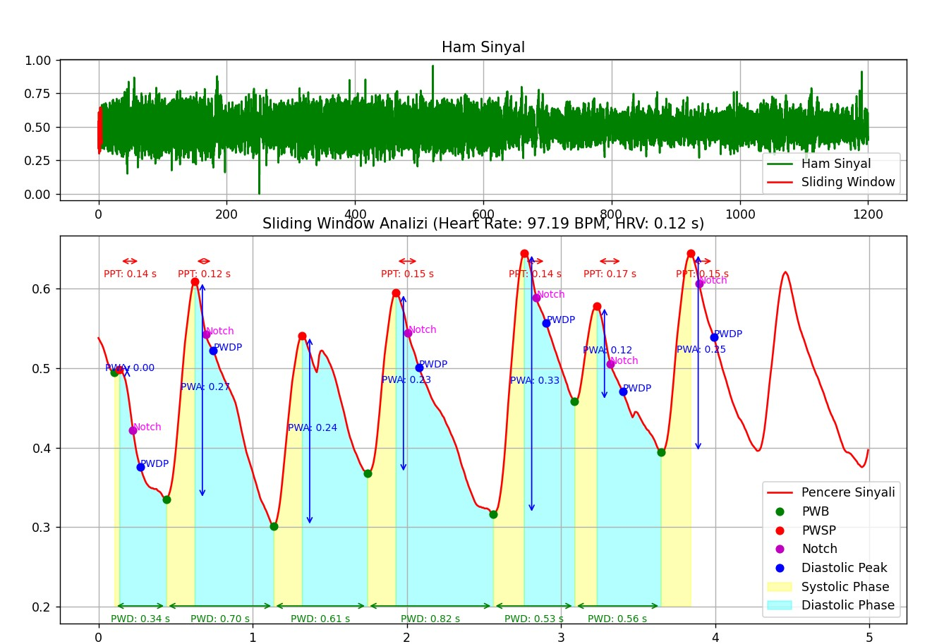

**1. Trough Points (PWB and PWE) - Local Minima(GREEN)**

* **Definition:** The local minima of the PPG signal, indicating key transitions within the waveform.
  + **Pulse Wave Begin (PWB):** The local minimum preceding the systolic peak.
  + **Pulse Wave End (PWE):** The local minimum after the diastolic peak.
* **How We Found Them:**
  + For **PWB**, we analyzed the region preceding each PWSP (systolic peak) and selected the last local minimum before the peak.
  + For **PWE**, we analyzed the region after the PWDP (diastolic peak) and selected the first local minimum in that segment.

**2. Pulse Wave Systolic Peak (PWSP) - Systolic Peak(RED)**

* **Definition:** The highest point of the systolic phase in the PPG waveform.
* **How We Found It:**
  + Using the find_peaks function, we identified the peaks in the signal. o We ensured a minimum time interval (e.g., 0.6 seconds) between peaks to avoid false positives caused by noise or small fluctuations.
  + The highest value in each cardiac cycle was labeled as the **PWSP**.

**3. Dicrotic Notch - Secondary Inflection Point(PURPLE)**

* **Definition:** A secondary local minimum that occurs after the systolic peak and represents a transition in blood flow dynamics.
* **How We Found It:**
  + **Range:** We limited the search to the region between **PWSP + 0.05 seconds** and the first PWB after PWSP (**PWB - 0.05 seconds**).
  + **Method 1:** In this range, we searched for a point where the first derivative crossed zero (negative to positive transition).
  + **Method 2 (Backup):** If no such zero-crossing existed, we analyzed the second derivative and selected the point with the lowest value (global minimum).
  + **Alternative Method:** If neither of the above methods succeeded, we used the third derivative to identify a zero-crossing where the slope changes from positive to negative.

**4. Pulse Wave Diastolic Peak (PWDP) - Diastolic Peak(BLUE)** • **Definition:** The local maximum that occurs after the dicrotic notch.

* **How We Found It:**
  + **Range:** The search was limited to the region between the dicrotic notch and the following PWB. o **Method:** We analyzed the first derivative and selected the point where it transitioned from positive to negative (indicating a local maximum).
  + **Alternative Method:** If no such transition was detected, we simply identified the maximum value in the region.
* **Metrics Calculated**
* **1. Pulse Transit Time (PPT)**
* **Definition:** The time difference between the systolic peak (**PWSP**) and the diastolic peak (**PWDP**).
* **2. Pulse Wave Amplitude (PWA)**
* **Definition:** The amplitude difference between the systolic peak (**PWSP**) and the preceding trough point (**PWB**).
* This metric reflects the strength of the blood pulse in the arterial system.
* **3. Pulse Wave Duration (PWD)**
* This metric is related to the duration of one cardiac cycle and overall heart rate variability.
* **4. Systolic Phase Duration**
* **Definition:** The duration of the systolic phase, defined as the time between **PWB** and the following **PWSP**.
* This metric represents the active pumping phase of the heart.
* **5. Diastolic Phase Duration**
* **Definition:** The duration of the diastolic phase, defined as the time between **PWSP** and the next **PWB**.
* This metric reflects the relaxation phase of the cardiac cycle.
* **6. Heart Rate (HR)**
* **Definition:** The number of heartbeats per minute (BPM).
* This metric is a direct measure of cardiac activity.
* **7. Heart Rate Variability (HRV)**
* **Definition:** A measure of variation in time intervals between consecutive heartbeats.
* This metric reflects the adaptability and variability of the cardiovascular system.