Prompt Pilot

Introduction
Prompt Pilot is a support tool designed to help users craft better prompts for AI-powered image generation platforms like DaVinci. These platforms rely heavily on the quality and structure of text prompts to produce visually compelling and accurate images. However, many users—especially beginners—struggle to write effective prompts, resulting in poor or irrelevant outputs. This project addresses the gap by guiding users in creating structured, detailed, and creative prompts. By offering smart suggestions, templates, and real-time feedback, Prompt Pilot aims to enhance prompt quality, reduce trial-and-error cycles, and improve the overall user experience in visual AI generation tools.

Problems
- Many users struggle to write effective prompts for AI image generators like DaVinci.

- Poorly written prompts often lead to irrelevant, low-quality, or disappointing image results.

- There is a lack of structured guidance for users—especially beginners—on how to construct prompts effectively.

- The process of trial-and-error takes time and reduces user satisfaction.

- Users cannot easily predict how their prompt will influence the AI's output, leading to frustration and inconsistency.

Business Needs
- Provide users with intelligent guidance and templates to help them write better prompts.
- Improve the overall quality of generated images by enhancing prompt clarity and creativity.
- Reduce the time and effort required to find a prompt that works.
- Create a tool that not only supports prompt generation but also educates users on how AI interprets inputs.
- Deliver a smoother, more satisfying image-generation experience, especially for new users.

Success Criteria
- At least 70% of users report improved image results after using Prompt Pilot.
- Prompt creation time decreases by at least 40% on average per user.
- Prompt Pilot’s smart suggestions or templates are used by over 50% of users.
- User satisfaction ratings increase by 30% compared to baseline prompt-only experience.
- MVP usage analytics show consistent engagement and repeat usage within the first month of launch.

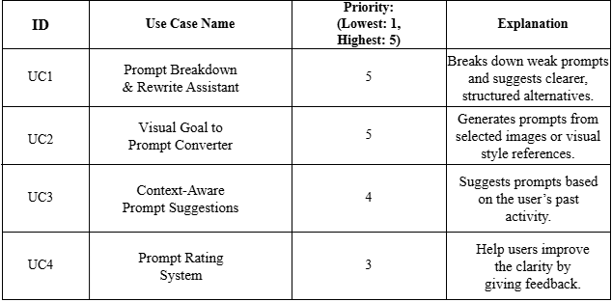
Use Case Priority List

The table above presents the prioritized use cases for the Prompt Pilot project, focusing on enhancing the quality and effectiveness of user-generated prompts for AI image tools. UC1 and UC2 are given the highest priority, as they directly address the core user challenges: weak prompt structure and difficulty translating visual goals into text. For UC2,It helps users understand how a visual style can be described in prompt form, offering inspiration even if they want to create something slightly different. UC3 adds personalization by learning from user history, while UC4 focuses on feedback loops to refine prompt clarity. These use cases form the foundation for a smart, user-centered prompt assistance system.

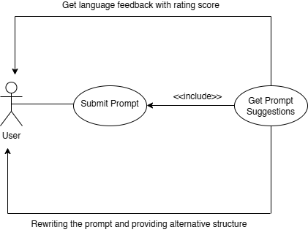

Use Case Diagram for General Structure

This use case diagram represents the core interaction flow of the Prompt Pilot system. The primary actor is the User, who interacts with the system by submitting a prompt (Submit Prompt). This main use case includes the Get Prompt Suggestions function, which means that every time a user submits a prompt, the system will automatically suggest improved or alternative versions.
Additionally, after submitting a prompt, the system performs two key supportive actions:
- Language Feedback with Rating Score: The system analyzes the linguistic quality of the prompt and returns feedback to the user, helping them understand clarity, grammar, and expressiveness.
- Prompt Rewrite and Structure Suggestion: The system offers a revised version of the submitted prompt with improved structure, guiding the user toward more effective input creation.

This diagram reflects the intelligent assistance process that makes Prompt Pilot more than just a suggestion engine—it’s a real-time prompt improvement companion.

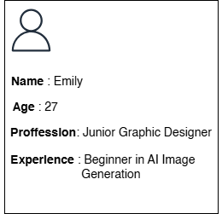

User Persona Template

This user persona represents the target audience of the Prompt Pilot application. It helps the team understand the needs, goals, and pain points of real users. By focusing on this profile, we can build features that solve actual problems, improve user experience, and align the product with user expectations.

Goals:
- Generate creative and high-quality AI visuals quickly.
- Learn how to write effective prompts.
- Get inspired by examples and visual styles.

Pain Points:
- Wastes time trying random prompts.
- Doesn’t understand why some prompts fail.
- Needs a tool that teaches and supports her.

USER STORIES (Based On Emily’s Needs)

Prompt Understanding:
As a beginner user, I want the system to break down my prompt and explain what's missing so that I can understand how to improve it.
Visual-to-Prompt Conversion:
As a visual thinker, I want to select an example image and get a suggested prompt so I can recreate or get inspired by similar styles.
Language Feedback:
As a non-native English speaker, I want the system to check the grammar and clarity of my prompt so that it works better with the AI tool.
Prompt History:
As a frequent user, I want to view my previously used prompts so that I can refine or reuse them when needed.
Save Favorites:
As a creative professional, I want to save my best-performing prompts as favorites so that I can easily access them again.

Product Backlog

ID | User Story | Priority | Status | Story Points | Acceptance Criteria
PB-01 | As a beginner, I want to system to rewrite my prompt and explain what's missing so that I can understand how to improve it. | High | To do | 5 | System analyzes the prompt and suggest at least one improved version.
PB-02 | As a visual thinker, I want to select an example image and get a suggested prompt so I can recreate or get inspired by similar styles. | High | To do | 8 | System generates a complete prompt based on selected visual/style reference.
PB-03 | As a non-native English speaker, I want the system to check the grammar and clarity of my prompt so that it works better with the AI tool. | Medium | To do | 5 | System highlights grammar/clarity issues and gives real-time feedback.
PB-04 | As a frequent user, I want to view my previously used prompts so that I can refine or reuse them when needed. | Medium | To do | 3 | Users can see a chronological list of past prompts with timestamp.
PB-05 | As a creative professional, I want to save my best-performing prompts as favorites so that I can easily access them again. | Low | To do | 2 | Users can mark prompts as favorite and access them via a separate “Favorites” list.

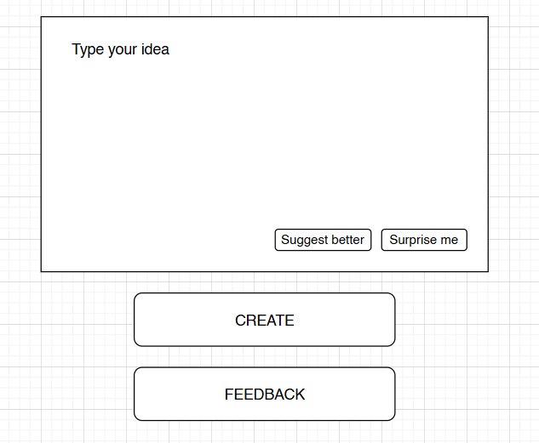

UI MOCK UP FOR UC1 AND UC4
This mockup presents the user interface enhancements designed for UC1 (Prompt Breakdown & Rewrite Assistant) and UC4 (Prompt Rating System), building on the existing app features. While "Surprise me" and "Create" are already available in the app, two new functionalities are introduced: "Suggest Better" provides users with improved, clearer versions of their input prompt, and "Feedback" offers real-time analysis on prompt clarity and language quality. These additions aim to help users refine their prompts with structured guidance and actionable feedback before generating AI images.

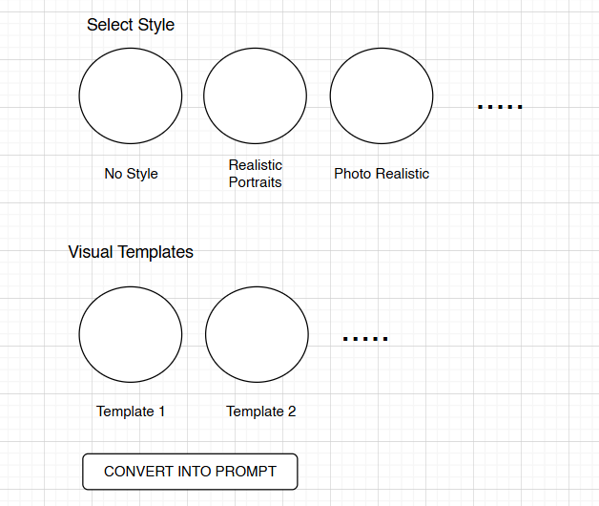

UI MOCK UP FOR UC2

This mockup illustrates the interface for UC2 (Visual Goal to Prompt Converter). While the “Select Style” feature already exists in the current app, this design introduces a new section: “Visual Templates” combined with a “Convert into Prompt” button. Users can choose a style and a visual template, then click “Convert into Prompt” to automatically generate a structured, AI-ready prompt based on their selections. This enhancement bridges visual choices with prompt creation, providing a more guided and accessible experience for users unfamiliar with prompt writing.

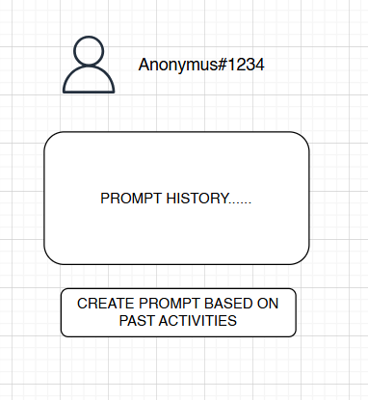

UI MOCK UP OR UC3
This mockup illustrates the interface for UC3 (Context-Aware Prompt Suggestions), placed within the profile section of the app. It displays the user’s prompt history alongside a new feature: the “Create Prompt Based on Past Activities” button. By clicking this button, users receive personalized prompt suggestions generated from their previous inputs and preferred styles. This feature allows users to leverage their historical data to craft more effective and tailored prompts, improving both consistency and creative outcomes.
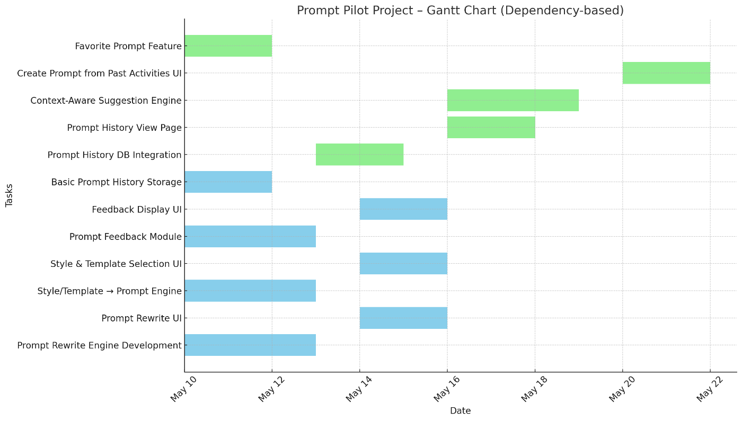
Gantt Chart Of Prompt Pilot Project Sprint Backlog

This Gantt chart presents the timeline for the Prompt Pilot project, structured based on task dependencies rather than fixed sprints. Independent tasks such as "Prompt Rewrite Engine Development" and "Favorite Prompt Feature" begin simultaneously, while dependent tasks like "Prompt Rewrite UI" or "Create Prompt from Past Activities UI" are scheduled to start only after their prerequisite components are completed. This approach ensures efficient use of resources while respecting workflow constraints. Tasks from different functional groups (e.g., core features, personalization, and enhancements) are planned with overlapping where possible and sequencing where necessary, resulting in a realistic and WIP-friendly project schedule.

Prompt Quality Comparison – Why Prompt Writing Matters ?

To demonstrate the impact of prompt quality in AI image generation, a simple scenario was tested using the theme "Van Gogh building the Eiffel Tower." The first image was generated using a basic prompt:
“Van Gogh is building Eiffel Tower.”
The result simply depicted the Eiffel Tower in a Van Gogh-like style, but without any human figure or construction context.



Next, the prompt was expanded to:
“Picture the Van Gogh while he is building Eiffel Tower. He carries some bricks to build it.”
This time, the images showed a clear visual narrative — Van Gogh himself is visible, interacting with the environment, and engaging in the act of construction.
This comparison highlights the critical role of clarity, detail, and context in prompt crafting. It proves that even small improvements in prompt structure can lead to dramatically more meaningful and accurate visual outputs — exactly the type of enhancement Prompt Pilot is designed to support.




The quality of a prompt makes all the difference in AI-generated images. A vague sentence often leads to basic or unrelated visuals, while a well-crafted, detailed prompt can bring creative ideas to life. In our tests, even small changes in wording led to dramatically better results. That’s exactly why Prompt Pilot exists — to help users write clearer, smarter prompts and get more out of their AI tools.

A/B Test Impact Simulation (Scenario)
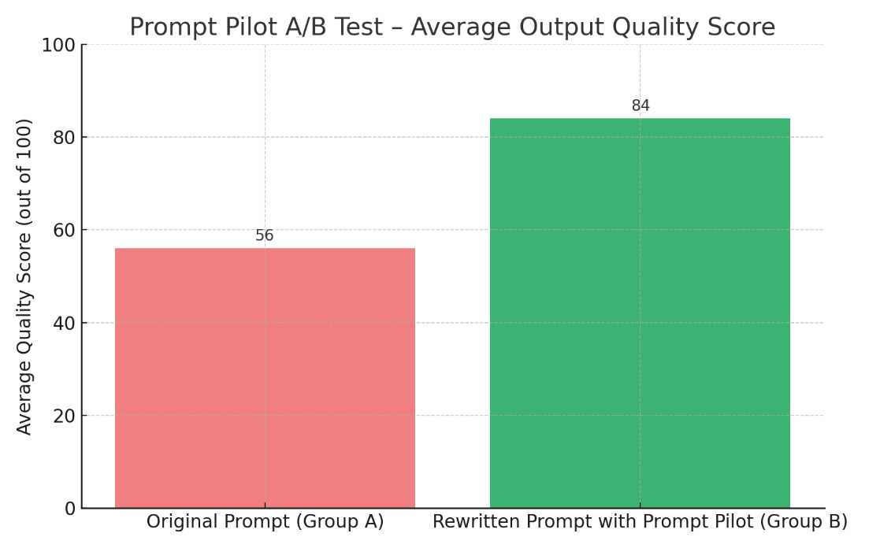

To simulate the impact of Prompt Pilot on prompt quality, an A/B test scenario was designed. Group A users generated AI images using their original prompts , while Group B used rewritten prompts enhanced by Prompt Pilot’s suggestions. The results show a significant improvement: Group B achieved an average image quality score of 84, compared to just 56 for Group A. This demonstrates that Prompt Pilot’s rewriting feature meaningfully enhances prompt clarity and context, resulting in more accurate and visually compelling AI outputs.

Abstract
Prompt Pilot is a support tool that helps users write better prompts for AI image generation. Many users struggle to get the results they want because their prompts are too vague or unclear. This project was created to solve that problem by offering features like prompt rewriting, converting visual ideas into prompts, giving feedback on clarity, and suggesting new prompts based on past usage. Prompt Pilot makes it easier for anyone—especially non-technical users—to create more accurate and creative prompts. Built with Agile methods and real user needs in mind, it improves both the experience and the outcome of working with AI-powered image tools.

