**SOURCE MONİTOR**

***KİVİYAT GRAFİĞİ***

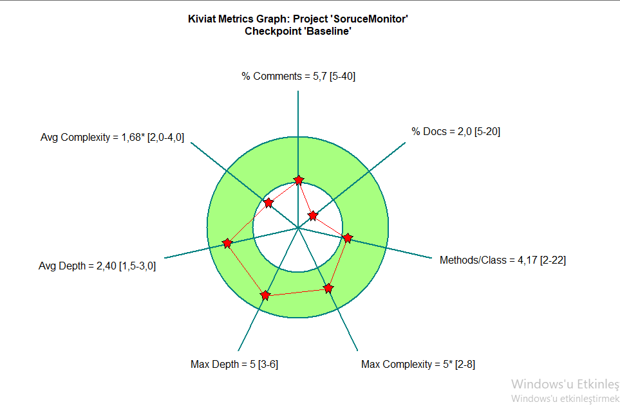

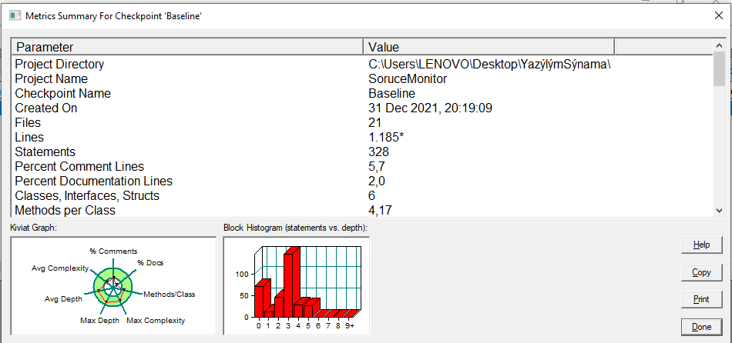**BLOCK HİSTOGRAM**

**GİTHUB LİNKİ**

<https://github.com/BerkTUNA/YazilimSinamaFinal>