卡通人物

**Heritage and Design: Factors Driving Consumer Choices for Fernandes**

Poppe de Ruiter(2976722)

Berk Yilmaz(7473230)

Keimpe Veeman(2044919)

Chengyu Meng(5061520)

Yannick Kurvers(8008701)

Team 7

**Statement of Originality**

We, the aforementioned students, herewith declare to have written this document and that we are responsible for the content of it. We declare that the text and the work presented in this document is original and that no sources other than those mentioned in the text and its references have been used in creating it.

Utrecht University School of Economics is responsible solely for the supervision of completion of the work, not for the content.

**Overview**

This project will begin with an introduce to Fernandes’s marketing strategies, following by a analysis of survey data. It will explore how cultural identity and package aesthetics influence consumers’ decision, ultimately providing recommendations for Fernandes."

**Word count: 5633**

Marketing ECB2MKT

Final report

**Table of Content**

**1.Introduction** 3

**1.1 Motivation** 3

**1.2 Background** 3

**1.3 Overview of the Report** 3

**1.4 Research question** 4

**1.5 Significance of the Study** 4

**2. Fernandes’ Marketing Strategy** 5

**2.1 Product** 5

**2.2 Price** 5

**2.3 Place** 5

**2.4 Promotion** 6

**2.5 Market Segmentation** 7

*2.5.1 Behavioral Segmentation* 7

*2.5.2 Psychographic Segmentation* 7

*2.5.3 Demographic Segmentation* 7

**2.6 Brand Positioning and Identity** 8

*2.6.1 Emotional Appeal and Community Involvement* 8

**2.7 Conclusion** 8

**3. Methodology and Data Analysis** 9

**3.1 Data Collection and Methodology** 9

*3.1.1 Variables* 10

**3.2 Data Analysis and Sample Regressions** 10

*3.2.1 The initial Regression* 10

*3.2.2 A Graphical Representation of Regression One* 12

*3.2.3 The Second Regression* 13

*3.2.4 The Correlation Matrix* 15

**4.Influence of Cultural Identity on Consumer Purchase Decisions** 17

**4.1 Introduction** 17

*4.1.1. Cultural dimensions theory* 17

*4.1.2. Social identity theory* 18

*4.1.3 Consumer culture theory* 19

**4.2. Survey Findings** 20

**4.3 Implications for Fernandes's strategy** 24

**5. Influence of Packaging Aesthetics on Consumer Purchase Decisions** 25

**5.1 Introduction:** 25

**5.2 Visual Appeal and Design Elements** 27

*5.2.1 Fernandes Innovations Packaging Design* 28

**5.3 Survey Findings** 29

**5.4 Implications for Fernandes’ Marketing Strategy** 30

**6. Recommendations for Marketing Strategy** 32

**6.1 The four marketing P’s** 32

*6.1.1 Product* 32

*6.1.2 Place* 33

*6.1.3 Price* 34

*6.1.4 Promotion* 34

**6.2 Limitations and further recommendations** 35

**Appendix A: Sources** 37

**Appendix B: The Survey, Codebook, Teamwork Learning Agreement and Rmarkdown** 39

**1.Introduction**

**1.1 Motivation**

Purchases are a rationality in an ever-evolving social environment and therefore, examining the antecedents of consumer buying is crucial to future orient marketing strategies. A well-known soft drink brand, Fernandes plans to boost up its market position by undergoing a consumer-oriented approach. In this research study, cultural identity, packaging aesthetics and their effect on Fernandes ‘decision to purchase is used as themes.

This is the reason why the motivation of this study is to offer accurate information to Fernandes on how to optimise their marketing strategies. From associating the cultural identity and packaging aesthetics with the consumers’ behaviour, Fernandes can strengthen the positioning of the products and advertising appeals correspondingly.

**1.2 Background**

The purpose of this study is to identify the role of consumer cultural identity and packaging specific appeal factors on consumer decision-making for Fernandes soft drinks. Specifically, it aims to:

* Identify cultural elements that resonate with Fernandes’ target audience.
* Determine packaging design elements that enhance consumer appeal.
* Provide strategic recommendations to Fernandes based on findings.

**1.3 Overview of the Report**

* Fernandes’ Marketing Strategy: Overview of current strategies at its business level of operation may include product differentiation, pricing, place, and promotion.
* Questionnaire Analysis: Disclosure of survey outcomes focusing on part of cultural identity and packaging appearance.
* Influence of Cultural Identity on Consumer Purchase Decisions: What precisely cultural identity entails in the context of choice and the purchase decision.
* Influence of Packaging Aesthetics on Consumer Purchase Decisions: Exploring the role of packaging appeals in people’s decisions.
* Recommendations: A set of tactical recommendations for Fernandes derived from research results.

**1.4 Research question**

The core question is: How do consumer perceptions of cultural identity and packaging aesthetics influence the purchase decisions of Fernandes soft drinks?

**1.5 Significance of the Study**

By using this kind of research Fernandes is able to get a deeper insight of the company’s consumer profiling. Hence there is evidence that cultural identification is a remnant force within the consumer market, particularly within multicultural countries such as the Netherlands. It also assists Fernandes to ask marketers what explorations help them to recognize cultural motifs and values across the groups in order to market to each group effectively. This first touchpoint consumer-product experience, packaging aesthetics play a crucial role in guiding customers’ decisions in the marketplace.Understanding these factors helps Fernandes better cater to its diverse consumer base and strengthen its market position

**2. Fernandes’ Marketing Strategy**

**2.1 Product**

Fernandes has carved out a distinct niche in the beverage market by emphasising its unique and exotic flavours, which are deeply rooted in its Surinamese heritage. This cultural differentiation is a cornerstone of Fernandes' product strategy, helping the brand stand out amidst intense competition. The company's product portfolio includes a variety of traditional and innovative flavours, designed to appeal to both nostalgic consumers and those seeking new and adventurous taste experiences. This approach not only broadens Fernandes' consumer base but also reinforces its identity as a culturally rich and diverse beverage brand. The exotic flavours resonate well with consumers who appreciate the cultural story behind the products, thus fostering a deeper connection with the brand.

**2.2 Price**

Fernandes employs a dynamic pricing strategy that allows it to stay competitive while maintaining a premium image. This strategy involves adjusting prices periodically and offering special promotions during cultural events and holidays, which helps attract price-sensitive consumers without devaluing the brand. By highlighting the high quality and unique nature of its beverages, Fernandes is able to justify a higher price point, appealing to consumers who value distinctiveness and quality. This pricing approach is aligned with Coca-Cola's broader strategy of balancing affordability with premium positioning to maximise market penetration and profitability.

**2.3 Place**

The distribution strategy of Fernandes ensures that its products are widely available across various retail environments, from large supermarkets to small convenience stores. This extensive distribution network maximises market reach and accessibility, making it easy for consumers to find and purchase Fernandes products. Additionally, Fernandes leverages online sales channels to cater to the growing segment of digital shoppers. This multi-channel distribution approach is essential for meeting the evolving shopping preferences of consumers and ensuring that the brand remains accessible to a broad audience. By integrating its distribution strategy with Coca-Cola's vast network, Fernandes benefits from enhanced logistical support and market reach.

**2.4 Promotion**

Promotion is a crucial element of Fernandes' marketing strategy. The brand blends traditional and digital marketing techniques to build brand awareness and foster loyalty. Promotional campaigns often highlight the cultural significance of Fernandes' products, using storytelling to create a deep emotional connection with consumers. Social media plays a pivotal role in Fernandes' promotional strategy, allowing the brand to engage directly with consumers and build a community around its products. Platforms like Instagram and Pinterest are particularly effective for showcasing visually appealing content that highlights the exotic nature of Fernandes' beverages. Additionally, influencer partnerships help extend the brand's reach and credibility, promoting Fernandes authentically to a broader audience. Coca-Cola's extensive experience and resources in digital marketing further enhance these efforts, ensuring that Fernandes' promotional activities are both innovative and impactful.

**2.5 Market Segmentation**

Fernandes employs a comprehensive market segmentation strategy that includes behavioural, psychographic, and demographic segmentation.

*2.5.1 Behavioral Segmentation*

Fernandes targets consumers based on their purchasing behaviour, focusing on factors such as purchase frequency and brand loyalty. Loyalty programs and special promotions are designed to reward regular consumers and encourage repeat purchases.

*2.5.2 Psychographic Segmentation*

By understanding consumers' lifestyles, interests, and values, Fernandes tailors its marketing messages to resonate with different psychographic segments. Campaigns that emphasise the adventurous and exotic nature of Fernandes' flavours appeal to consumers seeking unique and culturally rich experiences.

*2.5.3 Demographic Segmentation*

Fernandes considers demographic factors such as age, gender, income, and education level in its marketing strategy. This enables the brand to design targeted initiatives that cater to specific demographic groups, ensuring broad appeal and relevance across different consumer segments. This segmentation approach helps Fernandes effectively meet the diverse needs and preferences of its target market.

**2.6 Brand Positioning and Identity**

Fernandes' brand positioning is centred on its cultural heritage and vibrant packaging. The use of bright colours and cultural motifs on its packaging not only attracts consumer attention but also conveys a sense of quality and freshness. This distinctive packaging helps Fernandes stand out on retail shelves and reinforces its brand identity.

*2.6.1 Emotional Appeal and Community Involvement*

Fernandes leverages emotional appeal by associating its products with positive cultural experiences and memories. The brand's active participation in local events and cultural festivals helps build strong relationships with consumers and reinforces its cultural significance. Community involvement is a key aspect of Fernandes' marketing strategy, fostering consumer loyalty and brand advocacy. Coca-Cola's global reach and marketing expertise further amplify these efforts, ensuring that Fernandes maintains a strong and resonant brand presence both locally and internationally.

**2.7 Conclusion**

Fernandes' marketing strategy is a well-rounded approach that effectively combines product differentiation, dynamic pricing, extensive distribution, and impactful promotion. By staying true to its cultural roots and continuously engaging with consumers, Fernandes has successfully carved out a unique niche in the beverage market. The brand's strategic integration into the Coca-Cola family has further amplified its reach and capabilities, positioning it for continued growth and success. With a focus on cultural identity, vibrant packaging, and community engagement, Fernandes is well-positioned to maintain its relevance and appeal in the competitive beverage market.

**3. Methodology and Data Analysis**

**3.1 Data Collection and Methodology**

The raw data for this study was collected through the use of an online survey consisting of 103 respondents aged 10 to 30+. We employed stratified random sampling to ensure that our data was adequate in terms ensuring we represented those across various different demographic backgrounds and segments.

The entirety of this study’s data analysis was performed in the programming language R. The Rmarkdown file is attached to the QR code in Appendix C. Each question’s proceeding answer was assigned a numerical value in order to be interpreted through statistical analysis methods. Some questions represented a spectrum of answers, namely answers in ascending order of satisfaction with Fernandes products; and others were dummy variables that represented a single independent variable. An example would be the respondent’s place of birth. All questions that included personalised written responses were left out of the statistical analysis as they will be interpreted in the “Recommendations” section in detail manually.

The main statistical analysis method being utilised in this study is the Ordinary Least Squares (OLS) regression, which is mainly used to determine the relationship and interplay between different independent variables within a dataset. In this case, it will be used as a means of seeing which variables, and therefore the questions asked in our survey, have statistically significant relationships with our dependent variable, which is “identifying as a Fernandes customer”.

*3.1.1 Variables*

The notable independent variables being examined in this study include but are not limited to “Age, Place of Birth, Familiarity with Fernandes, Locating Suriname on a Map, Motivation for Drinking Fernandes, and The Importance of Flavor in Soft Drinks”. For the full list of variables, see regression outputs and the Appendix. By the inclusion of all of these variables within different sample regressions, we wish to see the effect of each variable on whether or not they contribute to an individual’s notion in declaring themselves as a customer of Fernandes. Through the inclusion of the sample regressions, we are able to see whether each variable has a statistically significant impact on the dependent variable, and whether the effect is observed as positive or negative. The larger and more positive the coefficient of each variable, the more sizable the positive effect will be on a person identifying as a Fernandes customer, and vice versa.

**3.2 Data Analysis and Sample Regressions**

*3.2.1 The initial Regression*

Throughout the study, we conducted two regressions. The first of which included all of our 16 independent variables, and our dependent variable Fernandes_customer, all of which we thought were relevant to include within the context of the study. Both regressions were tested with the Breusch-Pagan method, and Heteroskedasticity was not present, therefore the standard errors and measures of statistical significance were accurately calculated with no further need of correction. The first regression output is as follows:

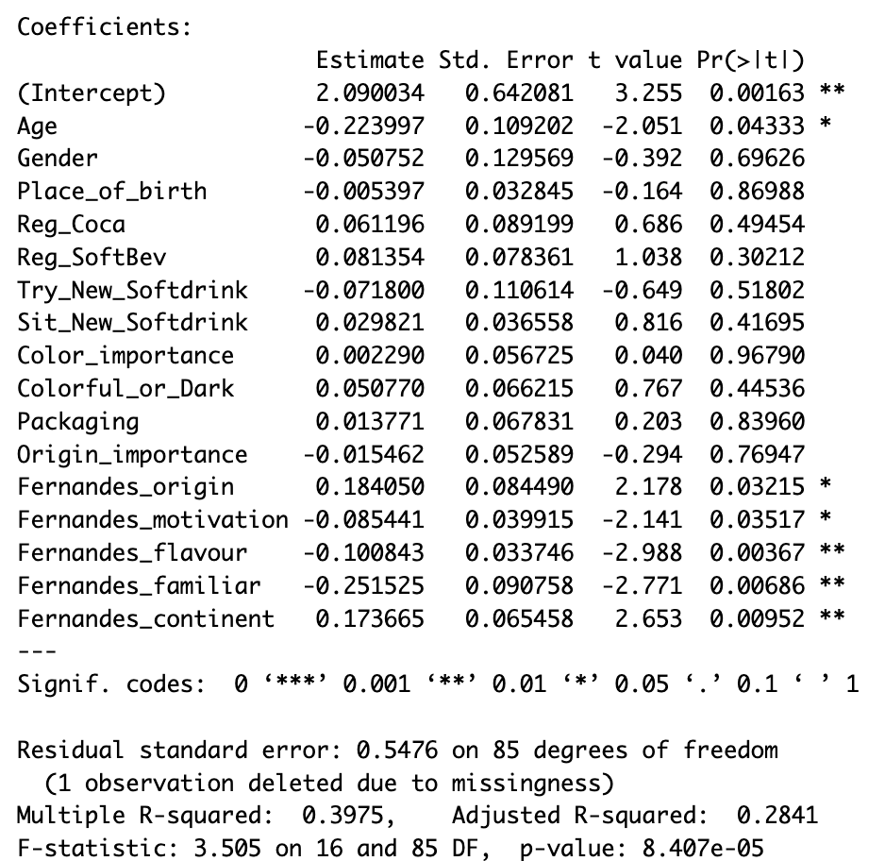

**Figure 1: The Initial Regression**

The R squared value of the regression is 0.28, which indicates that 28% of the variance in identifying as a Fernandes customer was explained by the variance of our independent variables within this model. The initial regression analysis had 6 statistically significant variables: Age, Fernandes_origin, Fernandes_motivation, Fernandes_flavour, Fernandes_familiar and Fernandes_continent respectively.

Namely, the fact that the variables Age and Fernandes_familiar have statistically significant negative coefficients is of major importance, as it indicates that with increasing age, and with increasing familiarity with the Fernandes brand, there’s a negative association between identifying as a Fernandes customer. Mind that while the coefficient for Fernandes_continent is statistically significant and positively correlated, it’s not ready for making inferences because it’s a series of dummy variables corresponding to each continent (1 for Asia, 2 for Africa etc.), so while it is statistically significant, we will not be interpreting it just yet.

*3.2.2 A Graphical Representation of Regression One*

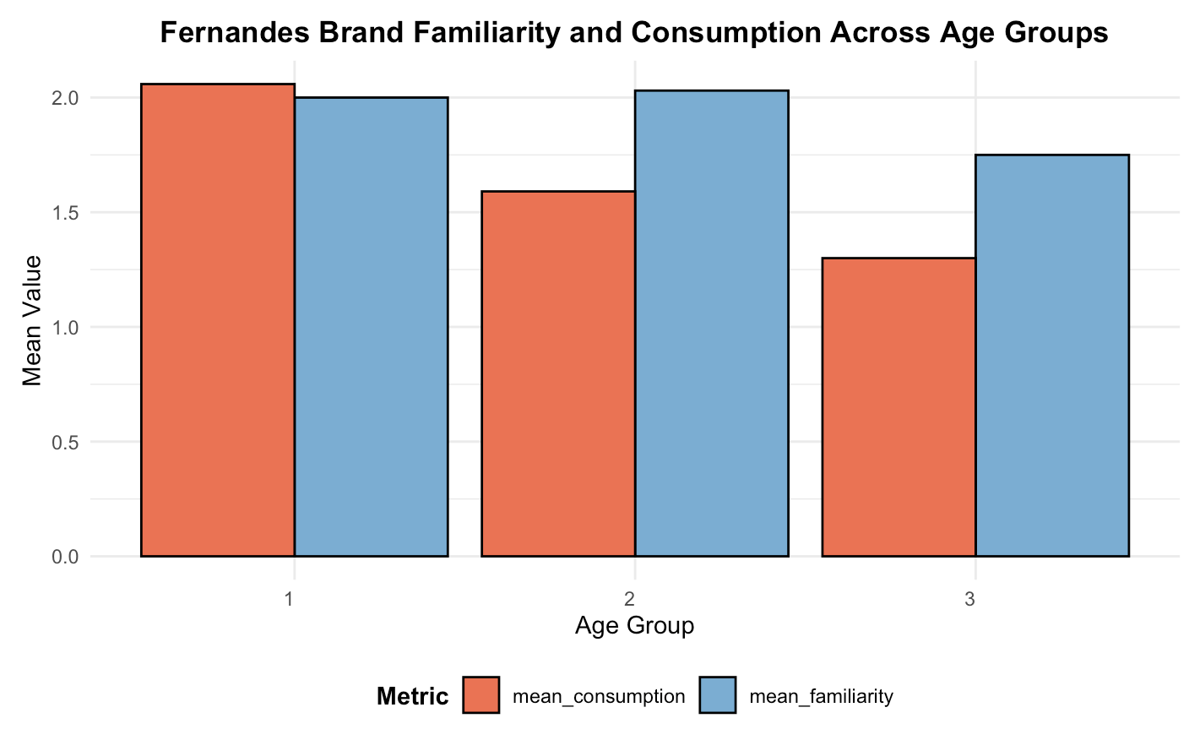

**Figure 2: Fernandes Brand Familiarity and Consumption Across Age Groups, where age groups 1,2 and 3 correspond to 10-20, 20-30, 30+ years old respectively.**

The data, which we can now interpret because of the apparent statistical significance, indicates that with increasing age Fernandes consumption decreases. The data demonstrates how even though on average, the 20-30 years old age group are slightly more familiar with Fernandes, it’s the 10-20 years old that seem to consume it the most. Surprisingly, on average for 10-20 years old respondents, the number of people that said they are active Fernandes consumers Fernandes exceeded the number of respondents that said they were Familiar with the brand. This could indicate that the younger generation pays less attention to a product’s name than the way it tastes or its label as a soft drink brand. This phenomenon could create new room for market research in examining the purchasing patterns of the younger generation of customers. It’s also the 10-20 years old age group that has the highest mean value of identifying as a Fernandes customer, compared to the other two age groups. And unsurprisingly, the 30+ year old age group is on average both the least familiar with Fernandes and has the lowest mean value of identifying as a customer.

*3.2.3 The Second Regression*

One of the main areas of question in this study was the inquiry whether there was prejudice about the brand, which may or not be caused by its marketing. Therefore, now that it’s been demonstrated that there’s a statistically significant negative relationship between being familiar with the brand and identifying as a customer (those who know about the brand consume it less), the next step is to find the root of the issue, which we proposed may be caused by a predisposition towards the country of Suriname. Furthermore, to test this hypothesis we conducted a second Sample Regression in which we only analysed the data for those who correctly identified which continent Suriname was located in. The second regression output is:

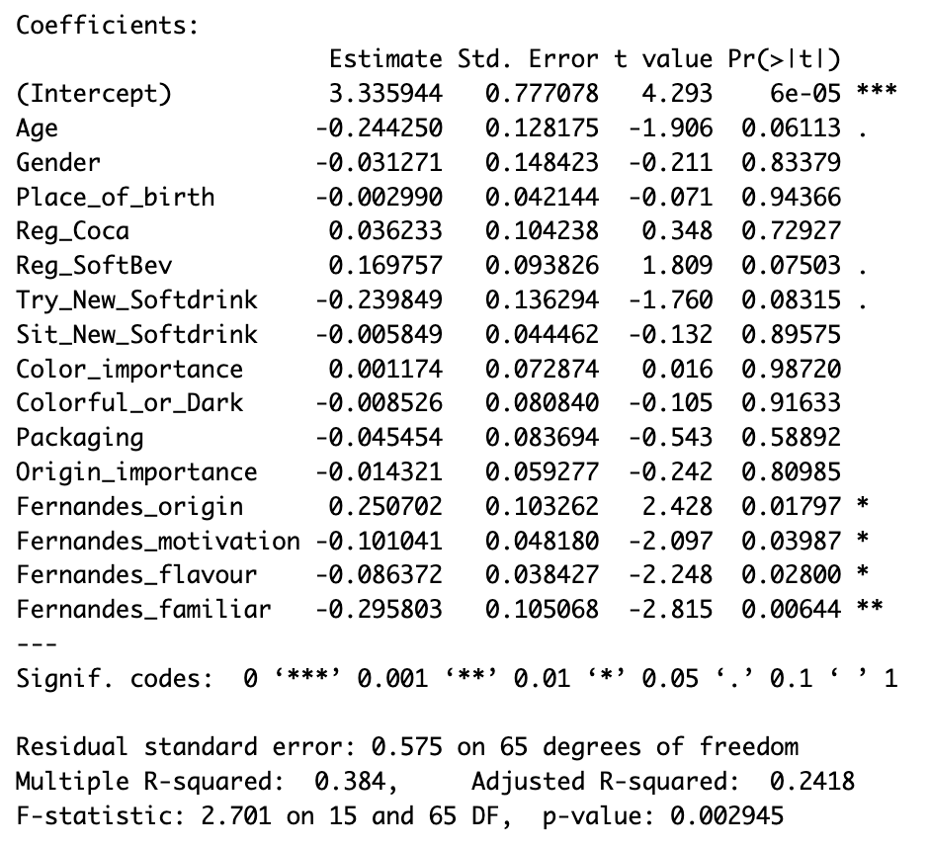

**Figure 3: The Second Regression**

Notice Fernandes_continent is now missing in the regression analysis, as we only used the data for when Fernandes_continent is equal to 4, which stands for South America and is the only correct identification of the location of Suriname.

The most notable difference between the two regression models, aside from the fact that the second graph has a smaller number of statistically significant variables and a lower R Squared value of 24%, is the fact that the coefficient for Fernandes_Familiar is even more negative than in the first regression (-0.29 to -0.25). While this may seem like a small difference, it also signifies how respondents that were correctly able to identify Suriname’s continent were even less likely to declare themselves as a Fernandes customer, given that they are familiar with the brand. This occurrence suggests the possible presence of negative preconceived notions about Suriname which may be impacting the customer reach of Fernandes, although at this point in the study, making a concrete conclusion would be inaccurate given the limited number of respondents (103) and in order to test this hypothesis we would need a much larger sample size consisting of many more groups of individuals.

*3.2.4 The Correlation Matrix*

The correlation matrix for all of the numeric variables examined in the study is demonstrated in the diagram below. The matrix designates colours to show the degree of correlation between each variable, with dark blue signifying highly positive correlation and orange indicating severely negative correlation.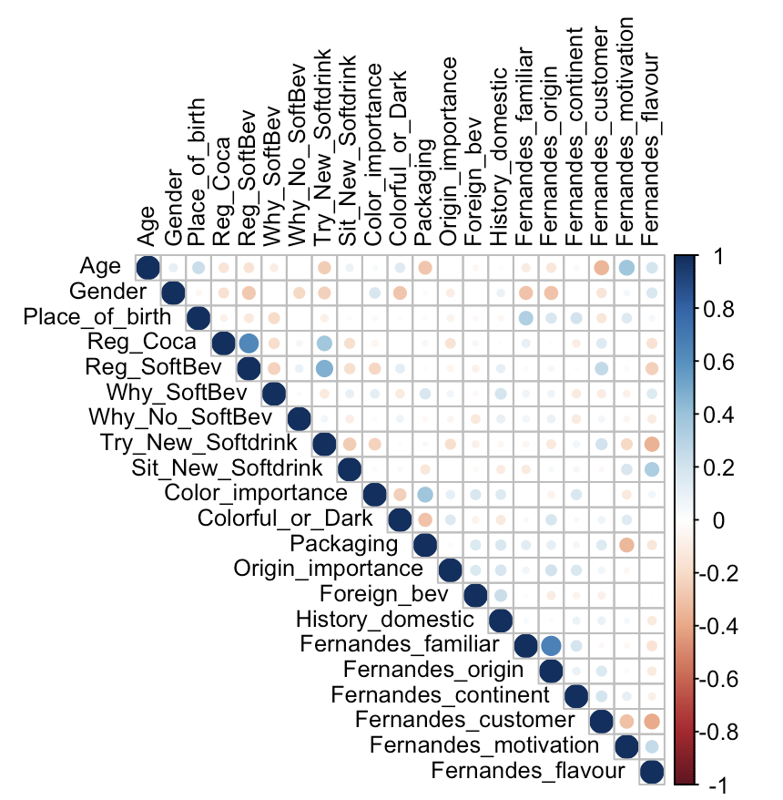

**Figure 4: The Correlation Matrix**

**4.Influence of Cultural Identity on Consumer Purchase Decisions**

**4.1 Introduction**

In a more complex than ever globalised market, understanding consumer behaviour has become much more complicated. Companies must recognize factors that influence a consumer's purchase decision to stay competitive. Among these factors, cultural identity stands out as increasingly important. The relation between cultural identity and practices is a “custom complex” consisting of “customary practice and of the beliefs, values, sanctions, rules, motives, and satisfactions associated with it” (Shweder et al. 1998). The cultural identity of a product shapes how it is perceived and interacted with by consumers through dimensions such as traditions, language and social norms.

*4.1.1. Cultural dimensions theory*

Through several theoretical frameworks, the important role of cultural identity becomes apparent in shaping consumer behaviour and purchase decisions. Firstly, the cultural dimensions theory: This framework was designed to understand differences in culture across countries. It consists of six key dimensions: power distance, individualism-collectivism, masculinity-femininity, uncertainty avoidance, short vs. long-term, and finally indulgence vs. restraint which was added later on by other researchers.

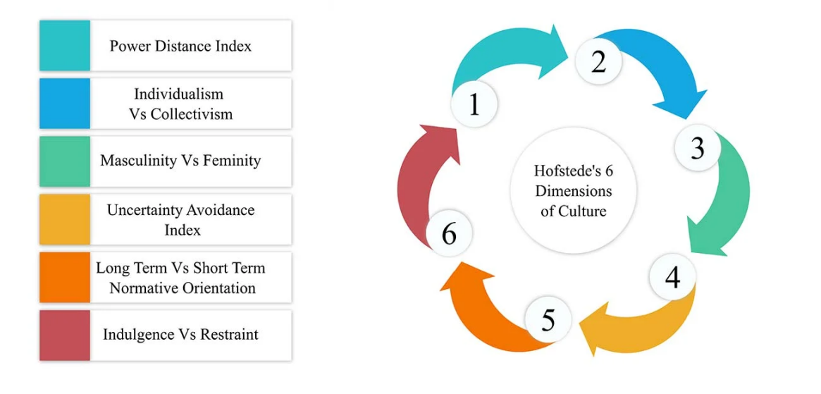

**Figure 5: Hofstede’s 6 dimensions of culture**

An individual country receives a score from 0-100 on each of the six dimensions. Say for instance that a country has a high collectivism score, a company may have to design its packaging and advertising to appeal more to groups as opposed to individuals.

*4.1.2. Social identity theory*

The social identity theory, which was proposed by Henri Tajfel and John Turner (in 1979), posits that individuals derive part of their self-concept from their membership in social groups. The theory seeks to explain that groups, people (such as social class, family, sports team etc.) belong to, are an important source of pride and self-esteem, by explaining the social conditions and cognitive processes underlying intergroup behaviours.

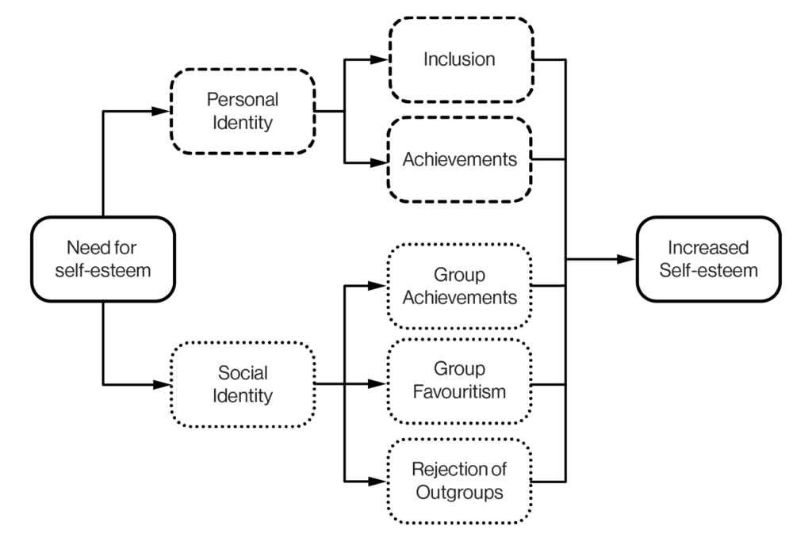

**Figure 6: An overview of the social identity theory**

In the context of consumer behaviour, purchase decisions are influenced by social identity through the desire to conform to the expectations and norms of one’s group. Products and brands that reflect a consumer's own groups norms and expectations are often chosen more frequently. An example of this: An ethnic minority group is likely to prefer a brand that recognizes and respects their cultural heritage. This leads to an increased loyalty toward such a brand, by the minority group.

*4.1.3 Consumer culture theory*

Consumer culture theory is a theory which Eric Arnould and Craig Thompsom (2005) delve into. It explores the complicated interplay between cultural processes and consumption. The theoretical approach accentuates that the purchasing behaviour of a consumer is not only dependent on the individual choice but also deeply embedded in cultural and social contexts. The consumer culture theory shows how consumers use brands and especially products to show and construct their identities. This is thanks to the fact that cultural identity influences the symbolic meanings that are attached to products. This identity can vary a lot across different cultural contexts. A luxury good, seen as status and success in one culture, for instance, could mean the opposite in another. Marketers should understand different cultures for their products to resonate with their target audience’s identity.

So, companies must keep some important cultural identity factors in mind when entering a product into the market. They should align their product or brand to the values and norms of their target group. They also need to show cultural relevance in marketing and messaging through advertisements, packaging and product designs. Another thing to keep in mind is the social identity and group affiliation of their target group, this relates to the social identity theory. Lastly, a strong brand heritage and authenticity rooted in specific cultural identities is able to create a loyal customer base.

**4.2. Survey Findings**

In our survey we had quite a few questions related to cultural identity:

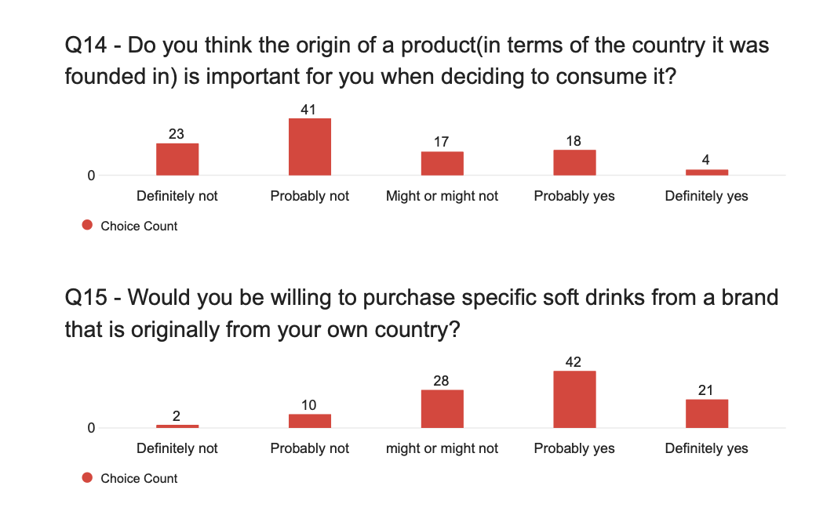

**Figure 7: Q14 ~ Do you think the origin of a product is important for you when deciding to consume it? And Q15 ~ Would you be willing to purchase specific soft drinks from a brand that is originally from your own country?**

It is apparent from question 14 that the majority of the survey participants do not think the origin from which a product comes is important when deciding to consume it. Whilst around 19,4 % do find it important. Question 15 shows that although most people don't find the origin of a brand important, they would be willing to purchase a soft drink from a brand originally from their own country. This heavily contradicts the results of question 14.

As mentioned in the social identity theory, purchase decisions are influenced by social identity to conform to expectations and norms of one’s group. So, even though people don't think they are biassed in their purchasing choice (Q14), they would buy a product (in this case a soft drink) that reflects their own country's norms and expectations. Results from these survey questions back up the research done by Henri Tajfel and John Turner (1979).

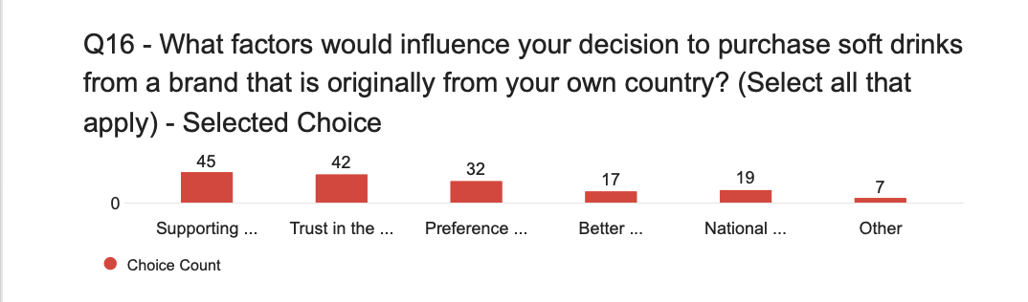

**Figure 8: Q16 ~ What factors influence your decision to purchase soft drinks from a brand that is originally from your own country?**

Question 16 results show that the reason for purchasing soft drinks from a brand from their own country would mostly be: supporting local businesses (45x), trust of the quality of domestic products (42x) and the preference for familiar tastes and flavours (32x). National pride or patriotism was chosen 19 times. These results build upon those of Q14 and Q15 as consumers are influenced by social identity, especially those trusting domestic products and participants pressing on the national pride or patriotism option.

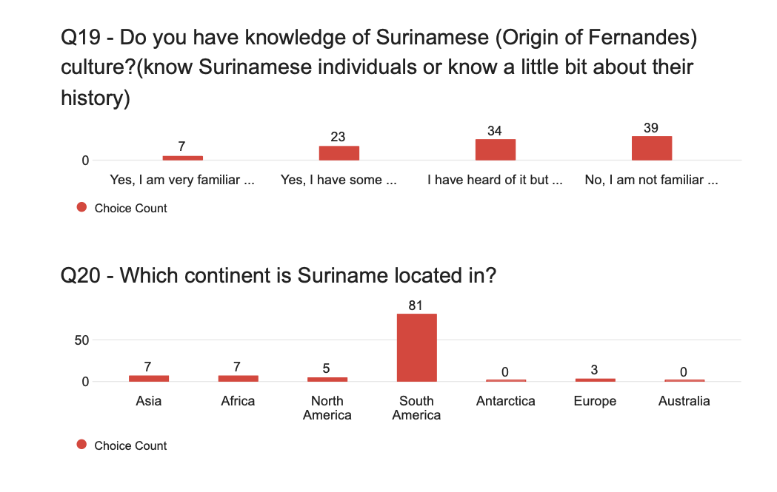

**Figure 9: Q19 ~ Do you have knowledge of Surinamese culture? And Q20 ~ Which continent is Suriname located in?**

Question 19 shows that most of our survey participants do not have an extensive knowledge of the Surinamese culture, visible in the fact that 39 participants are not at all familiar and 34 know very little. Question 20 confirms that 81 of the 103 participants know in which continent Suriname is located. So, 22 people had very little knowledge on Suriname.

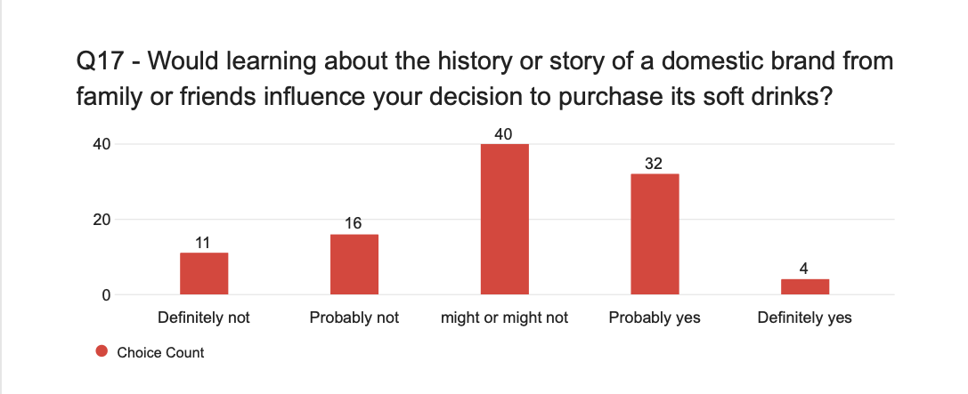

**Figure 10: Q17 ~ Would learning about the history or story of a domestic brand from family or friends influence your decision to purchase its soft drinks?**

Question 17 of the survey displays that 36 of the participants’s purchase decisions would be influenced by more knowledge about the history or story of a brand. The correlation of this result to Q19 and Q20 tells us that since there were participants that didn’t have much knowledge on Suriname, and participants also agreed that more insight on a brands history or story would influence their purchasing decision, this would mean that wider recognition of Suriname and Fernandes would be beneficial to the brand.

**4.3 Implications for Fernandes's strategy**

The cultural identity of Fernandes is crucial for its market success. Applying Hofstede’s cultural dimension theory to Fernandes, is a way for the brand to enhance its appeal and build a stronger brand loyalty. For instance, to capitalise in countries such as Suriname where there is a high-power distance culture, leveraging their long-standing heritage and market dominance is a way of reinforcing the brands image.

As seen in the results of the survey, Fernades would also benefit from leveraging the social identity theory and the consumer culture theory. They can achieve this through the continued use of cultural symbols, flavours and colours that resonate with their target audience. These elements are embedded into Surinamese and Caribbean cultures, so these familiar symbols strengthen the emotional connection and loyalty towards the brand.

**5. Influence of Packaging Aesthetics on Consumer Purchase Decisions**

**5.1 Introduction:**

In today's over-crowded marketplace, where competition thrives and a wide array of consumer choices, packaging aesthetics wield considerable influence over consumer behaviour, particularly within the beverage industry. As quoted by (Anttoni Taimela, 2024), "A well-designed package can trigger curiosity and communicate product quality, serving as a bridge to engage the consumer’s interest." This section delves into exploring the intricate relationship between packaging aesthetics and consumer preferences, with a focus on the brand: "Fernandes" soft drinks. By delving into relevant theories and empirical evidence, one of our objectives is to provide nuanced insights into how the roles of visual appeal, colour psychology, and design elements in shaping consumer behaviour, ultimately steering purchasing decisions.

Indeed, as emphasised that:

The presentation of the product now holds as much importance as the product itself."

Anttoni Taimela further illuminates that colour transcends mere visual appeal, wielding formidable psychological influence. Colour psychology emerges as a cornerstone in packaging, evoking diverse emotions and associations critical in moulding consumer perceptions.

Illustrative examples abound in packaging colour associations (Anttoni Taimela, 2024):

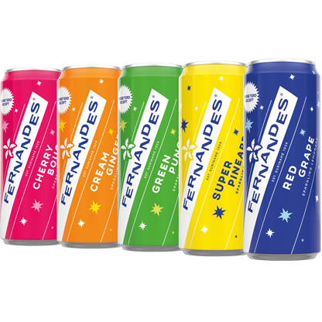

**Figure 11: Fernandes: Frisdrank (diverse smaken)**

Red: Encourages impulse buying

Blue: Triggers a more reflective purchase response

Orange: Attention-grabbing and promotes positivity

Black: Exudes sophistication

Theoretical Background:

Understanding the intricate relationship between packaging aesthetics and consumer behaviour hinges upon the Elaboration Likelihood Model (ELM).

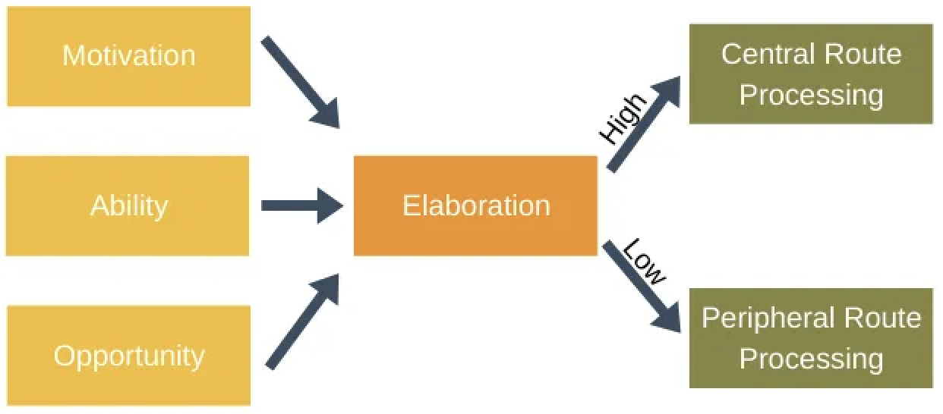

**Figure 12: Elaboration Likelihood Model (ELM) - Leader**

This theoretical framework posits that consumers engage in information processing through two distinct routes: the central route, which entails deep cognitive processing, and the peripheral route, which relies on superficial cues. Packaging aesthetics primarily function as peripheral cues, exerting subtle influence on consumer attitudes and behaviours. (Gonzalez, N., 2022)

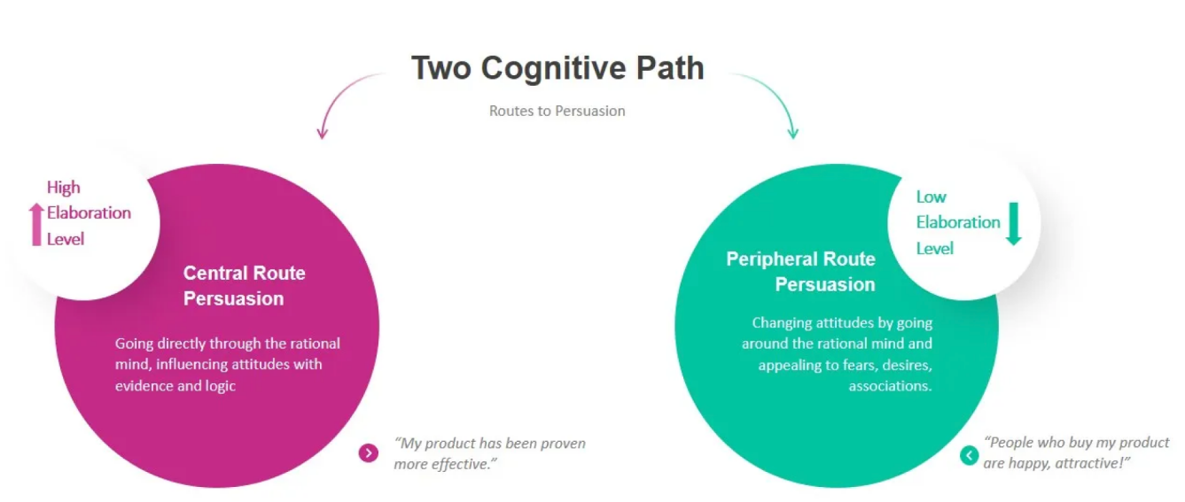

**Figure 13: Elaboration Likelihood Model (ELM) - Two Cognitive Path**

(Esquivel, K., 2022) mentioned that: Brooke Miller's interpretation of the Elaboration Likelihood Model (ELM) highlights three key characteristics across processing stages. Initially, individuals' interest levels in a topic determine their route: central for topics of passion, peripheral for less engaging content. Subsequently, engagement levels determine route choice: high involvement leads to the central route, while low interest prompts reliance on peripheral cues. Those on the central route are more likely to experience enduring opinion changes due to deep cognitive processing, whereas peripheral processing often leads to more transient shifts in attitudes.

**5.2 Visual Appeal and Design Elements**

The significance of visual appeal in packaging cannot be overstated. Numerous studies have highlighted its profound impact on consumer behaviour, showing that visually striking packaging can evoke emotions and influence perceptions. Recent evidence strongly suggests that packaging plays a pivotal role in consumer behaviour. According to a 2018 survey from (Michael Dillon, 2024), an overwhelming 72% of American consumers reported that product packaging design significantly influenced their purchase decisions, with another 67% indicating that the materials used in packaging were equally impactful. This phenomenon can be attributed to the fact that packaging serves as the initial point of contact for buyers during shopping or browsing activities.

Design elements like colour schemes, typography, imagery, and overall packaging design play pivotal roles in capturing consumer attention. Fernandes emphasises the importance of packaging that resonates with its target audience, effectively communicating the brand's identity and values.

*5.2.1 Fernandes Innovations Packaging Design*

According to the work of "Fernandes Innovations Packaging Design," (Pablo Van Gastel, 2024)highlights Coca-Cola Enterprises' commission for the development of three innovative designs for the exotic Fernandes brand. The resulting creations are as follows:

Purple Sensation:

Introducing a captivating addition to the flavour repertoire, Purple Sensation boasts an intense pomegranate flavour with reduced sugar content. This variant joins the ranks of Pink Melon and Cherry Bouquet Sugar Free cans and bottles, embodying the brand's commitment to flavour diversity.

Guaraná:

Venturing into the energy drinks market, Fernandes presents Guaraná, incorporating an ingredient native to South America. The design for this 250ml aluminium slim can strike a balance between boldness and palatability, aligning with industry standards while remaining unmistakably Fernandes.

Sparkling Coco:

Embracing the burgeoning popularity of coconut-infused beverages, Fernandes introduces Sparkling Coco, a tantalising concoction reflecting the fresh, sweet essence of the tropics. Available in ethnic shops and restaurants, this dreamy addition embodies Fernandes' commitment to innovative product offerings.

**5.3 Survey Findings**

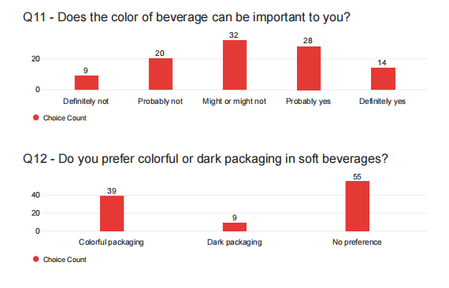

**Figure 14: Q11 - Does the color of beverage be important to you?**

Many consumers and users agree that the colour of a beverage holds considerable significance in their decision-making process, as it often serves as a visual cue to let them know about the flavour, freshness, and overall appeal of the drink.



**Figure 15: Q12 - Do you prefer colorful or dark packaging in soft beverages?**

While colourful packaging tends to attract a lot of attention and is often associated with vibrancy and freshness in the soft drinks space, it is worth noting that a significant number of people do not have a clear preference for colourful or dark packaging options.

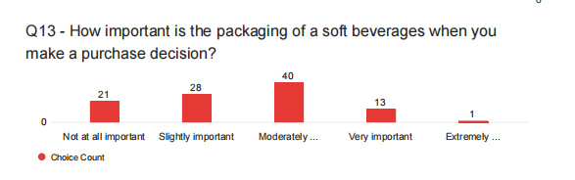

**Figure 16: Q13 - How important is packaging of soft beverages…?**

Interestingly, when considering the importance of packaging in the soft drink decision process, a noteworthy trend emerges: while most people believe that packaging is somewhat influential, there is a surprising split in the extent to which they consider packaging to be critical.

Contrary to expectations, fewer respondents tended to categorise packaging as "very important" or "extremely important," while the majority of respondents rated packaging as being of varying degrees of importance, ranging from "not important at all" to "slightly important" and "moderately important." This nuanced range of perceptions highlights the complexity of consumers' attitudes toward packaging when purchasing soft drinks.

**5.4 Implications for Fernandes’ Marketing Strategy**

Recognizing the significant influence of packaging aesthetics on consumer purchase behaviour offers Fernandes a distinctive avenue for refining its marketing approach. By strategically incorporating visually appealing design elements that resonate with consumer preferences, Fernandes can bolster brand perception, amplify product appeal, and ultimately drive sales. Furthermore, leveraging packaging as a potent branding mechanism has the potential to set Fernandes apart from its competitors, fostering sustained consumer connection and loyalty.

Packaging aesthetics has a considerable influence on consumer perceptions and purchasing decisions, especially in the competitive environment of the beverage industry. For Fernandez, optimising packaging design to seamlessly connect with consumer preferences is a strategic imperative. By implementing the insights gained from this research, Fernandez can strengthen its position in the soft drinks market, such as better colour decision, and considering brighter colour, which could cultivate lasting relationships with consumers and solidify its brand influence.

**6. Recommendations for Marketing Strategy**

**6.1 The four marketing P’s**

As far as we know now, Fernandes has expressed themselves into the Netherlands. A unique niche in the Dutch market. To get further integrated and penetrated in the Dutch market, we will set some recommendations for the brand for some more consumer loyalty and a better market position. We will go through the most 4 important marketing tools: Product, Place, Price, and Promotion. We will ground our recommendations through our survey and analysis of consumer behaviour and market trends with regard to the brand Fernandes.

*6.1.1 Product*

Our results show that cultural identity has a significant impact on consumer behaviour, especially in markets with diverse demographics. For Fernandes, using cultural motifs and stories can improve brand loyalty and market penetration. By capitalising on the sentiment of 'the people', where chauvinism always plays a big role. The brand must continue to integrate cultural elements into its branding and marketing efforts to maintain the connection with and benefit from their own people. Looking at where Fernandes is based, the Netherlands, this can be advantageous due to the increasing multicultural society. This cultural and exotic origin allows Fernandes to differentiate itself from other soft drinks.

Packaging plays a role in consumer decision-making. Consumers are more attracted to warm bright colours than colder colours. The study confirmed this view. Bright colours with a positive image also convey this to consumers. From our research, Fernandes does not come out well in terms of the artistry of their packaging. Fernandes should invest in packaging that matches consumers' preference for bright and colourful designs. This not only attracts attention but also gives a sense of freshness and quality. Trends should always be taken into account as time progresses and consideration should always be given to whether packaging should change to still stand out among shelves and in the offer leaves.

*6.1.2 Place*

To achieve maximum reach within their market segment, it is important to improve or optimise distribution channels. Ensuring that the product is available in different retail environments so that it is within eye reach of all kinds of people. This needs to be done nationwide at the major distribution centres in the Netherlands. But this should also happen at the local tobacconist or the small cafeteria. This creates an even wider audience. Moreover, an online shopping platform can be looked at. This is a growing segment that also appeals to a completely different target group. A target group that is also growing. Always keep your eyes open for new trends and other emerging markets.

Given the cultural diversity in the Dutch market, a regional focus can be advantageous. Align distribution strategies with regions where there is more diversity of Surinamese culture. Consider the randstad and Almere region. Focus on making culturally conscious choices and improve market penetration. Working with local distributors who understand regional preferences and dynamics can further strengthen Fernandes' market presence.

*6.1.3 Price*

To compete in a highly saturated market, Fernandes needs to adopt a dynamic pricing strategy. Look for competition prices and combine this with temporary discounts and promotions. Periodic price adjustments can attract (especially price-sensitive) consumers without deteriorating as a brand. Special offers, especially during holidays, festivals and cultural and local events will boost Fernandes' visibility. As a result, sales of Fernandes will also go up.

Highlighting the quality and the exotic nature of Fernandes' products may justify a slightly higher price point. Fernandes has many unique flavours and also a piece of intrinsic cultural heritage value in it. Highlighting this to be associated with the brand would perhaps justify a slightly higher price point. When good marketing is applied that emphasises these strong cultural ties, consumers will be more willing to pay a higher price. Bundling products in discount packs and discounts on large stocks could also strengthen sales.

*6.1.4 Promotion*

Developing and presenting marketing campaigns that focus on the cultural significance of Fernand's products can create a deeper emotional connection with consumers. By leveraging its unique background and taking the storytelling to an emotional level. This can connect with consumers and makes the brand more memorable in consumers' minds. Short but powerful so that the power of repetition is well reflected. Collaborations with cultural organisations and influencers who can promote Fernandes' products and cultural story in an authentic and unique way. In this, Fernandes has very high potential to further enhance promotional efforts.

Integrating digital marketing strategies, including social media campaigns, partnerships with influencers and targeted online ads, can increase Fernandes' reach. Investing in sports campaigns can also ensure greater reach. Sport is the No.1 entertainment of the population and here too lies a huge potential for Fernandes. Be built a loyal online community. Community engagement initiatives such as sponsoring local events and participating in cultural festivals can strengthen the Fernandes brand presence and consumer loyalty.

Important thing to keep in mind is to always test new strategies before they are widely used and implemented. This can prevent marketing fiascos and will increase effectiveness when something new is actually introduced to the market. Constantly keep abreast of trends and look for the relevant market data for your marketing strategy. Always taking feedback seriously from consumers and integrating it where necessary to stay relevant. Maintaining good and clear communication with your own employees, producers and relations as a company. Communication is key to avoid unexpected and unnecessary problems.

**6.2 Limitations and further recommendations**

The recommendations are based on our research, but of course there are limitations and risks to which we should not close our eyes.

Consider consumer market variability. Consumer preferences can vary significantly by region and demographics. What works in one market may not necessarily be successful in another. Moreover, fads can be over quickly. Today's generation is quickly fed up with the same thing over and over again.

The sample size of the study's sample and demographics are not fully representative of the broader market. Further research with larger and more diverse samples is needed for more general, and most importantly, better conclusions.

Changes in packaging and marketing strategies involve financial risks and potential disruptions. It is crucial to address these changes incrementally and monitor their impact closely.

In conclusion, the recommendations provided, based on thorough research and analysis, offer a good plan for Fernandes to navigate the competitive beverage market successfully. With a focus on cultural identity, packaging aesthetics, strategic distribution, competitive pricing, and engaging promotions, Fernandes is well-positioned to have value to the consumers and show brand loyalty.

**Appendix A: Sources**

Arnould, E. J., & Thompson, C. J. (2005). Consumer culture theory (CCT): Twenty years of research. Journal of Consumer Research, 31(4), 868-882.

Dillon, M. (2024, April 29). How does product packaging impact consumer buying behaviour? Meyers. <https://meyers.com/meyers-blog/how-does-packaging-affect-consumer-behavior/#:~:text=The%20effect%20of%20packaging%20on,see%20while%20sleeping%20or%20browsing>

Esquivel, K. (2022, February 12). Two routes: Central & peripheral, but we are choosing peripheral. Medium. <https://medium.com/@kayla.esquivel4/elaboration-likelihood-model-7662054e6e5e>

Gonzalez, N. (2022, February 12). The central or peripheral route: How the elaboration likelihood model is still present on social media. Medium. <https://nagonzalez383.medium.com/the-central-or-peripheral-route-how-the-elaboration-likelihood-model-is-still-present-on-social-5f04dd40143b>

Hofstede, G. (1984). Culture's consequences: International differences in work-related values. SAGE Publications.

Shweder, R. A., Goodnow, J. J., Hatano, G., LeVine, R. A., Markus, H., & Miller, P. J. (1998). The cultural psychology of development: One mind, many mentalities. In W. Damon (Ed.), Handbook of child psychology (5th ed., Vol. 1, pp. 865–938). Wiley.

Tajfel, H., & Turner, J. C. (1979). An integrative theory of intergroup conflict. In W. G. Austin & S. Worchel (Eds.), The social psychology of intergroup relations (pp. 33-47). Brooks/Cole.

Taimela, A. (2024, April 2). Unwrapping the impact: How packaging influences buying decisions. Limepack. <https://www.limepack.eu/blog/takeaway-packaging-eu/unwrapping-the-impact-how-packaging-influences-buying-decisions>

Van Gastel, P. (2024). Fernandes innovations packaging design. nu. <https://nuamsterdam.nl/en/projects/fernandes-packaging-design>

**Appendix B: The Survey, Codebook, Teamwork Learning Agreement and Rmarkdown**

The survey utilised in this study can be accessed via the following QR code on the left. To see the full questionnaire codebook in a single spreadsheet, the associated dataset, the teamwork learning agreement, in addition to the completed Rmarkdown file outlining each step of statistical analysis, scan the QR code on the right to be directed to the GitHub repository.

