# Expression Tree Example

# BerkaJ OEZTUERK

## Summary

An application is created from scratch, written in C, which provides the following functionalities to solve the coding exercise 1 and 2.

* Tree Construction Methods
* Tree Traversal Methods
* Solution to
  + Coding Exercise 1
  + Coding Exercise 2
* Test cases for both coding exercises

## Code Metrics

## 

## Code Analysis

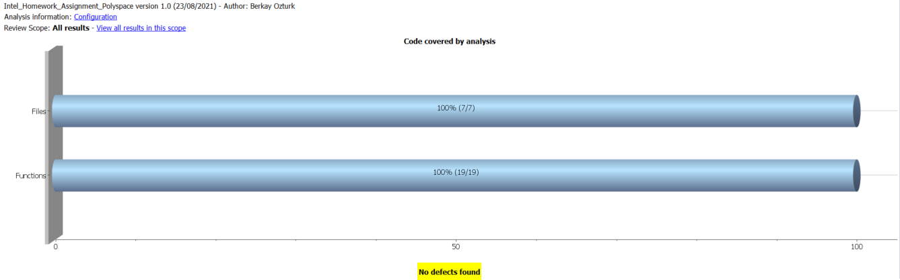

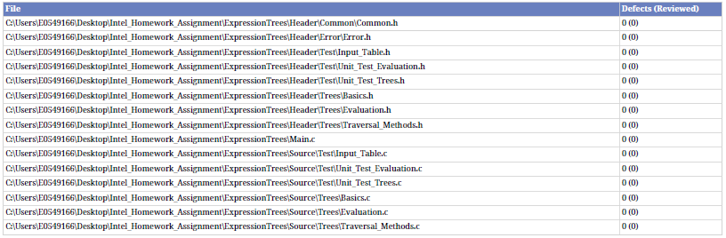

## Possible Defects Covered by Analysis (Checks)

## 

