

**ÇANKAYA UNIVERSITY**

**FACULTY OF ENGINEERING**

**COMPUTER ENGINEERING DEPARTMENT**

**Project Report**

**Version 1**

**CENG 407**

Innovative System Design and Development I

**P2019-11**

**FATIGUE DETECTION**

*İrem KAYMAKÇILAR*

*201611036*

*Damla Ebru PARLAK*

*201511047*

*Hümeyra ÜNAL*

*201611060*

*Berkay EKEBAŞ*

*201611017*

Advisor: *Abdül Kadir GÖRÜR*

Table of Contents

Table of Contents i

Abstract iii

Özet: iii

1. Introduction 1

1.1 Company Background 1

1.2 Problem Statement 2

1.3 Solution Statement 2

1.4 Related Work 2

2. Literature Search 3

2.1 Real Time-based Fatigue Detection Systems 3

2.2 Face Recognition 3

2.2.1 What is Face Recognition? 3

2.2.2 Some Examples of Face Recognition Algorithms 3

2.3 How to Detect Fatigue Symptoms 5

2.3.1 Detecting the symptoms of fatigue with Driver Behavioral Measures 5

2.3.2 Detecting the symptoms of fatigue with Vehicle-Based Measures 6

2.4 Technology Used 6

3. Software Requirements Specification 7

3.1 Introduction 7

3.1.1 Purpose 7

3.1.2 Scope of Project 7

3.1.3 Glossary 8

3.1.4 Overview of Document 8

3.2 Overall Description 8

3.2.1 Product Perspective 8

3.2.2 Product Features 8

3.2.3 User Characteristics 9

3.2.4 Constraints 9

3.3 Requirements Specification 9

3.3.1 External Interface Requirements 9

3.3.2 Functional Requirements 10

3.3.3 Performance Requirements 10

*Normalization* 11

3.3.4 Software system attributes 11

4. Software Design Description 12

4.1 Introduction 12

4.1.1 Purpose 12

4.1.2 Design Goals 12

4.1.3 Glossary 12

4.1.4 Overview of document 12

4.2 Architecture design 13

4.2.1 Simulation Design Approach 13

4.2.2 Use case diagram 14

4.2.3 Activity Diagram 15

4.2.4 Interface design 16

4.3 System Architecture 17

4.3.1 Data Management 17

4.3.2 Hardware/software mapping 17

4.3.3 Access control and security 18

# Abstract

In recent years, road accidents have increased significantly. Driver fatigue is one of the major causes of these traffic accidents. Fatigue increases the risk of injuries or other accidents. Also, it can reduce drivers’ attention, ability to make decisions, and it can result in the inability to stay awake, increased errors in judgment, etc. Accidents involving fatigued drivers tend to be particularly serious since the driver does not have a quick enough reaction time, and is too slow to attempt to avoid an accident. Due to these situations, giving drivers early warning that they need to take a break is vital for safe travel. Therefore, there is a need for a system to measure the fatigue level of the driver and alert him when he/she feels drowsy to avoid accidents.

Automatic vision-based driver fatigue recognition is one of the most prospective commercial applications based on facial expression analysis technology. Deriving an effective face location from original driver face images is a vital step for successful fatigue facial expression recognition.

**Key words:** Fatigue, fatigue detection for drivers, drowsiness, real-time drowsiness for drivers

# Özet:

Son yıllarda trafik kazaları önemli ölçüde arttı. Sürücünün yorgun olması, bu trafik kazalarının en önemli nedenlerinden biri. Yorgun halde trafiğe çıkmak, yaralanma veya diğer kaza riskini artırır. Ayrıca, sürücülerin dikkatini, karar verme yeteneğini azaltabilir ve uyanık kalamama, yargılamada hatalar vb. ile sonuçlanabilir. Yorgun sürücülerin neden olduğu kazalar, sürücünün yeterince hızlı tepki gösteremediği ve olası kazadan kaçınamadıkları dolayı ciddi olma eğilimindedir. Bu durumlar nedeniyle, sürücülere mola vermeleri konusunda erken uyarı vermek güvenli bir seyahat için çok önemlidir. Bu nedenle, sürücünün yorgunluk seviyesini ölçmek ve kazaları önlemek için uykulu hissettiğinde onu uyarmak amaçlı bir sisteme ihtiyaç vardır.

Otomatik görme tabanlı sürücü yorgunluğu tanıma sistemleri, yüz ifadesi analiz etme teknolojisine dayanan, ileriye dönük ticari uygulamalardan biridir. Orijinal sürücünün yüz görüntülerinden etkili bir yüz konumu elde etmek, başarılı bir yorgunluk tespitinde yüz ifadesi tanıma hayati bir adımdır.

**Anahtar Kelimeler:** Yorgunluk, sürücüler için yorgunluk tespiti, uykulu olma, sürücüler için gerçek zamanlı uykulu olma

# Introduction

Fatigue is generally defined as a feeling of the lack of energy and motivation that can be physical or mental. In general, fatigue affects task performance: a reduction in alertness, longer reaction times, memory problems, poorer psychometric coordination, and less efficient information processing [15]. Fatigue leads to decreased actual performance and decreased motivation to perform any task needs focusing. As well as, these general effects on task performance are mirrored by similar effects when the task is driving a vehicle. Fatigue has specific and inevitable consequences of driving behavior. To draw from these results, driver fatigue is a major cause of traffic accidents. Automatic vision-based driver fatigue recognition is one of the most prospective commercial applications based on facial expression analysis technology. Deriving an effective face location from original driver face images is a vital step for successful fatigue facial expression recognition. We plan to adopt more than one algorithm to describe and normalizing facial expression images. We are aiming to find a crucial solution to save passenger lives due to that is the major cause of traffic accidents. Accidents involving sleepy drivers tend to be particularly serious since the sleepy driver does not have a quick enough reaction time and is too slow to attempt to avoid an accident. Giving drivers early warning that they need to take a break is vital for safe travel. We are planning to place two cameras into the car and check the face expression, road lines at the same time while drivers are driving. According to these inputs, the system will give a result that can be referred to as the fatigue level of the driver.

## Company Background

**Bozankaya**

Bozankaya was founded in 1989 in Germany as an R&D company. In 2003, the company expanded to Turkey, where it became a powerful domestic brand, building on its R&D investments of the previous years. Bozankaya started out in Turkey with initially 20 employees and has now grown to around 1,000 employees, including nearly 100 R&D engineers in its R&D Center.

Bozankaya is the first domestic company producing 100% electric buses in Turkey. Bozankaya’s focus on innovation is reflected in its investment in its R&D infrastructure: Bozankaya has set up an R&D center with an R&D team of 70 engineers in 2015. The company also maintains close relationships with universities and co-operates with them on research projects: in recent years, Bozankaya has worked with nearly 20 academicians from more than 10 universities.

## Problem Statement

There are many preventable traffic accidents caused by drivers who are tired and have a long response time. Vehicle collisions lead to significant death and disabilities as well as significant financial cost to both security and individual due to the driver impairments. Environmental loss is one of the disadvantages of the accident. These accidents result in human as well as nonhuman loss. The driver can be warned before possible accidents occur and can stop and rest as a result. Our aim is to find a solution to prevent these accidents.

## Solution Statement

We plan to build a system that monitors and analyzes the movements of the vehicle and the driver. This system will fetch data from cameras that monitor driver and car behavior. When it receives the necessary information, the system will decide whether drivers need to take a break or not based on the results of the analysis of the input from the cameras. It will combine multiple symptoms to have a reliable result.

## Related Work

To increase traffic security and to reduce the number of traffic accidents, numerous universities, automotive companies (Toyota, Audi, Mitsubishi, etc.) and governments (Europe Union, etc.) are contributing to the development of Advanced Driver Assistance System for driver analysis. In this sense, the use of visual information to know the driver’s drowsiness state and understand their behavior is a still active research field. This problem requires the recognition of human behavior when in a state of fatigue through the analysis of eyes, mouth, and head. This is not an easy task, even for humans because there are many factors involved, such as changing illumination conditions and a variety of possible face poses.

# Literature Search

## Real Time-based Fatigue Detection Systems

Drivers’ fatigue detection is a car safety technology that helps them for preventing possible accidents caused by the fatigued driver. Several manufacturers, such as Audi, Volvo, and Mercedes, currently come with drowsiness detection systems that monitor a vehicle’s movements (steering wheel actions, lane deviation, time-driven etc.). When drowsiness is detected, drivers are typically warned with a sound and the appearance of a coffee cup icon as an indicator on the vehicles’ dashboard.

## Face Recognition

### What is Face Recognition?

The facial recognition system is a technology that can identify or verify a person from a digital image or video etc. As compared with other biometrics systems using fingerprint and iris etc. face recognition has distinct advantages because of its non-contact process. The images can be caught from a distance without any necessary interaction with the person. These systems became very popular in recent years. The facial recognition market is expected to grow to $7.7 billion in 2022 from $4 billion in 2017. That’s because facial recognition has all kinds of commercial applications. It can be used for everything from surveillance to marketing.[1]

### Some Examples of Face Recognition Algorithms

This section contains information about facial recognition algorithms that are used for fatigue detection previously in the projects we came across while searching for our literature review document:

#### Hidden Markov Model

Classifying driving state at each time slice separately from it in before and after time slices obviously has less meaning. Therefore, a dynamic fatigue detection model based on Hidden Markov Model (HMM) is proposed in this part. Driver fatigue can be estimated by this model in a probabilistic way using various physiological and contextual information. Electroencephalogram (EEG), Electromyogram (EMG), and respiration signals were simultaneously recorded by wearable sensors and sent to a computer by Bluetooth during the real driving. From this physiological information, fatigue likelihood can be achieved using kernel distribution estimate at different time sections. Contextual information offered by specific environmental factors was used prior to fatigue. As time proceeds, the posterior of fatigue can be obtained dynamically by this HMM-based fatigue recognition method.[2]

#### Active Appearance Model

The driver fatigue is measured using a single mean using eye condition, and head gesture which are the critical factors of fatigue. The face is detected using an AdaBoos algorithm, and then the head gesture is also identified. The eye’s close and open state is detected using an active appearance model before the driver fatigue is recognized using PERCLOS. The dynamic and fast method is used for real-time detection. The landmarks used in fatigue detection are improved with Active Appearance Model (AAM) by using AdaBoost with CART and helps to reduce extra information from facial features. The accuracy of the fatigue detection system and the ability of AAM are improved by using Gabor filter.AAMs are basically statistical models of shape and appearance. In a nutshell, the mean shape and appearance of a dataset and their principal modes of variation are extracted during the training phase. Then, they are used to fit new unseen samples by a combination of mean and deviation seen during the training.[3]

#### Procedural Content Generation

Procedural Content Generation (PCG) is the automation of media production. This media can be anything a human would usually authors, such as poetry, paintings, music, architectural drawings or film PCG algorithm is one that either generates a large amount of content for a small investment of input data, or one that adds structure to random noise.[4]

#### Linde, Buzo, and Gray

LBG was proposed in 1980. Its original name was Generalized Lloyd Algorithm (GLA) because it extended the Lloyd's technique from mono- to k dimensional cases. The name LBG comes from the initials of its authors: Linde, Buzo, and Gray. It is an algorithm that at every iteration, generates a quantizer whose MQE is less than or equal to the previous one. This is obtained by a process where the two main necessary conditions for a quantizer to be optimum are alternatively obtained. These two conditions are the Nearest Neighbor Condition (NNC) and the Centroid Condition (CC).[5]

## How to Detect Fatigue Symptoms

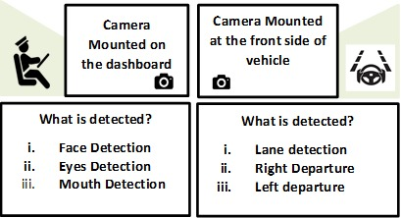

### Detecting the symptoms of fatigue with Driver Behavioral Measures

Fatigue is a term used to describe an overall feeling of lack of energy. Fatigue is also known as tiredness, reduced energy, physical or mental exhaustion, or lack of motivation. Causes of fatigue can be psychological, physiological, and physical. There some warning signs that are seen on a fatigued person.

* Tired eyes
* Tired legs
* Whole-body tiredness
* Stiff shoulders
* Trouble concentrating
* Weakness or malaise
* Boredom or lack of motivation
* Exhaustion, even after sleeping
* Irritability
* Nervousness, anxiety, or impatience

### Detecting the symptoms of fatigue with Vehicle-Based Measures

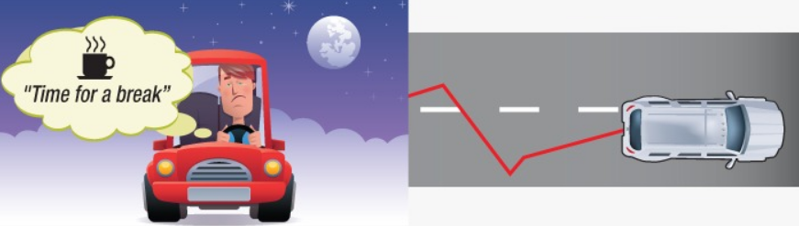

Other than drivers’ appearance we can measure the fatigue based on the driving performance which forms on the way they control the vehicle. These measures include steering wheel movement (SWM), speed variability and standard deviation of lateral position [6]. Car manufacturers such as Mercedes (MERCEDES Attention Assist™) and Volvo (Driver Alert Control) use this technique to evaluate driver drowsiness. These symptoms usually occur during the later stage of fatigue. Furthermore, these measures are highly dependent upon road geometry and are effective in a limited range of conditions. When exposed to real environments with substantial variation, these systems often fail to function effectively.[7]

## Technology Used

In this fatigue detection system, we will be using a variety of different libraries. For preprocessing and machine learning we will use OpenCV [8], Scikit Learn [9], TensorFlow [10], Keras [11]. For GUI (Graphical User Interface) we will use wxpython[12]. These libraries are supported by Python. Due to this, we will be using Python language for preprocessing, machine learning and GUI part of the project.

# Software Requirements Specification

## Introduction

### Purpose

This document is a Software Requirement Specification (SRS) for a fatigue detection system that we will work on. In recent years, road accidents have increased significantly. One of the major reasons for these accidents, as reported is driver fatigue. Accidents involving sleepy drivers tend to be particularly serious since the sleepy driver doesn't have a quick enough reaction time. Therefore, there is a need for a system to measure the fatigue level of the driver and alert him when he/she feels drowsy to avoid accidents. The aim of our project is to detect the user 's face and observe the change in facial characteristics to prevent any accidents caused by fatigue driving. The features described below are used to monitor the level of fatigue. One of the most important features is that it warns drivers that they need to take an early break. [13]

### Scope of Project

At the beginning of the project, our aim is to minimize traffic accidents. We know that fatigue has a major impact on the occurrence of accidents. In order to prevent these accidents, we aimed to create a system that stimulates fatigue to a certain level.

We will thoroughly examine the differences in the users’ face and eyes constantly and, we will consider road lanes too. The researches show that the proximity of the user to the lanes on the road is an important factor. Deviations will have a great effect on fatigue warnings. Because as the fatigue level of the users’ increases, their attention and concentration on the road will decrease.

We will develop our project by adding new ideas parallel to our consultant considering face, eye and road control. Our document research and previously developed projects will help us to use new ideas and methods.

### Glossary

Table 1 Glossary of SRS

|  |  |
| --- | --- |
| **Term** | **Definition** |
| User | The driver. |
| UI | User interface. |
| OpenCV | Open Source Computer Vision Library |
| Software Requirements Specification (SRS) | A document that completely describes all of the functions of a proposed system and the constraints under which it must operate. For example, this document. |
| Symptom | A physical or mental feature is regarded as indicating a condition of disease, particularly such a feature that is apparent to the patient. |

### Overview of Document

This document has three main parts. The first part, “Introduction” explains the main purpose, scope, glossary, references of this project. The second part, “Overall Description” contains the product perspective, features, user characteristics, and constraints. In the third part, “Requirements Specification” contains external interface requirements, functional requirements, performance requirements and software system attributes.

## Overall Description

### Product Perspective

The fatigue detection system will process the images of the user and generate a result based on both user behavioral measures and vehicle-based measures. Users’ behavioral measures can be tired and closing eyes, constant yawning, trouble concentrating, etc. Vehicle-based measures can be an unsafe lane change. Using these measurements, the system will produce a result and according to that result, the system will alert the user if s/he needs to take a break or not.

### Product Features

The fatigue detection system will constantly measure the behaviors that we have mentioned above. The system will measure any data that can lead to increased fatigue levels. According to these results, the system will alert the user.

### User Characteristics

The user does not need any skill or knowledge to use the fatigue detection system. The system constantly measures the behaviors that we have mentioned, and it automatically alerts the user if necessary. The system cannot be activated or deactivated manually; it runs as the engine of the car runs.

### Constraints

This subsection of the SRS should provide a general description of any other items that will limit the developer’s options. These include

1. Hardware limitations;

The fatigue detection system should have two cameras. (Camera 1: Will be used for monitoring drivers’ behavior, Camera 2: Will be used for lane tracking.)

1. Parallel operation;

The fatigue detection system will take input from both camera 1 and camera 2. These cameras should work parallel in order to provide a solid result.

## Requirements Specification

### External Interface Requirements

#### User interfaces

Since the fatigue detection system does not require sign up or login options, when the system starts working the main screen should pop up. This main screen will contain different kinds of information. These can be described as:

* The user can select which algorithm can be used for fatigue detection
* The parameters will be adjustable
* The screen will show which algorithm is running,
* What parameters are used while the algorithm running,
* When the input is given to the system, what outputs are obtained from this input

#### Hardware interfaces

To be able to obtain inputs in this system the user will need two different cameras:

* Camera 1: It will be used for monitoring drivers' behavior.
* Camera 2: It will be used for lane tracking.

#### Software interfaces

The machine that will be used for this fatigue detection system should have these libraries:

* OpenCV
* Scikit Learn
* TensorFlow/Keras

#### Communications interfaces

This fatigue detection system does not require any internet connection.

### Functional Requirements

The system will run when the user starts the car. If the face detection camera can recognize users’ face, the system will process the images and it will compare the results as time goes by. Since there are two cameras, the system will interact with both and the system will combine the data obtained from both cameras. If multiple symptoms occur, the system will give alert to the user after the analyze of the symptoms. However, only one of the symptoms occurs the system will decide whether that symptom is important or not. According to these results, the system will determine fatigue level and it may give an alert if the symptom is important.

### Performance Requirements

The steps given below are to perform the implementation of the fatigue detection system.

#### **Normalization**:

The basic objective of normalization is to reduce redundancy which means that information is to be stored only once. Storing information several times leads to wastage of storage space and an increase in the total size of the data stored. If a database is not properly designed, it can give rise to modification anomalies. Modification anomalies arise when data is added to, changed or deleted from a database table. Similarly, in traditional databases as well as improperly designed relational databases, data redundancy can be a problem. These can be eliminated by normalizing a database. Normalization is the process of breaking down a table into smaller tables. So that each table deals with a single theme. There are three different kinds of modifications of anomalies and formulated the first, second and third normal forms (1NF, 2NF, 3NF) is considered sufficient for most practical purposes. It should be considered only after a thorough analysis and complete understanding of its implications. The necessity of such a process can be discussed in the future.

### Software system attributes

#### Accuracy

The fatigue detection system should be able to know the difference between a fatigued driver and a normal driver.

#### Functionality

This system will work as intended and detect a certain level of fatigued drivers.

#### Portability

If this system will be used in a real car, this fatigue detection system should be adjusted according to the new operating system.

# Software Design Description

## Introduction

### Purpose

The purpose of this SDD is to describe the implementation of the Fatigue Detection System. The Fatigue Detection System is designed for drivers to detect their fatigue level.

### Design Goals

In recent years, road accidents have increased significantly. Accidents involving sleepy drivers tend to be particularly serious since the sleepy driver does not have a quick enough reaction time. Therefore, there is a need for a system to measure the fatigue level of the driver. Afterward, according to these measurements, the system alerts the driver when he/she feels drowsy to avoid accidents. The aim of our project is to detect the users' face and observe the change in facial characteristics to prevent any accidents caused by fatigue driving. One of the most important features is that the system warns drivers that they need to take an early break

### Glossary

Table 2 Glossary of SDD

|  |  |
| --- | --- |
| **Term** | **Definition** |
| SDD | Software Design Document |
| User | The driver |
| UI | User interface |

### Overview of document

This document contains ‘Architecture Design’ and ‘System Architecture’ topics. ‘Architecture Design’ contains ‘Simulation Design Approach’, ‘Use Case Diagram’, ‘Activity Diagram’ and ‘Interface Design’ subheadings and ‘System Architecture’ contains ‘Data Management’, ‘Hardware/Software Mapping’ and ‘Access Control and Security’ subheadings.

## Architecture design

### Simulation Design Approach

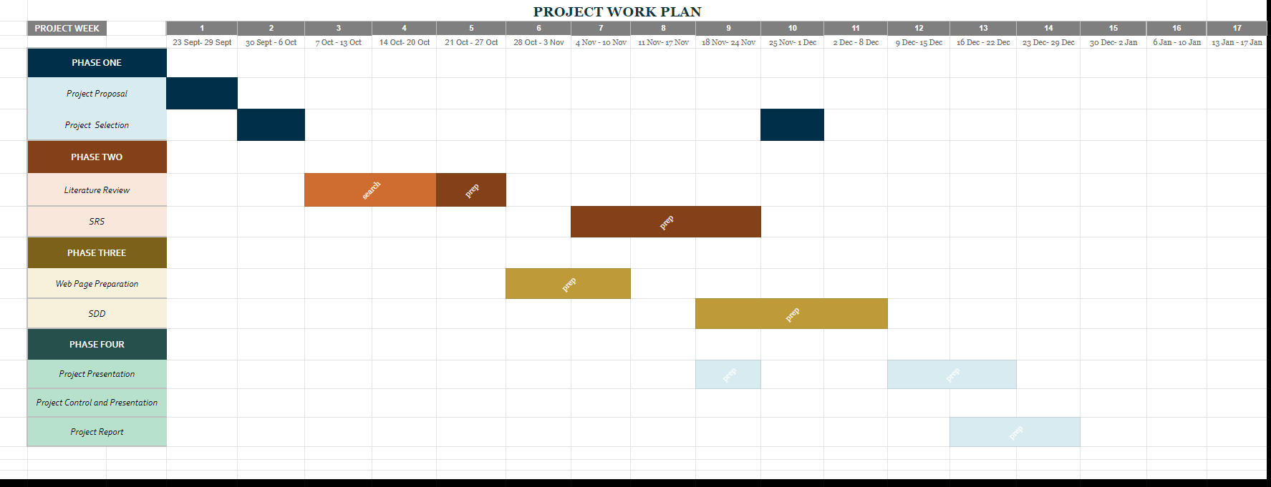While developing this system, we used Scrum. Scrum is incremental and iterative. In scrum, the main work is divided into sprints which should be completed within a certain period of time which could be 30 days on average. Iteration length of every sprint must be equal because scrum is an agile development methodology. Every Sprint includes tasks that have own story points and risk points. The development team should have a daily meeting every morning which should be a maximum of 15 minutes. Scrum has three main roles which are product owner, scrum master, and development team. The product owner is the person who delivers the requirements, the scrum master is the person who manages the development team. The development team is the group of developers who work on the project according to schedule. There are some advantages of Scrum. The first advantage is that it is easier to cope with changes because of short sprints and constant feedback. Another advantage is problems can be handled swiftly due to morning meetings. Also, it makes it possible to create quality products at scheduled times. [14] Our work plan was designed according to this guide.

Figure 1 Work Plan

### Use case diagram

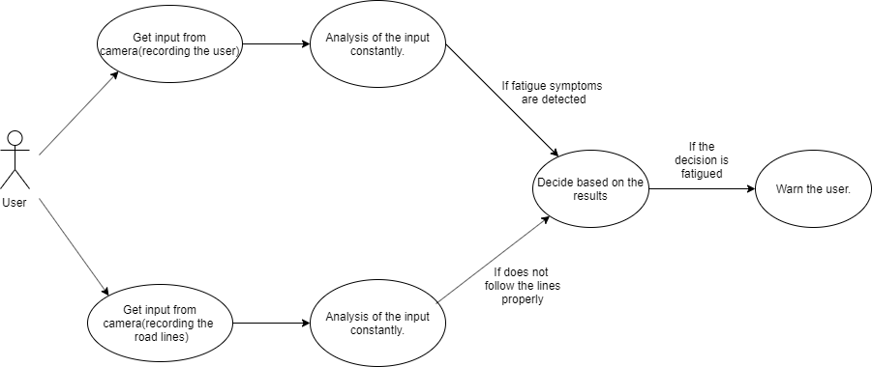

Figure 2 Use Case Diagram

**Description:**

Figure 2 shows the use case diagram when the driver starts the system. When the user starts the engine, two cameras start to record. While one of them records the users' face, the other one records the road lanes. Each input gets analyzed and the system will check for fatigue symptoms.

If the recorded symptoms are exceeding the specified limit system will warn the user.

**Initial Step-By-Step Description:**

1. The system starts to get input from cameras.

1.1. The dashcam starts recording the driver.

1.2. Front cam starts recording the road lanes

2.Analysis of the inputs from the cameras

2.1. If there are any fatigue symptoms on the users’ facial expressions it will record it as a symptom.

2.2. If the user does not follow the road lanes it will be recorded as a symptom

3. If recorded symptoms exceed a certain level warn the user.

### Activity Diagram

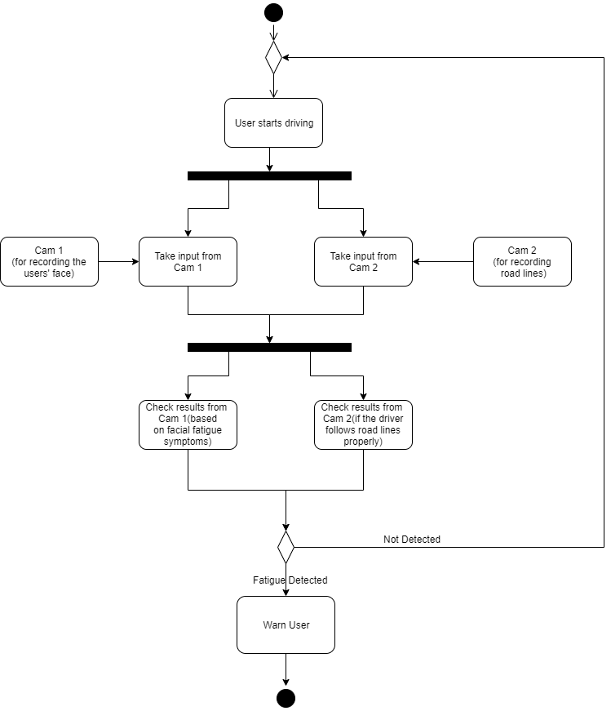

Figure 3 Activity Diagram

Fig3 shows the flow of the system. When the system starts working, it will get inputs from two different cameras simultaneously (dashcam and front cam) and analyze it for fatigue symptoms. This process repeats as long as the system is on or until fatigue is detected.

### Interface design

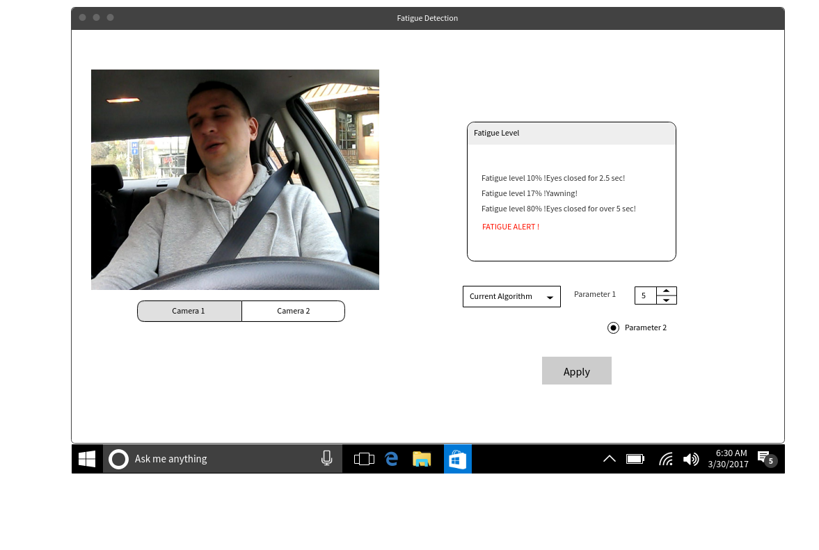

Figure 4 Testing UI 1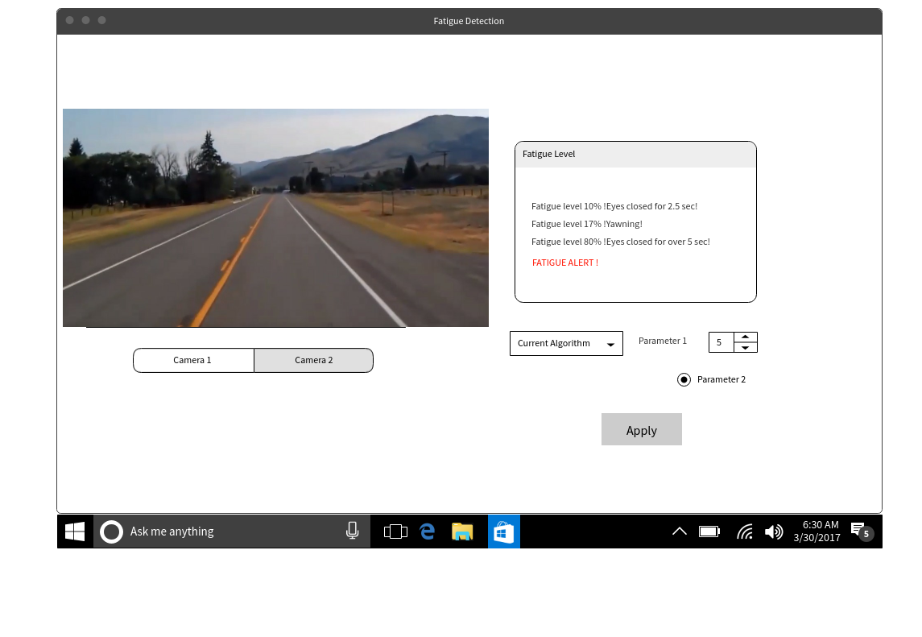

**Figure 5 Testing UI 2**

The user interface will consist of 3 parts. The first one is for cameras. The user will be able to switch between these cameras. The second part will be the output box. This box will print the output of each frame that was received from both cameras. The third part will consist of a dropdown box that contains a different algorithm that can be selected, and a parameter section that will allow the user to change the parameters of the algorithms. After making changes in these parts, the user will be able to click on the ‘Apply’ button and get outputs from different algorithms and parameters. If the fatigue level starts increasing, the output box will give alert both as in text and in sound.

## System Architecture

### Data Management

This fatigue detection system will work on a computer. Due to this, the data that we obtained from users' driving session will be stored in the computer.

### Hardware/software mapping

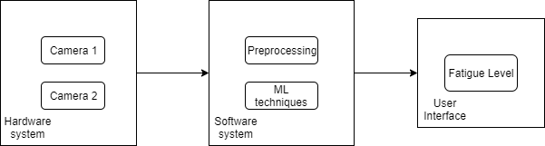

**Figure 6 Hardware/Software Mapping**

In Figure 6:

* Camera 1: This camera will be used for monitoring drivers' behavior.
* Camera 2: This camera will be used for lane tracking.

#### Preprocessing

Preprocessing can be referred to as the preparation process of giving the data that was obtained from camera 1 and camera 2 as our input for the next step (ML Techniques). We will be using the OpenCV library for this process.

#### Machine Learning Techniques

The process of learning begins with observations of data, such as examples, direct experience, or instruction, in order to look for patterns in data and make better decisions in the future based on the examples that we provide. There is three types of machine learning techniques:

1. Unsupervised Learning
2. Supervised Learning
3. Reinforcement Learning

We will use Scikit Learn, Tensorflow/Keras libraries for this process.

### Access control and security

In this system, when the driver starts to drive, and the system starts to receive input. We store the data and only the computer uses the data we obtain while the driver is driving. Therefore, no security problems will be encountered.

**REFERENCES**

[1]<https://us.norton.com/internetsecurity-iot-how-facial-recognition-software-works.html>  
  
[2]<https://searchenterpriseai.techtarget.com/definition/facial-recognition>  
  
[3]<https://www.researchgate.net/publication/304456168_Dynamic_Driver_Fatigue_Detection_Using_Hidden_Markov_Model_in_Real_Driving_Condition>  
  
[4]<https://www.cs.cmu.edu/~efros/courses/LBMV07/Papers/cootes-eccv-98.pdf>  
  
[5]<https://pdfs.semanticscholar.org/892f/a8cadedc265d41dd4d0680274fc7c9afa536.pdf>

[6]<http://www.inescporto.pt/~jsc/publications/conferences/2018LicinioEUVIP.pdf>  
  
[7]<https://pdfs.semanticscholar.org/d77e/c188ca65bca836ea7b54058e9c2af8424dc6.pdf?_ga=2.214630871.1947781020.1572535074-2031531292.1572535074>

[8] <https://opencv.org/>

[9] <https://scikit-learn.org/stable/>

[10] <https://www.tensorflow.org/>

[11] <https://keras.io/>

[12] <https://wxpython.org/>

[13] [An Improved Fatigue Detection System Based on Behavioral Characteristics of Driver](https://www.researchgate.net/publication/319895202_An_Improved_Fatigue_Detection_System_Based_on_Behavioral_Characteristics_of_Driver)

[14] H. Lei, F. Ganjeizadeh, P. Jayachandran and P. Ozcan, "A statistical analysis of the effects of Scrum and Kanban on software development projects", 2016.

[15] Lyznicki, J M., Doege, T C., Davis, R M., & Williams, M A. (1998) Sleepiness, driving, and motor vehicle crashes. Journal of the American Medical Association, 279(23), pp. 1908-1913

<http://cengproject.cankaya.edu.tr/wp-content/uploads/sites/10/2017/12/SDD-ieee-1016-2009.pdf>

<http://cengproject.cankaya.edu.tr/wp-content/uploads/sites/10/2017/10/SRS_Simulacrum_2ndEd.pdf>