Accuracy of the determined requirements

* Deformations of each mechanical part, including joints (bearings):
  + Prepare Mask for tracking for 2 mechanical parts
    - * The mechanical part fixed to the ground

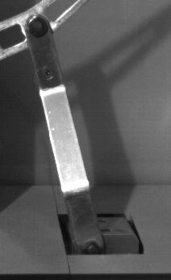

* + - * One bearing

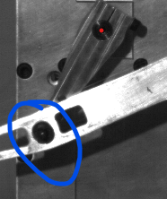

*I chose these parts because they’re not covered by other moving parts throughout the video and also they’re less affected by the lighting.*

*(In the document they said all mechanical parts, but that would be hard to do esp due to the problem I mentioned earlier. I suggest we do only for two parts and then explain we could possible scale it but it would need more work).*

* + Detect and track edges of the mechanical parts with as many as possible points
  + Choose one point for each part (kind of like a Center for them) and track the edge throughout the video. We can get the position graph and see if there’s any movement happening between the edge points and the center point to see any deformation.
  + Present our graph findings and inform how similarly they can use the code for other similar systems to detect differences.  
      
    *(I know it won’t be accurate esp because we will be losing some points and also the reading would also be affected by the motion when the components become blur and all, but this is the best I could think of and we can also list the problems we faced when presenting).*
* Detecting vibration frequencies in the system:
  + We already have the motion of the system graph (The position and speed). We can perform FFT on the position and detect at which part of the video there’s the most motion hence more vibration.  
    *(I know it’s not ideal but this is what I can think of what we can realistically do given the time we have left).*
* Validating the virtual controller trajectory using camera measured trajectories.
  + We have the virtual controller trajectory (The graph they gave us), all we have to do is compare it with the one we got by our graph.   
    *(We already have our graph and we can say we validate it’s the same).*
* Additionally: Detecting differences between the motions of the 7 recordings:
  + We have to plot the motion trajectory graph for all 7 of the video (The position and speed) and present them… see if they have any difference.

Insight in the developed/used code

* Try to understand what the code does and how we structured everything. I believe they’ll question us individually of what each line of code does. And Idk about University of Antwerp but at my Home university if we have a one-to-one assessment you’re not allowed to put comments in your code so it’s best to know about it before the presentation.

Quality of the practical elaboration

* I think the best we can do is try to produce the graphs and label them properly so that we can describe them properly. We can also try to have different MATLab script or sections within the script while demonstrating what we did. I think having the graphs as a picture and the tracking videos prepared before the presentation is better given because I believe we only have 15 mins to present.

Completeness of the overview in possible approaches based on preliminary research

* I believe this is about what different tactics we’ve tried and why we chose what we have now. I think this one Berkay should handle it, given that you’ve have some recordings and you did the most research. It doesn’t have to be deep, I think we just need to say some words about it.