Advertisement Investments Distribution of Turkey by Medium

E. Berke Karagöz  
*Dept. of Computer Technology and Information Systems*  
*Bilkent University*Ankara, Turkey  
e.berkekaragoz@gmail.com

Sinan Işık  
*Dept. of Computer Technology and Information Systems*   
*Bilkent University* Ankara, Turkey  
isiksinan7@gmail.com

*Abstract* — Advertising is important for every aspect of a business because the objective of it is reaching out to the customer. It helps a business to earn more by allowing people to know about the products and services. This paper works on the data about advertising investments of Turkey that is provided by Turkish Association of Advertising Agencies (TAAA). By using the data provided by TAAA (rd.org.tr), visualizations have been made in order to reveal which media investments were made by years. The result of this study is expected to expose the change with different types of data visualization over years. The study also indicated that within the period of 8 years, there is a significant change in digital and traditional media investments in Turkey.

Keywords - Media, Investments, Marketing, Advertisement, TAAA, IAB, Turkey, Medium, Distribution

Türkiye’nin Mecralara Göre Medya Yatırımları Dağılımı

*Özet* — Reklamcılık bir işletmenin her yönü için önemlidir çünkü hedefi müşteriye ulaşmaktır. İnsanların ürünler ve hizmetler hakkında bilgi sahibi olmasını sağlayarak bir işletmenin daha fazla kazanmasına yardımcı olur. Bu çalışma, Türkiye Reklamcılar Derneği tarafından sağlanan Türkiye’nin reklam yatırımlarına ilişkin veriler üzerinde çalışmaktadır. Türkiye Reklamcılar Derneği tarafından sağlanan veriler kullanılarak yıllara göre hangi medya yatırımlarının yapıldığını ortaya koymak için görselleştirmeler yapılmıştır. Bu çalışmanın sonucunun farklı veri görselleştirme türleri ile değişimi yıllar içinde ortaya çıkarması beklenmektedir. Çalışma aynı zamanda 8 yıl içinde Türkiye’de dijital ve geleneksel medya yatırımlarında önemli bir değişiklik olduğunu göstermiştir.

Anahtar Kelimeler - Medya, Yatırımlar, Pazarlama, Reklam, TAAA, IAB, Türkiye, Dağılım

# Introduction

The objective of marketing is to promote products or services to potential customers. There have been many innovations in marketing throughout history. The most important of them is the development of technology. As a result of developing technologies, the marketing and advertising strategies of firms and consumption habits of customers have been changed. Widespread usage of the internet has a great impact on both firms’ marketing and advertising strategies and consumption habits of customers [1]. The interaction of the user with the advertisement increases at the same level as the time spent on the internet [2]. Since the internet covers communication and information tools of both past and future, it has a constantly changing developing and growing structure. This has a great impact on marketing industry trends. Even if digital marketing has grown exponentially, it is not true to ignore huge investments in marketing through traditional media. Past communication and information tools that are under the traditional marketing correspond to books, magazines, newspaper, radio and television which can be also called traditional. With the rise of the internet, everyday life is changed and the attention of customers is shifted [1]. Thus, it is not surprising that there will be shifting also in advertising approaches. Being aware of this quick shift between traditional and digital marketing is crucial for companies to reach out to the target customers.

It is not easy to decide on a marketing strategy for almost all businesses without considering the size of it. Analyzing the preferences of people and keeping track of competitors’ strategies are not an easy task most of the time. Spending money in the right direction from the budget that is allocated for marketing is very crucial because it can make huge differences for businesses to use marketing properly [2]. That is why having knowledge about different types of marketing strategies and the effects of them can highlight the companies and make a difference between them. It is a debate whether choosing traditional marketing or digital marketing to appeal to the customer for a specific type of product or service. By gaining insight about both marketing aspects can get a better idea about preferring the appropriate market and application method [3].

# Study area and methodology

In this study, the quantitative data of Turkey, which is our study area, are organized and analyzed in order to interpret with visualization. We have used the data provided by the Turkish Association of Advertising Agencies (TAAA) and IAB (Interactive Advertising Bureau). TAAA is the only association that publishes data related to media investments in Turkey. In the website of TAAA (rd.org.tr) there are Media and Advertising Investment Reports that are published twice per year for the first and second half of the year. We have cleaned and prepared the data to be used in this study. The distribution of investments and money spent on various media are examined by exhibiting the changes over the years. The data collected from TAAA is also presented in relation with a developed country which is the USA in order to make a comparison of expenditure and see the different distribution of media. In the website of TAAA (rd.org.tr) there are Media and Advertising Investment Reports that is published twice per year for the first and second half of the year. We have cleaned and prepared the data to be used in this study.

# Results and dıscussıon

The media investments have been categorized to 6 different mediums as a general outline. These categories are consisting of: Cinema, Digital, Outdoor, Press, Radio and TV.

## **Media Investments Distribution of Turkey**

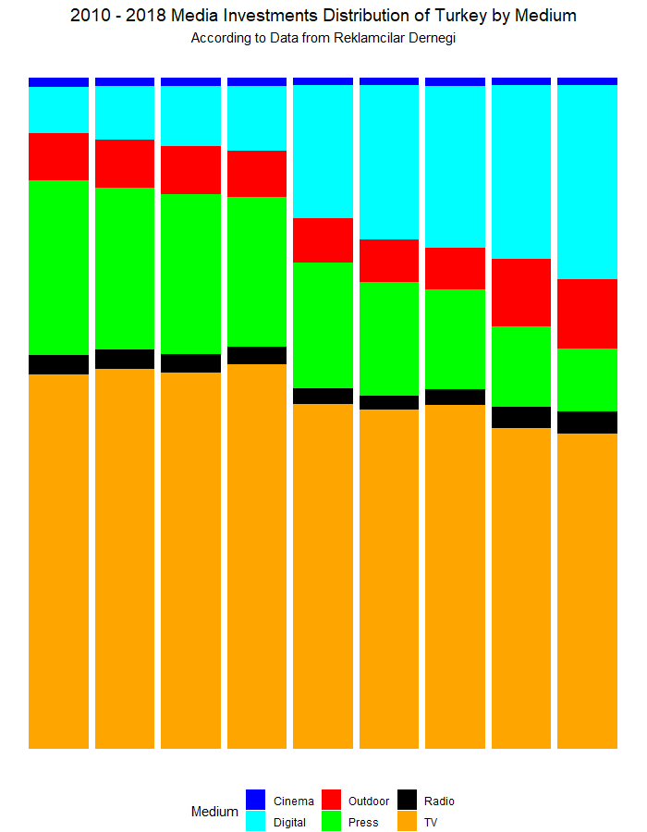

*Figure 2: 2010 - 2018* *Media Investments Distribution of Turkey by Medium According to Data from TAAA*

The most invested media is TV in Turkey. It allocates almost half of the budget every year of Turkey since 2010. The second one at the years close to 2010 is press media however, it is taken over by digital media afterwards. Cinema and radio have the least invested categories [4].

The investments going to press is decreasing every year while digital media investments are increasing. The reason behind this is, digital media is more efficient and effective than press media [5]. Digital marketing tools aim to appeal to target customers rather than reaching to general community. TV’s investments are also decreasing with the same reasoning as press. Digital media can be a substitute of other media since, it can contain the functionalities they have [6].

Figure 2 visualizes the difference of the media investments distribution by year. Each color represents a medium and the vertical axis shows the percentage they got out of the total investments.

It is clear that while press marketing is decreasing, digital marketing channels are increasing. Majority of the investments are going into TV advertisements; however, it is also slowly decreasing. The minimum investments that the digital marketing got is at 2010 with 252 million TL. However, it constantly grew and got 2.385 million TL of investments at 2018 [7]. This is an attention-grabbing amount of growth.

## **Digital vs Traditional Media Investments of Turkey**

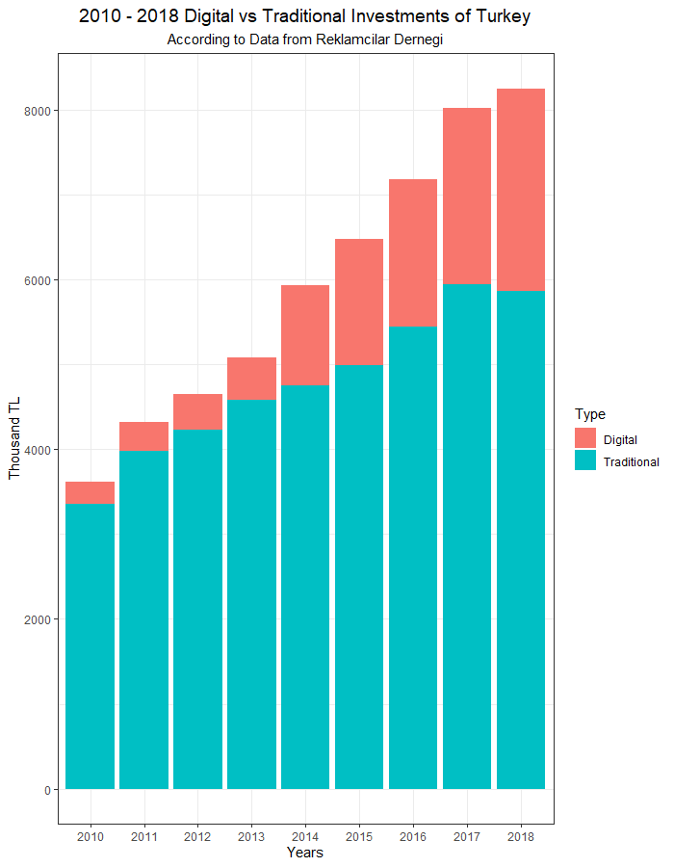

*Figure 3: 2010 - 2018 Digital vs Traditional Media Investments of Turkey According to Data from TAAA*

The debate related to marketing strategies is long and

lasting since the usage habits of people keep changing day by day. With the shift of attention there is also the shift of advertising. Certain businesses have specific essentials when choosing an advertising strategy but still there is an ongoing debate about marketing. There are two main types of marketing strategies which are traditional and digital [3]. In order to clarify these terms, it is required to mention their scope. Traditional marketing is a conventional way of marketing that is not online. It covers 5 major categories: print (magazines, newspapers), broadcast (TV, radio), direct mail, telephone and outdoor (billboards, fliers) [8]. On the other hand, digital marketing is any form of marketing that utilizes the internet. It includes any marketing that is online such as social media ads, email marketing and search engine marketing [9].

Figure 3 illustrates the amount of spending on digital and traditional advertising investments between the years 2010 and 2018. The vertical axis represents the money spent in thousand TL, and the horizontal axis represents years at 1-year intervals.

It can be seen that the total money spent on advertising is increased year to year. Digital advertising investments are increased faster than traditional ones [4]. While the difference between 2 aspects is extreme in 2010, digital seems to close the gap with traditional because the internet is becoming one of the most used tools.

## **Turkey and the USA Internet Usage Comparison**

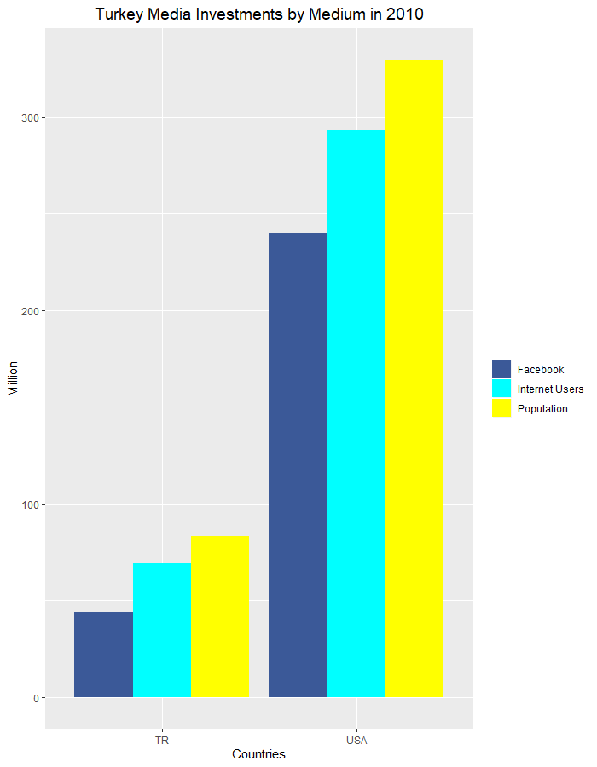

*Figure 4: 2019 Estimates of Internet Usage and Population of Turkey and the USA According to Data from Internet World Stats*

Population is a crucial part of marketing since it depends on people that could be reached. If the population is high the return of investments will be higher however, it does not mean that the return of investments rate will be high also. To find out about the effects of population, Turkey and the USA has been compared by population and internet penetration rate.

Figure 4 compares Turkey and the USA by internet penetration rate. The horizontal axis is the amount of people and the groups are by the countries. The colors represent Population, Internet and Facebook Users. It can be seen that the USA has more amount of people that they can do marketing to. Which means that they are more likely to have a bigger market and impact. However, there is not a noticeable difference internet penetration rate wise.

The USA has approximately 329 million and Turkey has approximately 83 million population. While the USA has 89% internet penetration rate, Turkey has 83.3%. This means that Turkey should place importance on digital media as much as the USA does [10], [11].

## **Turkey and the USA Media Advetisement Expenditures Comparison**

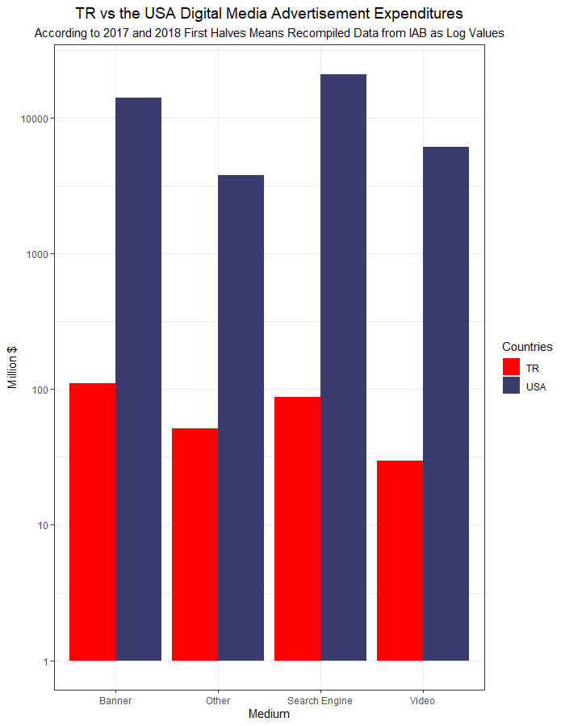

*Figure 5: Turkey and the USA Digital Media Advertisement Expenditures According to Interactive Advertising Bureau*

The USA has made 89.791 million U.S. dollars of expenditures to digital media in total in first halves of 2017 and 2018 while Turkey has made 559 million U.S. dollars. This is a vast amount of difference between two countries. The USA has made expenditure on search engines the most by spending 41.957 million U.S. dollars. However, Turkey made the most expenditure on banners with 221 million U.S. dollars [12], [13].

Figure 5 illustrates the amount of expenditure between the TR and the USA the vertical axis represents the money spent in Million $, and the horizontal axis represents media consist of Banner, Search Engine, Video and Other. The red bars represent the Turkey and the blue part of the bars represent the USA. Since there is a huge gap between the 2 countries in terms of money spent on advertising, logarithmic scale is used in order to clarify the difference.

It can be seen that the total money spent by the USA on digital advertising are much higher than TR [12], [13]. The distribution of four media are close when the country examined within itself. However, when two countries are compared to each other, it is obvious that there is a significant gap between. As a result, with the help of logarithmic scale, the difference is aimed to be demonstrated.

## **Media Investments in Turkey in 2010**

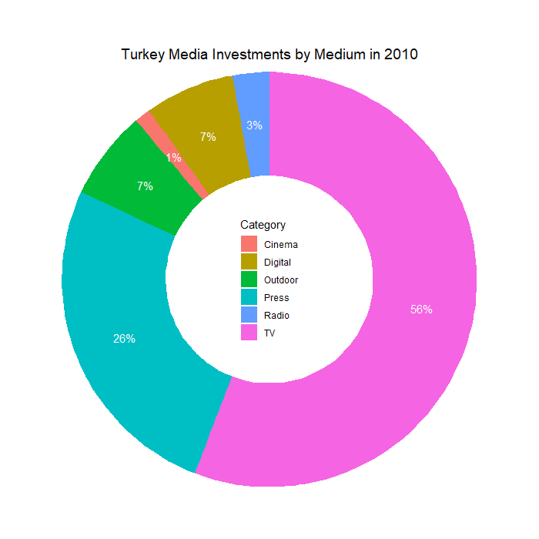

*Figure 6: Media Investments in Turkey by Medium in 2010*

Turkey has made 3.612 million ₺ of investments to media in 2010 in total. The main allocation of budgets for media were made for TV with 56% and press with 26% of the total investments. These two media combined together are worth 2.960 million ₺ and were 82% of the total investments. The digital media only had 7% with 252 million ₺ of capital goods [7].

In 2010’s press media were more effective compared to the later stages of advertising since, digitalization was not spread enough to suppress press media with digital media [14]. The media investments distribution in Turkey is visualized in Figure 6. Digital media is not a part of the mainstream media investments as such as TV and press. Instead, it is a minor part of the investments along with cinema, radio and outdoor media. This changed at the later phases of the Turkey’s marketing approach [7].

## **Media Investments in Turkey in 2018**

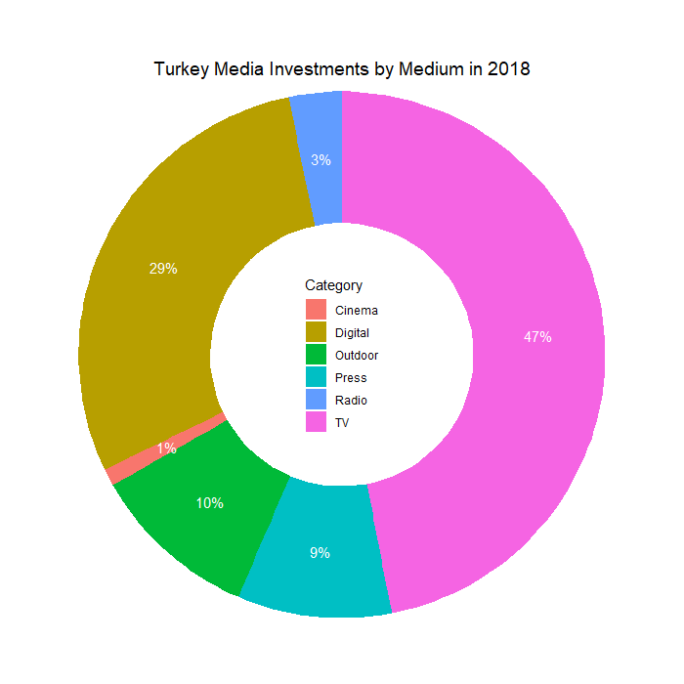

*Figure 7: Media Investments in Turkey by Medium in 2018*

According to Figure 6 and 7, it is clear that the majority of media spending for Turkey is allocated for TV. However, it is apparent that the money spent on TV are decreased in an interval in 8 years. Beside this, the media investments allocated for digital are dramatically increased.

Digital media is no more in the minor media category. It has 29% with 2.385 million ₺ of investments in 2018. Press is decreased to 9% with 781 million ₺ of investments. Digital media has become the substitute of press since those media can be digitalized without major difficulty [7].

There is a noticeable amount of growth in total media investments in Turkey. There is a total of 8.251 million ₺ of media investments in 2018. Compared to 2010, there is 128% growth rate by adding 4.639 million ₺ to, 2010 total investments, 3.612 million ₺ [7].

## **Descriptive Statistics**

To be able to analyze the changes in investments, descriptive statistical analysis was conducted. Table 1 contains the statistical data of distribution of investments by yearly data and categorized by the medium. They were analyzed with maximum values (Max), 95% percentile, 75% percentile, average value, 25% percentile, 5% percentile, minimum values (Min), standard deviation (Std), coefficient of skewness (Skew) and the coefficient of kurtosis (Kur). All categories have 9 number of available data (NAD) since it is created from 2010 to 2018.

The biggest difference between minimum and maximum value is digital media investments as discussed. The difference is 2.133 million ₺, almost is equal to the current highest invested year of digital media. Which means that it came from nearly non-existing state [14].

Cinema media gets the lowest investments throughout all the categories. Its growth is stable and in-line with the growth of the total investments. Radio and outdoor media are in a similar situation however, they fluctuate more than cinema. TV has the highest amount of investments however, its share is slowly decreasing. Not only the share of investments on press is decreasing, its investments is also decreasing, even though the growth of the total investments made in media [7]

*Table 1. Descriptive Statistical Values of Media Investments in Turkey Between 2010 and 2018*

|  |  |  |  |  |  |  |  |  |  |  |  |
| --- | --- | --- | --- | --- | --- | --- | --- | --- | --- | --- | --- |
| **MI of Turkey** | **Descriptive Statistics** | | | | | | | | | | |
| **Million TL** | **NAD** | **Max** | **95%** | **75%** | **Average** | **25%** | **5%** | **Min** | **Std** | **Skew** | **Kur** |
| Television | 9 | 3.875,00 | 3.834,00 | 3.680,00 | 3.076,78 | 2.606,00 | 2.447,79 | 2.017,69 | 649,97 | -0,15 | -1,55 |
| Press | 9 | 1.139,00 | 1.118,57 | 1.114,00 | 1.029,90 | 963,00 | 942,12 | 781,00 | 115,68 | -0,97 | -0,40 |
| Outdoor | 9 | 852,00 | 805,00 | 449,00 | 460,09 | 328,10 | 306,35 | 252,00 | 217,15 | 0,92 | -0,97 |
| Radio | 9 | 269,00 | 255,00 | 169,00 | 161,80 | 129,80 | 121,07 | 103,72 | 59,47 | 0,90 | -1,01 |
| Cinema | 9 | 89,00 | 85,00 | 81,14 | 66,52 | 54,15 | 53,30 | 45,50 | 15,63 | 0,19 | -1,74 |
| Digital | 9 | 2.385,00 | 2.077,00 | 1.736,00 | 1.152,96 | 421,10 | 344,10 | 251,84 | 810,64 | 0,20 | -1,78 |

# Conclusıon

Although digital marketing has grown rapidly over the years when compared to traditional marketing, specific brands are still using the traditional way of marketing [15]. Thus, even if the interaction of people with traditional marketing decreases, the expenditure rates shows that the presence of traditional marketing has a certain place. The debate between the digital marketing and traditional marketing is far from over. Questions in people’s minds that are related to where to invest will keep coming because there is no straight answer for these types of questions. However, with the help of data visualization it is clarified that the development of information and communication technologies changed the way people interact with the world. As a result of the huge adoption of smartphones, the popularity of digital marketing has exploded. This is the reason behind the growth of digital marketing that is illustrated with donut charts as a result of 8 years data.

# References

|  |  |
| --- | --- |
| [1] | K. Francis, "Small Business - Chron.com," Chron.com, 12 February 2019. [Online]. Available: https://smallbusiness.chron.com/internet-impacted-businesses-321.html. [Accessed 2 January 2020]. |
| [2] | B. Smith, "31 Advertising Statistics to Know in 2018," WordStream, [Online]. Available: https://www.wordstream.com/blog/ws/2018/07/19/advertising-statistics. [Accessed 2 Jan. 2020]. |
| [3] | Sherman, "Digital Marketing vs Traditional Marketing: Which Produces Greater ROI?," Digital Marketing Blog, 6 Oct. 2019. [Online]. Available: https://www.lyfemarketing.com/blog/digital-marketing-vs-traditional-marketing/. [Accessed 30 Dec. 2019]. |
| [4] | R. Derneği, "Medya Yatırımları," Reklamcılar Derneği, [Online]. Available: https://www.rd.org.tr/medya-yatirimlari. [Accessed 4 Dec. 2019]. |
| [5] | "Find Market Research Companies, Facilities, Jobs, Articles, More," Quirks, [Online]. Available: https://www.quirks.com/articles/is-digital-media-less-effective-than-traditional-media. [Accessed 15 Dec. 2019]. |
| [6] | Uhuru Network, 3 May 2016. [Online]. Available: https://uhurunetwork.com/social-media-vs-traditional-media/. [Accessed 15 Dec 2019]. |
| [7] | "Medya Yatırımları," Reklamcılar Derneği, 2010-2018. |
| [8] | "9 Traditional Marketing Techniques That Still Matter," Online Marketing Institute, 1 June 2018. [Online]. Available: https://www.onlinemarketinginstitute.org/blog/2018/06/9-traditional-marketing-techniques-still-matter/. [Accessed 30 Dec. 2019]. |
| [9] | K. Carmicheal, "Traditional Marketing vs. Digital Marketing: Why Not Both?," HubSpot, [Online]. Available: https://blog.hubspot.com/marketing/traditional-marketing-vs-digital-marketing. [Accessed 30 Dec. 2019]. |
| [10] | "Europe Internet Use and Population Statistics," [Online]. Available: https://www.internetworldstats.com/stats4.htm. [Accessed 4 Dec. 2019]. |
| [11] | "Europe Internet Use and Population Statistics," [Online]. Available: https://www.internetworldstats.com/stats14.htm. [Accessed 4 Dec 2019]. |
| [12] | "IAB ABD 2018 İlk Yarı Dijital Reklam Yatırımları Açıklandı," IAB TURKEY, [Online]. Available: https://www.iabturkiye.org/iab-abd-2018-ilk-yari-dijital-reklam-yatirimlar. [Accessed 4 Dec 2019]. |
| [13] | "IAB Turkey Released 2018 Digital Ad Spend," IAB TURKEY, [Online]. Available: https://www.iabturkiye.org/iab-turkey-released-2018-digital-ad-spend. [Accessed 4 Dec 2019]. |
| [14] | "The rise of social media," Our World in Data, [Online]. Available: https://ourworldindata.org/rise-of-social-media. [Accessed 2 Jan. 2020]. |
| [15] | "Advantages of Traditional Marketing," Strategic Marketing, 8 Nov. 2018. [Online]. Available: https://thinkstrategic.com/advantages-traditional-marketing/. [Accessed 2 Jan. 2020]. |