**Viewing Zabbix Reports**

**1. Introduction**

This document (1) provides information on how to install and use the software file used to generate summarized acknowledgments reports in our Zabbix system with just one click. The software provided to you retrieves data from the Zabbix database, generates reports, and presents them in Excel format.

**2. Installation**

First and foremost, it should be noted that the software provided only works on a Linux server where Zabbix is installed and running with MySQL.

**2.1 Installation Steps:** First, don't forget to take a SNAPSHOT to ensure there are no issues with the system 😊 The steps to be taken are as follows:

Snapshot (Recommended)

Include the file provided to you on the server via FTP or SFTP

Installation of Node.js

Installation of the MySQL module

Installation of the Express module

Installing Dependencies: Open Terminal or Command Prompt, navigate to the project directory, run the commands, and you'll be ready to start the installation process.

**Installation Steps:**

1.Open Terminal or Command Prompt and navigate to the project directory.

**2.**Download the necessary source to install Node.js by running sudo yum install node. This command will prompt the installation screen.

1. 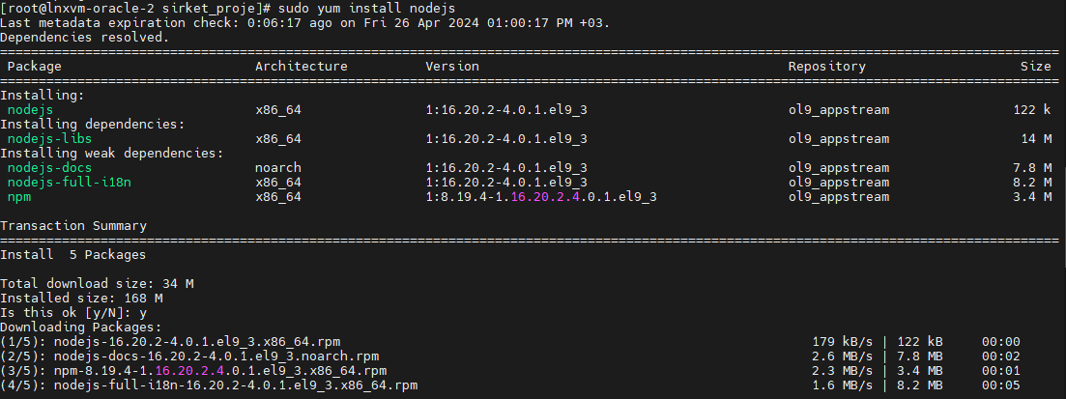
2. Open the app.js file with the Nano editor and customize/modify the necessary parts related to MYSQL according to your own settings (PORT, HOST, USER, PASSWORD, DATABASE).
3. 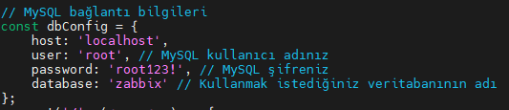
4. NOTE: It is not recommended to use the (.) symbol in the password (MYSQL CANNOT DECODE IT INTERNALLY).
5. You can start running it with node app.js.
6. 
7. You can access the screen by going to the web URL with the machine's IP and port, for example: http://192.168.52.70:4000/
8. 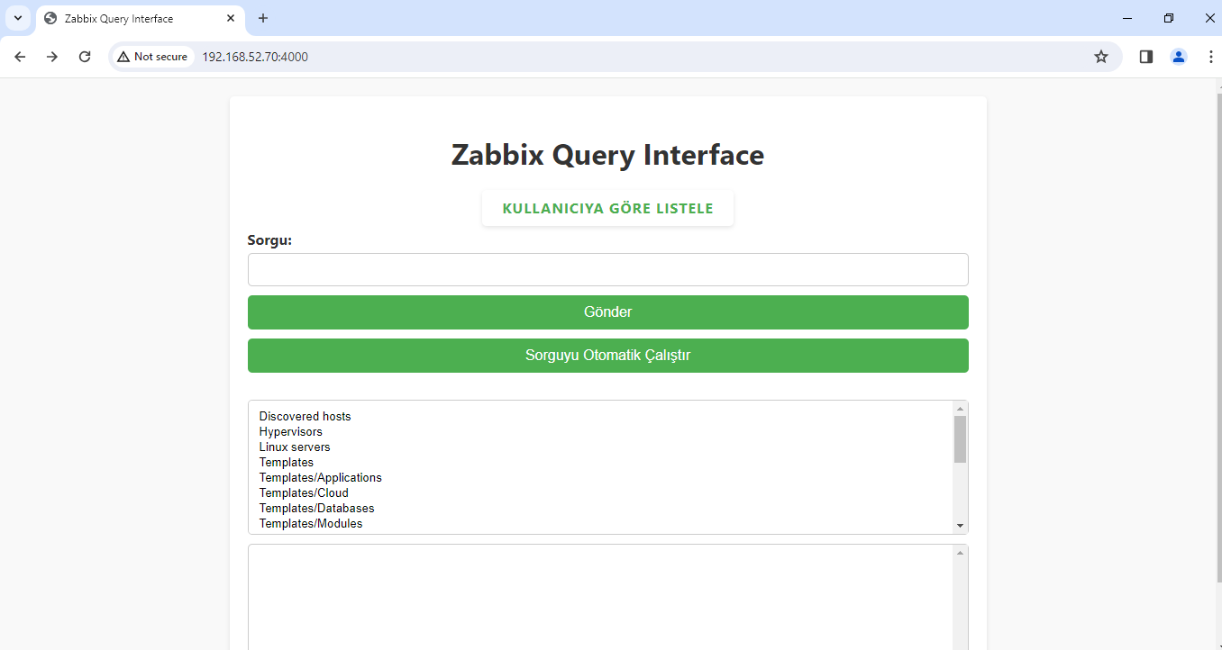

**3.** **Use** The homepage contains a total of 3 buttons, 2 listboxes, and 1 textbox. The first button navigates to the second page. When the "Send" button is pressed, it displays any query from the textbox in tabular form below. Pressing the "Run Query Automatically" button executes a query process from the severity of acknowledges' events. The "Template" contains the templates available in your Zabbix; if there is an alarm, the second template specifies which host it came from. Just click on it, and you'll see its output below. **3.1.USE(2):** you can find the log of their last acknowledges entry. A log process occurs from the time of the last received alarm to what was acknowledged. After clicking the "Export to Excel" button, you can export it to Excel after selecting the user for whom you want to get the output, and you'll have a document record. 😊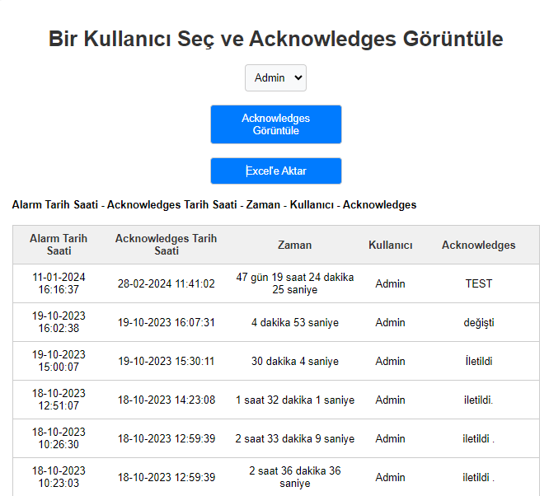

**4.Result**:Sonuç olarak raporlama çıktısının görsel arayüzü ekrana gelmiş bulunmaktadır.

As a result, the visual interface of the reporting output is displayed on the screen.

(1) Represents the first page.

(2) Represents the second page, accessible via /user.html.

***İyi Çalışmalar*** 😊